Tiếng Anh 7 – i-LEARN SMART WORLD

UNIT 2 TEST
Note: Each correct answer earns 0.2 points.

I. PRONUNCIATION (0.8 points)
A. Choose the word whose underlined part is pronounced differently.
1. A. lunch B. hurt C. junk D. much
2. A. give B. get C. ginger D. good
B. Choose the word that has a different stressed syllable from the rest.
3. A. advice B. tired C. toothache D. fever
4. A. vitamin B. medicine C. favorite D. overweight

II. VOCABULARY AND GRAMMAR (2.4 points)
Choose the best option (A, B, C or D) to complete each of the following questions.
5. You should __________ regular exercise, go swimming and lead an active life.
A. take B. have C. do D. play
6. Fruit and vegetables are good for you because they provide __________ vitamins.
A. lots of B. much C. few D. a little
7. I can’t eat __________ dairy foods like cheese and butter because they make me sick.
A. much B. a few C. some D. any
8. My grandma has __________ good books about food and cooking.
A. any B. some C. a little D. much
9. Jackson always __________ scrolling through Facebook and Instagram. That’s why he feels tired in the morning.
A. stays up late B. gets some sleep C. takes vitamins D. takes medicine
10. You should __________ during winters, or you may catch a cold.
A. have a cough B. do exercises C. see a doctor D. keep warm
11. Student A: “I have a really bad ______. It hurts so much that I can’t eat.”
Student B: “Why don’t you see your dentist?”
A. fever B. sore throat C. toothache D. headache
12. Student A: “Why are you drinking warm water?”
Student B: I have a __________ and it feels better when my neck’s warm.”
A. sore throat B. headache C. earache D. sick
13. My dad hurt his __________ when he was moving the sofa yesterday. It hurt so much that he couldn’t stand up.
A. head B. back C. stomach D. ear
14. Student A: “I’m not feeling well. I think I have a fever.”
Student B: “_________”
A. You shouldn’t eat junk food.
B. You shouldn’t take vitamins.
C. You should go home and get some rest.
D. You should get enough sleep every day.

15. What does the sign mean?
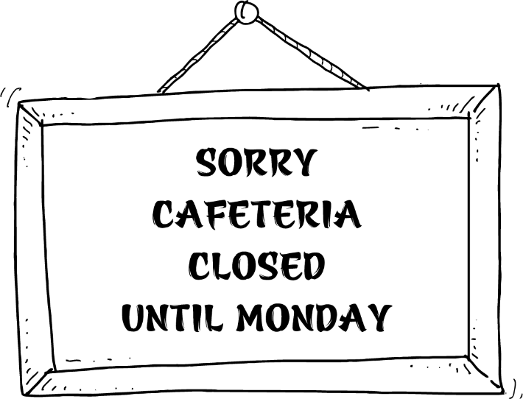 | A. You can’t eat or drink in the cafeteria on Mondays.  B. The cafeteria opens every day except Monday.  C. The cafeteria opens every Monday.  D. The cafeteria opens next Monday.

16. Read the prescription and choose the correct statement.
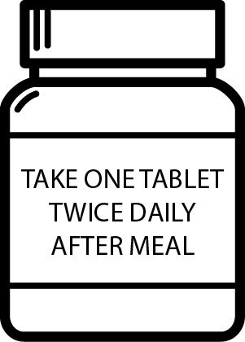 | A. You should take the medicine after eating, twice a day.  B. You should drink two tablets after every meal.  C. You shouldn’t take tablets after you finish your meal.  D. You should take one tablet per day after you eat.

III. WORD FORMATION (1.2 points)
Write the correct form of the words in brackets.
17. It’s very __________ to eat fried food every day. You can become overweight. (HEALTH)
18. If you want to be strong, you should have __________ meals with good ingredients. (HEALTH)
19. Last night, Andy ate too much and had a terrible ___________. (STOMACH)
20. You should eat __________ every day and you shouldn’t skip breakfast. (PROPER)
21. Mike couldn’t sleep last night. Today he was really tired, so he fell __________ in math class. (SLEEP)
22. Louisa never does any exercise. She’s __________and feels tired all the time. (FIT)

IV. LISTENING (2 points)
A. You will listen to an interview with James Olive. For questions 23-27, fill in the blanks with NO MORE THAN TWO WORDS.

According to James Olive:
- Many school cafeterias sell fast food like pizza, (23) _________ and soda. These foods contain lots of (24) _________ and salt, so students will get (25) _________ and have difficulty listening in class.
- Cafeterias should sell “brain food” like fruits and (26) _________. These foods help students (27) _________ and feel healthier.

B. You will hear Tom talking to his friend about his visit to the doctor. For questions from 28 to 32, listen and decide whether the statements are True (T) or False (F).

28. Tom had a headache yesterday morning.
29. The doctor advised Tom to stay in bed.
30. The doctor asked Tom to take some medicine.
31. The doctor told Tom not to stay up late every night.
32. Tom is going to play tennis tonight.

V. READING (2 points)
A. Read the following passage and complete the poster with suitable information. For each blank from 33 to 37, write NO MORE THAN THREE WORDS AND/ OR A NUMBER.

HOW TO BECOME HEALTHIER
Firstly, you should eat balanced meals. You should eat lots of fruit and vegetables because they are full of important vitamins. You shouldn’t eat too much fatty food. Things like chips and burgers have a lot of fat. Also, be careful with sugar. If you eat a lot of sweet food, the sugar gives you energy for a short time, but afterwards you will feel more tired. Secondly, exercise should be part of your daily routine. Don’t hurt yourself, start with gentle exercise. Exercise for at least 15 minutes every day. Or you can try a team sport or join a gym. Exercise can also be cycling instead of taking the bus, or using the stairs instead of the lift. Moreover, staying healthy requires enough sleep. It’s sometimes OK to go to bed late; but if you stay up late too often, it will be bad for your health. Try to sleep eight hours every night. Lastly, every year, you should go to the doctor for regular check-ups. When you get fit and healthy, you will feel great.

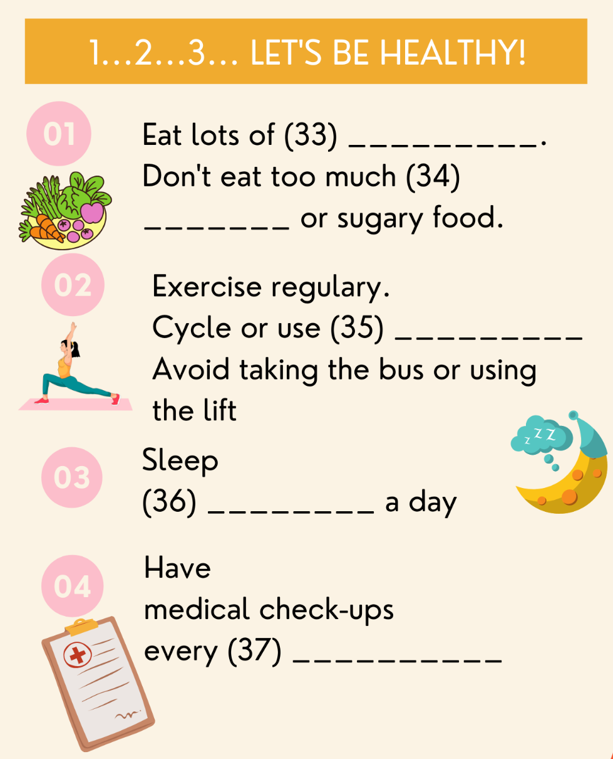

B. Read the online post and choose the word/ phrase (A, B, C or D) that best suits each blank.
WHAT SHOULD I DO?
My name is Libby and I’m 12 years old. I never manage to go to bed early during the week. I know I (38) __________ use my phone or tablet late at night, but I always do. I find it (39) __________ to fall asleep, but I don’t know why. I often miss breakfast, so I’m hungry by the morning break. In my school, you don’t need to go far for unhealthy food. There is a vending machine with (40) __________ sugary snacks and fizzy drinks like Coke or soda. My mum says I should eat some fruit or yogurt for a snack, but I keep forgetting to bring it to school with me. I also feel (41) __________ and have no energy during the day, which is really annoying. I really need to get fit and healthy for the school bicycle race. What do you think I should do to prepare for the race? Please give me (42) __________ advice on how to become a better me.

38. A. should B. shouldn’t C. don’t D. must
39. A. difficult B. easy C. harder D. healthy
40. A. much B. a little C. few D. lots of
41. A. healthy B. strong C. weak D. a fever
42. A. an B. some C. many D. a few

VI. WRITING (1.6 points)
A. Rewrite the following sentences without changing their meaning. Use the given word(s) if any.
43. My little brother doesn’t eat many vegetables.
→ My little brother eats only .
44. There is no milk in the refrigerator.
→ We don’t have .
45. The bottle is nearly empty of water.
→ There is not .
46. It’s important for you to do exercise if you want to get fit.
→ You should .
47. It’s not a good idea to sell drinks that contain lots of sugar in school cafeterias.
→ School cafeterias .

B. Use the given words or phrases to make complete sentences.
48. Eating / lot/ candies / cookies/ is not good/ you/.
→ .
49. How/ slices / pizza/ you/ want/?
→ .
50. Soda/ not/ give/ you/ energy/ and/ be/ bad/ teeth.
→ .

***End – Of – Test***

