

**PART 2: VOCABULARY**

**Task 1. Look at the pictures and complete the blanks with the words given.**

1. temple 2. cathedral 3. palace 4.memorial

5.square 6. art gallery 7. railway station 8. museum

9.chicken 10.meat 11. Noodle 12.chocolate 13.bread 14.sausage 15. Omelette 16. milkshake

**Task 2. Complete the blanks with given words.**

1. pharmacy 2. department store 3. hairdresser’s 4. fire station

5. health centre 6. petrol station 7. cemetery 8. museum

9. pagoda 10. suburb

**Task 3. Fill in the blanks with the words given.**

**1.Extra large 3. large 4.jeans 4. changingroom 9. medium**

**8. sweater 6. customer 2. try on 5.sales asistant**

**Task 4. Fill in the blanks using the words in the box.**

**1.** Steak-frites is a kind of meat dish. It's **beef** and French fries.  
**2.** We **grill** the sausages on the barbecue.  
**3.** You can get good **seafood** in this restaurant. They serve really good crab and shrimp.  
**4.** I don't like to eat grilled beef or pork, so I had grilled **lamp**.  
**5.** **Fry** the steak in a little butter. It's so good.  
**6.** Pad see ew is a popular dish from Thailand with fried **noodles**.  
**7.** I really like fried **pork**. Bacon is my favorite type.

**8.** I like to put chili in my **fish sauce** and pour it on my noodles.  
**9.** My mom uses **herbs** from the garden to make our food taste amazing.



**PART 3: GRAMMAR**

**Task 1. . Choose the right word to complete the sentences.**

**1.** _______________ shirt looks great. (**That**/ Those)

**2.** _______________ is a beautiful day today. (That/ **This**)

**3.** Look at _______________ man over there. (this/ **that**)

**4.** Do you like_______________ flowers? (that/ **those**)

**5.** I love_______________ shoes but I don’t like_______________ shirt. (**these**/ that), (those/ **that**)

**6.** What are the answers to_______________ questions? (this/**these**)

**7.** Let’s watch a movie. – _______________ is a good idea. (**This**/ That)

**8.** This book isn’t very good, but_______________ book’s great. (these/ **that**)

**9.** Whose house is_______________? (those/ **that**)

**10.** How much is_______________ T-shirt? (**this**/ those)

**11.** How much are_______________ shoes? (that/ **those**)  
**12.** Excuse me, how much is_______________ shirt? (**this**/ these)  
**13.** I like that skirt. Do you have_______________ in black? (**it**/ them)  
**14.** Do you have_______________ shoes in black? (this/ **these**)  
**15.** I like these shorts. Can I try_______________ on? (it/ **them**)  
**16.** What size are_______________ pants over there? (**those**/ these)  
**17.** How much is_______________ shirt by the window?  (**that**/ this)

**18.** _______________ new book “I learn Smart World 6” is very good.(**This**/ Those)

**19.** My brother can use_______________ machines well. (that/ **those**)

**20.** This T-shirt is nice. I want to try_______________. (**it**/ them)

**Task 2. Choose the right word to complete the sentences.**

**1.** This is ___________ (**my**/ I) book that is _________ (**your**/ you) book.

**2.** Music is __________ (I/ **my**) favourite subject.

**3.** __________ (**I**/ My) want to be a teacher and ___________ (**my** / me) sister wants to be a doctor.

**4.** Mai likes English but _________ (**her** / she) brother doesn’t.

**5.** _______________ (**Nam and Lan’s teacher**/ Nam and Lan teacher) is very nice and friendly.

**6.** Hoa’s pencil case ___________ (**is**/ are) blue. ___________ (**Her**/ She) friends’ pencil case are violet.

**7.** _________________ (**Those student’s school bags**/ Those students’ school bags) are very heavy.

**8.** What is _____________ (**your**/ you) father’s job?

- ___________________(**He**/ His) is an engineer.

**9.** How old _______________ (are/ **is**) ______________ (your/ you) sister?

- _______________ (**She**/ Her) is ten years old.

**10.** ____________ (**The women’s bikes**/ The womens’ bikes) are new but ___________ (the mens’ bikes/ **the men’s bikes**) are old.

**11.** The bird sang _____________ (**its**/ it/ it’s) happy tune.

**12.** Listen to _____________ (**her**/ hers/ her’s) carefully.

**13.** _____________ (**His**/ He/ She) uncle is a doctor. He is a nice person.

**14.** That old man is kind to_______________ (our/ **us**/ we).

**15.** William and Tracy love_____________ (**their**/ theirs/ they) dogs so much.

**16.** My car is new, but____________ (her/ **hers**/ she) is old.

**17.** The teacher told____________ (**us**/ our/ we) an interesting story.

**18.** I want to sit between you and______________ (he/ **him**/ his).

**19.** She has an apple in___________ (she/ **her**/ hers) hand.

**20.** Bob and Ted live near_____________ (them/ **their**/ they) school.

**Task 2. Use “a/ an/ some or any” to complete the sentences**

**1.** There isn’t **any** milk in the jar.

**2.** She’d like **some** orange.

**3.** There are **some** oranges and bananas.

**4.** Is there **any** meat in the fridge?

**5.** There aren’t **any** noodles.

**6.** There is **some** meat and **some** rice for lunch.

**7.** Are there **any** vegetables?

**8.** I have **some** fruit for you.

**9.** He eats **an** apple after his dinner.

**10.** Would you like **some** water, please?

**11.** She wants to buy **some** oranges for her mother.

**12.** Would you like **an** egg for breakfast?

**13.** Can you bring me **some** water, please?

**14.** I don’t want **any** sugar in the tea.

**15.** She has **a** sandwich for breakfast.

**16.** There is **some** milk in the bottle.

**17.** There are **some** onions on the table.

**18.** Do you need **an** expensive house?

**19.** Do you like **some** meat for breakfast?

**20.** She buys **some** new hats for her children.



**LISTENING**

**Task 1. Look at the pictures below and match them with the phrases given in the box**

1. J 2. F 3. D 4. B 5. H

6. E 7. A 8. G 9. C 10. I

|  |  |  |  |  |
| --- | --- | --- | --- | --- |
| Related image | Image result for take the second right | Related image | Related image |  |
| **A­­­­­­­­______________** | **B______________** | **C______________** | **D______________** | **E______________** |
| Image result for take the second left | Related image | Image result for go straight on | Image result for go past |  |
| **F______________** | **G______________** | **H______________** | **I______________** | **J______________** |

**Task 2. Now look at the map below. Listen the place that the speaker gives direction to.**

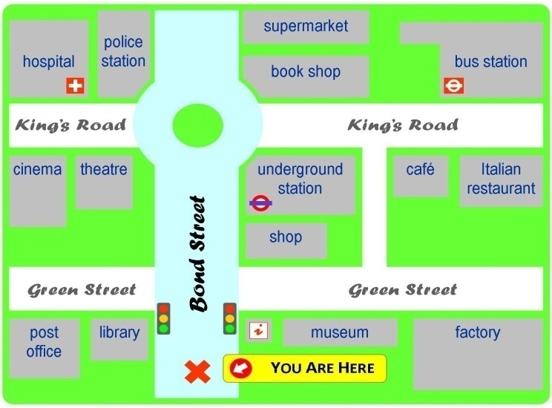

1. Speaker A gives directions to the post office

2. Speaker B gives directions to the underground station

3. Speaker C gives directions to the cinema

4. Speaker D gives directions to the… bus station …………………………..

**Listening transcript:**

A: Go straight on, then take the first left onto Green Street. Walk past the library, and it is the building next to the library on the left.

B: Go straight on, go past the traffic lights. You will see a shop on the right. Go past that, and it’s on the right, next to the shop.

C: Go straight on, go past the traffic lights, and go straight on, until you get to the roundabout. At the roundabout, turn left. Go past the theatre. It is the building next to the theatre, opposite the hospital.

D: Go straight on, go past the traffic lights, and take the second right onto King’s Road. Go past the bookshop. It’s the building next to the bookshop, opposite the cafe.



**SPEAKING**

**Task 1. Match the questions and answers. Then practice.**

1.C 2.D 3.I 4.G 5.A 6.E 7.F 8.B

**Task 2. Complete the dialogues with the phrases or sentences in the box**

1. I love *pho*. 2.A glass of orange juice, please.

3. I prefer something sweet. 4.Four cartons, please.

5. Twice a month. 6.Yes, two slices, please.

7. I just have some cereal each morning. 8. Four or five small meals.



**READING**

**Task 1*.* Read and answer the questions.**

**MY WEEKEND**

**1.** What meat is in bún chả?  
**The meat is grilled pork.  
2.** What do you eat bún chả with?

**You eat it with rice noodles, vegetables, and a sauce (in a small bowl).  
3.** What do they make the sauce in bún chả with?

**People make the sauce with sugar, lemon juice, chili, and fish sauce.  
4.** What do people make bún bò Nam Bộ with?

**People make bún bò Nam Bộ with beef, noodles, and herbs.  
5.** What do you put on top of bún bò Nam Bộ?

**You put peanuts on top.**

**Task 2: : Read the text then decide whether statements are true (T) or false (F).**

1. Pho is served with beef or hot dog. F

2. The writer likes Pho the best. T

3. People in other countries also like Pho. T

4. Anna eats Pho twice a day. F

5. The writer thinks that Pho in a restaurant is more delicious. T



**WRITING**

**Ta Write about a popular Vietnames dish_ PHO**

……………………………………………………………………………………………… ……………………………………………………………………………………………… ……………………………………………………………………………………………… ……………………………………………………………………………………………… ………………………………………………………………………………………………

……………………………………………….

………………………………………………….

………………………………………………….

………………………………………………….

………………………………………………….

………………………………………………….

………………………………………………….

………………………………………………….

………………………………………………….



