FORM 2026  Test 20 | ĐỀ THI HỌC KÌ II  Môn: Tiếng Anh - Lớp 8

Mark the letter A, B, C, or D on your answer sheet to indicate the word whose underlined part differs from the other three in pronunciation in each of the following questions.
Question 1. A. bury B. dump C. instruct D. rubbish
Question 2. A. other B. brother C. leather D. wealthy
Mark the letter A, B, C, or D on your answer sheet to indicate the word that differs from the other three in the position of primary stress in each of the following questions.
Question 3. A. wonder B. maintain C. oppose D. invent
Question 4. A. habitable B. promising C. nomadic D. maverllous
Mark the letter A, B, C, or D on your answer sheet to indicate the correct answer to each of the following questions.
Question 5. The workshop will start at 9:15. You should be ready _____________ 9:00.
A. by B. on C. for D. in
Question 6. You can’t have any chocolate! It’s _________!
A. your B. yours C. her D. mine
Question 7. _________and eye contact are examples of non-verbal communication.
A. Chatting B. Video call C. Body language D. Voice message
Question 8. “Can Mai translate French documents into Vietnamese?”
Jack wondered if Mai __________ translate French documents into Vietnamese.
A. can B. would C. could D. might
Question 9. To enable students to have more interactions in online classes, our teachers let us work in _.
A. epidemic B. breakout rooms C. experiment D. recognition
Question 10 To check ________, students now just scan their fingerprints on those machines.
A. attentive B. attention C. attendant D. attendance
Question 11.______ is the force that causes something to fall to the ground.
A. air B. force C. gravity D. pressure
Question 12. - Nick: Do you think we will live on the moon one day?
- Hoa: _________
- No, I can't. C. I won't live on the moon.
- I'm not sure about it. D. Yes, the moon is far from us.
Read the following announcement and mark the letter A, B, C or D on your answer sheet to indicate the correct option that best fits each of the numbered blanks from 13 to 16.
Hello! You are on a new planet!
To live here, you must know these things:
- Air: The air is different. You need (13)_____ spacesuit to breathe. Put on your suit. Do not take it off outside.
- Water: Water is important. Find water. Be careful (14)_____ the water you drink. It may contain contaminants. Clean it before you drink.
- Food: Food is not like Earth. You must find new food. Learn (15)_____ is safe to eat.
- Plants: Some plants are good. Some plants are bad. Do not touch plants you do not know.
- Learn: Learn about this planet before (16)_______
- Stay safe: Always stay with your group. Do not go alone. Tell someone where you go.
- Help: Help each other. We must work together to live here.

Question 13. A. an B. the C. a D. ø
Question 14. A. with B. by C. for D. on
Question 15. A. when B. where C. what D. why
Question 16. A. to exploring B. explore C. to explore D. exploring
Mark the letter A, B, C, or D on your answer sheet to indicate the correct answer to each of the following questions from 17 to 18.
Question 17. Put the sentences (a-c) in the correct order, then fill in the blank to make a logical text.
Most Vietnamese families have customs and traditions that they have observed for many generations. Firstly, they worship their ancestors, and they celebrate their death anniversaries every year. _____
a. Secondly, they take part in many national and regional festivals, for example, the Mid Autumn Festival and the New Harvest Festival.
b. That's the way they show their gratitude to their ancestors and teach their young children about traditions.
c. Thirdly, they celebrate many holidays during the year such as Tet and National Day.
A. b-c-a B. a-c-b C. b-a-c D. c-b-c
Question 18. Choose the sentence that can end the text (in Question 17) most appropriately.
A. They also show their interests in all festivals and holidays.
B. Next, celebrating holidays can make generations close to each other.
C. Finally, every generation can live happily together.
D. In this way, they keep their traditions alive and pass them down to the next generation.
Read the following passage and mark the letter A, B, C, or D on your answer sheet to indicate the correct word or phrase that best fits each of the numbered blanks from 19 to 24
Computers are helpful in many ways. First, they are fast. They can work with information even (19) ________ than a person. Second, computers can work with a lot of information (20)________. Third, they can store information for a long time. They do not forget things that the common people do. (21) ________, computers are almost always correct. They are not perfect, but they usually do not make mistakes.
Recently, it is important (22) ________ about computers. There are a number of things to learn. Many companies have computers (23)_____ work. In addition, most universities have day and night courses in Computer Science. Another way to learn is from a book, or from a friend. After a few hours of practice, you can (24) ________ with computers.
Question 19. A. quickly B. quicklier C. more quickly D. most quickly
Question 20. A. at the same time B. at the present time C. at times D. in time
Question 21. A. Finally B. However C. Although D. Therefore
Question 22. A. know B. knew C. knowing D. to know
Question 23. A. on B. in C. at D. within
Question 24. A. do B. play C. get D. work
Mark the letter A, B, C, or D on your answer sheet to indicate the sentence that is closest in meaning to the original sentence in each of the following question.
Question 25. Hanna said, "I will meet you outside the post office tomorrow."
A. Hanna said to me that she would meet me outside the post office the next day.
B. Hanna said me that she would meet you outside the post office the next day.
C. Hanna said to me that she would met me outside the post office the next day.
D. Hanna said to me that she would meet me outside the post office next day.
Question 26. I will send you the email. I reach the office.
A. When I will send you the email, I reach the office.
B. I will send you the email as soon as I reach the office.
C. Before I will send you the email, I reach the office.
D. I will send you the email while I reach the office.
Mark the letter A, B, C, or D on your answer sheet to indicate the sentence that is made from the given cues in each of the following question.
Question 27. She/ asked/ how long/ I/ live/ this town?
A. She asked how long I have lived in this town
B. She asked me how long she had live this town
C. She asked me how long I had lived in that town.
D. She asked me how long I have lived this town.
Question 28. I/ do/ homework/ while/ my sister/ listen/ music/ her room.
A. I was doing my homework while my sister was listening music in her room.
B. I did my homework while my sister was listening to music in her room.
C. I was doing my homework while my sister listened to music her room.
D. I was doing my homework while my sister was listening to music in her room.
Read the following sign or notice and mark the letter A, B, C or D on your answer sheet to indicate the correct answer to each of the following question.
Question 29. What does the sign say?
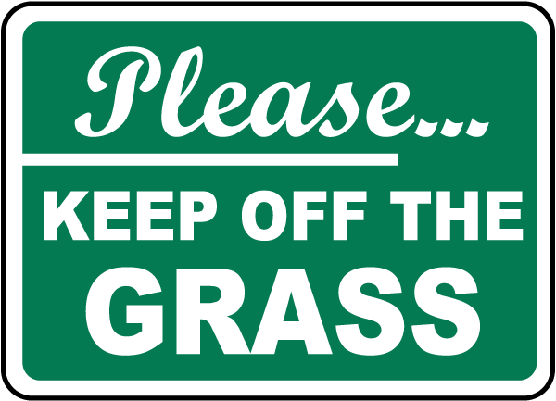
A. You can walk on the grass and play games there.
B. The grass should be kept clean and free of trash.
C. You should not walk on the grass.
D. The grass is for sitting and relaxing only.
Question 30. What does the notice say?
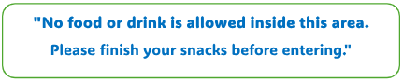
A. Only food is not allowed; drinks are fine.
B. You can eat and drink inside this area.
C. Do not bring food or drinks inside. Finish them first.
D. You can bring food but no drinks are allowed.
Read the following passage and mark the letter A, B, C, or D on your answer sheet to indicate the correct answers for the questions below from 31 to 36
Cell phones are an integral part of our society and their main use is communication. They keep students in touch with the rest of the world by giving them the power to interact with it. In the old days, if you forgot your lunch, you were at the mercy of the office calling home for you. Now, students have the ability to solve their own problems and handle certain emergencies on their own.
Cell phones also allow students to keep in touch with students at other schools or friends that don't go to school. While not directly beneficial to education, better relationships can lead to higher self-esteem and reduce isolation, which is good for everybody. In the same way, camera phones allow students to capture the kinds of memories that help build a solid school culture, and, in some cases, can act as documentation of misbehavior in the same way that store cameras provide evidence and deter bad behavior.
Academically, the cell phone can record a video of a procedure of explanation that may need to be reviewed later. It could be used to record audio of a lecture, as well, for later review. And just imagine if classes could be easily taped for students who are absent. What if they could even be streamed and seen from home instantly?

Question 31. Which does the passage mainly discuss?
A. Cell phones will be used as textbooks.
B. How to use some electronic devices in education.
C. Cell phones can be used as an excellent record.
D. How cell phones are used in communication and education.
Question 32. The word “ integral” in paragraph 1 is OPPOSITE in meaning to ______.
A. insignificant B. necessary C. unimportant D. easy
Question 33. According to the passage, cell phones help students to do all of the following EXCEPT?
A. write their assignment B. record audio of a lecture
C. keep in touch with their friends D. capture the kinds of memories
Question 34. The word “instantly” in paragraph 3 is CLOSEST in meaning to ______.
A. indirectly B. accidentally C. immediately D. slowly
Question 35. How can a cell phone help students academically?
A. deter bad behavior B. keep in touch with students
C. record a video D. call home
Question 36. What does the world “it” in the last paragraph refer to?
A. Video B. Procedure C. Explanation D. Cell phone
Four phrases/ sentences have been removed the text below. For each question, mark the letter A, B, C, D on your answer sheet to indicate the correct option that best fits each of the numbered blanks from 37 to 40.
Learning today is very different from my grandfather's time. (37) _____. Besides learning from teachers and textbooks, (38) _____. It provides us with various online sources (39) _____. Google helps us find the answers to almost any questions we have. The Internet also allows us to pursue our own interests. Learning has become more independent. Although most children in my village have fewer private learning facilities than the students in the city, we are still luckier than my grandfather's generation. (40) _____.

A. such as documents, clips, and programmes
B. we use the Internet
C. We have TVs to watch at home and a library and computers at school
D. It is easier and more convenient for us
Question 37. __________ Question 38. __________
Question 39. __________ Question 40. __________

