SỞ GIÁO DỤC VÀ ĐÀO TẠO  NINH THUẬN  ĐỀ CHÍNH THỨC  (Đề thi có 4 trang) | ĐỀ THI TUYỂN SINH VÀO LỚP 10 THPT  NĂM HỌC 2022-2023  Môn thi: Tiếng Anh  Ngày thi: 01.07.2022  Thời gian làm bài: 90 phút (Không kể thời gian giao đề)
SECTION 1. USE OF ENGLISH (3.0 points)
Mark the letter A, B, C, or D on your answer sheet to indicate the word whose underlined part differs from the other three in pronunciation.
1. A. instead B. meal C. ready D. ahead

Mark the letter A, B, C, or D on your answer sheet to indicate the word that differs from the other three in the position of primary stress.
2. A. engineer B. attend C. participate D. appearance

Mark the letter A, B, C or D on your answer sheet to indicate the word(s) CLOSEST in meaning to the underlined word(s).
3. All teachers should be aware of the real challenges that visually handicapped pupils have to face.
A. images B. tasks C. positions D. difficulties

Mark the letter A, B, C or D on your answer sheet to indicate the word(s) OPPOSITE in meaning to the underlined word(s).
4. I was surprised by the absence of our teacher of English. It was the English-speaking test!
A. fluency B. kindness C. thinking D. presence

Mark the letter A, B, C, or D on your answer sheet to indicate the correct answer to each of the following questions.
5. Nowadays, _________ can know when a volcano will erupt.
A. scientific B. scientifically C. science D. scientists
6. After five hours travelling by motorbike, they _________ quiet town by the beach.
A. arrived B. get C. went D. reached
7. Phong: "What about collecting used paper every day?" - Nam: “_________”
A. Yes, you must B. Well-done C. That’s a good idea D. Thanks, it’s nice of you
8. The two countries agreed to _________ full diplomatic relations
A. look up B. set up C. turn down D. put up with
9. Next Weekend, our family will go to Tan Son Nhat Airport to meet Daniel, _________ comes from Canada.
A. who B. whom C. whose D. that
10. She hurt herself while she _________ hide-and-seek with her friends.
A. was playing B. had played C. played D. is playing
11. Nam didn’t know ________ to find more information about the course.
A. that B. which C. where D. while
12. If Hoa were rich, she ________ around the world.
A. may travel B. travelled C. must travel D. could travel

Mark the letter A, B, C, or D on your answer sheet to indicate the underlined part that needs correction in each of the following questions.
13. I borrowed some milk from a neighbor of us as we didn’t have enough for breakfast.
A. some B. from C. of us D. have
14. The information Phong got from his from was such confusing that he didn’t know what to do.
A. The B. such C. that D. what to do
15. Many measures have been taken to rise people’s awareness of conservation needs.
A. have B. taken C. rise D. of

SECTION 2. READING (4.0 points)
Part 1. Read the following passage and select the letter A, B, c, or D to indicate the correct word that best fits each of the numbered blanks. (2.0 points)
DOLPHINS IN WALES
I fell in love with the Welsh landscape after (16) ___________ a television programme about dolphins off the west coast. I decided to (17) ___________ a holiday there. The programme (18) ___________ the best place to see them was Cardigan Bay and the best (19) ___________ was late afternoon.
The first evening I expected a long wait, (20) ___________ I sat on a bench with some fish and chips. (21) ___________ other people were there and after a few minutes we heard a child’s voice cry out, ‘There!’ The dolphins had arrived and they were playing and (22) ___________ fun. It was wonderful to see them as they should always be free.
I also (23) ___________ out that this area has beautiful beaches and fantastic castles to explore. It was the first time I had (24) ___________ in Wales and I knew it would not be the last. I have returned (25) ___________ the same place several times.
16. A. looking B. watching C. seeing D. playing
17. A. tour B. pass C. spend D. stay
18. A. told B. said C. talked D. spoke
19. A. period B. hour C. part D. time
20. A. so B. since C. but D. because
21. A. Lots B. All C. Many D. Much
22. A. feeling B. getting C. enjoying D. having
23. A. looked B. realized C. found D. learnt
24. A. been B. visited C. come D. gone
25. A. to B. for C. at D. on

Part 2. Read the following passage and mark the letter A, B, C, or D on your answer sheet to indicate the correct answer to each of the questions. (1.0 point)
The Wright Way To Fly

The inventors of the first airplane were not scientists. In fact, they did not even finish high school. The inventors of the first airplane were just ordinary brothers with a big dream – a dream of flying.

Wilbur and Orville Wright grew up in Indiana in a large family. Neither of the brothers finished high school. Instead of sitting in class and reading, they wanted to work and make things, like machines. When the brothers were 18 and 22 years old, they started up their own printing press and bicycle shop.

One day, Wilbur read an interesting story in the newspaper about a man trying to fly in a glider. The man died, but the story gave Wilbur an idea. He decided to teach himself about flying in order to make the perfect glider. Together, Orville and Wilbur successfully tested their new glider on the beach. Then the brothers decided to make their glider into a flying machine. They put an engine and propeller on the glider and called their new machine the “Wright Flyer”. The plane broke down on its first test, but the Wright brothers didn’t give up.

With a little more hard work, the Wright Flyer made a successful flight. On December 17, 1903, the Wright brothers made history of flying the Wright Flyer over the beach at Kitty Hawk, North Carolina. The airplane was born.
26. What is another good title for this reading?

A. “The First Glider” B. “American Inventions”

C. “Two Brothers’ Dream” D. “Gliders vs. Planes”

27. How did the brothers learn about planes?

A. They learned about them in school. B. Their father taught them.

C. They worked in a glider shop. D. They learned by themselves.

28. Why did the Wright brothers succeed in building the first plane?

A. They never gave up. B. They were good students.

C. They quickly gave up. D. They spent a lot of money.

29. What made the Wright Flyer different from a glider?

A. It had a propeller. B. It had an engine.

C. It could fly. D. It had an engine and propeller.

30. What is the lesson of this story?

A. Flying is too difficult for ordinary people.

B. If you don’t succeed at first, keep trying.

C. The airplane is an important invention.

D. Dreams can make you rich.

Part 3. For each question, choose the correct answer (A, B or C). (1.0 point)
 | 31.  A. Some of the pictures in the gallery are reserved.  B. We will keep any picture for you if you give us £25.  C. It costs £25 to show your picture in the gallery.
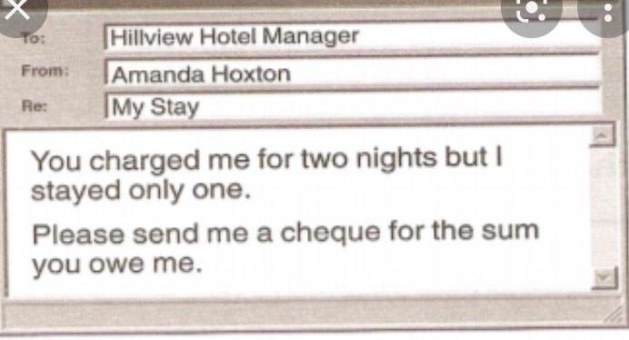 | 32. What does Amanda want the manager to do?  A. Chang her room booking  B. Give her a cheaper room  C. Return some money to her
 | 33.  A. When you buy two large cakes, we charge you for only one of them.  B. If you pay for two large cakes, we give you a small one as a present.  C. We give you a small free cake with every large one you buy.
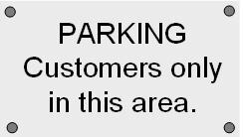 | 34.  A. This car park is for people who use the shop.  B. No parking here.  C. Anyone can park here.
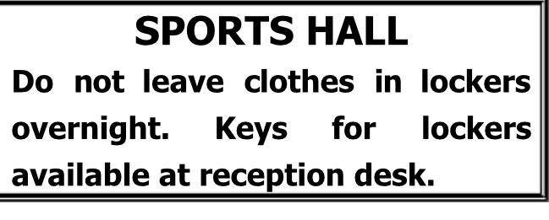 | 35.  A. You must remove your clothes from lockers by the end of the day.  B. You mustn’t leave keys in the lockers after taking your clothes out.  C. Any clothes left overnight can be collected from the reception desk.

SECTION 3. WRITING (3.0 points)
Part 1. Complete the second sentence so that it has a similar meaning to the first sentence, using the word in brackets. (1.0 point)
36. Peter rang 30 minutes ago. (SINCE)
_______________________________________________________________________.
37. Although it was raining heavily, the match continued until the last minute. (DESPITE)
_______________________________________________________________________.
38. I like the essay and you wrote it yesterday. (WHICH)
_______________________________________________________________________.
39. It took me half an hour to write that letter. (SPENT)
_______________________________________________________________________.
40. This shirt is too dirty for me to wear. (SO)
_______________________________________________________________________.

Part 2. Complete the second sentence so that it has a similar meaning to the first one.
41. "Don’t make so much noise”, the teacher said.
The teacher told her students _______________________________________________.
42. He went to bed early because of his sickness.
Because _______________________________________________________________.
43. He could not afford to buy the car.
The car was ____________________________________________________________.
44. I advise you to put your money in the bank.
You’d better ___________________________________________________________.
45. The mechanic is repairing his car.
His car is being _________________________________________________________.

Part 3 (1.0 point):
Write a letter of about 100 words to give your friend some tips for learning English well.
(DO NOT write your name or your personal information)

