Mã đề 9.1.48 | KIỂM TRA HỌC KÌ I  MÔN TIẾNG ANH LỚP 9- Hệ 10 năm  Năm học 2022- 2023  Thời gian làm bài: 45 phút  (Đề thi có 02 trang)
I. Listen and circle the correct picture A, B or C. (1,0pt)
1. How does the man travel to Liverpool?  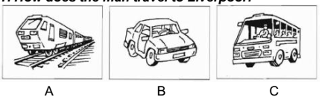 | 4. How did the man hear about the fire?  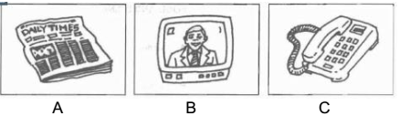
2. Which bill has just arrived?  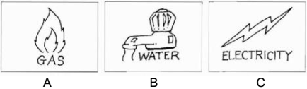 | 5. What time did Mr. Thompson ring?  P.M  A.M  P.M  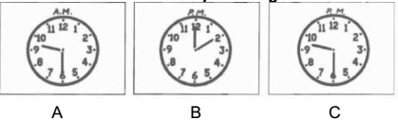
3. What will they do tomorrow afternoon?
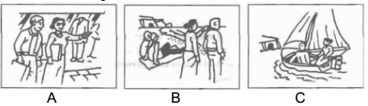
II. Listen and complete the questions given. (1,0pt)
PARK FARM
To see: | Farm Animals
Food in: (1) Black Cat Tea ______________ | Opens at: (2) ____________________
Closes at: 5 p.m. | Family ticket costs: (3) £ _______________
Don’t allow: (4) ____________ | Near : (5) _____________________
PART B- GRAMMAR AND VOCABULARY
Choose the best answers to complete the sentences. ( 2.0 point)
1. The craft of basket weaving is usually …………..from generation to generation.
a. turned down b. passed down c. come back d. closed down
2. They had to ……..the museum because it’s no longer a place of interest.
a. closed down b. get on with c. turn down d. face up to
3. I wish I …………how to paint ceramic pots
a. understood b. was c. know d. knew
4. I wish no child……….suffering from hunger
a. were b. is c. are d. can be
5. Every nation has respect for their long – preserved………….
a. behaviors b. practices c. traditions d. generations
6. Women…………to work. They used to stay at home to do the chores.
a. used to go b. didn’t used to go c. went d. used to travel
7. My father suggested that we …………..by air because it was much quicker.
a. should go b. didn’t go c. should not go d. will go
8. ………….. is a cave that is big enough for humans to go inside.
a. bay b. fortress c. cathedral d. carven
9. It is necessary for you…………about your country’s history.
a. know b. knew c. to know d. understand.
10. I was glad that you………..the scholarship.
a. gained b. win c. get d. will get

PART C: READING

I. (1.0pt) Choose the word that best fits the blank space in the following passage
There have been concerns about health problem in the area recently as the factories were reported to cause the pollution. To stay from worries, we decided (1)_______ a health check with the local doctor. We phoned to make an (2)_______ and at 9 o’clock the next morning, the doctor welcomed us at the door (3)_______ a lovely smile. After (4)_______ all necessary forms, we were given different tests. All the tests were done very quickly with the help of modern (5)_______. As she did the checks, the doctor said that a lot of people were worried about air pollution and came to her for health checks like us.
1. A. have B. to have C. having
2. A. arrangement B. arranging C. arranged
3. A. with B. in C. about
4. A. fill B. filled C. filling
5. A. tools B. equipment C. work
II. (1.0p) Read and choose the best answer for each question below.
Bill Gates is the co-founder of Microsoft, the world’s largest PC software company. He is among the richest people in the world. Bill Gates’ interest in computers started when he was a teenager. After high school, he was accepted to several top colleges in the USA: Harvard, Yale, and Princeton. He chose to go to Harvard to study law. At Harvard, he focused more on his interest in computers than on coursework. He often relaxed by playing video games in Harvard’s computer lab. He left Harvard before graduating because he wanted to open a software company with his friend Paul Allen. However, he later said, ‛I don’t think dropping out is a good idea.’ In 2007, he received an honorary degree from Harvard. He began his speech by saying this to his father in the audience. ‛I’ve been waiting more than 30 years to say this: Dad, I always told you I’d come back and get my degree.’ Bill Gates is no longer working full time for Microsoft. He is now, with his wife, running The Bill & Melinda Gates Foundation which aims to improve healthcare, reduce poverty, and promote education around the world.
1. When did Bill Gates first develop his interest in computers?
A. during his teenage years B. when he went to university
C. when he was at nursery school
2. What did he study at Harvard University?
A. computer science B. business C. law
3. What did he often do to relax while at Harvard?
A. play sports B. play video games C. go to parties
4. Why did he drop out of Harvard?
A. because he was ill B. because he wanted to study at another university
C. because he wanted to start a software company
5. What is the purpose of The Bill & Melinda Gates Foundation?
A. law B. healthcare, poverty reduction, and education C. computer software

PART D: WRITING
I. (1.0pt) Rewrite the following sentences in other way, beginning with the words/phrases given.
1. They say that he invented the telephone.
→It
2. “We will visit you next week”. My parents told me.
→My parents
3. My friend, Ba always get up late last year.
→My friend, Huy used
4. There was a storm offshore. We visited Ha Long Bay.
→Although
5. “Shall we visit Ha Long Bay, a natural wonder of the world?”
→He suggested that …………………..
II. (1.0pt) Write a short paragraph (80-100 words) about a wonder of Viet Nam.

HƯỚNG DẪN CHẤM
ĐỀ KIỂM TRA HỌC KÌ I
MÔN TIẾNG ANH LỚP 9- Hệ 10 năm
Năm học 2022- 2023
Thời gian làm bài: 45 phút

A- Listening:
I. Listen and choose the correct picture A, B or C.
Tổng 1.0 điểm. Mỗi đáp án đúng 0.2 đ
1- C 2- B 3- B 4- C 5- A
II. Listen and complete the questions given.
Tổng 1.0 điểm. Mỗi câu đúng 0.2 đ
1) Room 2) 10.30 (a.m) / half past ten 3) 17 4) dog(s) / your dog 5) (the) river
PART B- GRAMMAR AND VOCABULARY
Choose the best answers to complete the sentences. ( 2.0 point)
1. b 2. A 3. D 4. A 5. C 6. B 7. A 8. D 9. C 10. A
PART C: READING
I. (1.0pt) Choose the word that best fits the blank space in the following passage
1. B 2. A 3. A 4. C 5. B
II (1.0p) Read and choose the best answer for each question below.
1. A 2. C 3. B 4. C 5. B
PART C: WRITING
I. (1.0 point) Rewrite the following sentences in other way, beginning with the words/phrases given.
1. It is said that he invented the telephone
2. My parents told me they would visit me the next week
3. My friend, Huy used to get up late last year.
4. Although there was a storm offshore, We visited Ha Long Bay.
5. He suggested that we should visit Ha Long Bay, a natural wonder of the world.
II. (1.0 point) Write a short paragraph (80-100 words) about a wonder of Viet Nam.
- Name of the wonder and location 0.2 point
- The main features of the wonder 0.6 point
- Feeling and comment 0.2

