|  |  |
| --- | --- |
| **Tiếng Anh 8 Friends Plus** | **FP 8 - UNIT 3 - TEST 2**  **Test for Unit**  *Thời gian làm bài: 40 phút (Không kể thời gian giao đề)*  *-------------------------* |

**I. Pronunciation (1-4)**

**Câu 1.** Which word has the underlined part pronounced differently from that of the others?

**A.** inspire  **B.** tidy  **C.** skydiving  **D.** behind

**Đáp án đúng**: C

**Câu 2.** Which word has the underlined part pronounced differently from that of the others?

**A.** lonely  **B.** ocean  **C.** rose  **D.** world

**Đáp án đúng**: D

**Câu 3.** Which word has a different stress pattern from that of the others?

**A.** advantage  **B.** adventure

**C.** continuous  **D.** picturesque

**Đáp án đúng**: D

**Câu 4.** Which word has a different stress pattern from that of the others?

**A.** experience  **B.** extremely

**C.** inspirational  **D.** informative

**Đáp án đúng**: C

**II. Choose the answer (A, B, C or D) that best fits the space in each question. (5-14)**

**Câu 5.** What kind of adventure activities do you enjoy?

**A.** No, I prefer quiet indoor activities.

**B.** I love activities like rock climbing, zip-lining, and white-water rafting.

**C.** I enjoy eating ice cream.

**D.** I have a pet dog.

**Đáp án đúng**: B

**Câu 6.** They _____ their homework yet.

**A.** haven't done  **B.** didn't do

**C.** hadn't done  **D.** weren't doing

**Đáp án đúng**: A

**Câu 7.** We climbed to the top of a sand ___________ and the view was incredible!

**A.** rainforest  **B.** dune

**C.** valley  **D.** yacht

**Đáp án đúng**: B

**Câu 8.** She _____ her phone in the car, so she cannot call her friends.

**A.** has left  **B.** left

**C.** was leaving  **D.** had left

**Đáp án đúng**: A

**Câu 9.** We _____ to the new restaurant in town already.

**A.** have been  **B.** had been  **C.** was going  **D.** were

**Đáp án đúng**: A

**Câu 10.** I had to ___________ my old phone when I got a new one.

**A.** carry on  **B.** leave behind

**C.** stop off  **D.** inspire

**Đáp án đúng**: B

**Câu 11.** We hiked through the ________ and saw a beautiful waterfall at the end.

**A.** valley  **B.** yacht

**C.** dune  **D.** rainforest

**Đáp án đúng**: A

**Câu 12.** I _____ my best friend since childhood.

**A.** was knowing  **B.** knew

**C.** have known  **D.** had known

**Đáp án đúng**: C

**Câu 13.** My ___________ in the game was really good, but I still won!

**A.** opponent  **B.** desert  **C.** cave  **D.** adventure

**Đáp án đúng**: A

**Câu 14.** This book is so ___________, it makes me want to write my own story.

**A.** massive  **B.** huge

**C.** inspirational  **D.** dull

**Đáp án đúng**: C

**III. Look at the signs. Choose the best answer (A, B, C or D). (15-16)**

**Câu 15.**

What is true about the Tanzania advertisement?

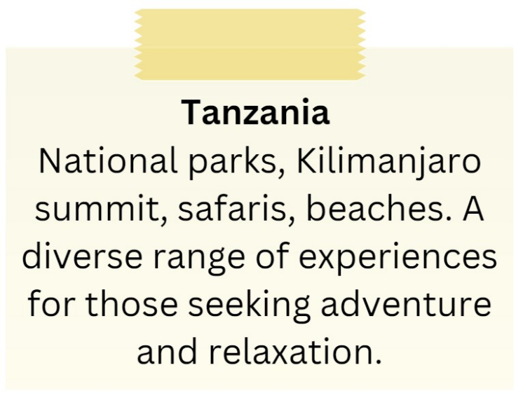

**A.** It excludes beach-related experiences.

**B.** It is focused solely on relaxation.

**C.** It features Kilimanjaro summit and safaris.

**D.** It promotes a single national park as the main attraction.

**Đáp án đúng**: C

**Câu 16.**

What is true about the Iceland advertisement?

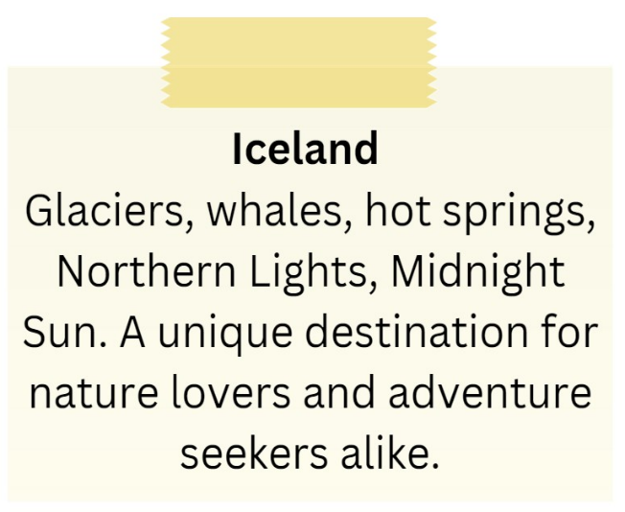

**A.** It includes attractions such as glaciers, whales, hot springs, and the Northern Lights.

**B.** It showcases skyscrapers and bustling city life.

**C.** It is exclusively for adventure seekers.

**D.** It emphasizes tropical beaches and sunbathing.

**Đáp án đúng**: A

**IV. Read the following passage and do as direct. (17-22)**

The Eiffel Tower is one of the most famous landmarks in the world and is located in Paris, France. It was built in 1889 as the entrance arch to the World's Fair and was originally intended to be a temporary structure. However, its popularity among the Parisian public ensured its permanence and it has since become an iconic symbol of the city.

The tower stands at 324 meters tall and is made of iron. Visitors can climb to the top for a stunning view of Paris or take an elevator to one of the observation decks. The tower also features two restaurants, a gift shop, and a post office.

The Eiffel Tower is an important cultural and historical landmark, and it has been featured in countless films, books, and photographs throughout the years. It is a must-visit destination for anyone traveling to Paris, and its unique architecture and stunning views make it a memorable experience for visitors of all ages.

**Câu 17.** The Eiffel Tower is located in Rome, Italy.

**A.** True  **B.** False

**Đáp án đúng**: B

**Câu 18.** The Eiffel Tower was built in 1889 for the World's Fair.

**A.** True  **B.** False

**Đáp án đúng**: A

**Câu 19.** The Eiffel Tower was originally intended to be a permanent structure.

**A.** False  **B.** True

**Đáp án đúng**: A

**Câu 20.** Visitors to the Eiffel Tower can climb to the top for a view of Paris or take an elevator to one of the observation decks.

**A.** False  **B.** True

**Đáp án đúng**: B

**Câu 21.** When was the Eiffel Tower built?

**A.** 1789  **B.** 2089  **C.** 1889  **D.** 1989

**Đáp án đúng**: C

**Câu 22.** What is the Eiffel Tower made of?

**A.** Stone  **B.** Copper  **C.** Glass  **D.** Iron

**Đáp án đúng**: D

**V. Choose the word (A, B, C or D) that best fits the blank space in the following passage. (23-28)**

What is swimming?

Swimming is a water-based sport that **_____23____** moving through the water using a variety of strokes. It can be enjoyed for leisure or as a **____24_____** sport.

How long has it been a sport?

Swimming has been practiced for thousands of **_____25____**, with evidence of swimming as a form of exercise and recreation dating back to ancient civilizations like Egypt and Greece.

Do I need to be in good shape to swim?

Swimming is a great low-impact exercise that can be enjoyed by people of all ages and fitness levels. It can help to **_____26____** cardiovascular health, build strength, and increase flexibility.

What equipment do I need?

To swim, you will need a swimsuit and **____27_____**, which can help to protect your eyes and improve visibility in the water. A swim cap can also be useful for keeping hair out of your face and reducing drag in the water.

What are the best places for swimming?

Swimming can be enjoyed in a variety of settings, including pools, lakes, rivers, and oceans. Community pools and aquatic centres are popular **____28_____** for swimming, and many beaches and parks also offer opportunities for swimming in natural bodies of water.

**Câu 23.** Swimming is a water-based sport that _____ moving through the water using a variety of strokes.

**A.** prevents  **B.** involves  **C.** ignores  **D.** dislikes

**Đáp án đúng**: B

**Câu 24.** It can be enjoyed for leisure or as a _____ sport.

**A.** ignored  **B.** competitive

**C.** boring  **D.** disliked

**Đáp án đúng**: B

**Câu 25.** Swimming has been practiced for thousands of _____.

**A.** hours  **B.** years  **C.** seconds  **D.** minutes

**Đáp án đúng**: B

**Câu 26.** It can help to _____ cardiovascular health, build strength, and increase flexibility.

**A.** ignore  **B.** decrease  **C.** increase  **D.** reduce

**Đáp án đúng**: C

**Câu 27.** To swim, you will need a swimsuit and _____.

**A.** shoes  **B.** hat  **C.** gloves  **D.** goggles

**Đáp án đúng**: D

**Câu 28.** Community pools and aquatic centres are popular _____ for swimming.

**A.** locations  **B.** foods  **C.** drinks  **D.** clothes

**Đáp án đúng**: A

**VI. Supply the correct form of the word given in each sentence. (29-34)**

**Câu 29.** All ____________ must arrive at the conference centre by 9:00am. (participate)

**Đáp án đúng**: participants

**Câu 30.** I ____________ spilled coffee on my shirt this morning. (accident)

**Đáp án đúng**: accidentally

**Câu 31.** The teacher's ____________ words left a lasting impact on her students. (inspire)

**Đáp án đúng**: inspirational

**Câu 32.** The ____________ of social media influencers is constantly changing. (popular)

**Đáp án đúng**: popularity

**Câu 33.** The presenter tried to ____________ the importance of team collaboration. (emphasis)

**Đáp án đúng**: emphasize

**Câu 34.** Can you ____________ the scenery on your walk through the park? (description)

**Đáp án đúng**: describe

**VII. Rearrange the groups of words in a correct order to make complete sentences. (35-36)**

**Câu 35.** We have had many / over the years, / adventures together / from hiking to / kayaking.

…

**Đáp án đúng**: We have had many adventures together over the years, from hiking to kayaking.

**Câu 36.** adventures. / had many / city and / explored the / Yesterday, we

…

**Đáp án đúng**: Yesterday, we explored the city and had many adventures.

**VIII. Rewrite each of the following sentences in another way so that it means almost the same as the sentence printed before it. (37-40)**

**Câu 37.** He last sent me postcards when he was in Paris.

The last time…

**Đáp án đúng**: The last time he sent me postcards was when he was in Paris.

**Câu 38.** She began writing the report 45 minutes ago.

She has …

**Đáp án đúng**: She has written the report for 45 minutes.

**Câu 39.** This is the second time I have seen Harry Potter.

I have …

**Đáp án đúng**: I have seen Harry Potter twice.

**Câu 40.** This is the first time I have been abroad.

I haven’t……

**Đáp án đúng**: I haven't been abroad before.

**IX. Listening: listen and do as direct.**

*Listen to two friends planning a trip and fill in the blanks.*

**Câu 41.** Friend 1 is planning a trip to ________ this summer.

**Đáp án đúng**: Europe

**Câu 42.** Friend 2 has never visited ________ before.

**Đáp án đúng**: Europe

**Câu 43.** Friend 1 is considering visiting Paris, Amsterdam, and ________.

**Đáp án đúng**: Berlin

**Câu 44.** They are planning to stay in Europe for about ________ weeks.

**Đáp án đúng**: two

**Câu 45.** Friend 2 is excited to have a travel ________ for the trip.

**Đáp án đúng**: buddy

**Câu 46.** Friend 1 wants to explore as much as possible and make the most of their ________ abroad.

**Đáp án đúng**: time

**Câu 47.** They will need to book their flights and ________ in advance.

**Đáp án đúng**: accommodations

**Câu 48.** Friend 2 has always wanted to visit Europe and is thrilled to have the opportunity to travel with a ________.

**Đáp án đúng**: friend

**Câu 49.** They plan to do a lot of sightseeing and ________-seeing while in Europe.

**Đáp án đúng**: culture

**Câu 50.** Friend 1 is hoping to have an ________ and unforgettable experience on their trip to Europe.

**Đáp án đúng**: exciting

**----HẾT---**