Unit 10 Test

I. PRONUNCIATION
Find the word which has a different sound in the bold part.
1. A. source B. south C. cloud D. amount
2. A. nuclear B. future C. sunlight D. pure
Choose the word that has a different stress pattern.
3. A. energy B. dangerous C. expensive D. easily
4. A. government B. polluting C. recycle D. resources
II. LISTENING
PART 1: Listen to the talk between Mr. Lam and his students. Choose the correct answer A, B, or C.
5. What does Mr. Lam say we use energy for?
A. Only for cooking.
B. Only for lighting.
C. For cooking, heating, and lighting.
6. What does Linh always do when she leaves a room?
A. She turns off the lights.
B. She leaves the TV on.
C. She opens the window.
7. Which of the following does Minh use to save energy?
A. High energy light bulbs.
B. Low energy light bulbs.
C. Solar panels to cook meals.
PART 2: Listen to the talk about energy sources. Fill in each gap with ONE word or a number.
8. Non-renewable sources are cheap and easy to __________.
9. In the future, we will rely more on __________ energy sources.
III. LANGUAGE USE
Choose the best answer A, B, C or D.
10. Look! They ________ solar panels on the roof of the school to produce energy.
A. install B. are installing C. installs D. is installing
11. Wind and water are ________ sources because we cannot run out of them.
A. non-renewable B. natural gas C. renewable D. dangerous
12. At the moment, scientists ________ new energy sources to protect the environment.
A. develop B. developed C. is developing D. are developing
13. Nuclear energy can be _______ to produce, but it is not always safe.
A. easily B. cheap C. expensive D. polluting
14. Nowadays, many countries _______ their use of coal to reduce pollution.
A. reduce B. are reducing C. reduces D. is reducing
15. Hydro energy comes _______ water, and we often build dams near the sea.
A. from B. at C. on D. to
III. READING ADVERTISEMENTS / NOTICES
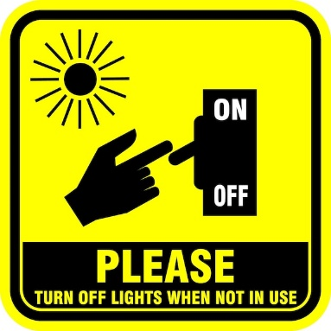
Look at the signs/notices and choose the best answer A, B, C or D.
16. What does this sign mean?
A. You should turn on the lights when you enter.
B. You must turn off the lights when leaving the room.
C. You are not allowed to use electricity here.
D. The lights are automatic.
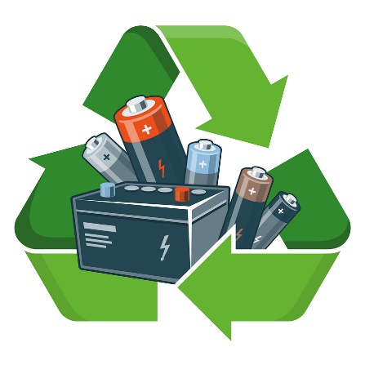
17. Look at the symbol on a battery. What does it tell you?
A. You should throw this battery in the trash bin.
B. You must not use this battery again.
C. You should recycle this battery to save resources.
D. This battery is very dangerous.
Read the notice and choose the best word (A, B, or C) to fill in each blank.

ENERGY SAVING TIP:
To save energy at school, students (18)______ turn off all electrical appliances when they are not in use. Please check that none of your taps (19)______ dripping. Thank you!

- A. should B. shouldn't C. can
- A. is B. are C. am
IV. LOGICAL ARRANGEMENT
20. Reorder the sentences to make a complete conversation about energy project.
a. I’m doing a project on energy sources, Dad.
b. Well, it's power that we use to provide us with light, heat or electricity.
c. Lan, what are you doing? It’s pretty late now.
d. Oh, I get it now. Where does it come from?
e. That sounds interesting. But do you understand what energy is?
A. c – a – e – b – d
B. c – e – a – b – d
C. a – c – e – b – d
D. c – a – b – e – d
21. Reorder the sentences to make a logical paragraph about saving energy.
a. Second, you should use low energy light bulbs instead of normal ones.
b. There are several simple ways to save energy at home.
c. Finally, remember to turn off the TV when you are not watching it.
d. First, you should always turn off the lights when leaving a room.
e. By doing these, you can reduce your electricity bill and protect the environment.
A. b – d – a – c – e
B. d – a – c – b – e
C. b – a – d – c – e
D. b – d – c – a – e
22. Reorder the sentences to make a conversation about renewable energy.
a. It’s energy that comes from the sun, wind or water.
b. What does "renewable energy" mean, Mr. Tan?
c. Because we cannot run out of them and they are easy to replace.
d. Why do we call them "renewable"?
A. b – a – d – c
B. b – d – a – c
C. a – b – d – c
D. b – a – c – d
23. Reorder the sentences to make a short announcement at school.
a. Our school is starting a "Green Week" to save energy.
b. Please turn off all the taps after using them.
c. Don't forget to switch off the air conditioners before you leave the class.
d. Let's work together to make our school better!
A. a – b – c – d
B. a – c – b – d
C. b – c – a – d
D. c – b – a – d

V. READING CLOZE
Read the text and choose the correct answer A, B, or C.
Nowadays, we use many different (24)______ of energy. Coal, oil, and natural gas are non-renewable sources. They are cheap, but they are (25)______ the environment. On the other hand, solar energy and wind energy are renewable. They are clean and (26)______ to use. At the moment, many people (27)______ solar panels on their roofs to catch sunlight. We (28)______ save energy every day to protect our planet for the future.
- A. sources B. types C. ways
- A. protecting B. polluting C. reducing
- A. dangerous B. expensive C. safe
- A. install B. are installing C. installed
- A. should B. shouldn't C. can't
VI. READING COMPREHENSION
Read the following passage and choose the best answer A, B, C, or D.
"Hello class. Today I’d like to tell you about two energy sources. Non-renewable sources like coal and oil are cheap and easy to use. People use them a lot. But they are limited and will run out soon. Renewable sources come from the sun, wind, or water. We call it solar energy, wind energy, and hydro energy. Renewable sources are available, clean and safe to use. But they are often expensive to produce. In the future, we will rely more on renewable energy sources because they are better for the environment."
- What are coal and oil?
A. Renewable sources B. Non-renewable sources C. Clean energy
- Why are renewable sources good for the environment?
A. Because they are expensive.
B. Because they will run out.
C. Because they are clean and safe.
- What is a disadvantage of renewable energy?
A. It is limited. B. It is expensive to produce. C. It is easy to use.
- According to the passage, what will we use more in the future?
A. Coal B. Natural gas C. Renewable energy
VII. READING AN EMAIL
Read the email and choose the correct answer A, B, C or D.
To: Class7C@school.com
From: Mr.Lam@school.com
Subject: Saving energy project
Hi students, I'm very happy that you are doing a project on energy now. Please remember to collect information about both renewable and non-renewable sources. You should also find some tips to save energy at school. Are you still working on your posters? Send them to me by this Friday. Best, Mr. Lam
- What are the students doing now?
A. Planting trees. B. Doing a project on energy. C. Painting the classroom.
- What information should students collect?
A. Only about solar energy.
B. Only about coal and oil.
C. About all types of energy sources.
- When is the deadline for the posters?
A. This Friday. B. Next Monday. C. Today.

VIII. WRITING
Rearrange the words to make complete sentences.
36. energy / are / Nowadays / sources / developing / scientists / new / renewable / .
> ................................................................................................................
37. energy / why / should / we / Can / tell / me / you / save / ?
> ................................................................................................................
Rewrite the sentences without changing their meaning.
- The students are doing a project on energy sources now. (Change into a Yes/No question)
- Are .........................................................................................................?
- It is important to turn off the lights when you leave the room. (Use "Should")
- You .........................................................................................................
- Wind energy and solar energy are renewable sources. (Use "Come from")
- Renewable energy .................................................................................
🎙️ AUDIO SCRIPT
Part 1 (Dựa trên bài nghe trang 111):
Mr. Lam: Class, we use energy for many things like cooking, heating, and lighting. It's important to save it. Linh, what do you do?
Linh: I always turn off the lights when I leave the room. I also turn off electrical appliances when I'm not using them.
Mr. Lam: Good. How about you, Minh?
Minh: I use low energy light bulbs at my house. But I don't use solar energy to cook meals yet.
Part 2 (Dựa trên bài đọc trang 110):
Speaker: There are two main types of energy sources. Non-renewable sources like coal and oil are cheap and easy to use, but they will run out soon. Renewable sources like the sun and wind are clean and safe. In the future, we will rely more on renewable energy sources because they are better for the environment.

✅ ĐÁP ÁN (ANSWER KEY)
- Pronunciation: 1.A (âm /ɔː/, còn lại âm /aʊ/) | 2.C (âm /ʌ/, còn lại âm /ju:/) | 3.C (nhấn âm 2, còn lại nhấn âm 1) | 4.A (nhấn âm 1, còn lại nhấn âm 2)
- Listening: 5.C | 6.A | 7.B | 8.use | 9.renewable
  - B (Thì hiện tại tiếp diễn với "Look!")
  - C (Renewable sources: Nguồn năng lượng tái tạo)
  - D (Thì hiện tại tiếp diễn với "At the moment")
  - C (Expensive: Đắt đỏ)
  - B (Thì hiện tại tiếp diễn chỉ xu hướng đang xảy ra với "Nowadays")
  - A (Come from: Đến từ)
  - B (Turn off the lights: Tắt đèn)
  - C (Recycle: Tái chế)
  - A (Should: Nên)
  - B (Chủ ngữ số nhiều "taps" đi với "are")
- • Logic: 20.A | 21.A | 22.A | 23.A
- • Cloze: 24.A | 25.B | 26.C | 27.B | 28.A
- • Reading: 29.B | 30.C | 31.B | 32.C
- • Email: 33.B | 34.C | 35.A

Writing
- • Nowadays scientists are developing new renewable energy sources.
- • Can you tell me why we should save energy?
- • Are the students doing a project on energy sources now?
- • You should turn off the lights when you leave the room.
- • Renewable energy comes from the wind and the sun. (Hoặc: Renewable energy comes from wind and solar sources.)

Giaoandethitienganh.info sưu tầm

