Period
LESSON PLAN
TIẾNG ANH 10 FRIENDS GLOBAL
UNIT 2: ADVENTURE
LESSON 2F: READING – LOST AT SEA
I. OBJECTIVES:
By the end of the lesson, Ss will be able to:
1. Knowledge:
- Vocabulary: disaster, rescue, nightmare, life jacket
- understand a survival story and use extreme adjectives
2. Ability:
- main skills: reading and speaking skills
- sub skills: listening and writing skills
- Conduct an interview about a survival story
3. Quality:
- Have positive attitude in English language learning so that they can participate enthusiastically in all classroom activities, especially with the topic conducted by the teacher
- Students can guess the missing parts of a text in exams
II. TEACHER AIDS AND LEARNING MATERIALS:
Lesson plan, PPT slides, student’s book, workbook, notebook, personal computer (if any), projector/TV, speakers, IWB software.
III. PROCEDURES:
A. Warm-up (5’)
a) Objective: Introduce the new lesson and set the scene for Ss to acquire new language; get students' attention at the beginning of the class by means of enjoyable and short activities as well as to engage them in the steps that followed.
b) Content: Game ‘Iceberg’ –
c) Outcomes: Students can gain more confidence and interest in the lesson.
d) Competence: communication, collaboration, guessing
e) Organisation of the activity:
TEACHER’S ACTIVITIES | STUDENT’S ACTIVITIES | CONTENTS
WARM-UP. T-Ss/ S-S/ Indiv  Game ‘ICEBERG’  - Divide class into groups and ask students to find the correct headline for each picture.  - There are 3 answers for a picture, choose the correct one to help the penguin go back with his friends. If student chooses correctly, the picture will disappear and ‘Click Here’ will show to help the penguin. If student doesn’t get it, the wrong answer will disappear.  - Invite groups to give answers.  - Lead in the new lesson. | - Play in groups.  - With one correct answer, that group get bonus.  - Volunteer to answer. | 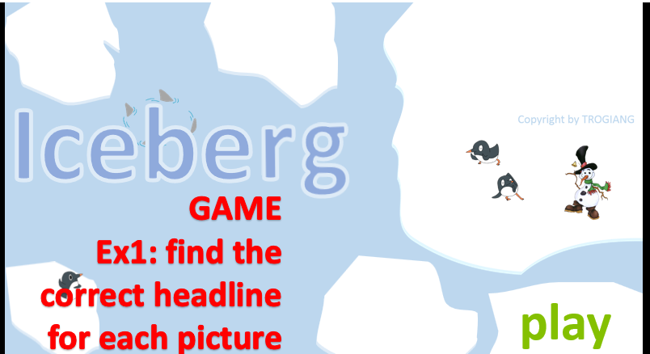  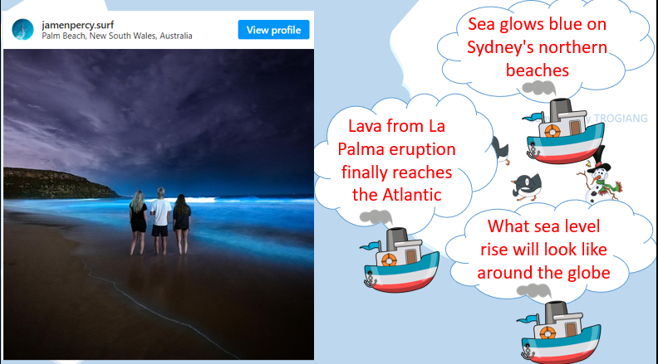  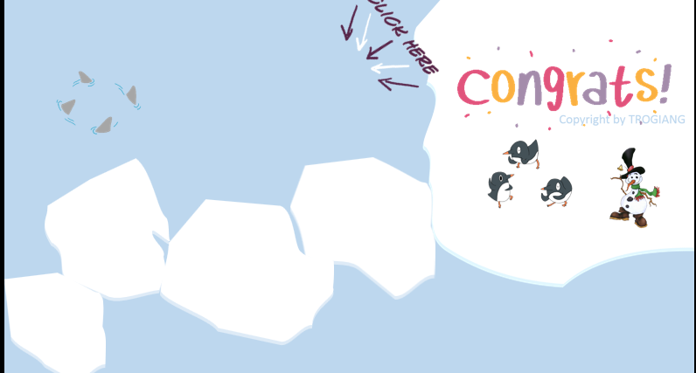

B. New lesson (35’)
- Activity 1: Presentation (6’)
a) Objective: Students get to know some new words in the lesson.
b) Content:
Vocabulary study
Listening
c) Outcomes: Students know how to pronounce the new words precisely and use them in appropriate contexts.
d) Competence: communication, presentation, guessing
e) Organisation of the activity:
TEACHER’S ACTIVITIES | STUDENT’S ACTIVITIES | CONTENTS
PRESENTATION. T-Ss/ S-S/ Indiv  Teach new vocabulary:  - Use pictures and explanation to present new words.  - Have students practice their pronunciation drills.  New words:  Disaster (n)  Rescue (v)  Nightmare (n)  Life jacket (n) | - Look, listen, and repeat in chorus and individuals. | 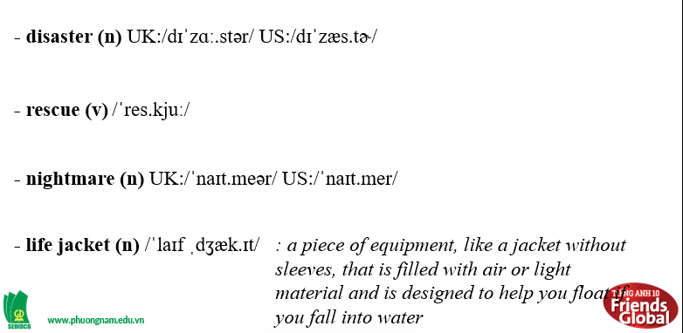
- Activity 2: Practice (23’)
a) Objective: Students can answer the questions to critical thinking, and they can finish the tasks in the textbook. Critical thing skills (guessing/ reasoning) and communication can also be practiced.
b) Content:
Reading
Speaking
c) Outcomes: Students can read and use the strategy in exams.
d) Competence: communication, collaboration, presentation
e) Organisation of the activity:
TEACHER’S ACTIVITIES | STUDENT’S ACTIVITIES | CONTENTS
PRESENTATION. T-Ss/ S-S/ Indiv  Activity 1 (3’): Task 2 page 28.  - Ask students to read out the first paragraph of the text and check if they chose correctly in exercise 1. Ask them to explain how they know what the right answer is.  - Check the answer.  Activity 2 (5’): Task 3 page 28.  - Go through the ‘Reading Strategy’ together.  - Ask students to read the box and highlight some main ideas that will help them do gap sentences task.  - Ask students to read the text and underline the words they think will help them to guess the missing parts of the text.  - Invite some students to share their ideas.  Activity 3 (5’): Task 4 page 29.  - Ask students to match sentences A-F with gaps 1-5 in the text.  - Check the answers.  - Ask them if any of these sentences match their ideas from exercise 3.  Activity 4 (4’): Task 5 page 29.  - Ask students to read the text again and write T or F.  - Check the answers and show students where to get the answers.  Activity 5 (3’): Task 6 page 29.  - Go through the Learn this! Box together.  - Ask students to complete the box with given adjectives.  - Check the answers.  Activity 6 (3’): Task 7 page 29.  - Ask students to read the text again and try to work out the meaning of the highlighted adjectives.  - Ask students to match the highlighted adjectives with the simpler adjectives in the table.  - Check the answers. | - Read the first paragraph and check if they chose answer correctly in exercise 1. And explain how they know what the right answer is.  - Listen to the teacher carefully and take note.  - Read the text and underline word, then think what might happen next in each gap.  - Volunteer to share their ideas.  - Complete the task.  - Check the answers with the teacher.  - Check if any of these sentences match their ideas.  - Read the text again and write T or F.  - Check the answers with the teacher.  - Listen to the teacher.  - Complete the box.  - Check the answers with the teacher.  - Read the text, find the meaning of the highlighted adjectives.  - Complete the table with correct answers.  - Check the answers with the teacher. | 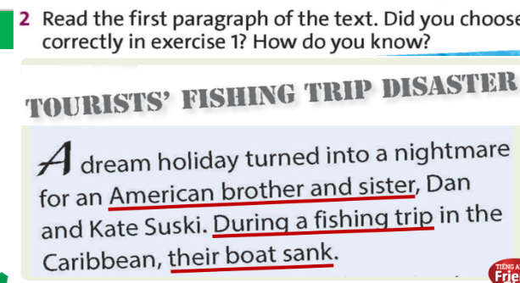  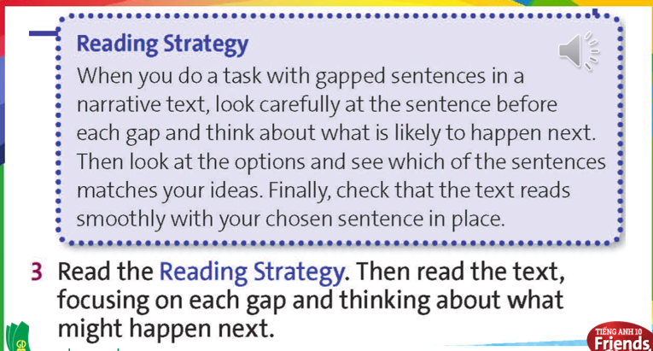  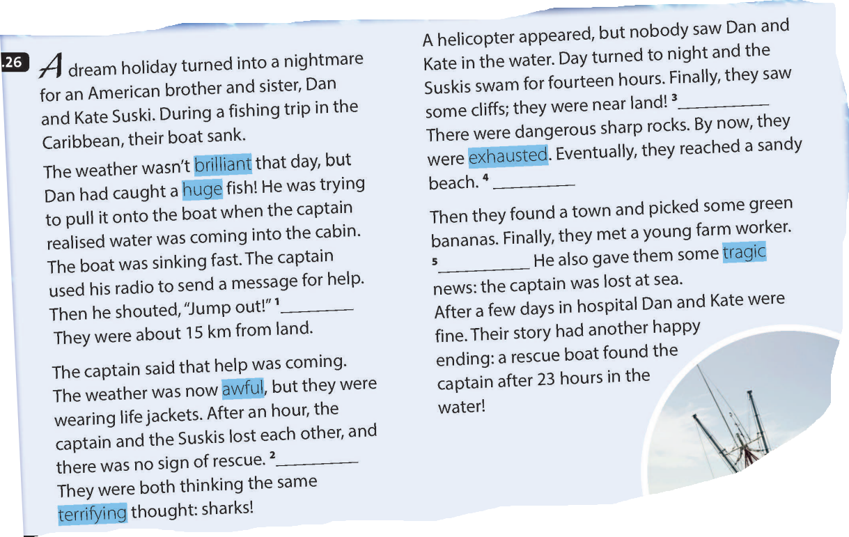  Answer:  1D  2A  3G  4E  5C  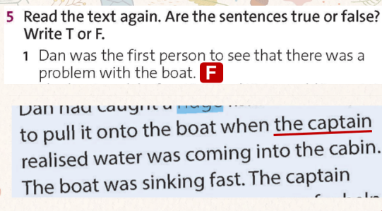  Answers:  1F  2F  3F  4T  5T  Answers:  1. good  2. dirty  3. hungry  4. small  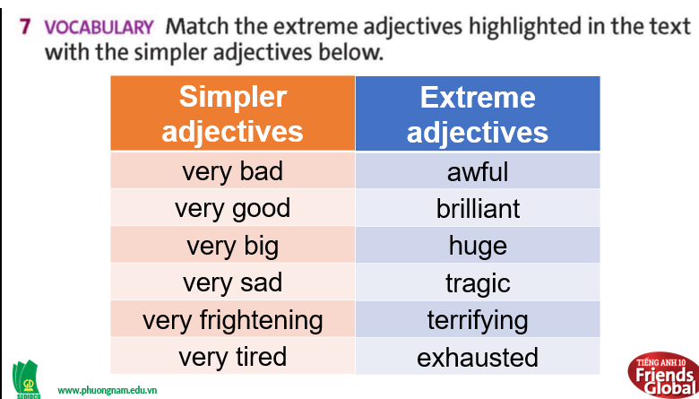

- Activity 3: Outcomes (6’)
a) Objective: Students can answer the questions to critical thinking. Communication can also be practiced.
b) Content: Work in pairs and act out an interview with Dan or Kate.
c) Outcomes: Students know how to prepare questions and answers for the interview.
d) Competence: Collaboration, communication, guessing
e) Organisation of the activity:
TEACHER’S ACTIVITIES | STUDENT’S ACTIVITIES | CONTENTS
PRODUCT. T-Ss/ S-S/ Indiv  - Ask students to work in pairs, take turns to be an interviewer and Dan/Kate.  - Invite some pairs to act out their interviews for the class. | - Student A: Write six questions using the prompts below/ their own ideas.  - Student B: Prepare the answers to Student A’s questions. Use as much information from the text as they can. | 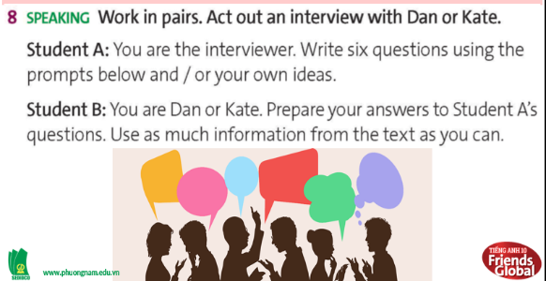  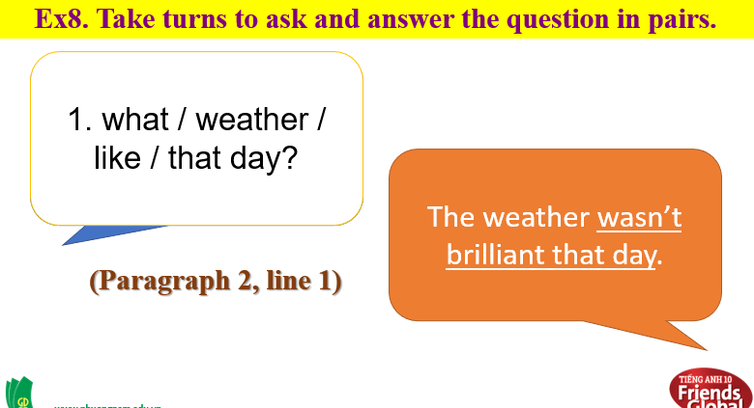
C. Consolidation (3’)
- Vocabulary: disaster, rescue, nightmare, life jacket
- Understand and use extreme adjectives and conduct an interview about a survival story.
D. Homework (2’)
- Learn by heart new words
- Practice talking about a time when you hurt or injured yourself
- Do exercise
- Prepare: Unit 2 – G- (page 30 – SB)

