School: ……………………………………….. | Date:……………………………………..
Class: ……………………………..................... | Period: 13

UNIT 2: LIFE IN THE COUNTRY
Lesson 1.2 – Grammar, pages 15 & 16
1. Objectives
By the end of this lesson, students will be able to…
1.1. Language knowledge/ skills
- practice and use quantifiers with countable and uncountable nouns correctly
1.2. Competences
- improve Ss’ communication, collaboration, analytical, critical thinking skills.
1.3. Attributes
- know what is good/bad about where you live.
2. Teaching aids and materials
- Teacher’s aids: Student’s book and Teacher’s book, class CDs, DCR– Phần mềm tương tác trực quan, DHA – Ứng dụng trò chơi tương tác, projector / interactive whiteboard /TV (if any), PowerPoint slides.
- Students’ aids: Student’s book, Workbook, Notebook.
3. Assessment Evidence
Performance Tasks | Performance Products | Assessment Tools
- Read about quantifiers with countable/  uncountable nouns and fill in the blanks.  - Read the examples on the left and circle the correct words  - Write sentences using the prompts.  - Talk about your town using lots of/a lot of, not enough, too many, and too much. | - Ss’ answers.  - Ss’ answers.  - Ss’ answers.  - Ss’ answers. | - Observation.  - Observation.  - Observation.  - Observation.
4. Procedures
A. Warm up: 5’
a. Objectives: to review lesson 1.1 and introduce the grammar point in the new lesson.
b. Content: categorizing activity.
c. Expected outcomes: Ss can put the words they learnt in lesson 1 into two groups: countable and uncountable.
d. Organization
Teacher’s activities | Students’ activities
Put the words below in the correct column: countable and uncountable nouns.  Air, noise, facility, vehicle, pollution, entertainment, transportation, people, nature, peace, thing, car.  Countable Uncountable  - Ask students to work in pairs to put the words in the box into the correct column: countable and uncountable nouns.  - Pick some Ss to give their answers.  - Give feedback. | - Work in pairs to put the words in the box into the correct column.  Answer Keys  Countable Uncountable  air, noise, pollution, entertainment, peace, nature, transportation facility, vehicle, people, thing, car
B. New lesson (35’)
1. Presentation: 15’
a. Objective: to help Ss know how to use lots of/a lot of, too many, too much, not enough correctly.
b. Content: tasks a & b.
c. Expected outcomes: Ss can talk life in the country and life in the city using lots of/a lot of, too many, too much, not enough.
d. Organization
Teacher’s activities | Students’ activities
Presentation:  - Ask Ss to underline quantifiers and circle the nouns after them:  1. There are lots of people.  2. There is too much work to do.  3. There are too many cars on the road.  4. There isn't enough time to play.  - Pick some Ss to underline quantifiers and circle the nouns on the board.  - Give feedback.  - Ask Ss to work in pairs to complete the rules with lots of/a lot of, too many, too much, not enough.  ………………………….means a large amount of something.  ………………………….means the amount of something countable is more than you want.  ………………………….means the amount of something uncountable is more than you want.  ………………………….means the amount is less than you want.  - Pick some Ss to fill in the blanks on the board.  - Give feedback.  - Remind Ss that too many, too much, not enough have a negative meaning  Task a: Read about verbs (to express preference) + gerund and fill in the blanks.  - Ask Ss to work in pairs to fill in the blanks to complete the conversation (using the DCR/PPT slides).  Task b: Listen and check your answers. Listen again and repeat.  - Play the CD and ask Ss to listen and check.  - Play the CD again and ask Ss to repeat. | - Read the five sentences again and underline quantifiers and circle the nouns after them.  Answer Keys:  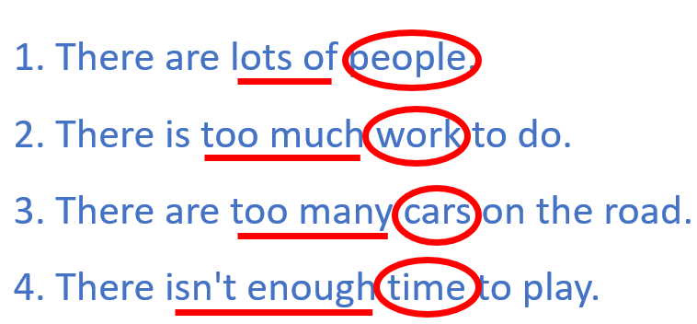  -Work in pairs to complete the rules.  Answer Keys:  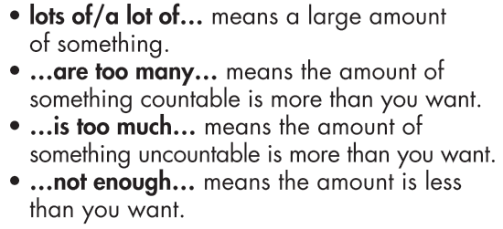  -Work in pairs to fill in the blanks to complete the conversation  -Listen and check.  Answer keys:  is too much, lots of, enough  -Listen and repeat.
2. Practice: 20 minutes
a. Objective: to help Ss practice using the correct quantifiers with countable and uncountable nouns.
b. Content: tasks a & b.
c. Expected outcomes: Ss can use quantifiers correctly.
d. Organization:
Teacher’s activities | Students’ activities
Task a: Read the examples on the left and circle the correct words.  1. There are too much/many vehicles on the road.  2. There aren't/isn't enough facilities in this village.  3. There is/are too much noise in my town.  4. This city doesn't have enough/many fresh air.  5. There isn't enough things to do/entertainment here.  6. There is lots of nature/vehicles here in the country.  - Ask Ss to read the sentences carefully and choose the correct words.  - Get Ss to check the answers with their partner and explain for their choices.  - Pick some Ss to give the answer and explain.  - Check Ss’ answers. | - Read the sentences carefully and choose the correct words.  - Check the answers with their partner  Answer Keys:  1. many 2. aren't 3. is  4. enough 5. Entertainment 6. nature
Task b: Write sentences using the prompts.  1. There/lots/peace and quiet/my village  2. My town/not/have/enough/entertainment  3. This city/have/much/pollution  4. There/many/vehicles/my street  5. There/lot/room/people/play/my city  6. There/not/many/things/do/my village  - Ask Ss to write sentences using gerunds and the prompts.  - Get Ss to pay attention to the type of sentences (affirmative, negative or interrogative) to use the correct structure.  - Set the time and monitor the class.  - Let Ss check with their partner.  - Pick seven students to write seven sentences on the board.  - Check Ss’ answers (using the DCR/PPT slides). | - Write sentences using gerunds and the prompts.  - Check with their partner.  - Write seven sentences on the board.  Answer Keys  1. There is lots of peace and quiet in my village.  2. My town doesn't have enough entertainment.  3. This city has too much pollution.  4. There are too many vehicles in/on my street.  5. There is a lot of room for people to play in my city.  6. There aren't many things to do in my village.
3. Production: 5’
a. Objectives: to help Ss to use the language in the real situation.
b. Content: task c
c. Expected outcomes: Ss can talk about their hobbies, using verbs expressing preferences correctly.
d. Organization
Teacher’s activities | Students’ activities
Task c: In pairs: Talk about your town using lots of/a lot of, not enough, too many, and too much.  - Ask Ss to work in pairs to talk about your town using lots of/a lot of, not enough, too many, and too much.  - Monitor the class and help them if necessary.  - Ask some Ss to talk about their town.  - Give feedback. | - Work in pairs to talk about your town using lots of/a lot of, not enough, too many, and too much.  - Share their ideas.  Sample answer:  There are lots of vehicles in my hometown.  My city has too much noise.

C. Consolidation and homework assignments: 5 minutes
- Grammar: lots of/a lot of, not enough, too many, too much.
- Do grammar and writing exercises in workbook on page 9.
- Prepare the next lesson: Lesson 1.3 – Pronunciation & Speaking, pages 16 & 17
- Do the exercises in Tiếng Anh 8 i-Learn Smart World notebook (page 14).
5. Reflection

a. What I liked most about this lesson today:
…………………………………………………………………………………………
b. What I learned from this lesson today:
…………………………………………………………………………………………
c. What I should improve for this lesson next time:
…………………………………………………………………………………………

