ĐỀ THI THỬ SỐ 11  TRƯỜNG THCS : …………………………….  LỚP : …………………………………………...  ( Đề theo cấu trúc mới Format 40 câu ) | SỞ GD – ĐT THÀNH PHỐ HỒ CHÍ MINH  KỲ THI TUYỂN SINH VÀO LỚP 10  KHÓA NGÀY……THÁNG……NĂM 20…  (Thời gian làm bài 90 phút)

I. Choose the word (A, B, C or D) whose underlined part is pronounced differently from the others.
1. A. opened B. closed C. contained D. finished
2. A. pond B. post C. ghost D. go
II. Choose the word (A, B, C or D)whose main stress is placed differently from the others in each group.
3. A. admit B. suggest C. remind D. manage
4. A. understand B. engineer C. benefit D. Japanese
III. Choose the word / phrase (A, B, C or D) that best fits the space in each sentence.
5. Every morning, I often sit in my garden and_____________ to my nightingale sing.
A. listening B. listen C. listened D. listens
6.I cannot sleep. The dog next door is making too much noise. I wish it ___________ quiet.
A kept B. would keep C. had kept D. will keep
7. John would be taking a great risk if he __________ his money in that business.
A. would invest B. invested C. had invested D. invests
8. He hardly has anything nowadays, ____________?
A. hasn’t she B. has he C. doesn’t he D. does she
9. It’s cold outside. __________ your coat.
A. Put on B. Put down C. Put off D. Put into
10. I’m not going out yet. I’m waiting ___________ the rain to stop.
A. for B. away C. from D. up
11. I look stupid with this haircut. Everyone will laugh ___________ me.
A. in B. at C. into D. away
12.Polluted water can directly do ___________ to people’s health and destroy marine life.
A. harm B. destruction C. terror D. ruin
13.“Why do we need clean air?” “Well, it ____________ us with a lot of oxygen”
A. protects B. provides C. preserves D. produces
14.The Browns had to use all their____________ to buy their house.
A. expense B. savings C. reserves D. remains
IV.Choose the best answer (A, B, C or D) for the following picture or sign.
15.Look at this photo and circle the statement (A, B, C, or D) that best describes it.
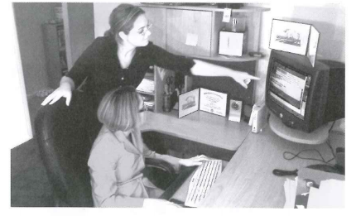
A.They’re working together at a desk.
B.They’re helping each other move a computer.
C.They’re handing decorations.
D.They’re arranging some furniture in a room.

16.Look at this photo and circle the statement (A, B, C, or D) that best describes it.
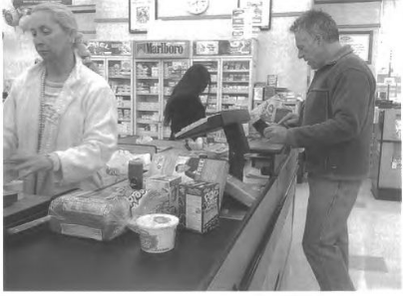
A.A purchase is being made.
B.The shopper is putting groceries in a plastic bag.
C.The woman is paying the cashier for the clothes.
D.There are some boxes under the counter.

V. Choose the word (A, B, C or D) that best fits the blank space in the following passage.
I went to Australia on a student program last year and I like to (17) _______you about it. I was very (18) _______when I knew I was going to Australia because I had never been there before. I didn’t think about the problems of speaking English (19) _______I met my host family. At first I couldn’t communicate with them because my English was so bad. All the five years I had been learning English wasn’t much used at all (20) _______we didn’t have real practice at school. Even though my grammar was good, my pronunciation wasn’t. My problem is (21) _______ ‘l’ and ‘r’. For example, Australian people often asked “What do you eat in Vietnam?” I wanted to tell them that we eat rice, but they didn’t (22) _________ when I said “We eat lice” …
17. A. say B. tell C. talk D. speak
18. A. exciting B. excites C. excited D. excite
19. A. after B. until C. when D. while
20. A. although B. even C. because D. so
21. A. pronouncing B. speaking C. reading D. telling
22. A. understand B. know C. seem D. react
VI.Read the passage, then decide if the statements that follow it are True or False
countries, electricity, gas and water are not luxuries but necessities. In developing countries, people even try to reduce using electricity, gas and water. Producers realize that products must not only work effectively but also save money. In a household, lighting often accounts for 10 percent to 15 percent of electricity bills. That is why some inventors from the Phillips and Company in Holland invented energy saving bulbs called compact bulbs. They are a good replacement for the 100-watt light bulbs which are often used. These new products use only a quarter of the electricity of standard bulbs and last eight times longer. Ultimately, the innovation like compact bulbs will save money as well as conserve the Earth’s resources.
23. In developed countries, electricity, gas, and water are necessities.
24. Compact bulbs should be replaced to spend less electricity on lighting.
25. In developing countries, people try to use electricity, gas and water economically.
26. The innovation like compact bulbs will not save any energy but money.
27. What is the passage mainly about?
A. People around the world are using more compact bulbs.
B. Energy is one of the most concerns in the world
C. Electricity is one of the most important sources of energy nowadays.
D. There are more and more innovations around the world.
28. We can infer from the passage that people in both developed and developing countries has realized
A. that energy is very expensive nowadays.
B. that compact bulbs use more electricity than standard bulbs do.
C. that compact bulbs can work eight times longer than standard bulbs do.
D. what are necessities and what are luxuries.
VII. Use the correct form of the word given in each sentence
29. Cuba gained……………..……from Spain in 1898. (depend)
30. He was short, overweight and generally ……………..…… (attract)
31. The church is in a poor state of ……………..…… (preserve)
32. Britain is increasingly a ……………..……society. (culture)
33. There are ……………..……ways of doing this job. (vary)
34. Try to act ……………..…… even if you feel nervous. (confidence)
VIII. Put the words in the correct order to make meaningful sentences.
35. but her mother/ enjoys films/ Her father/ plays/ is fond of. //
- Her father…………………………………………………………………………………….
36. that he didn’t smile/ about his exam results/ all week/ Paul was sad. //
- Paul was sad………………………………………………………………………………….
IX. Rewrite each of the following sentences in another way so that it means almost the same as the sentence printed before it

37. David is tired; therefore, he can’t score any goal.
→Because……………………………………………………………………………………..
38. Buy her a puppy or she will cry all day.
→If ……………………………………………………………………………………………
39.My nephew broke the plate. I received the plate as a present.
→My nephew ………………………………………………………………………….……..
40. I don’t play the piano as well as he does.
→He plays ……………………………………………………………………………………

ĐÁP ÁN ĐỀ THI THỬ SỐ 11
PHẦN TRẮC NGHIỆM
1.D | 2.A | 3.D | 4.C | 5.B | 6.B | 7.B | 8.D
9.A | 10.A | 11.B | 12.A | 13.B | 14.B | 15.A | 16.B
17.B | 18.C | 19.A | 20.C | 21.A | 22.A | 27.B | 28.A
PHẦN TỰ LUẬN.
CHỌN TRUE/FALSE

23.True
24.True
25.True
26.False
TỪ LOẠI
29.independence
30.unattractive.
31.preservation.
32.(multi)cultural
33.various
34.confidently
GHÉP CÂU
35. Her father is fond of plays but her mother enjoys films. (order can be changed)
36. Paul was sad about his exam results that he didn’t smile all week.
VIẾT CÂU
37. Because David is tired, he can’t score any goal.
38. If you buy her a puppy, she won’t cry all day. // you don’t buy her a puppy, she will cry…
39. My nephew broke the plate which I received as a present.
40. He plays the piano better than me/ I do.

