|  |  |
| --- | --- |
| **UBND HUYỆN CẨM GIÀNG** | **ĐỀ KHẢO SÁT HỌC SINH GIỎI CẤP HUYỆN**  **NĂM HỌC 2024-2025**  **MÔN:TIẾNG ANH 9**  **Thời gian làm bài: 150 phút**  **Đề thi gồm 06 trang** |

**A. LISTENING (20pts)**

**I. You will hear FIVE short conversations. Listen and choose the correct answer A, B, or C. You will hear each conversation TWICE. (5 pts)**

|  |  |
| --- | --- |
|  | **Tapescript** |
| 1. A |  |
| 2. C |  |
| 3. B |  |
| 4. B |  |
| 5. C |  |

**II. You will hear part of a radio interview in which Tina Whitem a magazine editor, talks about her life and work.** **Listen and choose the correct answer A, B, C or D. You will listen TWICE. (5 pts)**

6. B 7. A 8. C 9. D 10. B

**CEPT Practice B1 level-**

Woman: With us today, to tell us about his trip across Africa, is the biologist Paul Hart.

Man: We started on the east coast and travelled on foot across Africa to Gabon in the west, collecting plants and flowers along the way. It wasn't easy, but my route crossed a region rich in plants and I chose it because it won't stay that way for long when more roads are built. It was my only chance to get important information about the natural life of the area.

I had a team of eleven scientists. We walked from six in the morning, but the forest was so thick it took hours to cut our way through it, and some days we only walked one kilometre before dark. Fortunately, we carried special equipment that was very light and we took as little food as possible. But we were always tired when we put the tents up at night.

Sometimes we saw elephants or lions. They were amazing to watch and never attacked us. Every day, I collected plants and added to my notes. There was so much new information to write down. There were, of course, some low points, especially when I got anxious about the team. It was my job to make sure everyone got home safely.

Towards the end of the trip, I suddenly discovered one day that the food had nearly all gone. It was strange because we'd brought enough dried food with us to last the trip - food that wouldn't ever go bad - and we'd stopped at villages for fresh food too. But then I found that some of the team had eaten much more than they were supposed to. I was angry with them because it was a silly thing to do.

Then we started walking again. There were no maps for the area, but we had a local guide. Then one of the team got sick and we couldn't go any further. We let him rest, but he got much worse. Thankfully his life was saved by a fisherman who came along the river in a boat and took him to a doctor in the nearest village.

Finally, I returned home, and I'm back with my family and friends. I really missed them while I was away. But I learnt so much on the trip and I'm really glad I went. I was asked to go on another trip - this time to Australia - but I said that I couldn't because I'm busy here in London. And I think I've done enough travelling.

**III. You will hear a young woman who has applied for an office job talking about her jobs abroad. For each question, fill in the missing information in the numbered space. (5 pts)**

|  |
| --- |
| **Plymouth Sea Life Centre**   * **COST** * Adults **(11)** £ __3.70_____, children £2.00. Special prices for over sixties and school groups. * **OPENING TIMES**   Every day except 25 and **(12)** ____26/26th December________.   * **FOR CHILDREN** * Animals are fed every **(13)** ___hour_______ from 9.30 a.m. * Slide and **(14)** ____video___________ shows from 10.00 a.m. * **GROUPS** * Guided tours available – ask at the **(15)** ________information desk__________. |

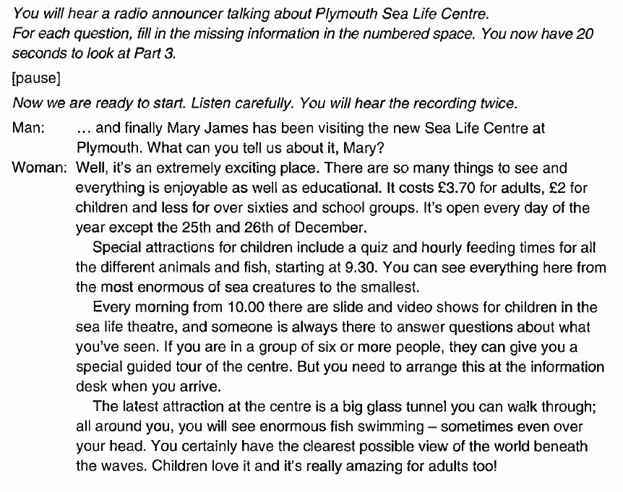

**IV. Look at the five sentences for this part. You will hear a conversation between a boy, Jim, and his mother. Decide if each sentence is True or False. If it is correct, write T. If it is not correct, write F. (5 pts)**

16. F 17. T 18. F 19. F 20. T

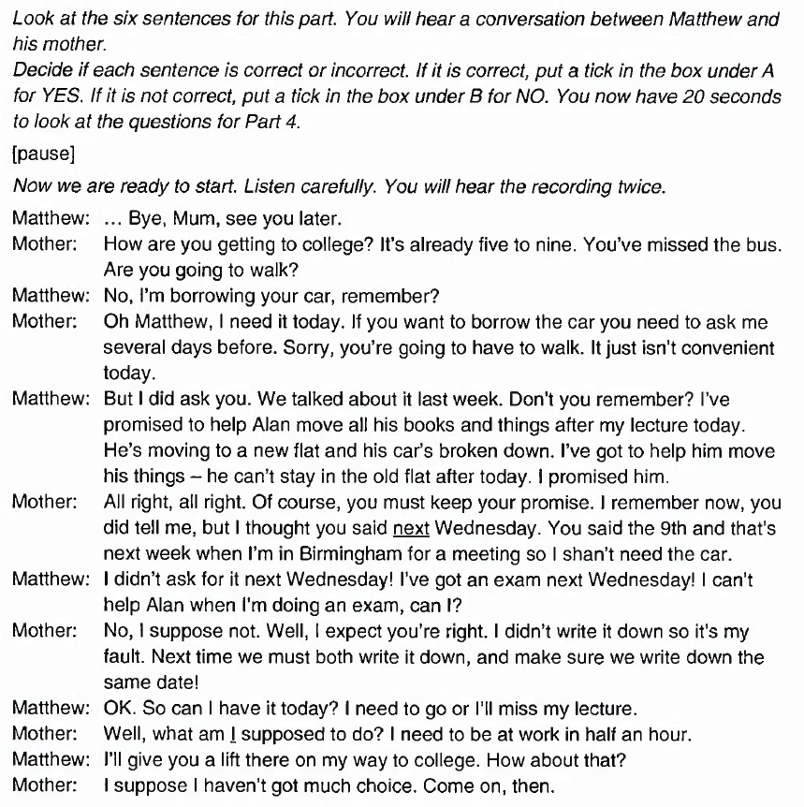

**B. GRAMMAR-VOCABULARY (25 pts)**

**I. Choose the word or phrase A, B, C or D that best fits the blank space in each sentence. (9 pts)**

21. D 22. A 23. B 24. D 25. B

26. C 27. C 28. A 29. C

**II. Read and choose the correct option to complete the advertisement. (3 pts)**

30. B 31. D 32. C

**III. Read and choose the correct option to complete the announcement. (3 pts)**

33. A 34. C 35. D

**IV. Find 05 errors in the following passage. Write the errors and write the correction in your paper. (5 pts)**

|  |  |  |  |
| --- | --- | --- | --- |
|  | **Line** | **Error** | **Correction** |
| **36** | 2 | learning | to learn |
| **37** | 3 | did | made |
| **38** | 5 | for | delete |
| **39** | 8 | politeness | polite |
| **40** | 10 | because of | because |

**V. Give the correct form of the words in brackets. (5 pts)**

41. scientist

42. interesting

43. laziness

44. successfully

45. socalise/socalize

**READING (25 pts)**

**I. The text below has five spaces. Put a given sentence A, B, C, D, E, F or G into its correct space. There are two sentences that you do not need to use. (5 pts)**

46. G 47. E 48. B 49. F 50. C

**II. Read the passage and decide which option A, B, C or D best fits each space. (10 pts)**

51. B 52. D 53. C 54. B 55. A

56. B 57. D 58. A 59. C 60. B

**III. Read the following passage and choose the best answer from A, B, C or D. (10 pts)**

61. B 62. C 63. A 64. C 65. B

66. A 67. D 68. D 69. C 70. B

**D. WRITING (30 pts)**

**I. Finish each of the following sentences in such a way that it means exactly the same as the sentence printed before it. (5 pts)**

71. No matter how hard does he work, support his large family.

72. The book was too complicated for us to understand.

73. They invited him to go to the stadium the next day/the following day

74. If you practice speaking English every day, you can improve your English.

75. She told Mary : “Why don’t you sign up for this club now?”

**II. This is part of a letter you have received from Elizabeth, your pen pal from England. In about 100 - 120 words, write a letter to answer her questions. (10 pts)**

|  |
| --- |
| A new restaurant has just opened in my town and it’s wonderful. Have you got a favourite restaurant? Tell me about the food and what you like about the restaurant. |

***NOTE: You are required to******sign your name as Ngoc Mai!***

1. Format: a letter: 1p

2. Content: 5p

3. Organization and cohension: Clear organization of ideas, with suitable paragraphing and linking: 2p

4. Range: Language of describing, explaining and expressing opinion: 2p

**III. “*Due to the outbreak of Covid-19 many students have to take online classes. Do you think that studying online is advantageous or disadvantageous?* ”**

**Write a paragraph about 150 - 170 words to give your opinion. (15 pts)**

+**Task fulfillment**

**Complete the task appropriately with all main ideas and important details: 8 p**

* Advantages (4p)
* Disadvatages (4p)

**+ Language 7p**

* Accurate grammar: appropriate vocabulary
* Variety of sentence types: appropriate linking devices
* Good organization