|  |  |
| --- | --- |
| **School: ………………………………………..** | **Date:………………………………..** |
| **Class: …………………………….....................** | **Period: ……………………….........** |

**UNIT 3: MUSIC AND ARTS**

**Lesson 2.2 - Grammar (Page 24)**

**I. OBJECTIVES**

By the end of the lesson, Ss will be able to:

**1.1. Language knowledge and skills**

- listen to 2 people asking and answering about musical instrument.

- use prepositions of time and possessive adjectives correctly.

**1.2. Competences**

- improve speaking, listening and writing skills.

- improve the use of English.

**1.3. Attributes**

- love music.

- choose a musical instrument to try practicing playing it.

**II. TEACHING AIDS AND LEARNING MATERIALS**

**1. Teacher’s aids:** Student book and Teacher’s book, class CDs, Digital Book (DCR phần mềm tương tác SB, DHA (từ vựng/ cấu trúc) phần mềm trò chơi tương tác), projector/interactive whiteboard / TV (if any), PowerPoint slides, handouts.

**2. Students’ aids:** Student’s book, workbook, notebook.

**III. ASSESSMENT EVIDENCE**

|  |  |  |
| --- | --- | --- |
| **Performance Tasks** | **Performance Products** | **Assessment Tools** |
| - Listen and repeat.  **-** Study the grammar box.  - Fill in the blanks with *in, on, or at*, and the correct possessive adjectives.  - Look at the table and write the answers.  - Ask and answer using the information in the table (in pairs). | **-** Ss’ performance.  - Ss’ task.  - Ss’ answers /performance.  - Ss’ answers.  - Ss’ answers/ presentation. | - T’s feedback.  - T’s observation.  - T’s feedback/Peers’ feedback.  - T’s feedback/Peers’ feedback.  - T’s observation, T’s feedback/Peers’ feedback. |

**IV. PROCEDURES**

**A. Warm up: (5’)**

**a) Objective:** Introduce the new lesson and set the scene for Ss to acquire new language; get students' attention at the beginning of the class by enjoyable and short activities as well as to engage them in the follow-up steps.

**b) Content:** Introduce vocabulary about musical instruments / review phrases about time expressions.

**c) Expected outcomes:** Ss review words about musical instruments and Ss have general ideas about the grammar point they are going to study in the new lesson.

**d) Organization of the activity:**

|  |  |
| --- | --- |
| **TEACHER’S ACTIVITIES** | **STUDENTS’ ACTIVITIES** |
| * **Option 1: Musical instrument**   - Have Ss look at the pictures and give names of musical instruments.  - Call Ss to give answers.  - Check Ss’ answers, give feedback and lead to the new lesson.    - Have Ss make sentences, using the vocabularies above.  à Lead to the new lesson.   * **Option 2: Time Expressions**   - Have Ss close all books and notebooks.  - Divide class into 4 groups.  - Have Ss in each group write down time expressions in English as many as possible (in about 2 minutes).  - Call Ss to write answers on the board.  - Check Ss’ answers, give feedback and evaluation.  - The group with the most correct answers will be the winner.  - Give a small present to the winner.  - Lead to the new lesson. | - Work in pairs.  - Give answers.  **Answers keys**  *1. guitar*  *2. piano*  *3. drum*  *4. saxophone*  *5. flute*  *6. violin*  - Make sentences and read them.    - Close books and notebooks.  - Work in groups of 4.  **Suggested answers**  ***Time Expressions:*** *yesterday, in the morning, in the afternoon, in the evening, on Sundays, on / at the weekends, at night, in the winter, in March, in 2022, …* |

**B. New lesson (35’)**

* **Activity 1: Presentation (10’)**

**a) Objective:** Introduce Prepositions of time and Possessive adjectives.

**b) Content:**

**-** Listen and repeat.

**-** Introduce the grammar point: Prepositions of time and Possessive adjectives.

**c) Expected outcomes:** Ss know how to use Prepositions of time and Possessive adjectives to do some following exercises.

**d) Organization of the activity:**

|  |  |
| --- | --- |
| **TEACHER’S ACTIVITIES** | **STUDENTS’ ACTIVITIES** |
| **Task a. Listen and repeat**  - Have Ss look at the picture (using DCR).  - Play audio (CD1 – Track 31) and have Ss listen and read the speech bubbles.  - Play the audio again and have Ss listen and repeat.  **Grammar box**   * **Option 1:**   - Have Ss look at the grammar explanation and read: Prepositions of time.    - Have Ss look at the grammar explanation and read: Possessive adjectives.    - Briefly explain the grammar point.  - Ask Ss to give more examples using Prepositions of time and Possessive adjectives.   * **Option 2:**   - Have Ss close books.  - Show sample phrases, have Ss read them and make comment on the way teacher uses preposition before time expressions.  **\*Suggested sample phrases**: *in the morning, in the afternoon, in the evening, on Sundays, on / at the weekends, at night, in the winter, in March, in 2022, …*  - Have Ss give answers.  - Give feedback and evaluation.  àLead to the grammar box and explain more: Prepositions of time.    - Next, show sample sentences, have Ss read them and make comment on the way teacher uses possessive adjectives (In each sentence: Identify which is possessive adjective, identify possessive adjective’s position).  **\*Suggested sample sentences:**  *1. My father worked in that company in 2015.*  *2.I study with her son.*  *3. His piano is quite new.*  *4. Their music performance is very great.*  - Have Ss give answers.  - Give feedback and evaluation.  àLead to the grammar box and explain more: Possessive adjectives.    - Have Ss give more examples of Prepositions of time and Possessive adjectives, encourage them to make sentences with their own ideas.  - Give feedback and evaluation. | - Look.  - Listen, then read.  - Listen and repeat.  - Look and read.  - Look and read.  - Listen and take notes.  **-** Give examples.  - Close all books.  - Look and answer.  - Give answers.  **-** Open the books and read the grammar box.  -Read and comment.  **Suggested answers**  ***1. Possessive adjectives****: my, her, his, their*  ***2. Position****: before noun*  - Open the books and read the grammar box.  - Give examples. |

* **Activity 2: Practice (19’)**

**a) Objective:** Students can use Prepositions of time and Possessive adjectives correctly.

**b) Content:**

- Fill in the blanks with ***in, on,*** or ***at***, and the correct possessive adjectives.

- Look at the table and write the answers.

**c) Expected outcomes:** Students can use Prepositions of time and Possessive adjectives in their speaking.

**d) Organization of the activity:**

|  |  |
| --- | --- |
| **TEACHER’S ACTIVITIES** | **STUDENTS’ ACTIVITIES** |
| **Task b. Fill in the blanks with *in, on, or at*, and the correct possessive adjectives**  - Demonstrate the activity on DCR, using the example.  - Have Ss fill in the blanks with in, on, or at, and the correct possessive adjectives.  - Have Ss work in pairs to check each other’s work.  - Have some Ss share their answers with the whole class.  - Give feedback, correct Ss’ answers if necessary.  **Task c. Look at the table and write the answers.**  - Demonstrate the activity on DCR, using the example.  - Have Ss look at the table and write the answers.  - Have Ss check answers with their partners.  - Call Ss to read or write answers.  - Check Ss’ answers, give feedback. | - Look and listen.  - Work individually.  - Work in pairs.  - Write answers on the board.  **Answer keys**    - Look and listen.  - Work individually.  - Work in pairs.  - Read or write answers.  **Answer keys** |

* **Activity 3: Production (6’)**

**a) Objective:** Students master the grammar point they study in the lesson.

**b) Content:**  Speaking: Ask and answer using the information in the table.

**c) Expected outcomes:** Ss produce the new language successfully, and they can apply the grammar point they have learnt in speaking and writing.

**d) Organization of the activity:**

|  |  |
| --- | --- |
| **TEACHER’S ACTIVITIES** | **STUDENTS’ ACTIVITIES** |
| **Task d. In pairs: Ask and answer using the information in the table**  - Divide class into pairs.  - Have Ss ask and answer using the information in the table.  - Then, encourage Ss to add their own ideas to practice.  - Have some pairs demonstrate the activity in front of the class.  - Give feedback and evaluation. | - Work in pairs.  - Have conversation in pairs.  - Present.  - Listen. |

**C. Consolidation and homework assignments (5’)**

**\*Consolidation**

**- Prepositions of time**

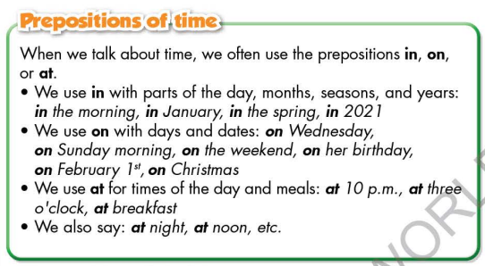

**- Possessive Adjectives**

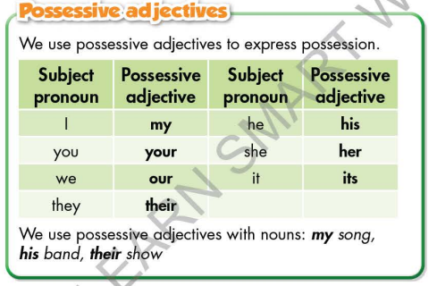

*.*

**\* Homework:**

- Make 2 sentences, use prepositions of time and possessive adjectives.

- Do the exercises in WB: Grammar (page 17).

- Complete the grammar notes in Tiếng Anh 7 i-Learn Smart World Notebook (page 19).

- Play consolation games in Tiếng Anh 7 i-Learn Smart World DHA App on [www.eduhome.com.vn](http://www.eduhome.com.vn)

- Prepare: Lesson 2.3 – Pronunciation and Speaking (page 25 – SB).

**D. Reflection**

a. What I liked most about this lesson today:

…………………………………………………………………………………………

1. What I learned from this lesson today:

…………………………………………………………………………………………

c. What I should improve for this lesson next time:

…………………………………………………………………………………………