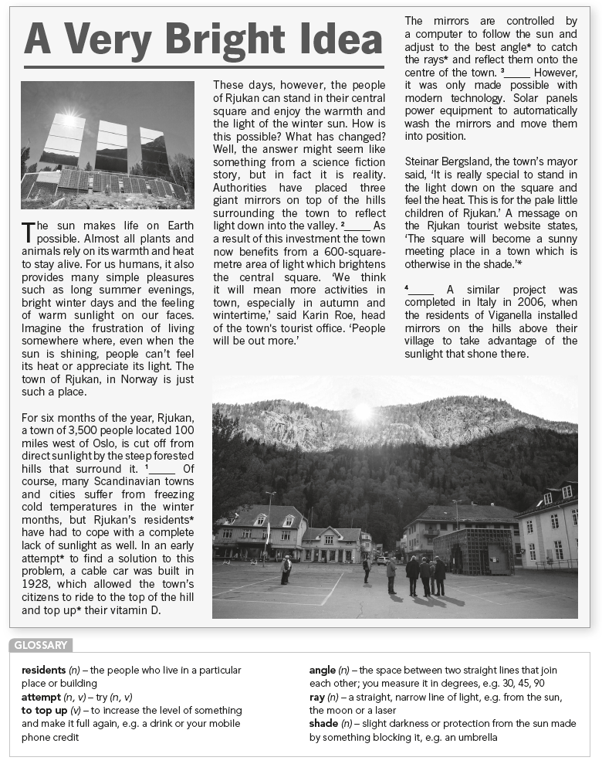

**Exercise 1: Read the text above. Complete gaps 1–4 with the sentences below. There is one extra sentence.**

1. **The huge mirrors were carried there by helicopters, as part of a project which cost 5 million kroner (£500,000).**
2. **This happens because between September and March the sun is so low in the sky that its light and warmth don't reach the small town at the bottom of the valley.**
3. **Environmentalists disapprove of the project, however.**
4. **However, Rjukan is not the only place to benefit from this kind of scheme.**
5. **The idea was first suggested 100 years ago by Sam Eyde, who was responsible for building the town of Rjukan.**

**Exercise 2: Read the text. Complete the gaps with the sentences below. There are two extra sentences.**

1. Which is true about the importance of the sun?
2. It prevents humans from becoming frustrated.
3. It is both practical and pleasant for people.
4. Its warmth is appreciated everywhere on Earth.
5. Every animal and plant needs it to live.
6. For half a year the town of Rjukan in Norway ___________________.
7. doesn't get direct sunlight because of its location.
8. isn't the only Scandinavian town without sunlight.
9. hasn't been able to find a solution to its problem.
10. doesn't allow its citizens to stay in the valley.
11. Now the people of Rjukan ___________________.
12. can finally stand in its central square.
13. are able to feel the sun in winter.
14. have sunlight everywhere in the town.
15. are organising more activities in cold months.
16. The newly installed giant mirrors ___________________.
17. make the town of Rjukan unique.
18. can wash and move themselves.
19. give the town a new meeting place.
20. aren't a completely new idea.

**ANSWER KEY**

Exercise 1:

A. Gap 2

B. Gap 1

D. Gap 4

E. Gap 3

Exercise 2:

1. B
2. A
3. B
4. D