|  |  |
| --- | --- |
| **Tiếng Anh 8 Friends Plus** | **FP 8 – REVIEW 2 - TEST 1**  **Test for Unit**  *-------------------------* |

**I. Pronunciation (1-4)**

**Câu 1.** Which word has the underlined part pronounced differently from that of the others?

**A.** behind  **B.** adventure  **C.** forest  **D.** valley

**Đáp án đúng**: B

**Câu 2.** Which word has the underlined part pronounced differently from that of the others?

**A.** hike  **B.** river  **C.** bike  **D.** diving

**Đáp án đúng**: B

**Câu 3.** Which word has a different stress pattern from that of the others?

**A.** alien  **B.** admiration

**C.** foreign  **D.** local

**Đáp án đúng**: B

**Câu 4.** Which word has a different stress pattern from that of the others?

**A.** energy  **B.** infrastructure

**C.** ecological  **D.** project

**Đáp án đúng**: C

**II. Choose the answer (A, B, C or D) that best fits the space in each question. (5-14)**

**Câu 5.** There are ______ people at the beach today. It’s summer time.

**A.** a little  **B.** few  **C.** enough  **D.** a lot of

**Đáp án đúng**: D

**Câu 6.** I have _______ finished my homework.

**A.** yet  **B.** just  **C.** still  **D.** already

**Đáp án đúng**: B

**Câu 7.** We haven't met before, _______?

**A.** haven't we  **B.** had we

**C.** have we  **D.** hadn't we

**Đáp án đúng**: C

**Câu 8.** The Sahara is the largest hot ______ in the world.

**A.** ocean  **B.** valley  **C.** cave  **D.** desert

**Đáp án đúng**: D

**Câu 9.** I have had ______ food to eat, I am not hungry anymore.

**A.** not enough  **B.** few

**C.** many  **D.** enough

**Đáp án đúng**: D

**Câu 10.** A ______ is a hill of sand formed by wind, usually along the beach or in a desert.

**A.** valley  **B.** ocean  **C.** dune  **D.** cave

**Đáp án đúng**: C

**Câu 11.** Niagara ______ is one of the most famous waterfalls in the world.

**A.** dune  **B.** falls  **C.** ocean  **D.** cave

**Đáp án đúng**: B

**Câu 12.** Sarah is coming to the party, _______?

**A.** aren't they  **B.** doesn't she

**C.** does she  **D.** isn't she

**Đáp án đúng**: D

**Câu 13.** Have you seen the new movie _______?

**A.** yet  **B.** still  **C.** already  **D.** just

**Đáp án đúng**: A

**Câu 14.** How many stars will you give for this restaurant?

**A.** It's a rainy day today.

**B.** I would give this restaurant five stars for its excellent food, service, and ambiance.

**C.** My favourite one is Star Cinema.

**D.** I have three siblings.

**Đáp án đúng**: B

**III. Look at the signs. Choose the best answer (A, B, C or D). (15-16)**

**Câu 15.**

Where is the proposed meeting location for the activity?

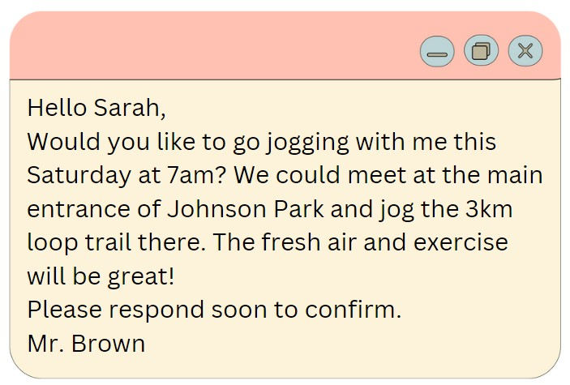

**A.** Hyde Park  **B.** Central Park

**C.** Smith Park  **D.** Johnson Park

**Đáp án đúng**: A

**Câu 16.**

What activity is being proposed in the message?

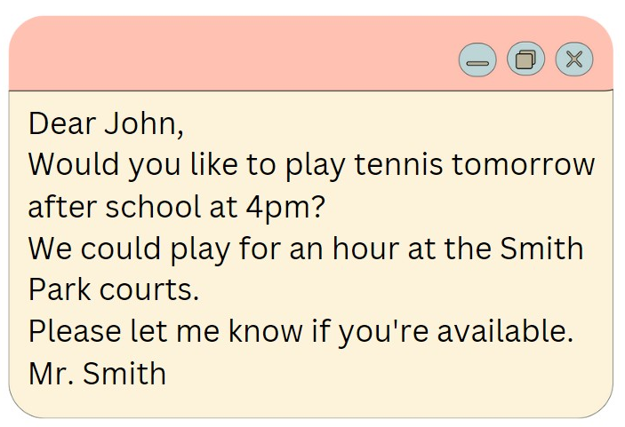

**A.** Playing tennis  **B.** Playing basketball

**C.** Going swimming  **D.** Going for a run

**Đáp án đúng**: D

**IV. Read the following passage and do as direct. (17-22)**

Bungee jumping is an exhilarating sport that originated in New Zealand in the 1980s. It involves jumping from a tall structure while attached to a bungee cord. Before participating, it's important to understand the risks and choose a safe and reliable provider.

Before jumping, consider your weight, height, and overall health. You'll be fitted with a harness and bungee cord before ascending the structure. At the top, you'll be signaled to jump.

As you fall, the bungee cord will stretch, giving you a brief sensation of weightlessness. When the cord contracts, you'll be pulled back up to the top.

While bungee jumping can be safe when done properly, there are risks involved, including injury or death. It's important to choose a reliable provider and follow all safety instructions.

Some tips for bungee jumping include choosing a safe provider, being in good physical shape, understanding the risks, and following all directions. Most importantly, have fun!

**Câu 17.** Bungee jumping originated in New Zealand in the 1980s.

**A.** True  **B.** False

**Đáp án đúng**: A

**Câu 18.** Bungee jumping does not involve a bungee cord.

**A.** True  **B.** False

**Đáp án đúng**: B

**Câu 19.** It is not important to consider your weight, height, and overall health before bungee jumping.

**A.** False  **B.** True

**Đáp án đúng**: A

**Câu 20.** Bungee jumping can be safe when done properly with a reliable provider.

**A.** True  **B.** False

**Đáp án đúng**: A

**Câu 21.** What should you consider before bungee jumping?

**A.** Your weight  **B.** Your height

**C.** Your overall health  **D.** All of the above

**Đáp án đúng**: D

**Câu 22.** What happens when you jump while bungee jumping?

**A.** The bungee cord stretches

**B.** You experience a brief sensation of weightlessness

**C.** The cord contracts and pulls you back up

**D.** All of the above

**Đáp án đúng**: D

**V. Choose the word (A, B, C or D) that best fits the blank space in the following passage. (23-28)**

The pervasive use of technology has altered the way teenagers live and interact today. Mobile phones, social media apps and the internet have become an integral **____23___** of their lives. On an **___24____**, teenagers spend around 9 hours a day using some form of technology. While technology has its benefits, excessive usage can negatively **___25____** teenagers' health and development. It can lead to poor sleep patterns as phones are kept close at night causing disruption. Teenagers staying glued to screens have less time for **____26___** activity and family interactions. This **___27___** connectivity also makes them prone to anxiety and mood swings. Social media can make teenagers insecure and get obsessed with projecting the right image. Though developments like online learning have made education accessible, teenagers becoming overly **___28___** on technology at a young age may lack essential life skills to function effectively. Parents need to monitor and guide teenagers to use technology in moderation to avoid its ill effects.

**Câu 23.** Mobile phones, social media apps and the internet have become an integral ___ of their lives.

**A.** bit  **B.** piece  **C.** part  **D.** section

**Đáp án đúng**: C

**Câu 24.** On an ____, teenagers spend around 9 hours a day using some form of technology.

**A.** usual  **B.** regular  **C.** average  **D.** normal

**Đáp án đúng**: C

**Câu 25.** While technology has its benefits, excessive usage can negatively ____ teenagers' health and development.

**A.** improve  **B.** affect  **C.** touch  **D.** build

**Đáp án đúng**: B

**Câu 26.** Teenagers staying glued to screens have less time for ____ activity and family interactions.

**A.** physical  **B.** running  **C.** moving  **D.** playing

**Đáp án đúng**: A

**Câu 27.** This ____ connectivity also makes them prone to anxiety and mood swings.

**A.** built-in  **B.** constant  **C.** always-on  **D.** one-time

**Đáp án đúng**: B

**Câu 28.** Though developments like online learning have made education accessible, teenagers becoming overly ____ on technology at a young age may lack essential life skills to function effectively.

**A.** using  **B.** wanting  **C.** relying  **D.** needing

**Đáp án đúng**: C

**VI. Supply the correct form of the word given in each sentence. (29-34)**

**Câu 29.** My uncle is a __________ of wine in France. (popular)

**Đáp án đúng**: producer

**Câu 30.** The __________ of the rainforest is a big problem. (destroy)

**Đáp án đúng**: destruction

**Câu 31.** Many __________ prefer to buy organic food. (consume)

**Đáp án đúng**: consumers

**Câu 32.** Many countries are still __________ their economies. (develop)

**Đáp án đúng**: developing

**Câu 33.** We should avoid __________ food and water. (waste)

**Đáp án đúng**: wasting

**Câu 34.** She is very __________ and loves to try new things. (adventure)

**Đáp án đúng**: adventurous

**VII. Rearrange the groups of words in a correct order to make complete sentences. (35-36)**

**Câu 35.** so that / we could / get / married. / We saved / money

…

**Đáp án đúng**: We saved money so that we could get married.

**Câu 36.** my heavy bag at / woman who / helped me with / the airport. / That’s the

…

**Đáp án đúng**: That’s the woman who helped me with my heavy bag at the airport.

**VIII. Rewrite each of the following sentences in another way so that it means almost the same as the sentence printed before it. (37-40)**

**Câu 37.** Do they need to practice more to become better at basketball? (ORDER)

Should they …

**Đáp án đúng**: Should they practice more in order to become better at basketball?

**Câu 38.** The population of the world is increasing rapidly. (pace)

The population …

**Đáp án đúng**: The population of the world is increasing at a rapid pace.

**Câu 39.** Susan started learning Japanese in 2022. (SINCE)

Susan …

**Đáp án đúng**: Susan has learned/ been learning Japanese since

**Câu 40.** Tennis is a sport that requires quick reflexes. It is popular in many countries. (Use relative clause)

Tennis, …

**Đáp án đúng**: Tennis, which is popular in many countries, is a sport that requires quick reflexes.

**IX. Listening: listen and do as direct. (41-50)**

**Câu 41.** Hardware and software are familiar terms that are used daily on phones and computers.

**A.** True  **B.** False

**Đáp án đúng**: A

**Câu 42.** Computer hardware refers to physical components such as monitors, keyboards, microchips, and hard drives.

**A.** False  **B.** True

**Đáp án đúng**: B

**Câu 43.** Computer programs and phone apps are hardware that instructs software to perform tasks.

**A.** True  **B.** False

**Đáp án đúng**: B

**Câu 44.** Games, photo editors, and browsers are examples of software.

**A.** True  **B.** False

**Đáp án đúng**: A

**Câu 45.** Hardware and software are distinct but interdependent.

**A.** False  **B.** True

**Đáp án đúng**: B

**Câu 46.** Hardware is the physical device, such as a phone, while software is its operating system and apps.

**A.** False  **B.** True

**Đáp án đúng**: B

**Câu 47.** Without software, our phones would function normally because they would have instructions to call, text, or go online.

**A.** False  **B.** True

**Đáp án đúng**: A

**Câu 48.** Without hardware, we would have programs but no device to run them on.

**A.** True  **B.** False

**Đáp án đúng**: A

**Câu 49.** Software does not require hardware to execute its commands.

**A.** False  **B.** True

**Đáp án đúng**: A

**Câu 50.** As technology advances, hardware and software will continue to support it in the future, regardless of its appearance.

**A.** False  **B.** True

**Đáp án đúng**: B

**----HẾT---**