Date of preparing: ………………………………….
Date of teaching: ………………………………….

Period……
UNIT 3: FRIENDS
Lesson 2 - Part 1 (Page 25) - Vocabulary and Reading

I. OBJECTIVES
By the end of the lesson, Ss will be able to…
1. Knowledge
- know more vocabularies that can go with “go”, “play”, “have”, “watch” and “make”.
- invite someone to do an activity.
2. Ability
- improve the use of English and Reading skills.
3. Quality
- have positive attitude in English language learning so that they actively participate in all classroom activities.
- relax after hard working time at school.

II. TEACHING AIDS AND LEARNING MATERIALS
Lesson plan, PPT slides, student’s book, workbook, notebook, personal computer (if any), projector/TV, speakers, DCR & DHA on Eduhome, handouts...
III. PROCEDURES
A. Warm up: (5’)
a) Objective: Introduce the new lesson and set the scene for Ss to acquire new language; get students' attention at the beginning of the class by means of enjoyable and short activities as well as to engage them in the steps that follow.
b) Content: Introduction of some after school activities.
c) Product: Ss know more activities they are going to study in the lesson.
d) Competence: Collaboration, creativity, communication.
e) Organization of the activity:
Teacher’s Activities | Students’ Activities
- Give greetings  - Check attendance  - Option 1: Game: Acting  - Invite 1 or 2 Ss who will be the actor to stand in front of the class.  - Give this / these students a small piece of paper with a verb phrase inside.  - Have this / these students act (use body language) to demonstrate the activity  - Have the rest of the class guess what the verb phrase is  - Have Ss give a big applause to the Ss who have the right answer  - Give feedback and lead to the new lesson.  *Verb phrases: go shopping, play badminton, watch a movie, have a party, make a pizza  - Option 2: Network of words  - Give Ss 2 key words: “Play” and “Go”  - Have Ss find out as many as possible words that can go after “play” and “go”  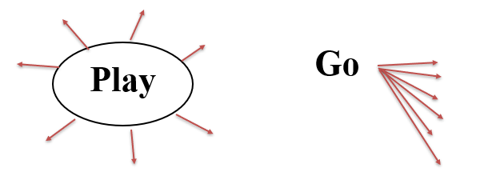  - Have Ss give answers  - Check the accuracy, spelling  → Lead to the new lesson | - Greet T  - Volunteer to be the actor  - Read and act  - Guess the activity  - Listen  - Work in groups  - Write answers  Suggested answers  Play: badminton, soccer, football, volleyball, basketball, video games, chess, …  Go: shopping, fishing, dancing, hiking, …

B. New lesson (36’)
- Activities 1: Vocabulary (17’)
a) Objective: Ss know more vocabularies that can go with “go”, “play”, “have”, “watch” and “make”
b) Content:
- Filling in the table
- Adding more words to the table
c) Products: Ss know how to pronounce the new words correctly and use them in appropriate situations.
d) Competence: Communication, collaboration, presentation, listening, creativity.
e) Organization of the activity:
Teacher’s Activities | Students’ Activities
a. Fill in the table. Listen and repeat.  - Demonstrate the activity, using the example in the book.  - Have Ss fill in the table  - Ask Ss to work in pairs to check their answers with their partners.  - Check answers as a whole class.  - Play the audio (CD1 – Track 34) for Ss to listen and repeat.  - Call some Ss to read the phrases again, correct their pronunciation and stress.  b. Add more words to the table  - Option 1:  - Have pairs add more words to the table  - Call Ss to share answers with the class  - Option 2: (For class with low-level students)  - Give a set of words, ask Ss to put them in the right column.  - Have Ss do the task in pairs  - Call Ss to give answers  - Check answers  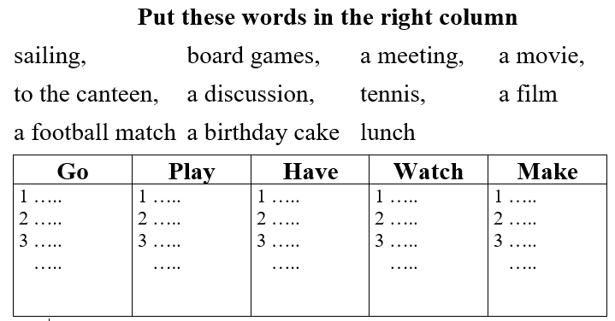 | - Look and listen  - Work in pairs  - Listen and check  - Listen and repeat  - Read  Answer keys  1. Go: shopping, swimming, to the beach, to the mall  2. Play: badminton, video games  3. Have: a party, a pizza, a barbecue, a cake  4. Watch: TV  5. Make: a pizza, a cake, a movie  - Work in pairs  - Give answers (Say or write on the board)  Suggested answers  1. Go: to school, to the movies, sailing, for a walk, …  2. Play: ping-pong, tennis, chess, board games, …  3. Have: a talk, a meeting, a headache, …  4. Watch: a movie / a film, a football match, …  5. Make: an appointment, breakfast, dinner, a mistake, …  - Work in pairs  - Give answers  .
- Activity 2: Reading (19’)
a) Objective: Ss can develop their reading skills in different types of text
b) Content: Reading the messages and filling in the blanks
c) Products: Ss can complete the task successfully and enhance their reading skills.
d) Competence: Collaboration, communication, analytical and synthesizing skills.
e) Organization of the activity:

Teacher’s Activities | Students’ Activities
Read the messages and fill in the blanks with the words from New Words (Vocabulary)  - Option 1:  - Demonstrate the activity  - Have Ss read the messages and fill in the blanks using the correct form of verbs from New Words. (Remind Ss to use the Present Continuous)  - Have Ss work in pairs to check answers with their partners  - Have some Ss share their answers with the class  - Give feedback  - Option 2: (For class with better students)  - Follow the same steps as option 1  - Give an extra activity:  - Have Ss work in groups and make similar messages, using their own ideas to make the messages more interesting.  - Have Ss prepare the messages by writing them down on a paper (format: text messages in a phone); then have them use cell phone to send messages to another member in the group. (Encourage Ss to use some popular messing apps like facebook messenger or zalo)  - Remind Ss to use the Present Continuous and the words / phrases in New Words.  - Have Ss share their work with the whole class.  (T can have Ss capture the screen, then show them on the TV or projector screen to check as a whole class)  - Check, give feedback and evaluation | - Read and fill in the blanks  - Check answers with partners  - Write answers  Answer keys  1. having  2. going  3. going  4. playing  - Work in groups  - Write on a piece of paper  - Send messages  - Show answers  Suggested messages  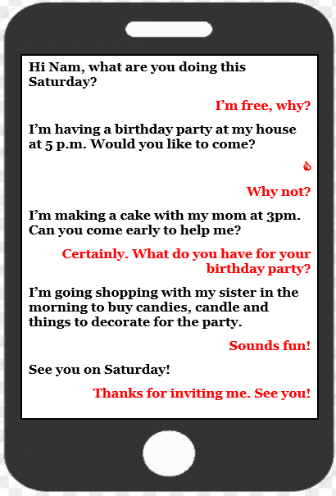

C. Consolidation (2’)
* Collocation:
1. Go: to school, to the movies, sailing, for a walk, …
2. Play: ping-pong, tennis, chess, board games, …
3. Have: a talk, a meeting, a headache, …
4. Watch: a movie / a film, a football match, …
* Invitation:
1. Do you want to come? / Would you like to come?
2. Come to my house

D. Homework (2’)
- Learn by heart the collocation.
- Make sentences with collocation with “go”, have”, “watch”, “play” and “make”.
- Do exercises in Workbook: Lesson 2 - New words – Part a and b (page 16).
- Prepare: Lesson 2 – Grammar (page 26 – SB).

