School: ……………………………………….. | Date:……………………………………..
Class: ……………………………..................... | Period: …………………………….........

UNIT 5: SCIENCE AND TECHNOLOGY
Lesson 1.1 - Vocabulary and Reading (pages 44 & 45)
I. OBJECTIVES
By the end of the lesson, Ss will be able to:
1.1. Language knowledge and skills
- use vocabulary related to technology (tablet, screen, inch, weight, gigabyte, storage)
- practice reading and understanding general and specific information about electronic devices
1.2. Competences
- improve communication, collaboration and critical thinking skills.
1.3. Attributes
- to understand how electronic devices work and their impacts on daily life.
II. TEACHING AIDS AND LEARNING MATERIALS
1. Teacher’s aids: Student book and Teacher’s book, class CDs, Digital Book (DCR phần mềm tương tác SB, DHA (từ vựng/ cấu trúc) phần mềm trò chơi tương tác), projector/interactive whiteboard / TV (if any), PowerPoint slides.
2. Students’ aids: Student’s book, workbook, notebook.
III. ASSESSMENT EVIDENCE
Performance Tasks | Performance Products | Assessment Tools
- Introduce some nouns about tablets.  - Fill in the blanks.  - Talk about what Ss want a tablet and a laptop to have.  - Read the article and complete the reading tasks.  - Talk about what tablet Ss would prefer to buy. | - Ss’ answers in notebooks.  - Ss’ answers.  - Ss’ answers/ presentation.  - Ss’ answers.  - Ss’ answers. | - T’s feedback.  - T’s observation/ DCR.  - T’s observation.  - T’s feedback/Peers’ feedback.  - T’s feedback/Peers’ feedback.
IV. PROCEDURES
A. Warm up: (5’)
a) Objective: Introduce the new lesson and set the scene for Ss to acquire new language; get students' attention at the beginning of the class by enjoyable and short activities as well as to engage them in the follow-up steps.
b) Content: Introducing some nouns and nouns phrases related to technical features of electronic devices.
c) Expected outcomes: Ss have general ideas about the topic of the new lesson: “Science and Technology”.
d) Organization of the activity:
TEACHER’S ACTIVITIES | STUDENTS’ ACTIVITIES
Asking questions:  - Show the pictures.  - Ask Ss about their opinions regarding electronic devices and their uses.  What can you see in the picture?  What are they?  Which devices do you often see?  Which devices do you often use?  Do they help make your life easier? How?  - Set time for this activity.  - Elicit answers from some Ss.  - Lead to the new lesson. | - Discuss the questions.  - Give answers.  Ss’ own answers

B. New lesson (35’)
- Activity 1: Pre-Reading (Vocabulary) (12’)
a) Objective: Ss accurately use and define technology vocabulary related to electronic devices.
b) Content:
- Vocabulary study (storage, weight, screen, inch, gigabyte, tablet).
- Speaking: Discuss what Ss want devices to have.
c) Expected outcomes: Ss know how to pronounce the new words correctly and use them in appropriate situations.
d) Organization of the activity:
TEACHER’S ACTIVITIES | STUDENTS’ ACTIVITIES
- Bring a tablet/ smart phone. Point to the screen. Have Ss work in pairs and ask What is it called?  - Lead to teach vocabulary.  Teaching Vocabulary  - Explain the meaning of the new vocabulary, using pictures, examples and explanations.  - tablet (realia/ picture)  - screen (realia)  - inch (explanation and realia such as ruler/ measuring tape)  - weight (explanation: how heavy the tablet is)  - gigabyte (GB) (translation)  - storage (picture: images of different tablet models with storage capacities)  - Have Ss read the words.  - Check Ss’ pronunciation and give feedback.  *Matching:  - Check Ss’ understanding by matching tablet descriptions with its features on the interactive whiteboard / TV (Books closed).  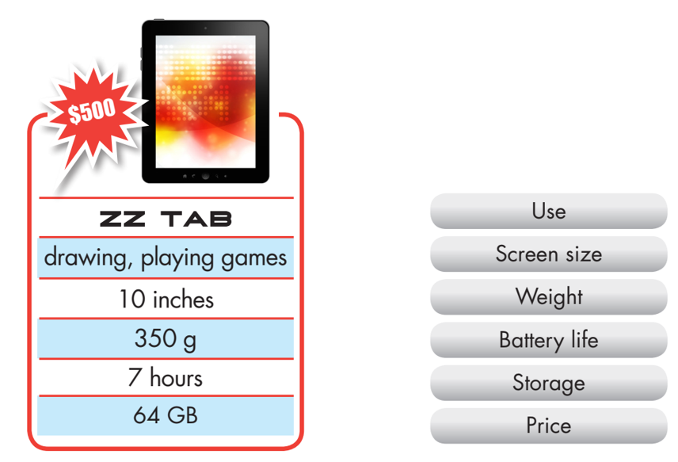  - Call Ss to give answers  - Check answers as a whole class.  - Call some Ss to read the words again.  - Correct Ss’ pronunciation if necessary.  Task a. Look at the pictures and fill in the blanks.  - Demonstrate the activity using the example.  - Have Ss fill in the blanks.  - Divide the class into pairs and have them check their  answers with their partners.  - Check answers as a whole class.  - Play audio. Have Ss listen and repeat.  Task b. In pairs: Talk about what you want a tablet and a laptop to have.  - Have pairs talk about what they want a tablet and a  laptop to have.  - Have some pairs share their ideas with the class.  - Give feedback. | - Work in pairs.  - Listen.  - Read.  - Match the words and descriptions.  Answer keys  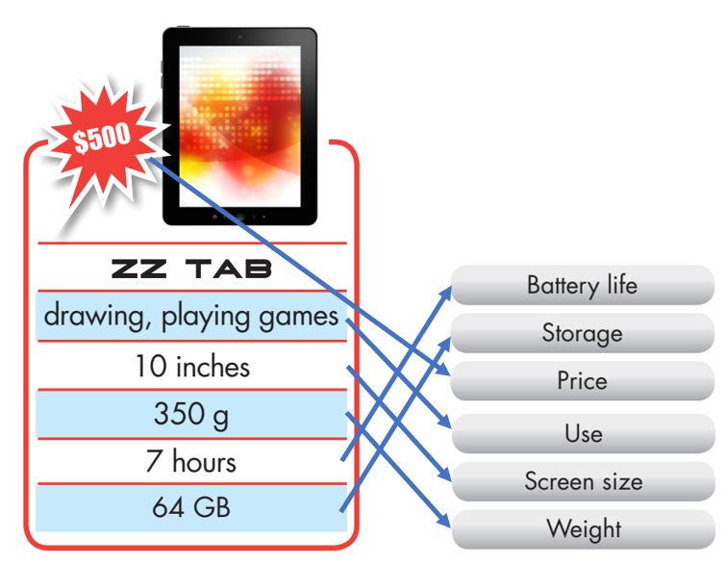  - Read the words again.  - Work in pairs.  - Share their ideas.  Answer keys  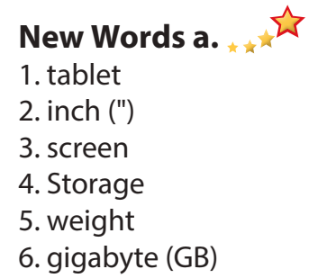  - Work in pairs.  Suggested answer  I want a tablet with a big screen.
- Activity 2: While - Reading (17’)
a) Objective: Students can develop their reading skill.
b) Content: Reading the magazine article about Portal’s tablets and choosing the main idea, reading the questions and giving the correct answers.
c) Expected outcomes: Students can read and understand general and specific information related to tablets.
d) Organization of the activity:
TEACHER’S ACTIVITIES | STUDENTS’ ACTIVITIES
Task a. Read the article about Portal's tablets and choose the best title.  - Use DCR to show the task. Ask Ss to read two options and find out key words in the text to select the correct answer.  - Have Ss read the article individually.  - Have Ss choose the correct answer.  - Have some Ss share their answers with the class (read), and explain their answers.  - Emphasize on phrases/ sentences in the topic sentences: Portal introduced its new tablet. Is it better than the Portal 6?  - Give feedback and correct Ss’ answers.  Task b. Now, read and answer.  - Use DCR to show the task.  - Have Ss read the text again and review the steps: read the questions, identify and underline the key words, find them in the text, and give the correct answers.  - Have Ss check answers with their partners.  - Call Ss to give answers and explain.  - Give feedback.  Task c. Listen and read.  - Play audio. Have Ss listen and read.  - Provide feedback on pronunciation and intonation if needed. | - Work individually.  - Choose the correct answer.  - Read and explain the answers.  - Check answers.  Answer keys  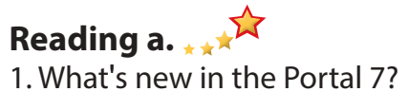  - Read, underline, find key words, and give the correct answers.  - Do the task.  - Check answers.  Answer keys  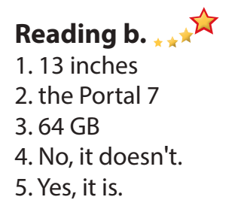  - Listen and read the text aloud.
- Activity 3: Post - Reading (6’)
a) Objective: Students can use the vocabulary and ideas from the reading text to develop their speaking skill.
b) Content: Speaking: Would you buy the Portal 6 or 7? Why?
c) Expected outcomes: Students can talk about their preferences and reasons for future home, and show their interest in what other students say.
d) Organization of the activity:
TEACHER’S ACTIVITIES | STUDENTS’ ACTIVITIES
Task d. In pairs: In pairs: Would you buy the Portal 6 or 7? Why?  - Have Ss work in pairs to draw a Venn diagram to provide the similarities and differences between Portal 6 and 7.  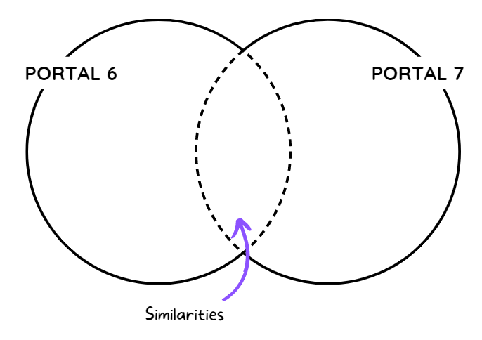  - Have Ss use the diagram to talk about their preferences between Portal 6 and 7, and explain the reasons.  - Move around to assist Ss if needed.  - Call some pairs to share their ideas with the whole class.  - Give feedback. | - Discuss in pairs and give the answers.  - Share the ideas.  Suggested answer:  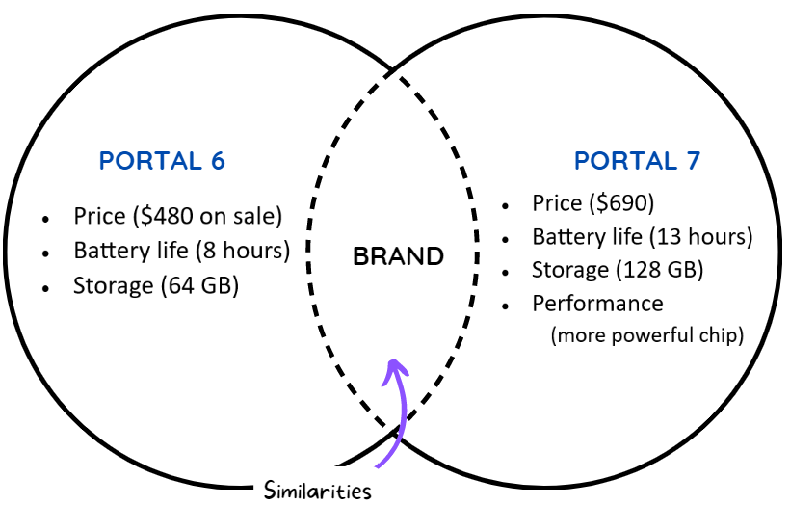  I'd buy the Portal 6 because it's cheaper.

C. Consolidation and homework assignments (5’)
* Consolidation:
- Retell nouns/ noun phrases about technical features of tablets.
* Homework:
- Learn the new words.
- Practice talking about words of electronic devices.
- Do the exercises in WB: Unit 5 - Lesson 1 - New words + Reading (pages 26 & 27).
- Do the exercises in Tiếng Anh 8 i-Learn Smart World Notebook (pages 38 & 39).
- Play the consolidation games in Tiếng Anh 8 i-Learn Smart World DHA App on www.eduhome.com.vn
- Prepare: Lesson 1.2 – Grammar (pages 45 & 46 – SB).

V. Reflection
a. What I liked most about this lesson today:
………….………………………………………………………………………………
- What I learned from this lesson today:
…………………………………………………………………………………………
c. What I should improve for this lesson next time:
…………………………………………………………………………………………

