Date of planning: 10/4/2022  Date of teaching: 13/4/2022 | Peroid 89,90 : UNIT 11: OUR GREENER WORLD  Lesson 2: A CLOSER LOOK _1
THIS UNIT INCLUDES:
Vocabulary  - Things that can be reduced, reused and recycled  Pronunciation:  - Rhythm in sentences  Grammar  - Articles  - First conditional | Skills:  - Reading about ways to go green.  - Talking about tips for going green.  - Listening about ideas for a green club.  - Writing a paragraph about ideas for a green club  Everyday English  Giving warnings

I. OBJECTIVE:By the end of this lesson, students will be able to gain the following things :
1. Knowledge:
- To introduce topic of the lesson Our greener world . To teach some new words about things that can be reduced, reused and recycled. Saying sentences with correct rhythm; Learning how to make Rhythm.
+ Vocabulary: use the words for things that can be reduced, reused and recycled;
- say sentences with correct rhythm;
- give warnings;
+ Grammar: - use the articles correctly;
- use the first conditional to talk about possibilities;
2. Competence: Students will be able to pratice reading and listening the conversation between Mi and Nick talked about ways to go green.
3. Quality/ behavior : The awareness of protecting the environment “go green” (to do more to protect nature and the environment). Having serious attitude to go green ; Having serious attitude to working in groups, individual work, cooperative learning and working.
II. TEACHING AIDS:
- Teacher: Text book, laptop, louspeaker, projector…
- Students : Text books, studying equipments….
- Work Arrangements: T_Ss , group works; individual ……
III. PROCEDURE:
1. WARM UP & INTRODUCTION (5’)
Aims: Vocabulary
- To revise/ teach some new words.
* Content: Review the previous lesson or have some warm-up activities to creat a friendly and relaxed atmostphere to inspire Ss to warm up to the new lesson. Guessing game .
* Outcome: Having a chance to speak English and focus on the topic of the lesson..
* Organisation : Teacher’s instructions…

Teacher’s & Student’s activities | Content
+ Greeting  + Playing game:  * Guessing game  - Revising phrases relating to localtions of houses, Eg. In the sea, in the city; in the counryside…  - Teacher (T) asks guides, gives instructions how to play guessing game.  - Ask Ss to open their book and introduce what they are going to study…. | + Greeting  + Playing game :  * Guessing game  - T _ Ss  - Students (Ss) listen and learn how to do.  - Ss answer.  - Open their book and write .
2. PRESENTATION (12’)
ACTIVITY 1:
Aim: To teach the terms reduce, reuse, and recycle.
* Content: To introduce some new words and the terms reduce, reuse, and recycle.
* Outcome: Ss learn how to use the terms reduce, reuse, and recycle. Know more some words.
* Organisation : Teacher’s instructions…

Teacher’s & Student’s activities | Content
1. The three Rs stand for Reduce- Reuse- Recycle. Draw a line from a symbol in column A to its matching word in column B and its meaning in column C.  *) Pre- teach vocabulary:  - Teacher uses different techniques to teach vocabulary (situation, realia, translation .....)  + Teacher may introduce the vocabulary by:  - providing explanations of the words;  - showing picture illustrating the word.  + Follow the steps to teach vocabulary  * Vocabulary  - reduce (v) giảm  - reuse (v) dùng lại  - recycle (v) tái chế tái sử dụng  - rubbish(n) rác thải  - wrap (v) gói, bọc …  - Repeat in chorus and individually  + Check vocabulary  - Have Ss read the information in the table and draw a line from a symbol in column A to the matching word in column B and its meaning in column C. Ss work in pairs to compare their answers before giving T the answers. Check and write the correct answers on the board.  - For stronger classes, elicit the difference between recycling and reusing from Ss.  - Explain the difference between these two terms again if necessary:  + Recycling means reprocessing an old item such as a newspaper, a glass or a can and turning it into a new product. For example, used paper is brought to a factory where it is reprocessed, cleaned and purified. This paper is then used to make new things such as books or newspapers.  + Reusing means avoiding the reprocessing procedure. It is when people use something over and over again until it cannot be used any more. For example, a used plastic bottle can be used again as a flower vase, or a butter container can be used to grow a small plant.  - Check the answers as a class. | 1. The three Rs stand for Reduce- Reuse- Recycle. Draw a line from a symbol in column A to its matching word in column B and its meaning in column C.  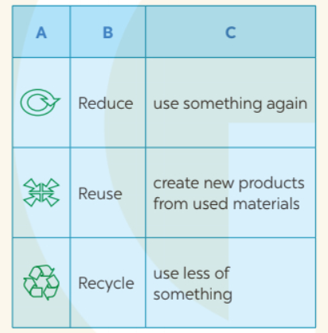  - T _ Ss  + Students (Ss) listen to the instructions carefully and learn how to do the tasks.  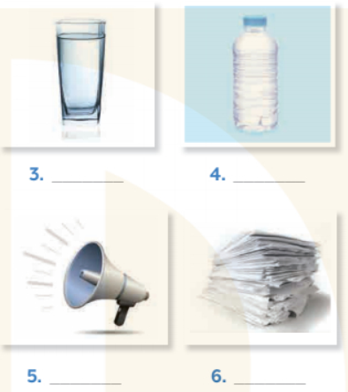  - 3Rs  Key :  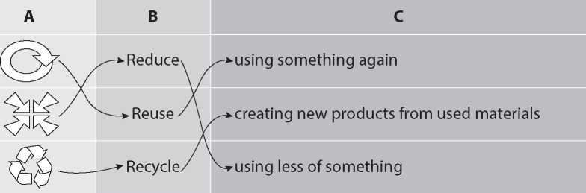
3. PRACTICE (15’)
ACTIVITY 2:
Aim: To revise / teach the words for things that can be reduced, reused and recycled.
* Content: Teach the words for things that can be reduced, reused and recycled. Write the word.
* Outcome: Ss can learn some words . Understanding more the things that can be reduced, reused and recycled.
* Organisation : Teacher’s instructions…

Teacher’s Student’s activities | Content
2. Write the word/ phrase in the box under each picture.  - Have Ss work in pairs to do this activity. Call on Ss from different pairs to go to the board and write the words.  - This activity can also be organized as a competition. Whichever pair finishes the activity first wins and can go to the board to write their answers. Confirm the correct answers  - Call on some Ss to write their sentences on the board. Correct if necessary. | 2. Write the word/ phrase in the box under each picture.  - Ss work in pairs  - Ss work independently.  - Give the answers  * Key:  1. rubbish 2. plastic bag 3.glass  4. plastic bottle 5. noise 6. paper  7. water 8. clothes
ACTIVITY 3:
Aim: To help Ss categorize things that can be reduced, reused and recycled.
* Content: Pair work . Put the words into groups.
* Outcome: Ss can categorize things that can be reduced, reused and recycled. 3Rs
* Organisation : Teacher’s instructions…

3. Work in pairs. Put the words from 2 into groups. Some words can belong to more than one group.  - Have Ss work in pairs to put the words from 2 in appropriate groups. Draw the table on the board and call three Ss to go to the board and write their answers. Discuss the answers with the class.  - Elicit some more words for each group from Ss. - Here are some suggested words:  + Reduce: electricity, gas  + Reuse: envelope, carton box, textbook  + Recycle: newspaper, textbook, plastic container  - Ask Ss add more words.  - T and other Ss give comments. | 3. Work in pairs. Put the words from 2 into groups. Some words can belong to more than one group.  Reduce Reuse Recycle  rubbish, plastic bag, noise, plastic bottle, paper, water plastic bag, glass, plastic bottle, paper, water, clothes rubbish, plastic bag, glass, plastic bottle, paper  - Ss to work in pairs  - Ss do themselves.  - Add more words  - Copy them
II. PRONUNCIATION: (10’)
ACTIVITY 4: Rhythm in sentences
Aim: To get Ss familiar with rhythm in sentences.
* Content: In sentence, the stressed and unstressed syllables combine to make rhythm
* Outcome: Learn how to make rhythm in sentences .
* Organisation : Teacher’s instructions…

Teacher’s Student’s activities | Content
4. Listen to these sentences, then repeat. Pay attention to the bold syllables.  - Tell Ss that in English, the stressed and unstressed syllables combine to make rhythm in a sentence.  - Ss have learnt about stress in two-syllable words, so T can remind them of the stress rule in two-syllable words (put stress on the first syllable in nouns and adjectives).  - In the sentences the bold parts are the stressed syllables. The aim of this activity is only to raise Ss' awareness of rhythm. It is not necessary to teach them in detail.  - Play the recording for Ss to listen to the sentences. Have them pay attention to the bold parts.  - Play the recording of each sentence again for Ss to repeat in chorus. Have Ss work in pairs to practise reading the sentences.  - Call on some Ss to read the sentences aloud.  - Comment on Ss'pronunciation.  - Check their pronunciation If necessary.  - Call on some Ss to read the words aloud. | 4. Listen to these sentences, then repeat. Pay attention to the bold syllables.  - T_ Ss  - Listen carefully.  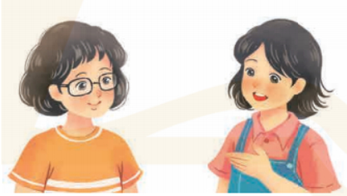  Audio script:  1. If you cycle, it'll help the Earth.  2. Water is good for your body.  3. The students are planting trees in the garden.  4. Is it better to use paper bags?  5. We are happy to walk to school
4. FURTHER PRACTICE (8’)
ACTIVITY 5:
Aim: To give Ss further practice with rhythm in sentences.
* Content: Practice the conversation with rhythm . Bold syllables
* Outcome: Ss parctice the conversation with rhythm with a classmate.
* Organisation : Teacher’s instructions…

5. Listen to conversation. Pat attention to the bold syllables. Then practise conversation with a classmate.  - Play the recording for Ss to listen to the conversation. Have them pay attention to the bold parts.  - Play the recording of each sentence again for Ss to repeat In chorus. Have Ss work In pairs to practise reading the conversation.  - Call on some Ss to read the conversation aloud.  - Comment on Ss' pronunciation.  - If there is time, have Ss make more sentences with two-syllable nouns they know. Then ask them to say their sentences in front of the class.  - Comment on their pronunciation . | 5. Listen to conversation. Pat attention to the bold syllables. Then practise conversation with a classmate.  - T_ Ss  - Listen to the instructions carefully then do the tasks.  - Do the tasks  Audio script:  Vy: What are you doing?  Mi: I'm writing an article about going green.  Vy: Great! I'm writing a poem about the 3Rs.  Mi: Let me read it.  Vy: I'm still writing. Wait for a minute.
5. WRAP-UP & HOME WORK (2’)

* Have Ss summarize what they have learnt in this period.
* HOME WORK
- remember some adjectives describing the city.
- Do more exercises in workbook.
- Prepare new lesson.

========================

