|  |  |  |  |  |
| --- | --- | --- | --- | --- |
| SỞ GD&ĐT BẮC GIANG  **TRƯỜNG THPT TÂN YÊN SỐ 2**  *(Đề thi có 04 trang)* | **ĐỀ KIỂM TRA ĐỊNH KÌ GIỮA HỌC KÌ 1**  **NĂM HỌC 2023 - 2024**  **MÔN: TIẾNG ANH -LỚP 10**  *Thời gian làm bài:* ***60 phút****, không kể thời gian giao đề* | | | |
|  | | **Mã đề thi: 360** |  |

***Lưu ý: - Thí sinh làm trực tiếp vào đề, tô phần trắc nghiệm vào phần phiếu trả lời trắc nghiệm***

***- Phần NGHE bắt đầu từ câu 26 đến câu 35***

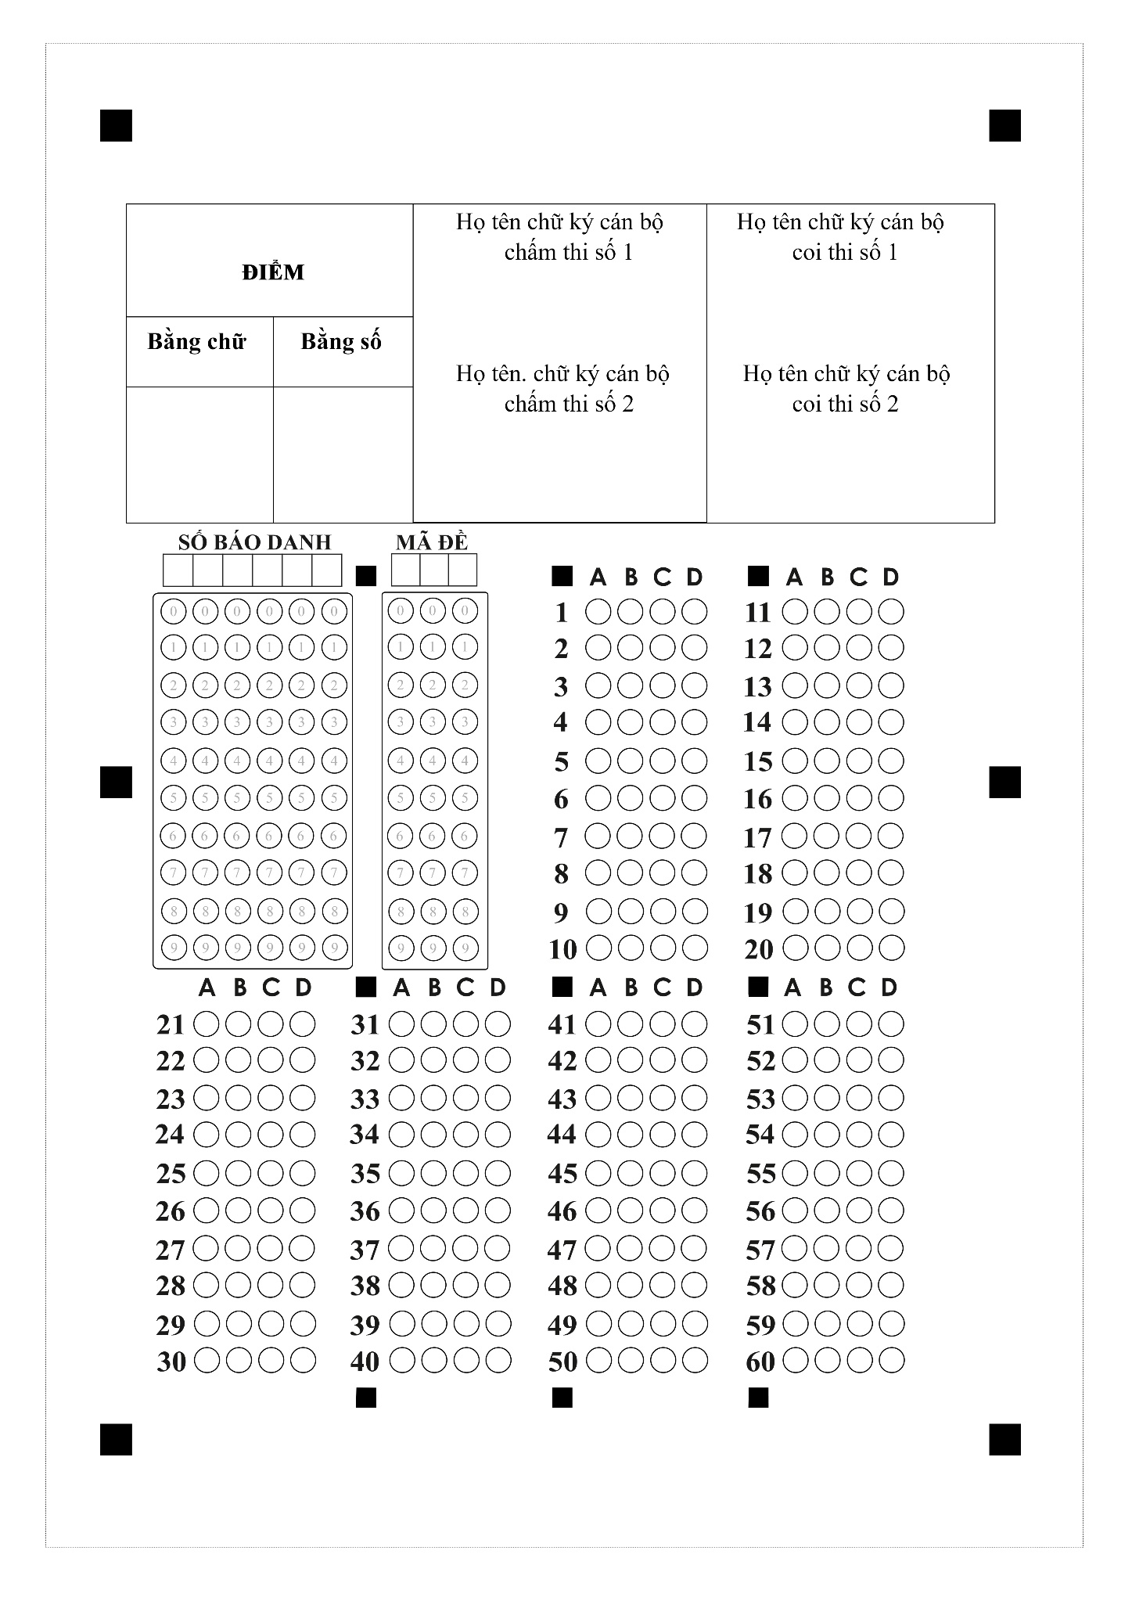

Họ tên: ……………………….….. Lớp: ……… SBD: ………….

**I. PHẦN TRẮC NGHIỆM (6,0 điểm):**

***Mark the letter А, B, C, or D on your answer sheet to indicate the word whose underlined part differs from the other three in pronunciation in each of the following questions.***

**Question 1. A.** develops  **B.** stays  **C.** hates  **D.** excepts

**Question 2. A.** carried  **B.** impressed  **C.** organized  **D.** involved

**Question 3. A.** organic  **B.** change  **C.** make  **D.** take

***Mark the letter A, B, C, or D on your answer sheet to indicate the word that differs from the other three in the position of stress in each of the following questions.***

**Question 4. A.** decide  **B.** common  **C.** music  **D.** careful

**Question 5. A.** recieve  **B.** attract  **C.** decide  **D.** litter

***Mark the letter A, B, C or D on your answer sheet to indicate the correct answer to each of the following questions****.*

**Question 6.** My mother often ______ to the supermarket to shop for groceries at weekends.

**A.** goes  **B.** going  **C.** went  **D.** go

**Question 7.** She loves romantic films, ____ her husband is interested in action films.

**A.** so  **B.** or  **C.** but  **D.** and

**Question 8.** They planned________________their holiday in the countryside.

**A.** spend  **B.** spent  **C.** spending  **D.** to spend

**Question 9.** She is a(n)________artist who can write music and sing very well.

**A.** talented  **B.** awful  **C.** skilless  **D.** bad

**Question 10.** The amount of greenhouse gases produced by human activities are known as__________

**A.** smoke  **B.** action  **C.** emissions  **D.** carbon footprint

**Question 11.** After the party, my classmates helped me do the__________.

**A.** laundry  **B.** household chores  **C.** washing-up  **D.** housework

**Question 12.** We should________________electricity usage to save the natural sources.

**A.** cutting down on  **B.** cleaning up  **C.** setting up  **D.** turning off

***Mark the letter A, B, C, or D on your answer sheet to indicate the option that best completes each of the following exchanges.***

**Question 13. Ann and Tim are talking about housework.**

**Ann:** “ Do you think that teenagers should do housework?”

**Tim**: “ ­­­­Well,________teenagers shouldn’t do the housework because they have to spend all their time studying.”

**A.** That’s right  **B.** Not at all  **C.** In my opinion  **D.** You’re welcome

***Mark the letter A, B, C, or D to indicate the word CLOSEST in meaning to the underlined word in each of the following questions.***

**Question 14.** Student are reminded to pick up **litter** that they see on the ground.

**A.** air  **B.** gas  **C.** rubbish  **D.** sugar

***Mark the letter A, B, C, or D to indicate the word OPPOSITE in meaning to the underlined word in each of the following questions.***

**Question 15.** After a stressful day at work, I put on some **upbeat** songs and feel better almost at once.

**A.** relaxed  **B.** sad  **C.** cheerful  **D.** talented

***Read the passage and choose the best answer for each of the numbered blanks.***

**What are the benefits of a green lifestyle?**

In addition to the health benefits already mentioned, such as increased exercise, healthier eating and better breathing, a green lifestyle has been shown to have a positive (16) _______ on mental health.  A green lifestyle can foster people’s need for a closer connection to nature, (17) ______stimulating positive emotions, leading to a lighter and happier mood. This closer connection to nature, such as through increased outdoor activities, can actually help people suffering from mental health issues find comfort: A report conducted by Natural England concluded that people (18) ______ participate in nature-based activities suffer less stress, anxiety and depression. When a more (19) _______lifestyle leads to losing excess weight or simply getting in better shape, it can also lead to stronger self-esteem in addition to physical health. Consuming less, reusing and recycling more, while raising (20) __________ of important climate changes can help prioritize. Gaining this awareness, taking responsibility for our environment.

**Question 16. A.** affect  **B.** choice  **C.** impact  **D.** chance

**Question 17. A.** but  **B.** yet  **C.** so  **D.** or

**Question 18. A.** whom  **B.** which  **C.** where  **D.** who

**Question 19. A.** acttively  **B.** activity  **C.** active  **D.** action

**Question 20. A.** hand  **B.** salary  **C.** price  **D.** awareness

***Read the following passage and choose the most suitable answer.***

**Plastic and the environment**

Plastic is a material we use every day. The first plastics were made more than 100 years ago from parts of plants. Plastics are now made from oil, coal and natural gas. We are using up these things so fast that the Earth’s supplies may run out. Because of this, scientists are investigating new ideas for making plastics from plants such as sweet potato, bamboo and flax.

Things made from plastic can be useful for people but bad for the planet. Some plastics can last for a long time without wearing out, and can be difficult to **get rid of** when they are not needed. **They** can remain in rubbish dumps called landfill sites for hundreds of years. Landfills can be smelly, ugly, and harmful to our planet.

Recycling is a good way to get rid of unwanted plastics. Recycled waste materials can be used again to make new products. This can be difficult as different types of plastic need to be recycled in different ways. Some kinds of plastics can be melted down and used to make new things such as bags and bottles. Others can be made into fibres (strands of material) for clothing.

Another way to protect the environment is to use canvas bags for shopping rather than plastic ones. A lot of plastic objects can also be reused. Plastic bottles can be refilled many times, rather than throwing them away once they are empty. Unwanted plastic goods such as CDs and toys can be sold or given away to charity shops.

**Question 21.** What is the passage mainly about?

**A.** Materials that plastic is made of..

**B.** The history of plastic and its usefulness..

**C.** The ways to reduce the harm of plastics on the environment

**D.** Plastic: effects and solutions to the problem.

**Question 22.** The phrase “**get rid of**” in paragraph 2 is closest in meaning to ________.

**A.** create  **B.** make  **C.** remove  **D.** keep

**Question 23.** According to the passage, things made from plastic are bad for our environment because ______.

**A.** they are a danger to marine life such as whales, turtles and so on.

**B.** plastics can exist for a long time without decomposing.

**C.** people reuse plastic objects before recycling them.

**D.** they are very convenient for people to use in different purposes.

**Question 24.** The word “**They**” in paragraph 2 refers to ________.

**A.** people  **B.** rubbish dumps  **C.** plastics  **D.** things

**Question 25.** According to the passage, which of the following is **TRUE?**

**A.** Plastics and plastic objects can be recycled or reused.

**B.** The history of plastic and its usefulness.

**C.** Some kinds of plastics can be melted down, then released into the river.

**D.** Plastic objects are useful for people without negative impacts.

**🖭 Listening**

***Part 1: Listen to the recording and mark the letter A, B, C or D on your answer sheet to indicate the appropriate answer. You will listen TWICE.***

**Question 26.** Duncan stayed in a hotel ________.

**A.** by the river  **B.** in the mountain  **C.** in a town  **D.** near the sea

**Question 27.** What is his teacher's nationality?

**A.** Canadian  **B.** Scott  **C.** French  **D.** English

**Question 28.** How much did Duncan pay for the course?

**A.** £205  **B.** £185  **C.** £250  **D.** £265

**Question 29.** What did he buy himself before the course?

**A.** shoes  **B.** ball  **C.** racket  **D.** clothes

**Question 30.** What did you do in the evening?

**A.** playing tennis  **B.** watching football matches

**C.** watching TV  **D.** dancing and singing

**II. PHẦN TỰ LUẬN (4,0 điểm)**

**🖭 Listening**

***Part 2: You will hear a woman giving information on the radio about a theatre school. Listen and fill in the blanks.***

|  |
| --- |
| **Information about the theatre school**   * Every week courses for children between (31) ___________ and 16 years old. * It costs (32) £ ______________ for children over 14. * The special show takes place on (33) ______________ afternoon. * The first summer course starts on July (34) _______________. * The phone number for booking form: (35) _______________. |

***Give the correct tense/ form of the verbs in the brackets.***

**Question 36.** She (do)_________________the laundry at the moment.

**Question 37.** There is someone at the door, I (open)_______________it.

**Question 38.** Look at the sun. It (be)_________________a beautiful day.

**Question 39.** His friends decided (send) __________________ him a surprise present on his birthday.

**Question 40.** Their boring performance made us (feel) __________________ very disappointed.

***Complete the second sentence so that it means the same as the sentence provided.***

**Question 41.** We often celebrate birthdays with a big cake

🡪Birthdays ______________________________________________________________.

**Question 42.** People will clean up the beach during the weekend.

🡪The beach _____________________________________________________________.

**Question 43.** Doing household chores is good for children

🡪It is good for ___________________________________________________________.

**Question 44.** Her parents don’t allow her to watch such TV shows.

🡪 Her parents don’t let _____________________________________________________.

**Question 45.** She didn’t turn up. We went to the cinema without her. (SO)

🡪______________________________________________________________________.

***Write a short paragraph (about 70 words) about a music event you attended to share your experience.***

***_________________________________________________________________________________________________________________________________________________________________________________________________________________________________________________________________________________________________________________________________________________________________________________________________________________________________________________________________________________________________________________________________________________________________________________________________________________________________________________________________________________________________________________________________________________________________________________________________________________________________________________________________________________________________________________________________________________________________________________________________________________________________________________________________________________________________________________________***

**-------------- THE END --------------**