School: ……………………………………….. | Date:……………………………………..
Class: ……………………………..................... | Period: …………………………….........

UNIT 4: COMMUNITY SERVICES
Lesson 1.3 – Pronunciation and Speaking (Page 30)

I. OBJECTIVES
By the end of the lesson, Ss will be able to:
1.1. Language knowledge and skills
- put stress on the first word in compound nouns.
- ask and answer about charity event (types, activities, names, etc.).
- plan a charity event for community.
1.2. Competences
- improve listening and speaking skills.
1.3. Attributes
- be active to take part in social activities.
- help other people.

II. TEACHING AIDS AND LEARNING MATERIALS
1. Teacher’s aids: Student book and Teacher’s book, class CDs, Digital Book (DCR phần mềm tương tác SB, DHA (từ vựng/ cấu trúc) phần mềm trò chơi tương tác), projector/interactive whiteboard / TV (if any), PowerPoint slides, handouts.
2. Students’ aids: Student’s book, workbook, notebook.

III. ASSESSMENT EVIDENCE
Performance Tasks | Performance Products | Assessment Tools
- Listen to the words and focus on the underlined words. | - Ss’ performance and answers. | - T’s observation.
- Listen and cross out the word that doesn’t follow the note in “a”. | - Ss’ performance and answers. | - T’s feedback/Peers’ feedback.
- Read the words with the correct stress to a partner. | - Ss’ performance. | - T’s feedback/Peers’ feedback.
- Ask and answer using the questions and the prompts. | - Ss’ performance. | - T’s feedback/Peers’ feedback.
- Practice with your own ideas. | - Ss’ performance. | - T’s feedback/Peers’ feedback.
- Plan a charity event for your community. Discuss and decide who to help, plan the event and complete the poster. | - Ss’ performance /  Presentation. | - T’s observation, T’s feedback/Peers’ feedback.

IV. PROCEDURES
A. Warm up: (5’)
a) Objective: Introduce the new lesson and set the scene for Ss to acquire new language; get students' attention at the beginning of the class by enjoyable and short activities as well as to engage them in the follow-up steps.
b) Content: Review words/ phrases about charity and fund raising events.
c) Expected outcomes: Ss remember old knowledge and use them in other speaking activities.
d) Organization of the activity:
TEACHER’S ACTIVITIES | STUDENTS’ ACTIVITIES
- Option 1: Word Dictation  - Prepare sound files of some phrases about charity and fund raising event.  - Play the files, have Ss listen and write down the phrases they can hear on the board.  - Check Ss’ answers.  - Have Ss tell the meaning and read the phrases again  - Correct Ss’s pronunciation if necessary.  - Suggested phrases: craft fair, fun run, art show, talent show, bake sale, car wash, book sale, ...  - Lead to the new lesson.  - Option 2: Charity events and slogans  - Have Ss look at the pictures of some charity events, discuss and say the right slogan for each picture.  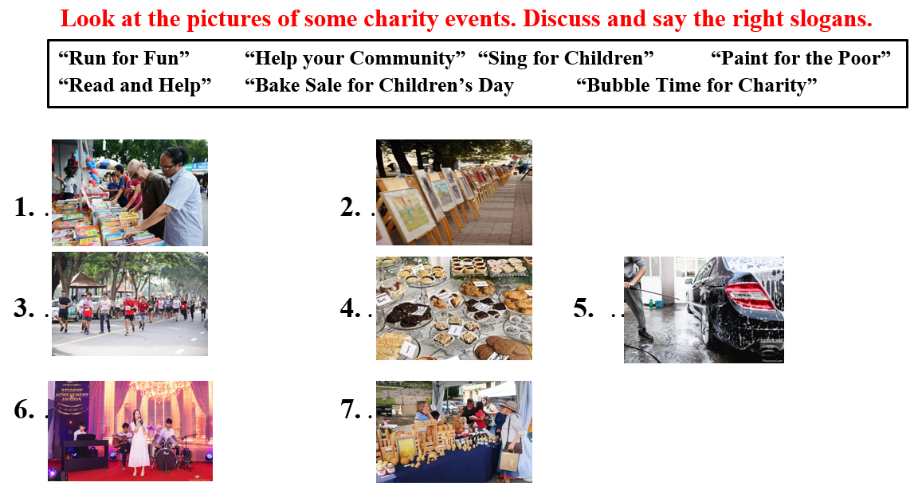  - Call Ss to read answers.  - Give feedback.  - Lead to the new lesson. | - Listen and write down.  - Listen and check.  - Tell the meaning and read the phrases again.  - Work in pairs, then give answers.  Answer keys  1. “Read and Help”  2. “Paint for the Poor”  3. “Run for Fun”  4. “Bake Sale for Children’s Day  5. “Bubble Time for Charity”  6. “Sing for Children”  7. “Help your Community”  - Give answers.  - Listen.

B. New lesson (35’)
- Activity 1: Pre-Speaking: Pronunciation (10’)
a) Objective: Introduce: Stress the first word in compound nouns.
b) Content:
- recognize compound nouns and know how to put stress on compound nouns.
- listen and check, find mistakes.
- practice.
c) Expected outcomes: Ss distinguish and put stress on the first word in compound nouns in their speaking.
d) Organization of the activity:
TEACHER’S ACTIVITIES | STUDENTS’ ACTIVITIES
Task a + b. Listen to the words and focus on the underlined words.  - Briefly explain compound nouns and give some examples using DCR.  - Play the recording (CD1, track 38).  - Ask Ss to listen and focus on the underlined words.  - Play the recording again, have Ss listen and repeat with a focus on the pronunciation feature.  Task c + d. Listen and cross out the word that doesn’t follow the note in “a”, then read the words with the correct stress to a partner.  - Play the recording (CD 1 – Track 39), have Ss listen and cross out the option that doesn’t follow the sound feature in “a”.  - Call Ss to give answers.  - Play the recording again and check answers as a whole class using DCR.  - Then have Ss practice saying the examples with a partner, using the correct stress feature.  - Call some Ss to read the words in front of the class.  - Ask Ss to find some more compound nouns and practice putting stress on them.  - Give feedback and evaluation. | - Listen, take notes.  - Listen again and repeat.  - Listen again and cross out the option that doesn’t follow the sound feature in “a”.  - Give answers.  - Listen again and check.  Answer keys  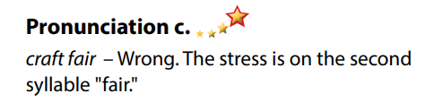  - Work in pairs.  - Read.  - Give answers.
- Activity 2: While-speaking (20’)
a) Objective: Students can talk about charity event.
b) Content:
- Ask and answer using the questions and the prompts.
- Plan a charity event for your community. Discuss and decide who to help, plan the event and complete the poster.
c) Expected outcomes: Ss produce the new language successfully.
d) Organization of the activity:

TEACHER’S ACTIVITIES | STUDENTS’ ACTIVITIES
*PRACTICE  Task a: Ask and answer using the questions and the prompts.  - Demonstrate the activity by asking and answering with a student.  - Have pairs ask and answer using the questions and the prompts.  - Remind Ss to put stress on the first word in compound nouns.  - Have some pairs demonstrate the activity in front of the class.  - Give feedback and evaluation.  Task b: Practice with your own ideas.  - Have students practice the conversation with their own ideas. Swap roles.  - Have some pairs demonstrate the activity in front of the class.  - Give feedback and evaluation.  *SPEAKING: Charity for the Community  Task a. You're planning a charity event for your community. In threes: Discuss and decide who you want to help, then plan your event and complete the poster.  - Divide the class into groups of 3.  - Have students discuss who they want to help and plan their events together.  - Have students complete the posters.  - Observe, give help if necessary. | - Observe, listen.  - Work in pairs.  - Present.  - Practice the conversation with their own ideas. Swap roles.  - Present.  - Work in groups of 3.  - Complete the posters.

- Activity 3: Production (5’)
a) Objective: Students report the results to the class.
b) Content: Share their answers with the class.
c) Expected outcomes: Ss produce the new language successfully in everyday speaking and writing.
d) Organization of the activity:
TEACHER’S ACTIVITIES | STUDENTS’ ACTIVITIES
SPEAKING: Charity for the Community  Task b. Share with the class.  - Have some Ss share their plan of the charity event with the class.  - Give feedback and evaluation. | - Present.  - Listen.

C. Consolidation and homework assignments (5’)
* Consolidation:
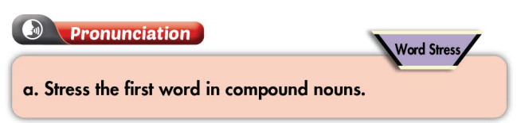

* Homework:
- Practice putting stress on compound nouns.
- Complete the poster for those who haven’t finished it in class.
- Prepare: Unit 4 - Lesson 2 – New words and Listening (page 31 – SB).
- Review the vocabulary and grammar notes in Tiếng Anh 7 i-Learn Smart World Notebook
(pages 22 & 23).
- Play consolation games in Tiếng Anh 7 i-Learn Smart World DHA App on www.eduhome.com.vn

D. Reflection
a. What I liked most about this lesson today:
…………………………………………………………………………………………
- What I learned from this lesson today:
…………………………………………………………………………………………
c. What I should improve for this lesson next time:
…………………………………………………………………………………………

