UNIT 4. MUSIC AND ARTS (ÂM NHẠC VÀ MỸ THUẬT)
A. VOCABULARY
New words | Meaning | Picture | Example
actor (n) | nam diễn viên |  | He is one of the country’s top actors.  Anh ấy là một trong những nam diễn viên hàng đầu quốc gia.
actress (n) | nữ diễn viên |  | Jennifer Lawrence is a famous American actress.  Jennifer Lawrence là một nữ diễn viên người Mỹ nổi tiếng.
audition (n) | buổi thử giọng | 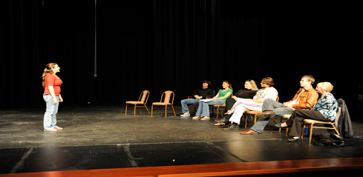 | We are holding auditions for new singers.  Chúng tôi đang tổ chức buổi thử giọng cho các ca sĩ mới.
comedian (n) | diễn viên hài | 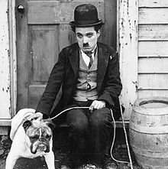 | Comedians make people laugh.  Nghệ sĩ hài khiến cho mọi người cười.
compose (v) | sáng tác | 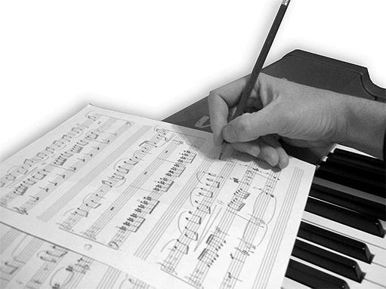 | Mozart composed his last opera in 1791.  Mozart sáng tác bản o-pê-ra cuối cùng năm 1791.
composer (n) | nhà soạn nhạc | 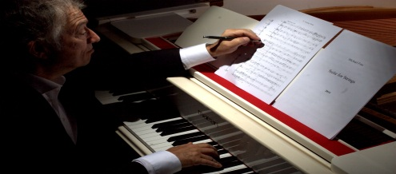 | He is one of the greatest composers in the world.  Ông là một trong những nhà soạn nhạc vĩ đại nhất thế giới.
decorate (v) | trang trí | 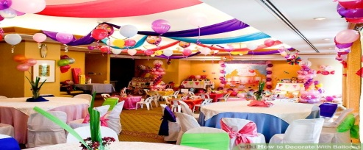 | They need to decorate the living room.  Họ cần phải trang trí phòng khách.
drama director (n) | đạo diễn phim |  | It is not easy to become a drama director.  Không dễ dàng để trở thành một đạo diễn phim.
essential (adj) | thiết yếu |  | Fresh water is essential for life.  Nước sạch là thiết yếu cho sự sống.
guitarist (n) | người chơi ghi-ta |  | Jim is the guitarist in his band.  Jim là người chơi ghi-ta trong nhóm.
leisure (n) | giải trí |  | The leisure industry is advancing at a fast pace.  Ngành công nghiệp giải trí đang phát triển với tốc độ nhanh chóng.
musician (n) | nhạc sĩ |  | Not many young people know this jazz musician.  Không nhiều người trẻ biết đến nhạc sĩ Jazz này.
painter (n) | họa sĩ | 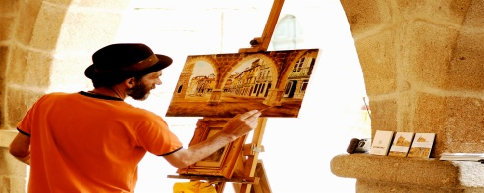 | Jane is studying to become a painter.  Jane đang học để trở thành một họa sĩ.
perform (v) | trình diễn | 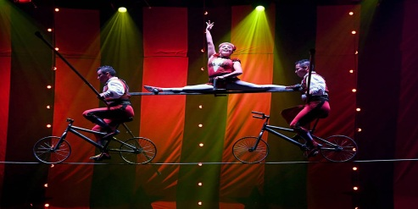 | The singer didn’t perform well last night.  Ca sĩ diễn không tốt đêm qua.
traditional (adj) | truyền thống |  | Elderly people like listening to traditional songs.  Những người già thích nghe những bài hát truyền thống.
B. GRAMMAR
I. SO SÁNH (COMPARISONS) VỚI “AS….AS”, “THE SAME AS”, “DIFFERENT FROM”
1. So sánh sự giống nhau: “as…as”, “the same as” (giống như)
- Cấu trúc câu so sánh ngang bằng được dùng để so sánh 2 người, vật, … có tính chất gì đó tương đương nhau.

Cấu trúc | S + to be + as + adj + as + noun/ pronoun/ clause. | S + V + the same + noun + as + noun/ pronoun.
Ghi chú | S: chủ ngữ, adj: tính từ, noun: danh từ, pronoun: đại từ, clause: mệnh đề.
Ví dụ | 1. Folk music is as melodic as pop music.  (Nhạc dân gian thì du dương như là nhạc pop.)  2. My paiting is as expensive as hers.  (Bức họa của tôi thì đắt bằng bức họa của cô ấy.)  3. This camera is as good as it was before.  (Cái máy ảnh này vẫn tốt như ngày nào.) | 1. She is the same height as me.  (Cô ấy có chiều cao như tôi.)  2. She has the same book as me.  (Cô ấy có cuốn sách giống tôi.)
2. So sánh sự khác nhau: “not as…as” (không bằng), “different from” (khác)
- Cấu trúc câu so sánh không ngang bằng được dùng để so sánh 2 người, vật, … khác nhau ở một mặt nào đó.
Cấu trúc | S + to be + not + so/as + adj + as + noun/ pronoun/ clause. | S+ to be + different from + noun/ pronoun.
Ví dụ | 1. Black and white movies are not as interesting as colour movies.  (Những bộ phim đen trắng thì không hấp dẫn bằng những bộ phim màu.)  2. My hometown is not as noisy as yours.  (Quê tôi không ồn ào như quê bạn.)  3. She is not as famous as she was before.  (Cô ấy không còn nổi tiếng như trước nữa.) | 1. Life in the city is different from life in the countryside.  (Cuộc sống trong thành phố khác cuộc sống ở vùng quê.)  2. His house is different from my house.  (Ngôi nhà của anh ấy khác ngôi nhà của tôi.)
Lưu ý | Ở cấu trúc “not as…as”, ta có thể thay thế “as” đầu tiên bằng “so”.
BÀI TẬP VẬN DỤNG CƠ BẢN
EX1. Hoàn thành các câu dưới đây, sử dụng cấu trúc so sánh “as…as” và tính từ trong ngoặc.
1. I am not ___________________ you. (tall)
2. This book is not ___________________ that one. (interesting)
3. This summer is ___________________ last summer. (hot)
4. Yesterday is was ___________________ today. (sunny)
5. I think my essay is ___________________ yours. (good)
6. My dog isn’t ___________________ it appears to be. (fierce)
7. Children nowadays are not ___________________ they used to be. (active)
8. Watching movie is not ___________________ reading books. (entertaining)
9. Jane is ___________________ as a doll. (pretty)
10. Cats are not ___________________ dogs. (friendly)
11. My brother said that going abroad was not ___________________ he thought. (amusing)
12. She didn’t want to be late, so she run ___________________ she could. (fast)
13. Please call me ___________________ possible. (soon)
14. Sleeping on the sofa is not ___________________ in bed. (comfortable)
15. This hotel is ___________________ the one near the beach but it is much better. (expensive)
16. My grandmother is ___________________ fairy godmother. (warm-hearted)
17. Do you think learning Japanese is ___________________ learning English? (difficult)
18. This musician is not ___________________ that one. (popular)
19. Ann looks ___________________ princess in her new dress. (gorgeous)
20. The river isn’t ___________________ it looks. (deep)
EX2. Dùng cấu trúc so sánh “different from” để hoàn thành những câu dưới đây.
1. My house is small and old. Your house is spacious and modern.
=> My house is ____________________________________________________.
2. My mother’s favourite food is noodle. My favourite food is rice.
=> My mother’s favourite food ________________________________________.
3. My best friend has a powerful personality. I have a weak personality.
=> My best friend’s personality ________________________________________.
4. Life in the countryside is quiet and peaceful. Life in the city is exciting.
=> _______________________________________________________________.
5. Lan’s school is Hai Ba Trung School. Hue goes to Nguyen Hue School.
=> _______________________________________________________________.
6. My hobby is collecting stamps. My brother’s hobby is playing the piano.
=> _______________________________________________________________.
7. My answer for this equation is “4” but Tom thinks it should be “5”.
=> _______________________________________________________________.
8. My sister’s hair is long and wavy. My hair is short and straight.
=> _______________________________________________________________.
EX3. Hoàn thành các câu dưới đây, sử dụng cấu trúc so sánh “the same….as” và danh từ trong ngoặc.
1. My sister has ___________________ me. (height)
2. Jim pursues ___________________ Jane. (hobby)
3. My best friend is at ___________________ me. (age)
4. My friends went to see ___________________ me. (movie)
5. This musician plays ___________________ me. (musical instrument)
6. Critics say that this paiter has ___________________ with that one. (style)
7. My brother is interested in ___________________ me. (subject)
8. This class has ___________________ that one. (number of students)
9. Anne bought ___________________ me yesterday. (dress)
10. She cut her hair ___________________ mine. (length)
11. My best friend likes ___________________ my brother. (books)
12. I bought my car at ___________________ hers. (price).
13. My mother likes ___________________ me. (TV programs)
14. He had ___________________ a famous actor. (appearance)
15. He puts on ___________________ usual. (old coat)
EX4. Gạch chân lỗi sai trong các câu sau và viết lại câu đúng.
1. My boyfriend is as strong like a horse.
_______________________________________________________________.
2. This exercise isn’t hard as I thought.
_______________________________________________________________.
3. Life in foreign countries is different life in home country.
_______________________________________________________________.
4. My parents share the same hobby as.
_______________________________________________________________.
5. His cat isn’t the same pretty as mine.

_______________________________________________________________.
6. This art museum is definitely different as the historical museum.
_______________________________________________________________.
7. Roses don’t have the same fragrance like lotuses.
_______________________________________________________________.
8. My essay is as length as yours.
_______________________________________________________________.
9. This island isn’t as beautiful than those I have visited.
_______________________________________________________________.
10. My mother is different appearacne from me.
_______________________________________________________________.
EX5. Sắp xếp những từ cho sẵn thành câu hoàn chỉnh.
1. difficult/ as/ Playing/ is/ piano/ guitar/ playing/ as/./
_______________________________________________________________.
2. horse/ run/ a/ Can/ fast/ as/ a/ as/ train/?/
_______________________________________________________________.
3. try/ as/ can/ you/ hard/ as/ should/ You.
_______________________________________________________________.
4. Tom’s/ totally/ is/ from/ My/ writing style/ different/./
_______________________________________________________________.
5. car/ same/ runs/ the/ speed/ at/ His/ mine/ as/./
_______________________________________________________________.
6. I/ went/ My/ school/ friend/ same/ the/ best/ and/ to/./
_______________________________________________________________.
7. good/ This/ fridge/ modern/ isn’t/ as/ my/ one/ as/ old/./
_______________________________________________________________.
8. Spending time/ isn’t/ with/ as/ computer/ as/ friends/ entertaining/ on/ spending time/./
_______________________________________________________________.
II. CÂU ĐỒNG TÌNH (EXPRESS AGREEMENT)VỚI “TOO/ EITHER”
 | TOO | EITHER
Chức năng | Được dùng trong câu khẳng định để diễn tả ý đồng tình với một điều khẳng định trước đó. | Được dùng trong câu phủ định để diễn tả ý đồng tình với một điều phủ định trước đó.
Vị trí | Thường đứng ở cuối câu. | Thường đứng ở cuối câu.
Ví dụ | 1. A: I love pop music. (Tôi thích nhạc pop.)  B: I love pop music too./ I love it too.  (Tôi cũng thích nhạc pop.)  2. Tom is interested in dancing, and Kate is interested in dancing too.  (Tom thích khiêu vũ và Kate cũng thích khiêu vũ.)  3. I wactched the concert on TV last night, and my husband watched it on TV last night too.  (Tôi đã xem buổi hòa nhạc trên TV tối qua và chồng tôi cũng xem nó.) | 1. A: My sister doesn’t know the name of that singer.  (Chị gái tôi không biết tên của cô ca sĩ đó.)  B: I don’t know either.  Hoặc sử dụng câu rút gọn:  I don’t either. (Tôi cũng không biết.)
Lưu ý |  | Trong câu rút gọn, chúng ta cần sử dụng các trợ động từ ở dạng phủ định.
BÀI TẬP VẬN DỤNG CƠ BẢN
EX6. Điền “too/ either” vào chỗ trống để hoàn thành câu.
1. My father is a musician. I am a musician __________.
2. I don’t like the smell of durian. My sister doesn’t like it __________.

3. I can’t wait to meet my parents and my sister can’t__________.
4. My favourite comedian is Rowan Atkinson. His favourite comedian is Rowan Atkinson__________.
5. My father loves watching football matches on TV and I love it__________.
6. My mother can’t open the jar and I can’t__________.
7. Jim should go to bed now and you should go to bed __________.
8. Your sister mustn’t skip breakfast and you mustn’t __________.
9. I find action movies so interesting and James finds them interesting __________.
10. Studying Math isn’t easy for me and studying English isn’t __________.
EX7. Viết câu đồng tình với “too/ either” trong những câu cho sẵn sau đây.
0. “I am not hungry now.”
=>“I am not hungry either.”
1. “They are my favourite footballers.”
=> “___________________________________________________________.”
2. “I want to be a good student.”
=> “___________________________________________________________.”
3. “I won’t come to his party.”
=> “___________________________________________________________.”
4. “It is not my pencil.”
=> “___________________________________________________________.”
5. “She will never forgive me.”
=> “___________________________________________________________.”
6. “I really admire him.’
=> “___________________________________________________________.”
7. “Yesterday I couldn’t sleep.”
=> “___________________________________________________________.”
8. ‘I am not working on my project.”

=> “___________________________________________________________.”
9. “I didn’t expect her to win the competition.”
=> “___________________________________________________________.”
10. “I should go out now.”
=> “___________________________________________________________.”
EX8. Đánh dấu √ trước câu đúng. Đánh dấu x trước câu sau, gạch chân lỗi sau và sửa.
1. My sister doesn’t want another ice-cream and I do either.
_______________________________________________________________.
2. I will go the park tomorrow and my sister will go to the park too.
_______________________________________________________________.
3. My favourite band is The Beatles and his favourite band is The Beatles either.
_______________________________________________________________.
4. The apples in our garden are ripe and the oranges won’t ripe too.
_______________________________________________________________.
5. My favourite drink is hot cacao. My friend’s favourite drink is beer too.
_______________________________________________________________.
6. My wife doesn’t like doing housework and I don’t either.
_______________________________________________________________.
7. I want to be a musician but my sister wants to be an actor either.
_______________________________________________________________.
8. My essay didn’t get good mark. Tom’s essay doesn’t either.
_______________________________________________________________.
EX9. Dựa vào đoạn văn sau viết câu đồng tình với “too/ either”.
Yesterday Ann and Jane went to the prom together. Both of them dressed up elegantly. They looked very beautiful. They really enjoyed the music there. Both Ann and Jane didn’t drink much because they weren’t thirsty. After the prom, they came home by bus. Ann and Jaen will never forget about the prom. They want to keep this happy memory forever.
0. Yesterday Ann went to the prom and Jane went to the prom too.
1. _______________________________________________________________.
2. _______________________________________________________________.
3. _______________________________________________________________.
4. _______________________________________________________________.
5. _______________________________________________________________.
6. _______________________________________________________________.
7. _______________________________________________________________.
BÀI TẬP NÂNG CAO
EX10. Dùng các từ cho sẵn, viết câu so sánh với “as…as” hoặc “the same…as”.
movies | hard | tasty | valuable | origin
fast | long | songs | talent | clothes
1. Can I borrow your ladder? My ladder isn’t ______________ yours.
2. Your cake is delicious. My cake isn’t ______________ yours.
3. None of Tom’s friends has ______________ him.
4. Both of us fancy rock music. She listens to ______________ me.
5. Jim likes ______________ Tom, and they often watch together.
6. Life nowadays isn’t ______________ it used to be. People now live more comfortably.
7. Her ring is not ______________ her necklace.
8. My cat has ______________ yours. They both come from Russia.
9. Kim bought ______________ her sister. They want to look like twins.
10. You should go home ______________ you can. Your mom is looking for you everywhere.
EX11. Viết lại câu, sử dụng cấu trúc so sánh “the same…as”.
1. My brother and I both have big brown eyes.
=> _______________________________________________________________.
2. My favourite subject is Math. Tim likes Math too.
=> _______________________________________________________________.
3. I have a problem with this exercise. Peter has a problem with it too.
=> _______________________________________________________________.
4. Louis and James are both 18 years old.
=> _______________________________________________________________.
5. I went to my local primary school. Jim went to my local primary school too.
=> _______________________________________________________________.
6. You and I both have dark brown hair.
=> _______________________________________________________________.
7. I left the meeting room at 11 a.m and so did you.
=> _______________________________________________________________.
8. My birthday is 5 April. Tom’s birthday is 5 April too.
=> _______________________________________________________________.
EX12. Viết lại câu, sử dụng cấu trúc so sánh “as…as”.
1. My doll is pretty but her doll is prettier than mine.
=> My doll ________________________________________________________.
2. Travelling by train is quite exciting but travelling by plane is more exciting.
=> Travelling by train => ____________________________________________.
3. My salary is high, but my husband’s is higher.
=>My salary ______________________________________________________.
4. I am disappointed about my team’s score. Ann is disappointed too.
=> I___________________________________________________________.
5. It’s warm today, but it was much warmer yesterday.
=> Today it ________________________________________________________.
6. I still feel a bit tired, but I am better than yesterday.
=> I don’t feel ______________________________________________________.
7. Tom’s essay is very good and mine is good too.
=> Tom’s essay _____________________________________________________.
8. The Smiths have lived here for quite a long time, but we’ve lived here longer.
=> The Smiths haven’t _______________________________________________.
EX13. Hoàn thành câu sử dụng câu đồng tình với “too/ either” sao cho nghĩa của câu không thay đổi.
1. My grandfaher worked for a tobacco company. My father also worked for a tobacco company.
My grandfather worked for a tobacco company and my father ______________________.
2. Both my father and my mother aren’t Vietnamese.
My father isn’t Vietnamese and my mother ______________________________________.
3. I fancy classical music and my brother also fancies classical music.
I fancy classical music _______________________________________________________.
4. Reading books is as relaxing as listening to music.
Reading books is relaxing and listening to music __________________________________.
5. My friend and I didn’t go to the concert last night.
My friend didn’t go to the concert last night and I _________________________________.
6. My parents and my teacher won’t allow me to play truant.
My parents won’t allow me to play truant and my teacher ___________________________.
7. I am never good at singing and paiting.
I am never good at singing and I _______________________________________________.
8. Both my brother and I rarely listen to traditional songs.
I rarely listen to traditional songs and my brother __________________________________.
EX14. Gạch chân đáp án đúng.
1. I can’t go to Berlin with you and your father can’t (either/ too).
2. I hardly skip breakfast and Jim (doesn’t skip breakfast either/ skips breakfast too).
3. We won’t go sailing tomorrow because of the storm and they (don’t/ won’t) either.
4. I want to be a famous actress in the future and my friemd Sarah (wants/ doesn’t want) it too.
5. They haven’t watched the movie yet and I (haven’t/ doesn’t have) either.
6. I will help my mom do the washing and my brother (will do it too/ don’t do it either).
7. My brother’s just got a new bike and I (have got a new bike too/ am got a new bike too).
8. For me, playing the piano is never easy and playing the guitar (is too/ isn’t either).
9. She is a warm-hearted person but her daughter (isn’t either/ isn’t).
10. Drinking alcohol is harmful to your body and eatung fast food (is harmful too/ isn’t harmful either).
EX15. Khoanh tròn đáp án đúng.
Nowadays, life is totally different (1) ______ 30 years ago. In the past, there weren’t as many people (2) ______ there are today, so houses were (3) ______spacious than today. Because there weren’t so many cars in the streets, the air was not as (4) ______as it is today. Our grandparents often earned a living by growing plants and raising animals. Life at that time depended a lot on the weather. In the present days, people live (5) ______comfortable and independent than before.
Our houses aren’t as large as it (6) ______be but they are all taller and more modern. We don’t grow plants to make more anymore and we don’t raise animals (7) ______. Instead, we work in big factories and tall buildings. There are also more ways of entertainment than before. Today’s life is more interesting and comfortabe (8) ______in the past.
1. A. from B. like C. as D. than
2. A. as B. more C.most D. so
3. A. as B. more C.most D. so
4. A. clean B. fresh C. polluted D. pollution
5. A. as B. more C.most D. so
6. A. have to B. must C. can D. used to
7. A. too B. so C. either D. also
8. A. from B. like C. as D. than
EX16. Đọc đoạn văn sau và điền T (true) trước câu trả lời đúng với nội dung bài đọc, điền F (false) trước câu trả lời khác nội dung bài đọc.
Ludwig van Beethoven
Ludwig van Beethoven, born in 17 December 1770, was a well-known German composer and pianist. At an early age, Beethoven showed his musical talents. His father Johann van Beethoven, together with composer and conductor Christian Gottlob Neefe, taught him about music. When Beethoven was 21 years old, he moved to Vienna. Here he started studying composition with Joseph Haydn. He soon became popular as a pianist. Unfortunately, Beethoven had problems with his hearing by his late 20s. In the last ten years of his life, he was almost deaf. In 1811, he stopped performing in public but he continued to compose. Many of his wonderful pieces of music came from the last 15 years of hif life. He lived in Vienna until he dies in 26 March 1827. His best-known compositions include 9 symphonies, 5 piano concertos, 1 violin concerto, and 32 piano sonatas. The list goes on. Beethoven always remains as one of the most famous and influential composers all over the world.
______ 1. Beethoven is only famous as a composer.
______ 2. When Beethoven was small, he studied composition with Joseph Haydn.
______ 3. Beethoven had problems with his hearing by his late 20s.
______ 4. In 1811, Beethoven stopped performing and composing.
______ 5. He lived in Vienna until his death.
KEY: P. 142

