Period
LESSON PLAN
TIẾNG ANH 10 FRIENDS GLOBAL
UNIT 2: ADVENTURE
LESSON 2C: LISTENING – ADRENALINE JUNKIES
I. OBJECTIVES:
By the end of the lesson, Ss will be able to:
1. Knowledge:
- Vocabulary: athletic, impressive, risky, spectacular, terrifying, thrilling
- Strategy to listen for key words and antonyms
2. Ability:
- main skills: listening and speaking skills
- sub skills: reading and writing skills
- Use the strategy to better listening skills
3. Quality:
- have positive attitude in English language learning so that they can participate enthusiastically in all classroom activities, especially with the topic conducted by the teacher
- keen on studying English
II. TEACHER AIDS AND LEARNING MATERIALS:
Lesson plan, PPT slides, student’s book, workbook, notebook, personal computer (if any), projector/TV, speakers, IWB software.
III. PROCEDURES:
A. Warm-up (6’)
a) Objective: Introduce the new lesson and set the scene for Ss to acquire new language; get students' attention at the beginning of the class by means of enjoyable and short activities as well as to engage them in the steps that followed.
b) Content: Game “Hidden Picture”
c) Outcomes: Students can gain more confidence and interest in the lesson.
d) Competence: communication, collaboration, critical thinking
e) Organisation of the activity:

TEACHER’S ACTIVITIES | STUDENT’S ACTIVITIES | CONTENTS
WARM-UP. T-Ss/ S-S/ Indiv  Game “HIDDEN PICTURE”  - Divide class into groups.  - Invite some students to guess extreme sports. Click on some colored boxes to give students hints about the word. If students get the correct answer before the teacher showing the full picture, they can get bonus. If students don’t get it, click ‘Show’ to share the answer.  - Have students read aloud the words.  - Lead to the lesson: “Adrenaline junkies and strategy to listen for key words and antonyms. Teacher can explain ‘Adrenaline junkie’ for students if they don’t know this term. | - Play in groups.  - Volunteer to answer. With one correct answer before the teacher showing the full picture, that group can get one bonus.  - Read aloud. |       Adrenaline junkie: a person with a compulsive desire for excitement and adventure. They’re the type of people who enjoy things like skydiving, extreme sports, or potentially dangerous lines of work

B. New lesson (34’)
- Activity 1: Presentation (7’)
a) Objective: Students know some new words and phrases
b) Content:
Vocabulary study
Speaking
c) Outcomes: Students know how to pronounce words correctly and use them in appropriate contexts.
d) Competence: communication, presentation
e) Organisation of the activity:

TEACHER’S ACTIVITIES | STUDENT’S ACTIVITIES | CONTENTS
PRESENTATION. T-Ss/ S-S/ Indiv.  Teach new vocabulary: (6’)  - Use pictures and explanations to present new words and phrases.  - Ask students to practice their pronunciation drills.  New words:  Athletic (a)  Impressive (a)  Risky (a)  Spectacular (a)  Terrifying (a)  Thrilling (a) | - Look, listen and repeat in chorus and individuals.  - Take note. | 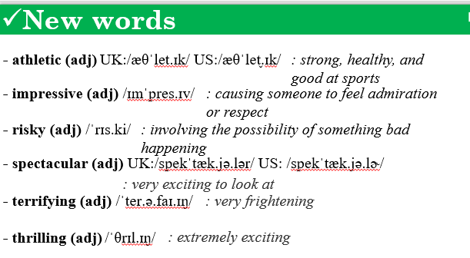
- Activity 2 Practice (21’)
a) Objective: Students can answer the questions to critical thinking, and they can finish the tasks in the textbook. Critical thing skills (guessing/ reasoning) and communication can also be practiced.
b) Content: Students read and choose the correct answer, practice speaking.
Listening
Speaking
c) Outcomes: Students read and listen, and they can apply the useful language in everyday conversations.
d) Competence: communication, collaboration, presentation
e) Organisation of the activity:
TEACHER’S ACTIVITIES | STUDENT’S ACTIVITIES | CONTENTS
PRACTICE. T-Ss/ S-S/ Indiv.  Activity 1 (2’): Exercise 1 page 25.  - Ask students to put these adjectives below into three groups.  - Check the answers.  Activity 2 (4’): Exercise 2 page 25.  - Have students describe the photos above. They can do it by answering some questions in the task and using adjectives from lesson 2A page 22.  - Invite some students to share their ideas.  - Check their answers and pronunciation.  Activity 3 (3’): Listening Strategy box.  - Introduce the Listening Strategy box and highlight some main points to help students improve their listening skill.  Activity 4 (4’): Listen to six people talking about BASE jumping and write the synonyms or words with the opposite meaning that they use for the underline words.  - Play the recording.  - Invite some students to give the answers.  - Play each small audio for each sentence. Give the answers to class.  Activity 5 (4’): Task 4 page 25.  - Ask students to read the sentences and think of synonyms for the underlined words.  - Invite some students to share their answers.  - Check the answers.  Activity 6 (4’): Listen and write T or F.  - Read questions, find keywords.  - Play the audio.  - Call out some students to give the answers.  - Play each small audio of each sentence and check the answers. | - Complete the task.  - Check the answers with the teacher.  - Describe the photos.  - Volunteer to answer.  - Receive feedbacks from the teacher.  - Listen to the teacher and underline important parts.  - Listen to the audio.  - Volunteer to answer.  - Check the answers with the teacher.  - Write some synonyms for the underlined words.  - Volunteer to answer.  - Check the answers with the teacher.  - Listen and write T or F.  - Volunteer to answer.  - Check the answers with the teacher. | 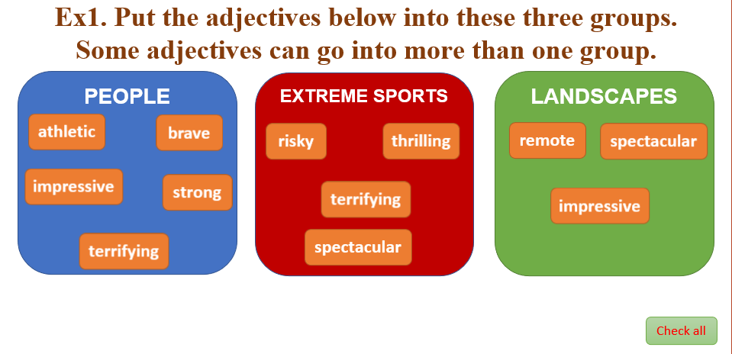  Suggested answers:  They are on a high mountain/ cliff.  They are skydiving/ jumping from a cliff.  I think they are people who like doing something risky and thrilling.  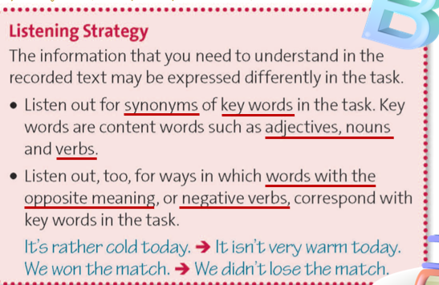  Answers:  2. over 30; young  3. brave  4. unfit  5. spectacular  6. hated  Suggested answers:  1. like = enjoy, adore, love  dangerous = unsafe, risky  2. told = said, spoke, advised  3. didn’t enjoy = hated, disliked  4. venue = site, place, location, scene, spot  5. dangers = risks, threats  6. great = amazing, excellent, impressive, brilliant  sportswoman = athletic  Answers:  1. T  2. T  3. F  4. F  5. F  6. T

- Activity 3: Outcomes (6’)
a) Objective: Ss discuss and give reasons to support their opinions about BASE jumping. Communication is also be practiced.
b) Content: Ss watch a video about BASE jumping. Then explain why they would or would not like to try BASE jumping and give three reasons.
c) Outcomes: Ss speak and listen mutually, they can apply some structures to approve or disapprove about something as well as use some adjectives they have learnt in their daily conversations.
d) Competence: Collaboration, communication, presentation
e) Organisation of the activity:
TEACHER’S ACTIVITIES | STUDENT’S ACTIVITIES | CONTENTS
PRODUCT. T-Ss/ S-S/ Indiv.  - Play the video.  - Students can work in pairs or groups to discuss if they would or would not like to try BASE jumping and give reasons.  - Ask student to raise their hands if they would like to try it and ask the reasons. With the others, ask why they wouldn’t like to try.  - Check students’ pronunciation. | - Watch the video.  - Discuss and give reasons.  - Raise their hand if they want to try and explain why. And the others that don’t like it, give reasons why they wouldn’t like to try. | 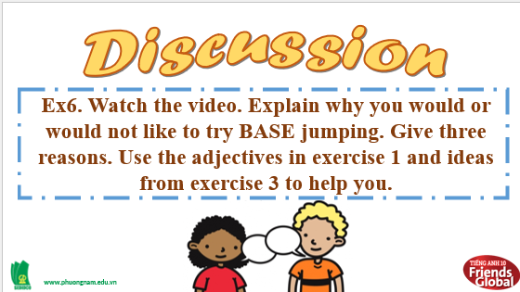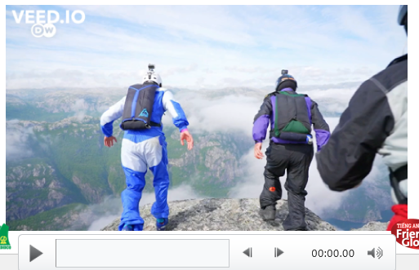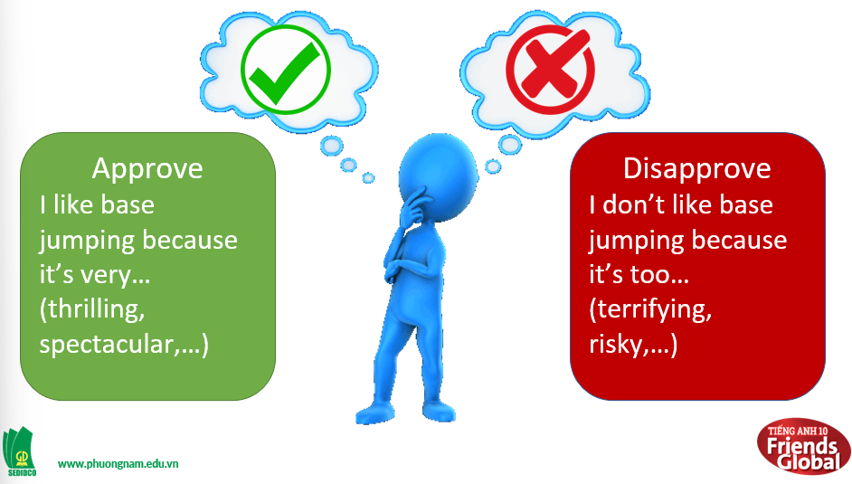
C. Consolidation (3’)
Vocabulary: athletic, impressive, risky, spectacular, terrifying, thrilling
Strategy to better listening skills.
D. Homework (2’)
- Learn by heart new words
- Do exercise
- Prepare: Unit 2 – D-Grammar (page 26 – SB)

