UNIT 7: TRAFFIC
Lesson 1: Getting started – Meeting in the schoolyard
I. OBJECTIVES
By the end of this lesson, Ss will be able to gain:
1. Knowledge
- An overview about the topic Traffic
- Vocabulary to talk about means of transport
2. Core competence
- Develop communication skills and cultural awareness
- Be collaborative and supportive in pair work and teamwork
- Actively join in class activities
3. Personal qualities
- Develop awareness of travelling in town/ city
- Be concerned to the local traffic

II. MATERIALS
- Grade 7 textbook, Unit 7, Getting started
- Computer connected to the Internet
- Projector/ TV/ pictures and cards
- hoclieu.vn

Language analysis
Form | Pronunciation | Meaning | Vietnamese equivalent
1. cycle (v) | /ˈsaɪkl/ | to ride a bike/ bicycle | đạp xe
2. traffic jam (n.phr.) | /ˈtræfɪk dʒæm/ | a line of vehicles waiting behind something that is blocking the road | tắc đường
3. cross the road (v.phr.) | /krɒs ðə rəʊd/ | pass the road | băng qua đường
4. rush hour (n.phr.) | /ˈrʌʃ aʊə(r)/ | usually happens twice a day, when the roads are full of traffic and trains are crowded because people are travelling to or from work | giờ cao điểm

Assumptions
Anticipated difficulties | Solutions
- Students may not be able to recognise means of transport and have experience of using them on the road.  - Students may not know how to work in teams. | - Give specific examples and ask questions to activate students’ knowledge.  - Give short, clear instructions and help if necessary.

Board Plan
Date of teaching
Unit 7: TRAFFIC
Lesson 1: Getting started – Meeting in the schoolyard
* Warm-up:
Miming game
I. Vocabulary
1. cycle (v): đạp xe
2. traffic jam (n.phr.): tắc đường
3. cross the road (v.phr.): băng qua đường
4. rush hour (n.phr.): giờ cao điểm
II. Practice
Task 1: Listen and read.
Task 2: Read the conversation again and choose the correct answer.
Task 3: Write one word from the conversation to complete each sentence.
Task 4: Look at the pictures and write a word under each.
Task 5: Game: Find someone who …
* Homework

III. PROCEDURES
Notes:
In each activity, each step will be represented as following:
* Deliver the task
** Implement the task
*** Discuss
**** Give comments or feedback

Stage | Stage aim | Procedure | Interaction | Time
WARM-UP | - To activate students’ knowledge on the topic of the unit  - To enhance students’ skills of cooperating with teammates | MIMING GAME  * Teacher gives instructions.  ** Get one student to the board. Teacher secretly shows 1 picture of a means of transport to that student. He/ She has to mime the picture and the other students have to guess. Have students take turns going to the board until the last picture.  **** Teacher checks and corrects if Ss pronounce the words incorrectly. | T-Ss  T-S  Ss-Ss  T-Ss | 5 mins
PRESENTATION | To help students use key language more appropriately before they read and listen | VOCABULARY  * T asks Ss to look at the photos and answer the questions:  1. What is he doing?  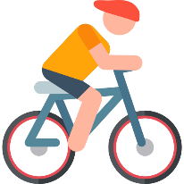  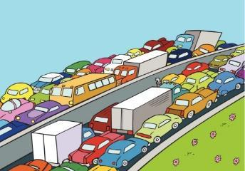  2. What is this?  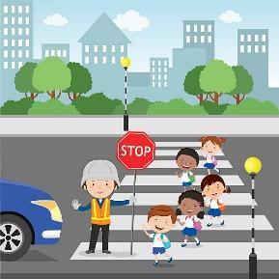  3. What are they doing?    4. Which time of the day do traffic jams usually happen?  ** Ss say the words.  **** T shows and says the words aloud and asks Ss to repeat them.  * T asks Ss to translate the words into Vietnamese.  Concept check: Slap the board | T-S | 5 mins
 | - To get students interested in the topic  - To set the context | TASK 1: LISTEN AND READ.  * Teacher asks Ss to look at the picture (p.72, 73), then answer the question:  Where are they?  * Teacher plays the recording, asks students to pay attention to the new words. (Teacher may check the meaning of some words if necessary.)  - Teacher can play the recording more than once.  - Students listen and read.  ** Teacher can invite some pairs of students to read aloud.  *** Teacher refers to the questions previously asked.  **** Then, teacher confirms the correct answer. | T-Ss  T-Ss  Pair work  T-Ss  T-Ss
PRACTICE | - To help Ss understand the main idea of the text | TASK 2: READ THE CONVERSATION AGAIN AND CHOOSE THE CORRECT ANSWER. (Ex 2, p. 74)  * T asks Ss to quickly read the conversation again.  ** Ss discuss and answer questions in pairs.  *** Ss share their answers as a whole class.  **** T asks them to read and listen to the conversation to check their answers. T encourages students to explain where they have found the answers in the conversation.  Answer key:  1. A  2. B  3. C | T-Ss  Ss-Ss  Ss  T-Ss | 3 mins
 | - To practise reading for specific information  - To practise scanning  - To develop Ss' knowledge of vocabulary | TASK 3: WRITE ONE WORD FROM THE CONVERSATION TO COMPLETE EACH SENTENCE. (Ex 3, p. 74)  * Teacher asks Ss to work individually to read the conversation and find the words and phrases and then share their answers with their partners who sit next to them. (peer check)  ** Ss do exercise individually.  *** Ss share and discuss with their partners to write all words down on the notebooks.  **** Teacher corrects their answers as a class.  Answer key:  1. cycled  2. should  3. jams  4. How  5. crowded | T-Ss  Ss  Ss-Ss  T-Ss | 7 mins
 | - To revise and develop the vocabulary about means of transport | TASK 4: LOOK AT THE PICTURES AND WRITE A WORD UNDER EACH.  (Ex 4, p. 74)  * Teacher asks students to work individually to complete the task.  ** Have students fill in the blanks with the most suitable words/ phrases.  *** Teacher nominates Ss to read the words aloud.  **** Teacher checks and gives the correct answers.  Suggested answers:  1. bicycle/ bike 2. car 3. bus 4. motorbike  5. plane 6. train 7. boat 8. ship | T-Ss  Ss  T-Ss  T-S | 10 mins
PRODUCTION | - To help Ss practise talking about how they go to school  - To practise team working  - To give students authentic practice in using target language | TASK 5: FIND SOMEONE WHO … WRITE YOUR FRIENDS’ NAMES IN THE BLANKS. THEN REPORT TO THE CLASS. (Ex 5, p. 74)  * Teacher gives Ss clear instructions in order to make sure Ss can do the survey effectively.  - Ask students to look at the survey and think of the needed structures to ask their friends.  - Students go around the class and ask at least 20 classmates (Do you usually walk to school? Have you ever gone to school by bus?…)  - Observe Ss while they are role playing, note their language errors.  ** Ss do as instructed.  **** Teacher gives Ss feedback.  - Choose some useful or excellent words/ phrases/ expressions/ word choices Ss have used to suggest for other students.  - Choose some typical mistakes and correct as a whole class without nominating the students’ names. | T-Ss  Ss  T-Ss | 10 mins
CONSOLIDATION | To help Ss memorise the target language and skills that they have learned | Teacher asks students to talk about what they have learnt in the lesson:  - Vocabulary of traffic and means of transport  - Reading for specific information and details  - Scanning | T-Ss | 2 min
HOMEWORK | To prepare for the next lessons. | - Do exercises in the workbook.  - Prepare the vocabulary for the next lesson: A closer look 1.  - Project preparation  + Teacher informs student of the final project of the Unit’s project  + Explain the requirements of the project: Find four traffic signs in your neighbourhood, then choose to make one of them out of a cardboard or other materials. Students will show their work and present in Lesson 7 – Looking back and Project.  + Teacher explains to students how they can get the information  + Put students into groups and ask them to discuss to assign tasks for each member. Help them set a deadline for each task.  (Teacher should check the progress of students’ preparation after each lesson.) | T-Ss | 1 min

UNIT 7: TRAFFIC
Lesson 2: A closer look 1
I. OBJECTIVES
By the end of this lesson, Ss will be able to gain:
1. Knowledge
- Verbs to use with means of transport
- Vocabulary to read the road signs
- Pronunciation: /aɪ/ and /eɪ/
2. Core competence
- Be collaborative and supportive in pair work and teamwork
- Actively join in class activities
3. Personal qualities
- Develop awareness of understanding the road signs and obeying the traffic rules

II. MATERIALS
- Grade 7 textbook, Unit 7, A closer look 1
- Computer connected to the Internet
- Projector/ TV/ small boards, markers
- hoclieu.vn

Language analysis
Form | Pronunciation | Meaning | Vietnamese equivalent
1. road sign (n.phr.) | /ˈrəʊd saɪn/ | a sign near a road giving information or instructions to drivers | biển báo giao thông
2. cycle lane (n.phr.) | /ˈsaɪkl leɪn/ | a part of a road that only bicycles are allowed to use | đường đi riêng cho xe đạp
3. traffic light (n.phr.) | /ˈtræfɪk laɪt/ | a set of lights that controls the traffic on a road. | đèn giao thông

Assumptions
Anticipated difficulties | Solutions
- Students may not be able to recognise the road signs and have experience of using them on the road.  - Students may not know how to work in teams. | - Give specific examples and ask questions to activate students’ knowledge.  - Give short, clear instructions and help if necessary.

Board Plan
Date of teaching
Unit 7: TRAFFIC
Lesson 2: A closer look 1
* Warm-up: Jumbled words
I. Vocabulary
1. road sign (n.phr.): biển báo giao thông
2. cycle lane (n.phr.): đường đi riêng cho xe đạp
3. traffic light (n.phr.): đèn giao thông
II. Practice
Task 1: Match the words in A with the phrases in B.
Task 2: Write the correct phrases under the signs.
Task 3: Work in pairs. Take turns to say which of the signs in 2 you see on the way to school.
Task 4: Listen and repeat. Pay attention to the sounds /aɪ/ and /eɪ/.
Task 5: Underline the words with the sound /aɪ/ and circle the words with the sound /eɪ/.
* Homework

III. PROCEDURES
Notes:
In each activity, each step will be represented as following:
* Deliver the task
** Implement the task
*** Discuss
**** Give comments or feedback

Stage | Stage aim | Procedure | Interaction | Time
WARM-UP | - To activate students’ knowledge on the topic of the unit  - To enhance students’ skills of cooperating with teammates | JUMBLED WORDS  * Teacher gives instructions.  ** In groups of 5, Ss will be given a small white board and a marker.  - Teacher shows the jumbled words on the screen one by one.  - Students work in groups to make the correct words and write down onto the small boards. When they finish, they hold the boards up to show their answers to teacher.  - Have students take turns to write until the last word.  **** Teacher checks and corrects if Ss write the words incorrectly.  Answer key:  1- otba -> boat  2- itanr -> train  3- npeilara -> airplane  4- rsotrpca -> sport car  5- otmiroekb -> motorbike | T-Ss  T-Ss  S-Ss  T-Ss | 5 mins
VOCABULARY | To help students use key language more appropriately | VOCABULARY  * T asks Ss to look at the photos and answer the question .  1. What is this? (road sign)  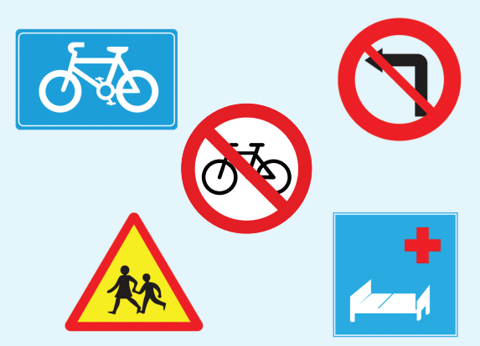  2. What is this? (cycle lane)  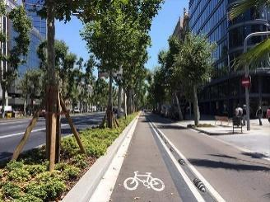  3. What is this? (traffic light)  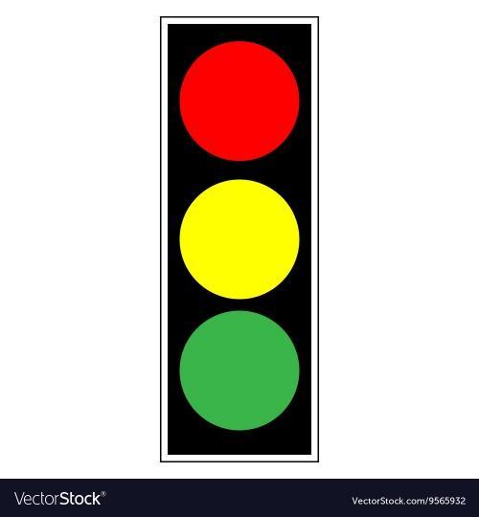  ** Ss say the words.  *** Other Ss correct if the previous answers are incorrect.  **** Teacher shows and says the words aloud and asks Ss to repeat them.  * Teacher asks Ss to translate the word into Vietnamese.  ** Ss says the word. | T-Ss  Ss  Ss-Ss  T-Ss  T-Ss  Ss | 5 mins
VOCABULARY | - To revise/ teach some collocations of a verb and a phrase related to different means of transport | TASK 1: MATCH THE WORDS IN A WITH THE PHRASES IN B. (Ex 1, p. 74)  * Teacher asks Ss to look at the table (p.74), identify the form (verbs and nouns – means of transport):  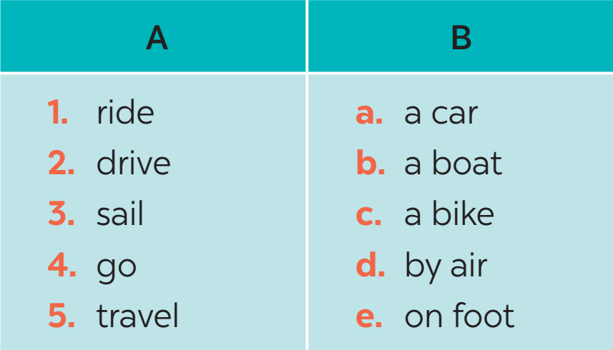  Answer key:  1. c 2. a 3. b 4. e 5. d  ** Ss work out and answer questions in pairs.  *** Ss share their answers as a whole class.  **** T asks them to check their answers.  * Teacher asks students to make their own sentences with these phrases. Then tell them to share their sentences with a partner and correct them. | T-Ss  Pair work  Ss-Ss  T-Ss  T-Ss | 3 mins
 | - To practise identifying the meanings of road signs  - To develop Ss' knowledge of vocabulary | TASK 2: LOOK AT THESE ROAD SIGNS. THEN WRITE THE CORRECT PHRASES UNDER THE SIGNS. (Ex 2, p.74)  * Teacher asks Ss to look at the road signs and guess their meanings. Then work and share their answers with their partners who sit next to them. (peer check)  ** Ss do Task 2 in pairs.  *** Ss share and discuss with their partners to write all words/ phrases down on the notebooks.  **** Teacher corrects their answers as a class.  Answer key:  1. Traffic lights 2. Hospital ahead 3. No right turn  4. Cycle lane 5. School ahead 6. No cycling | T-Ss  Pair work  Pair work  Ss-Ss  T-Ss  T-S | 7 mins
 | - To help Ss deeply understand how to read the road signs  - To practise the targeted language in life context. | TASK 3: WORK IN PAIRS. TAKE TURNS TO SAY WHICH OF THE SIGNS IN 2 YOU SEE ON THE WAY TO SCHOOL. (Ex 3, p. 74)  * Teacher gives suggestions and asks students to share their sentences.  *** Teacher nominates Ss to say the sentences aloud  **** Teacher checks and gives the corrections if they have mistakes. | T-Ss  S-S  T-S | 10 mins
PRONUNCIATION | - To help Ss identify the and classify the sounds | TASK 4: LISTEN AND REPEAT. PAY ATTENTION TO THE SOUNDS /aɪ/ AND /eɪ/. (Ex 4, p. 74)  * Teacher has students listen to the recording once first.  ** Students listen to the recording and read out the words.  *** Teacher plays the recording for them to listen and repeat each word as a class, then as individuals.  **** Teacher check students’ pronunciation if needed. | T-Ss  Ss  T-Ss  T-Ss | 10 mins
 | - To help students pronounce the sounds correctly in context  - To help students differentiate the sounds /aɪ/ and /eɪ/ | TASK 5: UNDERLINE THE WORDS WITH THE SOUND /aɪ/ AND CIRCLE THE WORDS WITH THE SOUND /eɪ/. THEN LISTEN, CHECK AND REPEAT. (Ex 5, p. 74)  * Teacher plays the recording again and asks students to underline and circle the appropriate sounds.  ** Ss do as instructed  **** Teacher gives Ss feedback.  - Choose some common mispronounced words that contain the sounds and suggest students practise using them.  - Choose some typical errors and correct as a whole class. | T-Ss  Ss  T-Ss
WRAP-UP | To consolidate what students have learnt in the lesson. | - Teacher asks students to summarise what they have learnt in the lesson. | T-Ss | 2 mins
HOMEWORK | To revise what they have learnt. | Do exercises in the workbook. | T-Ss | 1 mins

UNIT 7: TRAFFIC
Lesson 3: A closer look 2
I. OBJECTIVES
By the end of this lesson, Ss will be able to gain:
1. Knowledge
Know how to use:
- It to indicate distance
- should and shouldn’t
Structure | Examples
1. It to indicate distance | It is 4 kilometers from my house to school.
2. should | We should eat more vegetables and fruits.
3. shouldn’t | You shouldn’t stay up late everyday.
2. Core competence
- Be collaborative and supportive in pair work and teamwork
- Actively join in class activities
3. Personal qualities
- Develop awareness of understanding the road signs and obeying the traffic rules.

II. MATERIALS
- Grade 7 textbook, Unit 7, A closer look 2
- Computer connected to the Internet
- Projector/ TV/ pictures.
- hoclieu.vn

Assumptions
Anticipated difficulties | Solutions
- Students may not be able to know the distance between different places.  - Students may not know how to work in teams or fully understand the exercises and tasks. | - Give specific examples and facts to activate students’ knowledge.  - Give short, clear instructions and help if necessary.

Board Plan
Date of teaching
Unit 7: TRAFFIC
Lesson 3: A closer look 2
* Warm-up
Slap the board
I. Grammar
1. It indicating distance
2. Should/shouldn’t
II. Practice
Task 1: Write sentences with It. Use these cues.
Task 2: Work in pairs. Ask and answer questions about distances in your neighbourhood.
Task 3: Choose the correct option in brackets.
Task 4: Complete each sentence, using should / shouldn’t.
Task 5: Look at the pictures. Make sentences, using should /shouldn’t and the cues.
* Homework

III. PROCEDURES
Notes:
In each activity, each step will be represented as following:
* Deliver the task
** Implement the task
*** Discuss
**** Give comments or feedback

Stage | Stage aim | Procedure | Interaction | Time
WARM-UP | - To activate students’ knowledge on the topic of the unit  - To enhance students’ skills of cooperating with teammates | SLAP THE BOARD  * Teacher gives instructions and sticks some road signs pictures onto the board.  ** In 2 groups, Ss will choose 1 student in each group to go to the board.  - Teacher says a road sign message.  - Students quickly run and slap onto the correct road signs.  - Students take turns until they finish all of the signs.  Suggested answers:  1. Cycle lane  2. School ahead  3. No cycling  4. No right turn  5. Schools ahead  **** Teacher checks and corrects if Ss pronounce the signs incorrectly. | T-Ss  T-Ss  Ss-Ss  T-Ss | 5 mins
PRESENTATION | To introduce students the form of the key grammar and how to use them appropriately | IT INDICATING DISTANCE  - Teacher says: “This lesson today is going to tell you about “it indicating distance”  * Teacher draws students’ attention to the grammar point and the example  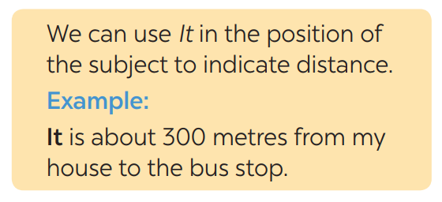  * Teacher asks Ss:  - What does the sentence tell us about?  Answer: Distance from his/her house to the bus stop.  - What is the structure used in the sentence?  Answer: It be (about) + distance from A to B.  ** Ss read the grammar explicitly and study the example.  *** Ss may discuss within groups/pairs before answering.  **** Teacher shows and says the sentences aloud and asks Ss to make similar sentences. | T-Ss  T-Ss  T-Ss  Ss  Ss-Ss  T-Ss | 5 mins
PRACTICE | To help student practise using It to write correct sentences | TASK 1: WRITE SENTENCES WITH IT. USE THESE CUES. (Ex 1, p. 75)  * Teacher asks Ss to look at the example and the task.  ** Ss work out and answer questions individually.  *** Ss share their answers in pairs.  **** T asks them to check their answers.  * Then tell them to share their sentences as a whole in class and correct for them.  Answer key:  1. It is about 700 metres from my flat to the Youth Club.  2. It is about 5 kilometres from my village to the nearest town.  3. It is about 120 km from Ho Chi Minh City to Vung Tau.  4. It is about 384,400 km from the Earth to the Moon.  5. It is not very far from Ha Noi centre to Noi Bai airport. | T-Ss  Ss  Ss-Ss  T-Ss  T-Ss | 7 mins
 | To practise asking and answering about distance | TASK 2: WORK IN PAIRS. ASK AND ANSWER QUESTIONS ABOUT DISTANCES IN YOUR NEIGHBOURHOOD. (Ex 2, p. 75)  * Teacher asks Ss to look at the example and identify the structure of the question: How far is it from … to …?  Then work with their partners who sit next to them to make similar conversations.  ** Ss do exercise 2 in pairs.  *** Ss write all conversations down on the notebooks.  **** Teacher corrects their answers as a class. | T-Ss  Pair work  Ss  T-Ss | 7 mins
 | To review the first use of should and shouldn’t | TASK 3: CHOOSE THE CORRECT OPTION IN BRACKETS. (Ex 3, p. 75)  * Teacher draws students' attention to the Remember box. Teacher asks them to study the examples and identify the structure:  S + should/ shouldn’t + V-inf  * Teacher gives suggestions and asks students to make some similar sentences using the structures.  *** Teacher nominates Ss to read aloud the sentences.  **** Teacher checks and gives the corrections if they have mistakes.  Answer key:  1. should 2. should 3. shouldn’t  4. should 5. shouldn’t | T-Ss  T-Ss  T-Ss  T-Ss | 5 mins
 | To practise using should and shouldn’t | TASK 4: COMPLETE EACH SENTENCE, USING SHOULD / SHOULDN’T. (Ex 4, p.75)  * Teacher gives Ss time to do the exercise individually and peer check with their partner.  *** Teacher nominates Ss to read aloud the sentences.  **** Teacher checks and gives the corrections if they have mistakes.  Answer key:  1. shouldn’t 2. should 3. shouldn’t  4. should 5. should 6. shouldn’t | Ss-Ss  Ss  T-Ss | 5 mins
PRODUCTION | To help students apply  should and shouldn’t in real context | TASK 5: LOOK AT THE PICTURES. MAKE SENTENCES, USING SHOULD/ SHOULDN’T AND THE CUES. (Ex 5, p.76)  * Teacher asks students to do the exercise individually.  ** Ss do as instructed.  **** Teacher gives Ss feedback.  - Choose some common mistakes and suggest students how to avoid them  - Choose some typical errors and correct as a whole class  Answer key:  1. He shouldn’t waste water.  2. They should wear their helmets.  3. She should be more careful.  4. They shouldn’t play football on the pavement.  5. They shouldn’t ride their bikes dangerously. | T-Ss  Ss  T-Ss | 5  mins
WRAP-UP | To consolidate what students have learnt in the lesson. | Teacher asks students to summarise what they have learnt in the lesson. | T-Ss | 2 mins
HOMEWORK | To revise what they have learnt. | Do exercises in the workbook. | T-Ss | 1 mins

UNIT 7: TRAFFIC

Lesson 4: Communication

I. OBJECTIVES
By the end of this lesson, students will be able to:
1. Knowledge
- Learn how to ask and answer about means of transport and some strange traffic rules.
- Practise using some grammar points and vocabulary related to the topic.
2. Core competence
- Develop communication skills
- Be collaborative and supportive in pair work and team work
- Actively join in class activities
3. Personal qualities
- Be benevolent and responsible

II. MATERIALS
- Grade 7 textbook, Unit 7, Communication
- Computer connected to the internet
- TV/ Pictures/ Projector
- hoclieu.vn

Language analysis
Anticipated difficulties | Solutions
1. Students may lack knowledge about the topic. | Provide students with information about the knowledge they do not know.
2. Students may have underdeveloped reading, speaking and co-operating skills. | - Encourage students to work in pairs, in groups so that they can help each other.  - Provide feedback and help if necessary.
3. Some students might excessively talk in the class. | - Define expectation in explicit detail. Have excessive talking students practise.  - Continue to define expectations in small chunks (before every activity).

Board Plan
Date of teaching
UNIT 7: TRAFFIC
Lesson 4: Communication
* Warm-up
Brainstorming
I. Everyday English
Task 1: Listen and read. Pay attention to the highlighted parts.
Task 2: Work in pairs, ask and answer about the means of transport.
II. Strange traffic rules!
Task 3: Which countries below keep to the left?
Task 4: Listen and check your answers in 3 and complete the sentence.
Task 5: Read, discuss which one is the strangest rule?
* Homework

III. PROCEDURES
Notes:
In each activity, each step will be represented as following:
* Deliver the task
** Implement the task
*** Discuss
**** Give comments or feedback

Stage | Stage aim | Procedure | Interaction | Time
WARM-UP | To introduce the lesson | Game: BRAINSTORMING  HOW DO YOU GO TO SCHOOL?  * Teacher divides the class into 2 teams and asks them to think of “MEANS OF TRANSPORT” (even the strangest ones).  ** Ss have 1 min to think of the words related to the topic or they can discuss with their partners.  *** Members from each team will take turns to run to the board and write one word.  **** Teacher corrects their answers.  - The team which has more correct words will be the winner  Suggested answers:  motorbike, bicycle, train, bus, plane, helicopter,… | T-Ss  Pair work  Ss-Ss  T-Ss | 5 mins
LEAD-IN | To lead in the lesson | Teacher leads students into the lesson by telling them what they are going to learn: “We are going to learn how to ask and answer about means of transport and some strange traffic rules”. | T-Ss | 1 min
EVERYDAY ENGLISH | To let students know the structure to ask and answer about means of transport | TASK 1: LISTEN AND READ THE CONVERSATION, PAYING ATTENTION TO THE HIGHLIGHTED PARTS. (Ex 1, p. 76)  * Teacher plays the record for Ss to listen and read the conversation about means of transport.  ** Ss listen and practise saying with their partners.  *** Teacher calls some pairs to read aloud.  **** Teacher corrects pronunciation if needed.  * Teacher asks Ss to pay attention to the highlighted parts and asks them some questions to elicit the new structure:  - Which tense do we use to ask and answer?  - Which question word do we use?  - …  ** Ss answer teacher’s questions to find out the new structure to ask and answer about means of transport to travel to places.  *** Some students give the new structure to the teacher.  **** Teacher corrects and writes on the board:  - Structure:  to ask:  - How do/ does + S + go to …?  to answer:  - S + go/goes by …  - S + V | T-Ss  Pair work  T-Ss  T-Ss  T-Ss  Ss  T-Ss  T-Ss | 10 mins
PRACTICE | To help students practise on how to ask and answer about means of transport. | TASK 2: WORK IN PAIRS. TAKE TURNS TO ASK AND ANSWER ABOUT THE MEANS OF TRANSPORT YOUR FAMILY MEMBERS USE EVERY DAY. (Ex 2, p. 76)  * Teacher has SS look at the situation in Ex 1 to make similar dialogue:  ** Ss work in pairs to make similar dialogue.  *** Teacher calls some pairs to present it in front of the class.  **** Teacher gives feedback and some comments.  Suggested answers:  A: How does your father go to school?  B: He usually drives his car but sometimes he goes by bus. How about your father?  A: He walks because we live near his office. | Pair work  T-Ss | 8 mins
STRANGE TRAFFIC RULES | To provide students with more knowledge about strange traffic rules | TASK 3: WHICH COUNTRIES BELOW KEEP TO THE LEFT? TICK THE CORRECT ANSWERS. (Ex 3, p.76)  * Teacher asks Ss to discuss in pairs and tick.  ** Ss do the task in pairs.  *** Teachers discuss with students about their answers.  Answer key:  - Task 3: The United Kingdom, Australia, Thailand | T- Ss  Pair work  T-Ss | 3 mins
 | To help students practise listening for details | TASK 4: LISTEN AND CHECK YOUR ANSWERS IN 3. THEN LISTEN AGAIN AND COMPLETE THE SENTENCE WITH NO MORE THAN THREE WORDS. (Ex 4, p. 77)  * Teacher plays the recording twice (if necessary).  *** Teacher calls some Ss to give their answers and explain them.  **** Teacher lets Ss listen and confirms the correct answers.  Answer key:  - Task 4: the same system | T-Ss  T-Ss  T-Ss | 5 mins
 | To help students know more about traffic rules around the world | TASK 5: READ, DISCUSS WHICH ONE IS THE STRANGEST RULE? (Ex 5, p. 77)  * Teacher has students work in groups to discuss which one they find strangest.  ** Ss work in groups.  *** 2-3 groups share their ideas.  **** Teacher encourages students to add more if they know. | T-Ss  Group work  Ss-Ss  T-Ss | 5 mins
WRAP-UP | To consolidate what students have learnt in the lesson | Teacher asks students to talk about what they have learnt in the lesson. | T-Ss | 1 min
HOMEWORK | To prepare for the next lesson: Skills 1 | - Do exercises in the workbook.  - Prepare for the next lesson. | T-Ss | 1 min

UNIT 7: TRAFFIC

Lesson 5: Skills 1

I. OBJECTIVES
By the end of this lesson, students will be able to gain:
1. Knowledge
- Reading: read for specific information about some rules about road safety
- Speaking: talk about how to avoid traffic accidents
2. Core competence
- Develop communication skills
- Be collaborative and supportive in pair work and teamwork
- Actively join in class activities
3. Personal qualities
Be benevolent and responsible

II. MATERIALS
- Grade 7 textbook, Unit 7, Skills 1
- Computer connected to the Internet
- TV/ Pictures, cards
- hoclieu.vn

Language analysis
Form | Pronunciation | Meaning | Vietnamese equivalent
1. pedestrian (n) | /pəˈdestriən/ | a person walking along a road/ street | người đi bộ
2. passenger (n) | /ˈpæsɪndʒə(r)/ | a traveler on a public or private vehicle but not the driver, pilot, or crew. | hành khách
3. obey (v) | /əˈbeɪ/ | comply with the command, direction, or request of (a person or a law) | tuân thủ
4. seat belt (n) | /ˈsiːt belt/ | a belt or strap securing a person to prevent injury, especially in a vehicle or aircraft | dây an toàn

Assumptions
Anticipated difficulties | Solutions
1. Students may lack knowledge about some lexical items. | Provide students with the meaning and pronunciation of words.
2. Students may have underdeveloped reading, speaking and co-operating skills. | - Let students read the text again (if needed).  - Create a comfortable and encouraging environment for students to speak.  - Encourage students to work in pairs, in groups so that they can help each other.  - Provide feedback and help if necessary.
3. Some students might excessively talk in the class. | - Define expectation in explicit detail.  - Have excessively talking students practise.  - Continue to define expectations in small chunks (before every activity).

Board Plan
Date of teaching
Unit 7: Traffic
Lesson 5: Skills 1
* Warm-up
Hangman
I. Reading
Vocabulary
- pedestrian (n): người đi bộ
- passenger (n): hành khách
- obey (v): tuân thủ
- seatbelt (n): dây an toàn
Task 1: Discussion: Look at the picture. Can you see anything that is dangerous?
Task 2: Read the following text and choose the correct answer.
Task 3: Read the text again and answer the questions.
II. Speaking
Task 3: Work in groups. Ask and answer the following question. Make a list.
Task 4: Discussion.
Task 5: Give advice on dangerous situations on the road.
* Homework

III. PROCEDURES
Notes:
In each activity, each step will be represented as following:
* Deliver the task
** Implement the task
*** Discuss
**** Give comments or feedback

Stage | Stage aim | Procedure | Interaction | Time
WARM-UP | To introduce the topic of reading | GAME: HANGMAN  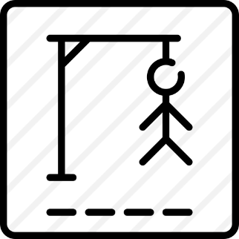  D A N G E R O U S  * Teacher divides the class into 2 teams and asks them to think of a word which has 9 letters in it related to the topic “ON THE ROAD”.  ** Ss have 1 min to think of the words related to the topic or they can discuss with their partners.  *** Each member from each team guesses the letter in the secret word in turn.  **** Teacher corrects their answers.  - The team which can find or guess the secret first will be the winner. | T-Ss  Ss  Group work  T-Ss | 5 mins
LEAD-IN | To lead in the lesson about Skills 1 | Teacher leads students into the lesson by telling what they are going to learn: “We are going to read a passage about some rules about road safety.” | T-Ss | 2 mins
READING | To provide students with some lexical items before reading the text | VOCABULARY  - Teacher introduces the vocabulary by:  + Providing the synonyms or antonyms of the words.  + Providing the pictures of the words.  + Providing the definitions of the words.  - pedestrian (n): người đi bộ  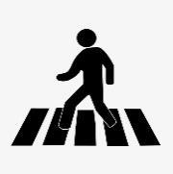  - passenger (n): hành khách  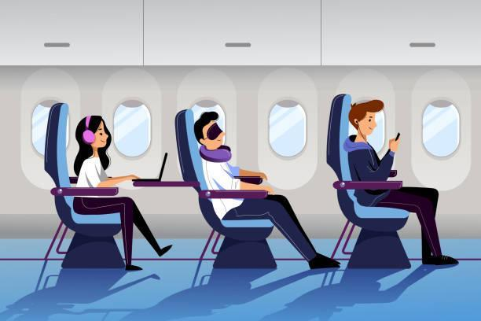  - (to) obey : tuân thủ  - seatbelt (n): dây an toàn  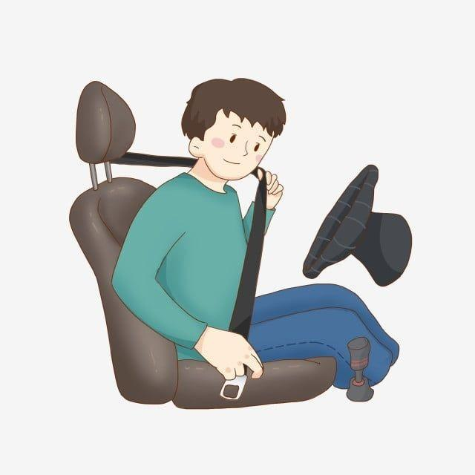  Concept check: Rub out and Remember | T-Ss | 8 mins
 | To introduce words related to skin conditions to Ss and help Ss have a general idea of what they are going to read | TASK 1: LOOK AT THE PICTURE. CAN YOU SEE ANYTHING THAT IS DANGEROUS? (Ex 1, p. 78)  * Teacher asks Ss to work in pairs to look at the Picture in Ex 1 and discuss what they see that is dangerous?  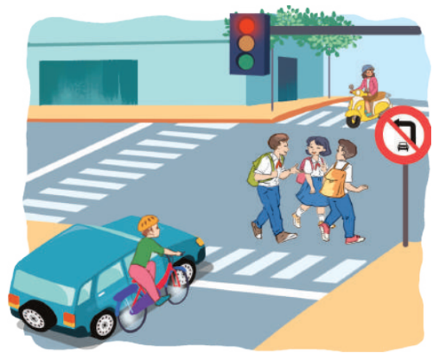  ** Ss work in pairs.  *** Teacher calls some Ss to check what they have discussed.  **** Teacher corrects.  Suggested answers:  The students are crossing the road. But they do not walk in the right place and they are not careful. | T-Ss  Pair work  T-Ss  T-Ss
 | To help Ss develop their reading skills for main ideas and specific information (scanning) and help them focus on the road safety rules | TASK 2: READ THE FOLLOWING TEXT AND CHOOSE THE CORRECT ANSWER. (Ex 2, p. 78)  This text is about ______.  A. rules for pedestrians  B. traffic lights  C. traffic rules  * Teacher has Ss read the first sentence of the text in detail to do the exercise and asks them how to do this kind of exercise.  ** Ss do the task independently.  *** Teacher tells Ss to compare their answers in pairs before calling some of them to check.  **** Teacher confirms the correct answer and explains if needed.  Answer key: C | T-Ss  Ss  Pair work  T-Ss | 9 mins
 | To help Ss further develop their reading skills for specific information (scanning) | TASK 3: READ THE TEXT AGAIN AND ANSWER THE QUESTIONS. (Ex 3, p. 78)  * Teacher asks Ss: reading each question, locating where the information appears in the text, reading that part carefully and circling the correct answer.  ** Ss do the task independently.  *** Teacher has Ss compare their answers in pairs and call some Ss to give their ideas.  **** Teacher checks and confirms the correct answers.  Answer key:  1. They should cross the street at the zebra crossing.  2. We should use the cycle lane.  3. We should give a signal (before we turn while riding a bike).  4. We must wait for buses to fully stop when you get on or off a bus.  5. We mustn’t stick any body parts out of the window (when you are in a moving vehicle). | T-Ss  Ss  Pair work  T-Ss
SPEAKING | To help Ss talk about how they apply the rules in the reading themselves | TASK 4: WORK IN GROUPS. ASK AND ANSWER THE FOLLOWING QUESTION (Ex 4, p.78)  “When you are a road user, what should you NOT do?”  MAKE A LIST IN GROUPS. COMPARE YOUR LIST WITH OTHER GROUPS’.  * Teacher asks Ss to work in groups and tells them to focus on the rules for road users in the text to talk about which one they have to obey every day.  ** Ss work in groups. Teacher goes around and listens and gives help if needed.  *** Teacher calls on some Ss to share their answers with the class.  **** Teacher listens and gives comments. | T-Ss  Group work  T-Ss  T-Ss | 5 mins
 |  | TASK 5: READ THE FOLLOWING SENTENCES ABOUT THESE PEOPLE. THEN WORK IN GROUPS. DISCUSS WHO IS BEING SAFE, AND WHO ISN’T. (Ex 5, p.78)  * Teacher has Ss work in groups and asks them to take turns to discuss the situations.  ** Ss work in groups to do the task. Teacher goes around, listens and gives help if needed.  *** Teacher calls on some groups to share their answers with the class.  **** Teacher comments. | T-Ss  Group work  T-Ss  T-Ss | 7 mins
 | - To provide Ss an opportunity to practise giving advice on dangerous situations on the road | TASK 6: GIVE ADVICE ON DANGEROUS SITUATIONS ON THE ROAD.  Structure: S + should/shouldn’t + V-inf  * Teacher has students give advice on how to avoid dangerous situations on the road.  ** Students do the task in groups.  *** Teacher calls on some groups to share their answers with the class.  **** Teacher comments and corrects if needed. | T-Ss  Group work  T-Ss  T-Ss | 3 mins
WRAP-UP | To consolidate what students have learnt in the lesson | Teacher asks students to talk about what they have learnt in the lesson. | T-Ss | 2 mins
HOMEWORK | To prepare for the next lesson: Skills 2 | - Do exercises in the workbook.  - Prepare for the next lesson. | T-Ss | 1 min

UNIT 7: TRAFFIC

Lesson 6: Skills 2

I. OBJECTIVES
By the end of this lesson, students will be able to:
1. Knowledge
- Listening
+ use the lexical items related to the topic Traffic
+ listen for main ideas and specific information about traffic problems in Mumbai.
- Writing: write about traffic problems in your area.
2. Core competence
- Develop communication skills
- Be collaborative and supportive in pair work and teamwork
- Actively join in class activities
3. Personal qualities
Be benevolent and responsible

II. MATERIALS
- Grade 7 textbook, Unit 7, Skills 2
- Computer connected to the Internet
- Pictures
- hoclieu.vn

Anticipated difficulties | Solutions
1. Students may lack knowledge and experiences about the topic. | Prepare some hand-outs.
2. Students may have underdeveloped listening, writing and co-operating skills. | - Play the recording many times if necessary.  - Encourage students to work in pairs, in groups so that they can help each other.  - Provide feedback and help if necessary.
3. Some students might excessively talk in the class. | - Define expectation in explicit detail.  - Have excessively talking students practise.  - Continue to define expectations in small chunks (before every activity).

Board Plan
Date of teaching
Unit 7: Traffic
Lesson 6: Skills 2
* Warm-up
Brainstorming
I. Listening
Task 1: Discuss.
Task 2: Listen to the recording and choose the correct answer A, B, or C.
Task 3: Listen again and write ONE word or number in each gap.
Task 4: Discuss: Compare traffic problems in Mumbai to the traffic problems in Ha Noi.
II. Writing
Task 5: Tick the traffic problems in big cities in Viet Nam.
Task 6: Write a paragraph of about 70 words about the traffic problems in your town / city.
Peer check and cross check
* Homework

III. PROCEDURES
Notes:
In each activity, each step will be represented as following:
* Deliver the task
** Implement the task
*** Discuss
**** Give comments or feedback

Stage | Stage aim | Procedure | Interaction | Time
WARM-UP | To activate students’ prior knowledge and vocabulary related to the lesson | BRAINSTORMING  * Teacher writes on the board the word “Traffic problems” and asks Ss some questions:  + What does this word mean?  + What do we have to suffer from these problems?  + Can you name some traffic problems?  ** Ss think of these questions and discuss with their partners if needed.  *** Teacher calls some students to give their answers.  **** Teacher listens and gives comments. | T-Ss  Group work  T-Ss  T-Ss | 5 mins
LEAD-IN | To introduce the new lesson | Teacher introduces students the content of the lesson: “In the lesson today, we are going to listen to a person talking about traffic problems in his city - Mumbai.” | T-Ss
PRE-LISTENING | To help Ss brainstorm the topic and prepare for the listening text | TASK 1: WHAT CAN YOU SEE IN THIS PICTURE? WHAT IS SPECIAL ABOUT IT? (Ex 1, p. 79)  * Teacher asks Ss to work in pairs to the problems they can find in the picture on page 79.  ** Ss work with their partner to do the task.  *** Teacher calls on some Ss to answer.  **** Teacher gives comments and leads Ss to task 2.  Suggested answers: traffic jams, vehicle overload, people’s awareness about traffic rules… | T-Ss  Pair work  T-Ss  T-Ss | 3 mins
WHILE-LISTENING | To help Ss develop their skills of listening for main idea | TASK 2: LISTEN TO THE RECORDING AND CHOOSE THE CORRECT ANSWER A, B, OR C. (Ex 2, p. 79)  * Teacher asks Ss to read and underline the key words.  ** Ss work independently to guess then listen to the recording once to check their guess.  *** Teacher calls on some students to give the answers they have listened.  **** Teacher gives feedback.  Answer key: C | T-Ss  Ss  T-Ss  T-Ss | 6 mins
 | To help students develop their skills of listening for specific information | TASK 3: LISTEN AGAIN AND WRITE ONE WORD OR NUMBER IN EACH GAP. (Ex 3, p. 79)  * Teacher asks Ss to read and underline the key words.  ** Ss work independently then listen to the recording again  **** Teacher confirms the correct answers for their predictions.  Answer key:  1. jams 2. problem / jams 3. 20 / twenty  4. roads 5. obey | T-Ss  Ss  T-Ss | 6 mins
POST-LISTENING | To help Ss use what they have listened to life context | TASK 4: DISCUSSION: COMPARE TRAFFIC PROBLEMS IN MUMBAI WITH TRAFFIC PROBLEMS IN HA NOI.  * Teacher tells Ss to work in groups to discuss and compare traffic problems in Mumbai with traffic problems in Ha Noi. Write down in the notebooks in full sentences.  ** Ss work in groups. Teacher moves around and offers help if needed.  *** Teacher invites some Ss to share their answers.  **** Teacher corrects if needed.  E.g. The traffic jams in Ha Noi are as serious and frequent as they are in Mumbai. | T-Ss  Group work  T-Ss  T-Ss | 5 mins
PRE-WRITING | To help Ss prepare ideas to write a passage | TASK 5: TICK THE TRAFFIC PROBLEMS IN BIG CITIES IN VIET NAM. (Ex 4, p. 79)  * Teacher writes on the board “Your City’s Traffic Problems” and asks Ss to tick the traffic problems in big cities in Viet Nam and asks them to give out more problems that they see in their city.  ** Ss think of it and can discuss it with their partners.  *** Teacher calls on some Ss to raise their ideas.  **** Teacher listens and confirms.  Suggested answers:  Too many vehicles  Narrow roads  People’s awareness  … | T-Ss  Pair work  T-Ss  T-Ss | 5 mins
WHILE-WRITING | To help Ss write a passage about 70 words about the traffic problems in their town / city | TASK 6: WRITE A PARAGRAPH OF ABOUT 70 WORDS ABOUT THE TRAFFIC PROBLEMS IN YOUR TOWN / CITY. (Ex 5. p.79)  * Teacher tells Ss that they are going to write a passage about the traffic problems in their town/city.  ** Teacher reminds Ss of the structure of a passage and steps to make an outline for the passage.  ** Ss work independently to do the task and try to use the notes from the previous tasks.  Teacher goes around and helps if necessary. | T-Ss | 10 mins
POST-WRITING | To peer check, cross check and final check students’ writing | PEER CHECK AND CROSS CHECK  *** Teacher asks Ss to share their writing with their partners. Then, call on some Ss to show their writing in front of the class.  **** Teacher checks ideas, grammar, vocabulary and gives comments.  Suggested answers:  The most serious traffic problem in our city – Ha Noi is the traffic jam. Although the public transport system in Ha Noi is quite modern and convenient, many people prefer using their own motorbikes. The reason for that is because most roads and streets in Ha Noi are quite small and include many tiny lanes. Therefore, using private vehicles allows them to get to their destinations without walking long distances. The situation usually gets worse at rush hours when people all go to work or return home from work and schools. In conclusion, people should try to use public transport more often to reduce the traffic jams and exhaust. | Ss-Ss  T-Ss | 3 mins
WRAP-UP | To consolidate what students have learnt in the lesson | Teacher asks students to talk about what they have learnt in the lesson. | T-Ss | 1 mins
HOMEWORK | To allow students to finalize their passage after being checked by friends and teacher | - Prepare for the next lesson: Looking back & Project.  - Rewrite the passage on the notebook.  - Do exercise in the workbook. | T-Ss | 1 min

UNIT 7: TRAFFIC

Lesson 7: Looking back & Project

I. OBJECTIVES
By the end of this lesson, students will be able to:
1. Knowledge
- Review the vocabulary and grammar of Unit 7
- Apply what they have learnt (vocabulary and grammar) into practice through a project
2. Core competence
- Develop communication skills and creativity
- Be collaborative and supportive in pair work and team work
- Actively join in class activities
3. Personal qualities
- Be benevolent and responsible
- Develop self-study skills

II. MATERIALS
- Grade 7 textbook, Unit 7, Looking back & Project
- Computer connected to the Internet
- TV/ Pictures, A4 cards and coloured pencils
- hoclieu.vn

Assumptions
Anticipated difficulties | Solutions
1. Students may have underdeveloped speaking, writing and co-operating skills when doing a project. | - Encourage students to work in pairs, in groups so that they can help each other.  - Provide feedback and help if necessary.
2. Some students might excessively talk in the class. | - Define expectation in explicit detail.  - Have excessively talking students practise.  - Continue to define expectations in small chunks (before every activity).

Board Plan
Date of teaching
Unit 7: Traffic
Lesson 7: Looking back & Project

* Warm-up
Quick revision check
I. Looking back
Task 1: Label each sign. Work in pairs. What does each sign tell us to do?
Task 2: Fill in each gap with one word to complete the sentences.
Task 3: Write complete sentences, using these cues.
Task 4: Choose A, B, or C to complete the sentences.
II. Project
Traffic signs
Task 5: Traffic signs exhibition
* Homework

III. PROCEDURES
Notes:
In each activity, each step will be represented as following:
* Deliver the task
** Implement the task
*** Discuss
**** Give comments or feedback

Stage | Stage aim | Procedure | Interaction | Time
WARM-UP | - To help students revise the vocabulary items they have learnt in the unit.  - To enhance students’ skills of cooperating with team mates. | QUICK REVISION  * Teacher asks Ss to think of what they have already learnt in Unit 7.  ** Ss work in pairs to do the task.  *** Teacher calls some students to retell.  **** Teacher confirms and leads them to do all the exercises in books. | T- Ss  Pair work  T-Ss  T-Ss | 3 mins
LOOKING BACK | To help Ss revise the vocabulary items (verbs) they have learnt in the unit | TASK 1: LABEL EACH SIGN. WORK IN PAIRS. WHAT DOES EACH SIGN TELL US TO DO? (Ex 1, p. 80)  * Teacher has Ss work individually.  ** Ss do this activity individually, then compare their answers with their partners.  *** Teacher asks for Ss’ answers.  **** Teacher confirms the correct ones.  Answer keys:  1. Red light  2. School ahead  3. Hospital ahead  4. Cycle lane  5. No left turn  6. Do not cycle  What does each sign tell us to do?  Suggested answers:  2. A ‘School ahead’ sign means (that) you must go slowly.  3. A ‘Hospital ahead’ sign tells you that there is a hospital ahead.  4. A ‘Cycle lane’ sign means (that) you can cycle there.  5. A ‘No left turn’ sign means (that) you can’t turn left.  6. A ‘No cycling’ sign means (that) you can’t cycle there. | T-Ss  Ss  T-Ss  T-Ss | 16 mins
 | To help Ss revise the vocabulary items (adjectives) they have learnt in the unit | TASK 2: FILL IN EACH GAP WITH ONE WORD TO COMPLETE THE SENTENCES. (Ex 2, p. 80)  * Teacher has Ss work individually.  ** Ss do this activity individually, then compare their answers with their partners.  *** Teacher asks for Ss’ answers.  **** Teacher confirms the correct ones.  Answer keys:  1. user  2. ride  3. passenger  4. fly  5. traffic | T-Ss  Ss  T-Ss  T-Ss
 | To help Ss revise grammar points (the structure with It) | TASK 3: WRITE COMPLETE SENTENCES, USING THESE CUES. (Ex 3, p. 80)  * Teacher asks Ss to recall the structures of asking and answering about distance, and tell them to do Ex 3 in the book.  ** Ss do the exercise individually and swap with their partners.  *** Teacher calls some Ss to check their answer.  **** Teacher confirms the correct answer.  Answer keys:  1. It is over 100 km from my home town to Ho Chi Minh City.  2. It is about 25 km from here to my grandparents’ house.  3. It is not very far from our school to the city museum.  4. How far is it from your house to the gym?  5. Is it a long distance from Ha Noi to Ban Gioc Waterfall? | T-Ss  Ss-Ss  T-Ss  T-Ss
 | To help Ss revise the grammar points of the unit (the use of modal verbs should/ shouldn’t) | TASK 4: CHOOSE A, B, OR C TO COMPLETE THE SENTENCES. (Ex 4, p. 80)  * Teacher asks Ss to do the task.  ** Ss work individually to do the task.  *** Teacher calls Ss to give out their answers.  **** Teacher checks and confirms their answer.  Answer keys:  1. A 2. B 3. C  4. A 5. C 6. B | T-Ss  Ss  T-Ss  T-Ss
PROJECT | To allow students to apply what they have learnt into practice through a project. | TASK 5: TRAFFIC SIGNS EXHIBITION.  * Teacher has students work in groups as divided in Lesson 1 and gives instructions to students as follow:  1. Review all the signs they have prepared at home.  2. Discuss and finalize in groups.  3. Tell the class about the signs.  ** Ss work in groups to do the task.  *** Teacher calls some groups to present their signs to the class.  **** Teacher listens and confirms. Ask students to complete the self-assessment. Identify any difficulties, weak areas, and provide further practice. | T-Ss  Group work  T-Ss  T-Ss | 22 mins
WRAP-UP | To consolidate what students have learnt in the lesson | Teacher asks students to talk about what they have learnt in the lesson. | T-Ss | 3 mins
HOMEWORK | To prepare for the next lesson | Prepare for the next lesson: Unit 8 – Getting started. | T-Ss | 1 min

