ĐÁP ÁN ANH 8 (ĐỀ A)
Choose the word/phrase (A, B, C or D) that best fits the space or best answers the question given in each sentence. (3.5pts)
- Which word has the underlined part pronounced differently from that of the others?
A. planet B. character C. happy D. classmate
- Which word has the underlined part pronounced differently from that of the others?
A. reserved B. received C. booked D. annoyed
- Which word has a different stress pattern from that of the others?
A. message B. furniture C. cousin D. invent
- Which word has a different stress pattern from that of the others?
A. orphanage B. delivery C. experiment D. directory
- If I’m not there when you phone, please ______________ a message.
A. leave B. take C. keep D. call
- After school, students spend about two hours _________________ their homework.
A. to do B. doing C. did D. do
- My grandma hasn’t got ___________________ space in her cupboard for all of them.
A. so B. too C. enough D. many
- I don’t thinks doing volunteer work will take _____ a lot of time.
A. of B. up C. with D. about
- I think the child can do that work by___________________.
A. himself B. myself C. yourself D. themselves
- Please don’t talk so loudly on the phone!
A. Yes, sure. B. Of course not. C. I’m sorry D. I’m afraid so.
- My parents both go out to work so they share the household _____________.
A. furniture B. equipment C. chores D. arrangement
- Are you nervous before going to a new school? – Actually, I’m a little shy with people I don’t know.
A. reserved B. generous C. outgoing D. humorous
- Let’s put the ___________________ cushions on the couch in the middle of the living room.
A. small square green B. green small square
C. square small green D. green square small
- You must take all reasonable ________________ to protect yourself and your family
A. safety B. precautions C. intentions D. protections

Look at the signs. Choose the best answer (A, B, C or D) for questions 15 and 16. (0.5pt)
15. This sign says:
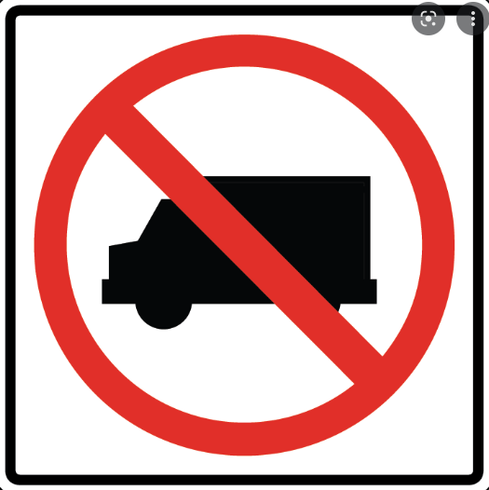
A. Trucks parking only.
B. Don’t drive your truck on this way.
C. Danger! Trucks are on the way.
D. No trucks. Safely enter this way.
16. What does the sign mean?
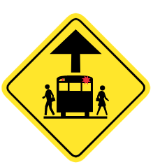
A. Road for children crossing.
B. No pedestrians and vehicles crossing.
C. Be careful! School area ahead.
D. School bus stop ahead.

Use the correct form of the word given in each sentence.
- To her ANNOYANCE, the strangers did not go away. (annoy)
- The headmaster made a clear SPEECH on traffic safety this month. (speak)
- The INJURED passengers were taken to the nearby hospital. (injure)
- Phuong Anh DEMONSTRATED her experiment on the model rockets to the class last week. (demonstrate)
- It’s so expensive for buying a lot of ELECTRIC equipment for that modern apartment. (electrify)
- A.G.Bell SUCCESSFULLY transmitted speech over a long distance in his experiment. (success)
Read the following passage. Decide if the statements from 17 to 20 are True or False, and choose the correct answers (A, B, C or D)
Most people agree that a person’s character is more important than their appearance, but many of us still worried about the way we look. Indeed, most of us have a part of our body would like to change if we could. Why don’t we like our bodies?
Perhaps appearance has never been so important as it is today. We are surrounded by “perfect” people all of the time, in the media and especially in advertising. There is a lot of pressure for everyone to “look good”, not just the supermodels and celebrities. We think that beautiful people have more fun. We also believe they have better careers. It’s true that how you feel about your appearance can have big impact on how you feel about yourself. If you look good, you feel good. But if you dislike your appearance, then you can be self-conscious and unhappy.
23. Many people worry about their appearance. TRUE
24. Some people agree that what’s inside is more important than what’s outside. FALSE
25. Only supermodels and celebrities have the pressure of looking good. FALSE
26. People think that looking good can help them get good jobs. TRUE
27. The word “perfect” in has closer meaning to:
A. necessary B. very great C. creative D. generous
28. The above passage tell us:
A. The importance of looking good. B. People get tired of their body.
C. We need to love our body. D. Personal appearance makes life difficult.
Choose the word (A, B, C or D) that best fits the blank space in the following passage. (1.5 pts)
It’s hard (1) _____________that before 1982 people in the United States hadn’t used cell phones and hadn’t ever sent text messages. In 1983 the first (2) _____________ cell phone company in the USA started in Chicago, even though the technology had existed since 1940s. By 1870 more than one million Americans were cell phone customers. Before that, people outdoors could only make phone calls from public (3) _____________ on the streets. Early cell phones were much larger (4) _____________ today’s models. Most of them were in cars, and they were very big, heavy and (5) _____________ as well. Owners of cell phones at that time had to pay more than a thousand dollars for them.
Nowadays, thanks to microchip technology, cell phones weigh (6) _____________ two ounces (60 grams) and have a talk time up to five hours with a battery life of several days. By 2003 there were 160 million cell phones users in the USA, and today more than 60% of the adult population in the USA own a cell phone.
29. A. to believe B. believe C. believing D. believed
30. A. countless B. commercial C. chemical D. electrical
31 A. telephone directory B. telephone books C. telephone booths D. mobile phones
32 A. then B. that C. those D. than
33 A. expensive B. dangerous C. successful D. distant
34 A. for B. about C. with D. at

- WRITING (3.0pts)
Rearrange the sentences from the cues given. (1.0pt)
35. The students started experimenting with way of flying the model rockets.
36. Why do we have to put all dangerous household objects out of children’s reach?

Finish the second sentences. Keep its meaning similar to the above (2.0pts)
37. Our bags are very big. We can put all our cell phones in them.
→ Our bags are _big enough for us to put all our cell phones in________
38. Grandma intends to travel to Bangkok for the Paris by Night Show.
→ Grandma is __ going to travel to Bangkok for the Paris by Night Show _______
39. No one helps my younger sister with her exercises at school.
→ My younger sister has to do __ her exercises at school by herself ___
40. It is not a good idea to leave a child at home without any adults.
→ I think people oughtn’t ___ to leave a child at home without any adults. ___________

