UNIT 11: Travelling in the future
Lesson 1: Getting started – I hope we will have a hyperloop soon!

I. OBJECTIVES
1. Knowledge
- An overview about the topic TRAVELLING IN THE FUTURE.
- Vocabulary to talk about future means of transport.
2. Core competence
- Develop communication skills and creativity
- Be collaborative and supportive in pair work and team work
- Actively join in class activities
3. Personal qualities
- Develop self-study skills

II. PREPARATIONS
1. Teacher
- Grade 7 textbook, laptop, TV/Projector/ pictures and cards, speakers, lesson plan, sachmem.vn…
2. Students
- Grade 7 textbook, notebooks, studying equipment ….
III. TEACHING PROCEDURES
Notes
In each activity, each step will be represented as following
* Deliver the task
** Implement the task
*** Discuss
 Giving comments or feedback
ACTIVITY 1 – WARM – UP & INTRODUCTION (5’)
a) Aims:
- To set the context for the listening and reading text.
- To introduce the topic of the unit.
b) Contents: Play the game “Chitchatting”
c) Products: Ss’ answers
d) Teaching steps:
Teacher’s and students’ activities | Content
* Teacher has Ss to look at the picture and talk about it by answering these questions.  ** Ss work in pairs to do the task.  *** Teacher calls on some Ss to give their ideas about it.   Teacher listens, comments, then leads Ss to the new lesson.  Questions  Teacher says: “In the lesson today we are going to learn a new unit about “Travelling in the future”. Let’s start to see and find out more information related to our new topic”. | Chitchatting  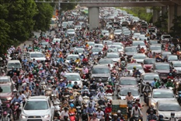  + How do you people travel every day?  + What do you think about the traffic in the picture?  + How about traffic in the future?

ACTIVITY 2 – PRESENTATION (15')
a) Aims:
- To introduce the new words.
- To set the context for the introductory conversation;
b) Contents:
- Teach the vocabularies
- Look at the pictures in the textbook and asks them some questions about the pictures.
c) Products:
- Lists of vocabularies
- Ss’ answers
d) Teaching steps:
Teacher’s and students’ activities | Content
* Teacher introduces the vocabulary by:  + showing the pictures illustrating the words  + providing the synonym or antonym of the words  + providing the definition of the words  ** Ss say the words.  *** Other Ss correct if the previous answers are incorrect.   Teacher shows and says the words aloud and asks Ss to repeat them.  Checking techniques: Rub out and Remember  * Teacher draws students’ attention to the pictures in the textbook and asks them some questions about the pictures. Teacher don’t confirm whether theirs are right or wrong.  + Who are they?  + Where are they?  + Where are they going?  + What can you see outside the coach?  + What can you see in the bubble?  + What could they be talking about?  ** Ss work out and answer questions in pairs.  *** Ss share their answers as a whole class.   T asks them to read and listen to the conversation to check their answers. | Vocabulary:  1. eco – friendly (a): [visual + explanation]  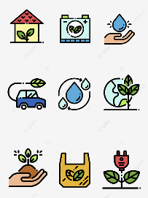  2. fume (n): [visual + explanation]  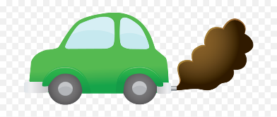  3. hyperloop (n): [visual + explanation]  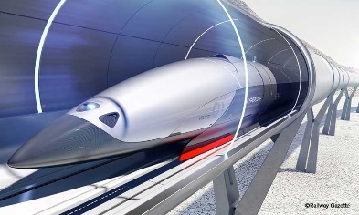  4. teleporter (n): [visual + explanation]  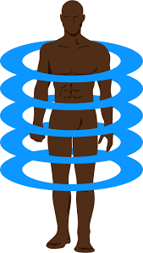  5. campsite (n): [visual + explanation]    Suggested answers:  + They are Minh and Ann.  + They are on a coach.  + They are going to the campsite.  + Outside the coach, we can see the crowded street. There is a traffic jam.  + In the bubble, there is a system of tubes. Minh is thinking about a means of transport.
ACTIVITY 3 – PRACTICE (15’)
a) Aims:
- To practice the targeted language and the background knowledge
- To help Ss read for specific information about Ann and Minh’s conversation.
– To help Ss recognise the words / phrases used to describe means of transport;
– To help Ss further understand the text.
b) Contents:
- Listen and read. What are Ann and Minh talking about?
- Read the conversation again and tick T (True) or F (False)
- Find the words and phrases that describe the means of transport in the conversation and write them in the correct columns.
c) Products:
- Answer key
d) Teaching steps:
Teacher’s and students’ activities | Content
* Teacher plays the recording, asks students to underline the words related to the topic. (Teacher may check the meaning of some words if necessary.)  - Teacher can play the recording more than once.  - Students listen and read.  ** Teacher can invite some pairs of students to read aloud.  *** Teacher refers to the questions previously asked.   Then, teacher confirms the correct answer: “Ann and Minh are talking about future modes of travel.  * Teacher asks Ss to work in pairs to read the conversation again and underline the key words in each sentence.  ** Ss work in pairs to do the task.  *** Ss answer and point out where in the conversation they find the information for their answers.   Teacher checks the answers as a class.  * Teacher asks Ss to work in pairs to read the conversation again and to underline the words / phrases that describe means of transport: hyperloop and teleporter.  ** Ss work in pairs to pick out words / phrases they have found to write down in the correct column.  *** Teacher asks some Ss to read out words / phrases they have found in the conversation to put into each column.   Teacher checks the answers as a class | Task 1. Listen and read. What are Ann and Minh talking about?  (Ex 1, 2, p. 114, 115)  Answer key: 2B  Task 2: Read the conversation again and tick T (True) or F (False). (Ex 3, p. 115)  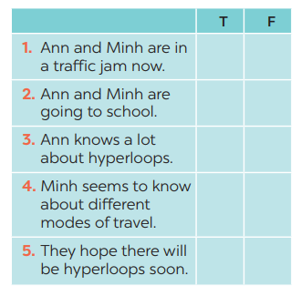  Answer keys:  - T 2. F 3. F 4. T 5. T  Task 3: Find the words and phrases that describe the means of transport in the conversation and write them in the correct columns. (Ex 4, p. 115)  Answer keys:
ACTIVITY 4 – PRODUCTION (15’)
a) Aims:
– To help Ss review vocabulary related to different means of transport;
– To give Ss a chance to develop creative thinking;
b) Contents:
- Do the quiz
c) Products:
- Answer key
d) Teaching steps:
Teacher’s and students’ activities | Content
* Teacher asks Ss to work in pairs to discuss to find out the vehicles in these sentences.  ** Ss work in pairs to do the task  *** Teacher reads out loud each question and the pairs answer. The pair who correctly completes its first wins  * Then, teacher has Ss work in pairs again to discuss how the vehicles they have thought of will be like in 50 years.  ** Ss work in pairs to do the task.  *** Teacher calls SS give any description about future means of transport they can imagine.   Teacher corrects grammar or pronunciation mistakes if needed. | Task 4: Quiz (Ex 5, p. 115)  1. It has two wheels and you pedal it.  2. It has four wheels. It runs on petrol or  electricity, and can carry up to eight  passengers.  3. It carries many passengers and runs  on tracks.  4. It sails on the sea. It needs wind to sail.  5. It travels in space. It can even carry  people to the moon.  Answer keys:  1. bicycle / bike  2. car  3. train  4. sailing boat  5. rocket / spaceship
IV. WRAP-UP & HOMEWORK
- Teacher asks students to talk about what they have learnt in the lesson:
+ Vocabulary of Traveling in the future
+ Reading for specific information and details
+ Scanning
- Do the exercises in the workbook
- Name at least 10 means of transport around the world.
- Prepare the next lesson “Unit 11 – A Closer Look 1”
V. FEEDBACK

……………………….…, ngày………….tháng…………..năm 2023
Duyệt của Tổ chuyên môn

