SPEAKING ASSESSMENT ENGLISH 6
UNIT 1: MY NEW SCHOOL
- Introduction - 0.4 pt (~2 ideas):
Share something about your family, school, house, friends, neighborhood,…
- Topic Speaking (Cue pictures) – 1.0 pt (~4 questions):
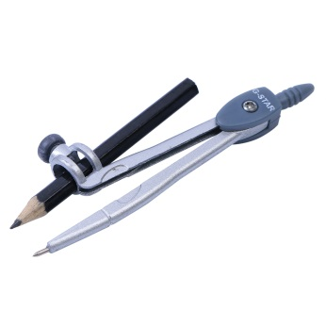  1 | 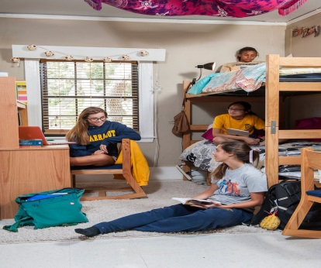  2 |   3
  8 | - - What is this?  - What do you see in the picture?  - - How do you spell it?  - - What are they doing?  - What are they wearing?  - - It’s one of the ways to help you keep fit and stay healthy.  - It’s a thing/ an object that we often use in math class to make a circle.  8  7  - It’s a kind of school that students live and study in. They only go home at weekends.  - It’s a set of clothes that all students wear when they go to school. |   4
  7 |   6 |   5

