

Tiết thứ ....
UNIT 12: ENGLISH-SPEAKING COUNTRIES
Lesson 3: A closer look 2

Class | Date of teaching | Attendence
7A | ..../09/2022
7B | ..../09/2022
7C | ..../09/2022
I. OBJECTIVES: By the end of this unit, students will be able to gain the following things:
1. Knowledge:
- Understand the use of use articles
- Practice using articles correctly
+ Pronunciation: Ask questions with the correct rising and falling intonation.
+ Vocabulary: Use the words related to people and places in English-speaking countries.
+ Grammar: Articles: a/an/the
2. Competence:
a) General competencies:
- Students will be able to know more words and phrases about English speaking countries.
- Be collaborative and supportive in pair work and teamwork
- Actively join in class activities
b) Specific competencies:
- Group work and independent working, pair work, linguistic competence, cooperative learning and communicative competence.
- Sts can introduce themselves or one another fluently.
3. Qualities: The love of country; The awareness about importance of speaking English; Be ready to talk about English speaking countries.
- Develop self-study skills.
II. PREPARATIONS
Teacher: Grade 7 text book, laptop, TV, pictures and realia, Computer connected to the Internet, Sach mem.vn
Students: Text books, pencils, pics, blank papers, realia,….
III. PROCEDURE:
In each activity, each step will be represented as following:
* Task delivering
** Task performance
*** Report and discussion
 Judgement
Activity 1. WARM UP (5’-IW, GW)
* Aim:
- To activate students’ prior knowledge related to the targeted grammar: the past simple.
* Content: Picture describing
* Product: Having a chance to speak English and focus on the topic of the lesson.
* Implementation: Teacher’s instructions…
Teacher’s & Student’s activities | Content
Picture describing  * Teacher asks students to describe the picture.    ** Students look at the picture and describe it.  *** Teacher and students discuss some sentences used to describe the picture:   Teacher corrects students answers if needed and confirms the use of articles “a/an” or “the” | Picture describing  - I see a clock. The clock is The Big Ben Clock Tower.  - I see two buses. The buses are double-decker ones.
Activity 2. KNOWLEDGE FORMATION (15'- PW, IW)
* Aim:
To teach students the use of articles “a/an” or “the”
* Content: Articles “a/an” or “the”
* Product: Ss learn how to use them.
* Implementation: Teacher’s instructions…
Teacher’s & Student’s activities | Content
* Articles: a/an/the  * Teacher lets students watch the following video and asks them to summarise the use of articles “a/an” or “the”:  https://www.youtube.com/watch?v=drTyYqbz6Xk  ** Teacher then asks students to study the grammar box and give some more examples.  *** Teacher and students discuss the examples.   Teacher confirms the answers and gives feedback. | * Articles: a/an/the  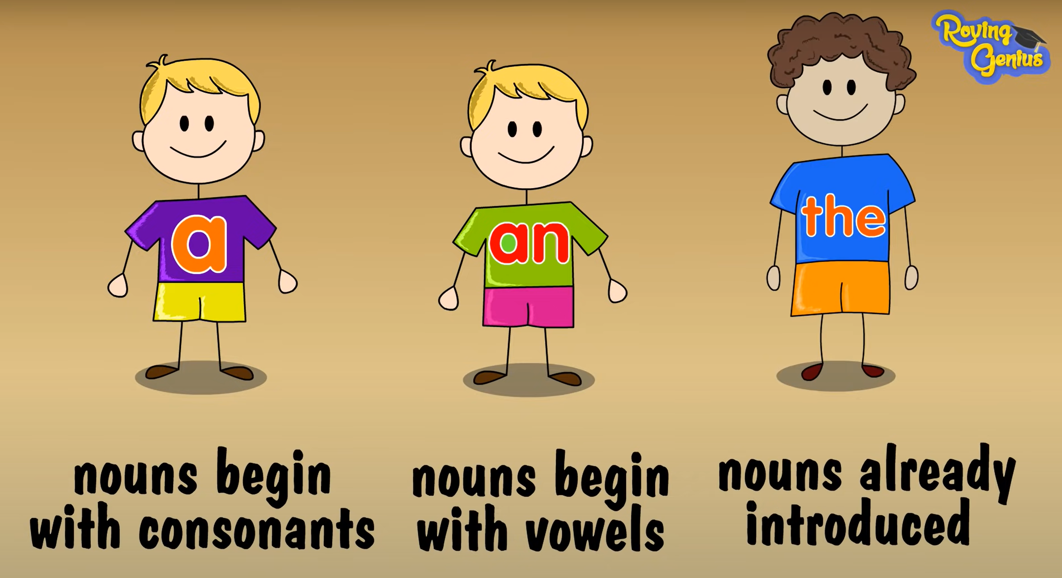
Activity 3. PRACTICE (15’-IW, PW, GW)
* Aim:
To help students revise the uses of articles they have learnt in Grade 6.
To help students practise the uses of the as presented in the Remember! box.
To teach students the use of articles with nationalities.

To give students further practice in articles.
* Product: Students’ answers.
* Implementation:
Teacher’s Student’s activities | Content
Task 1: Complete the sentences with “a / an” or “the” (p. 127)  * Teacher has students work individually.  ** Students work individually to complete sentences with the articles.  *** Teacher lets students work in pairs and exchange the answers before checking with the whole class (explain each sentence if necessary).   Teacher confirms the answers and gives feedback.  Task 2: Put in "the" where necessary. (p. 127)  * Teacher has students work individually.  ** Students work individually to complete the sentences.  *** Teacher lets students work in pairs and exchange the answers before checking with the whole class (explain each sentence if necessary).   Teacher confirms the answers and gives feedback.  Task 3: Put in “a / an” or “the”. (p. 127)  * Teacher allows students some time to read the table first, then do the exercise.  ** Students work in pairs to complete the task.  *** Teacher then has students compare their sentences. Teacher can go around to help students.   Teacher confirms the answers and gives feedback. (Note: The English, the Japanese, the French, but Australians, Canadians, Russians.)  Task 4: Complete the sentences with “a / an”, or “the” (p. 128)  * Teacher has students do this exercise individually.  ** Students complete the exercise individually.  *** Teacher lets students work in pairs and exchange the answers before checking with the whole class (explain each sentence if necessary).   Teacher confirms the answers and gives feedback. | Task 1: Complete the sentences with “a / an” or “the” (p. 127)  Answer key:  1. the  2. an  3. a  4. a  5. the  Task 2: Put in "the" where necessary. (p. 127)  Answer key:  1. The – x  2. x – the  3. the – the  4. the (SGV sai key)  5. the – the  Task 3: Put in “a / an” or “the”. (p. 127)  Answer key:  1. a  2. an  3. an  4. the  5. a  Task 4: Complete the sentences with “a / an”, or “the” (p. 128)  Answer key: (SGV sai key)  1. an  2. The  3. the  4. the  5. an  6. the
Activity 4. APPLICATION (7’-IW, PW, GW)
* Aim:
To provide students with more advanced practice in articles.
* Content: Game – Faster detective.
* Product: Students’ answer.
* Implementation: Teacher’s instructions
Task 5: Game – Faster detective.  * Teacher introduces the rules of the game:  - The class will be divided into 2 teams.  - Each team will have to detect errors in some sentences (if any) then make correction as fast as possible.  - The team with more correct answers will be the winner.  ** Students play the games.  *** Teacher lets the 2 teams discuss and give comments to their answers.   Teacher confirms the corrects answers and gives compliments to the winner. | Task 5: Game – Faster detective.  Answer key:  1. “What do you call a person from England?” – “The Englishman.”  Correct  - Edinburgh is a capital city of Scotland.  the  3. Queenstown is a amazingly beautiful town.  an  4. Are ancient castles an attraction of Scotland?  5. Where can you see a red telephone box?
* Wrap up  - To help Ss memorise the target language and skills that they have learned.  * Homework:  Reactivate the knowledge that students have gained.  - To prepare vocabulary for the next lesson: Communication. | * Wrap up  - Teacher asks students to summarise what they have learnt in the lesson.  - Teacher has them say out loud the articles.  * Homework:  To review the vocabulary in this lesson and prepare for the incoming Project lesson.  - Exercises in the workbook
V. FEEDBACK:
With 7A ……………………………………………………………………………..…
With 7B …………………………...……………………………………..……………
With 7C ………………………………………………………………………….……

