Thời gian làm bài: 40 phút (Không kể thời gian giao đề)
-------------------------
Họ tên thí sinh: .................................................................
Số báo danh: ......................................................................
Mã Đề: 038.
Câu 1. Which of the following statements is true?
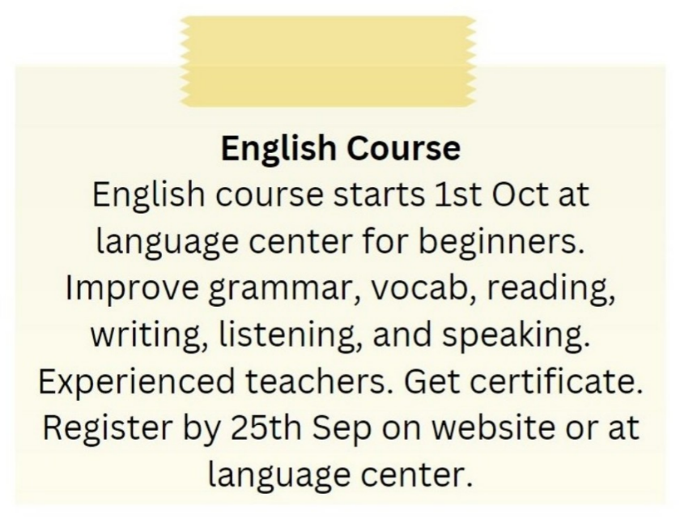
A. The English course does not provide a certificate.
B. The English course starts on 1st September.
C. The English course is taught by experienced teachers.
D. The English course is for advanced learners.
Câu 2. Look at the signs. Choose the best answer for the question.

A. Pedestrians will slow down the traffic.
B. You should drive carefully because of slow pedestrians.
C. You should slow your speed and pay attention to pedestrians.
D. Pedestrians should walk slowly.
Câu 3. Which of the following is NOT mentioned about the apartment?

A. It has a new kitchen B. It has a double bedroom
C. It has been recently painted D. It has a balcony
Câu 4. What alternative does Missie suggest if Tess can't lend her laptop?

A. Going to an internet cafe B. Finding someone else who can lend a laptop
C. Asking Tess to help with her work D. Using a desktop computer
Câu 5. What does Paul request from Alice in his message?
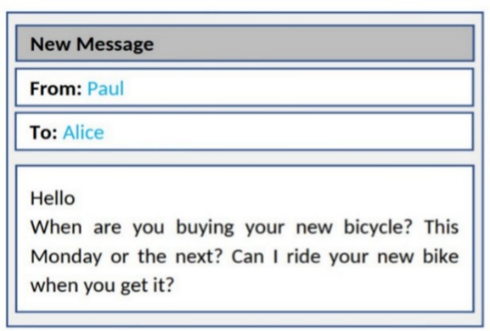
A. To try out her new bicycle when she gets it B. To borrow money for a bicycle
C. To teach him how to ride a bicycle D. To go bicycle shopping together
Câu 6. What does this note mean?
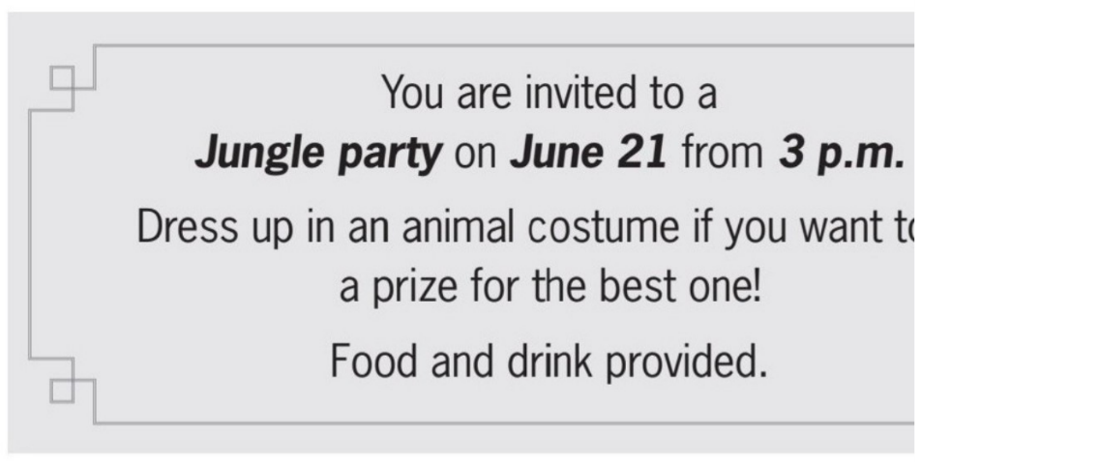
A. Guests might win something if they wear a costume.
B. Guests should bring some food and drink.
C. Guests will have a prize if they bring food and drink.
D. Guests must dress up as a type of animal.
Câu 7. Look at the signs. Choose the best answer for the question.

A. Be careful when driving as the road is slippery. B. Be careful when driving as the road is bumpy.
C. Be careful as the road is narrow ahead. D. Be careful as there is ice on the street.
Câu 8. What are the new students instructed to do?
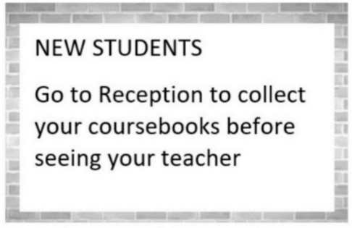
A. Collect their coursebooks from their teacher B. Go to their teacher first
C. See their teacher before going to Reception D. Go to Reception to collect their coursebooks
Câu 9. When is the concert featuring local talent taking place?

A. September 10th B. August 10th C. June 25th D. July 10th
Câu 10. When does the science club meet?
Science Club Notice:
Science club opening soon! Meets Tues/Thurs after school in room 205. First meeting on Sept. 14th at 3:30 pm.
A. Tuesday and Thursday after school B. Saturday morning
C. Sunday afternoon D. Monday and Wednesday after school
----HẾT---

