|  |  |
| --- | --- |
| **QUANG TRUNG LOWER SECONDARY SCHOOL**  **Teacher’s name: DO THI THANH** |  |
| **LESSON PLAN ENGLISH 6**  **UNIT 4: MY NEIGHBOURHOOD**  **Period 29 - Lesson 4: COMMUNICATION** | |

**STAGE I. DESIRED OBJECTIVES**

**I. Objectives:** By the end of this lesson, students can:

**1. Cognition**: Identify the topic and items of the lesson. Practice every-day English: ask for and give directions in a neighborhood.

- Asking for and giving directions.

**2. Competences:**

***\* General competence***: To develop their language skill as well as communication, self-study, team-work.

***\* Special competence***: Listen for specific information about directions to some places in a neighborhood; Talk about different places and give directions to these in a neighborhood.

**3. Attributes/ personal qualities:** Show their love for their neighborhood and living environment; To educate Ss to work hard, the love of their neighborhood.

**B. LANGUAGE FOCUS.**

**\* Key terms/Vocabulary**: square, art gallery, cathedral, temple, railway station, …

**\* Key grammatical structures**: Could you tell me the way to the ……, please? / Where is the nearest …………, please?

**C. INSTRUCTIONAL RESOURCES:**

- Pictures

- Textbook: English 6

- Computer - Projector.

**STAGE II: ASSESSMANT EVIDENCE**

|  |  |  |
| --- | --- | --- |
| **Performance Tasks** | **Performance Products** | **Assessment Tools** |
| 1. Know the traffic signs. And play the small game. | Ss’ answer and activities | T’s observation |
| 2. Listen to the conversation. Pay attention to the structure: Asking for and giving directions. | Ss’ pair-works  Ss’ oral practice | T’s observation  Peer’s correction |
| 3. Work in pairs to make the same conversation. | Ss’ pair-works  Ss’ oral practice | T’s observation  Peer’s correction |
| 3. Listen and fill the blanks with the missing words. | Ss’ individual work and answer | T’s observation  Peer’s correction |
| 4. Create an audio guide for Ninh Binh province. | Groups’ products and oral practices | T’s observation  Peer’s correction |
| 5. Present their audio guide for Ninh Binh province. | Ss’ presentation in front of the class. | T’s observation |

**STAGE III: TEACHING PROCEDURE/LEARNING EXPERIENCES**

**Activity 1. Warm-Up. (3 mins)**

**Step 1:** T shows some traffic signs and asks.

**What are they?**

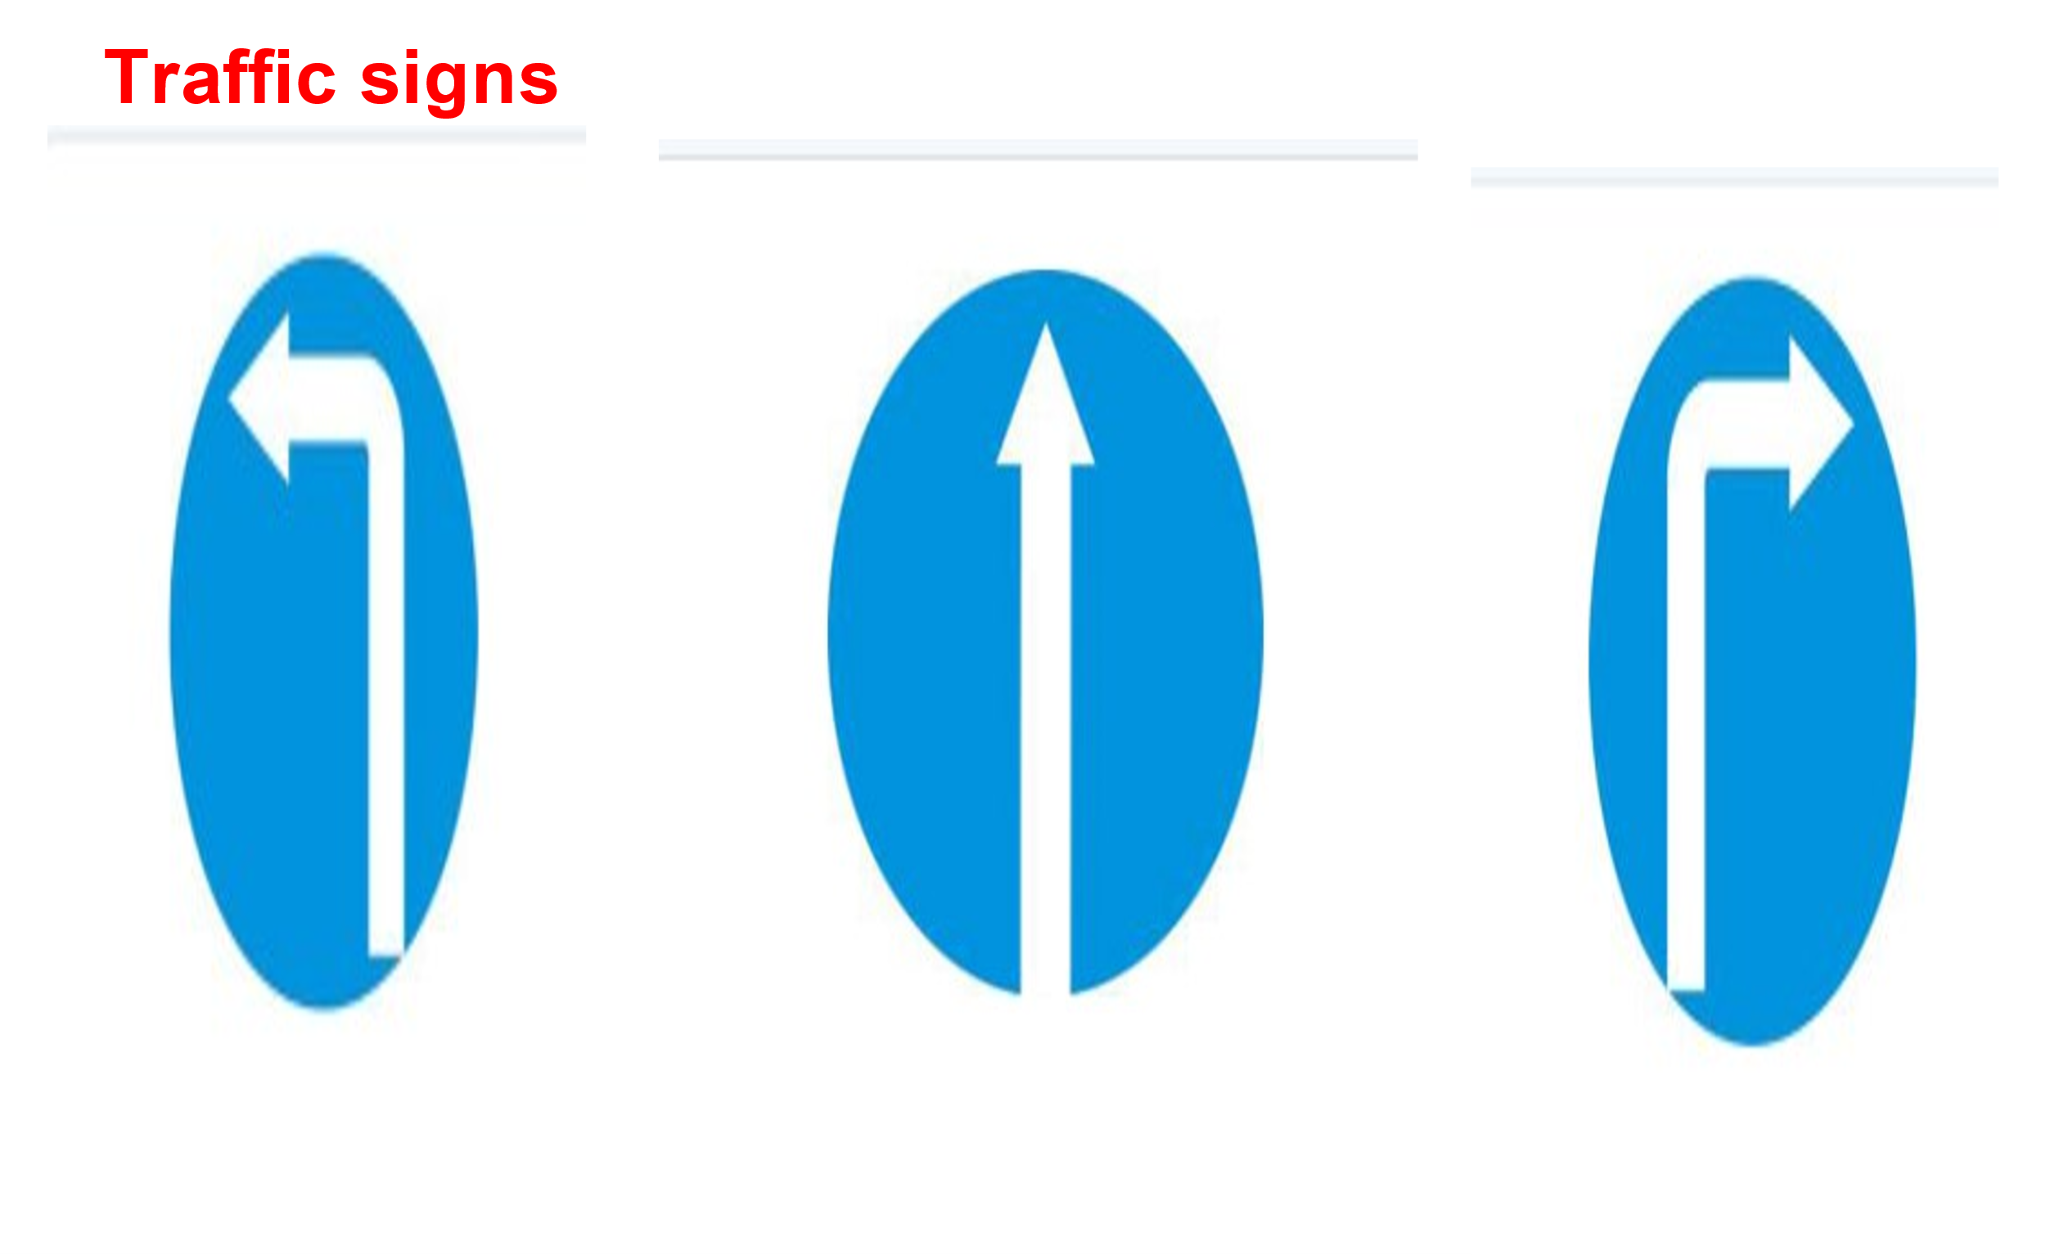

T guide Ss and show the traffic signs in body language.

**Step 2:** Ss answer the questions.

Ss guess the name of the place and explain their guess.

Practice as teacher’s request.

**Step 3:** Ss report the task.

Group 1 show their answer on the board.

**Step 4:** T confirms, gives comments, leads to the content of the lesson.

**Activity 2: Ex1. Listen and read the conversation. (6 mins)**

**Step 1**: T gives the task to Ss: T plays the recording for students to listen and read the dialogue between A and B at the same time.

T elicits the structures for directions.

**Step 2:** Ss do the task. T goes around the class to provide help. Ask students to pay attention to the sentences and phrases used to ask for and give directions.

**Step 3:**T writes the structures on the board.

T elicits the structures for directions.

**Step 4:** T asks Ss to work in pairs and take turns to practice the dialogue.

**Step 5:** Ss do the task in pairs.

**Step 6:** T calls some pairs to practice in front of the class.

**Step 7:** T gives feedback and corrections (if necessary).

T encourages them to talk as much as possible.

**Activity 3: Ex2. Work in pairs. Make similar conversations to ask for and give directions to places near your school. (8 mins)**

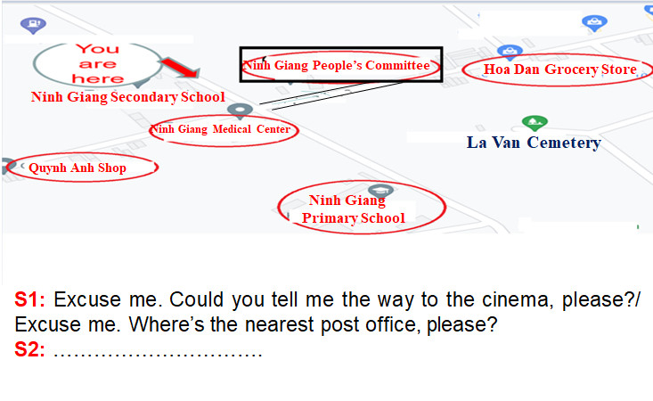

**Step 1:** T asks students to work in pairs to make similar conversations, using the structures and phrases for asking for and giving directions.

T encourages them to practice asking for and giving directions to some places near their school.

**Step 2:** Ss do the task – T moves around to observe and provides help.

**Step 3:** T calls some pairs to practice in front of the class.

Ss practice in front of the class.

**Step 4:** T gives comment and feedback on their performance.

**Activity 4: Nick is listening to an audio guide to Hoi An. Listen and fill the blanks. (5 mins)**

**Step 1:** T ask Ss to recall/ guess the words to fill in the blanks. Play Track 28 again, Ss fill in the gaps (individually) in 2'.

**Step 2:** Ss listen and fill in the gaps (individually). Ss compare the answer with a partner.

**Step 3:** T ask Ss to give their answers. Others give comments.

**Step 4:** T gives comments and key.

***\* Suggested key***:

1. straight

2. second

3. right

4. next to

**Activity 5: Look at the map below and create an audio guide for Ninh Binh province**. **(7 mins)**

**Step 1:** T asks students to look at the simplified map of Ninh Binh province carefully.

Work in groups.

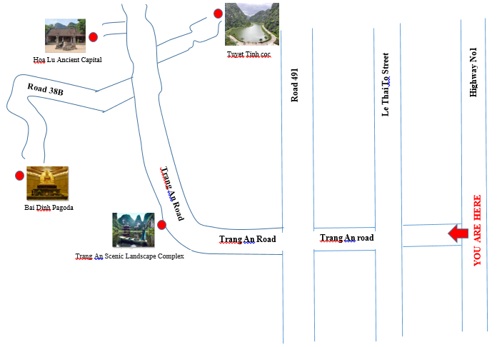

**Let’s start our tour in Ninh Binh province. We are in Highway No1 now.**

**- First, go to (1) …………... To get there, we …………….**

**- Then (2) ………………,**

**- Finally (3) ……..………**

**Step 2:** Ss read the instructions carefully. Ss do the task. T goes around the class to provide help.

**Step 3:** T checks if they know what they are supposed to do. Remind them of the expressions they can use to give directions.

**Step 4:** T gives comments and leads to the next exercise 5.

**Activity 6: Now present your audio guide to your class. (13 mins)**

**Step 1:** T asks each group to look through the guide again and prepare to report in front of the class. Practice presenting the audio in groups.

**Step 2:** Ss do as request. Ss practice presenting their audio guide in groups.

**Step 3:** T calls some Ss to present their audio guides to the whole class.

**Step 4:** T gives comments and corrects mistakes if there are any.

**Activity 7: Wrap-Up - Assignment. (3 mins)**

* **Wrap-Up: (2 mins)**

**-** T asks one student to sum up the content of the lesson.

T: What did we learn from this lesson?

Ss: Asking and giving for directions.

**Assignment. (1 min)**

- Practice how to show the way.

- Prepare the next lesson: **Unit 4** S**kills 1.**

|  |  |
| --- | --- |
|  | *Tam Điệp, ngày 7 tháng 11 năm 2022*  **Người viết kế hoạch bài dạy**  **Đỗ Thị Thanh** |