
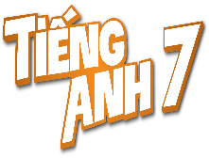
Tiết thứ ......
UNIT 10: ENERGY SOURCES
Lesson 4: Communication

Class | Date of teaching | Attendence
7... | ...../........./202....
7… | ..../......../202...
7…. | ..../......../202....
I. OBJECTIVES: By the end of this unit, students will be able to gain the following things:
1. Knowledge:
- Learn how to deal with some ways of asking for explanations
- Practise using some grammar points and vocabulary related to the topic
+ Vocabulary: - Use the vocabulary to talk about saves energy:
2. Competence:
a) General competencies:
Students will be able to know more words and phrases about energy resources; Develop communication skills and creativity; Actively join in class activities.
b) Specific competencies:
- Develop communication skills.
- Be cooperative and supportive in pair work and teamwork.
- Actively join in class activities.
3. Qualities:
- Be benevolent and responsible
- Be ready to know the words about energy resources.
- Develop self-study skills.
II. PREPARATIONS
- Teacher: Grade 7 text book, laptop, projector / TV/ pictures and cards.....
- Students : Text books, studying equipment….
III. PROCEDURE:
Notes: In each activity, each step will be represented as following:
* Deliver the task.
* Implement the task.
* Discuss.
* Give comments or feedback.
Activity 1. WARM UP (5’-IW, GW)
* Aim:
To introduce the lesson.
BRAINSTORMING
To lead in the lesson.
* Content: Playing a game: BRAINSTORMING
* Product: Having a chance to speak English and focus on the topic of the lesson..
* Implementation: Teacher’s instructions…
Teacher’s & Student’s activities | Content
GAME: BRAINSTORMING  * Teacher divides class into 2 teams and asks them to think of “TYPES OF ENERGY”  ** Ss have 1 min to think of the words related to the topic or they can discuss with their partners.  *** Each member from each team turn by turn run to the board and write one word.   Teacher corrects their answers.  - The team which has more correct words will be the winner  Teacher leads students into the lesson by telling what they are going to learn: “We are going to learn how to ask and answer for explanations and find out how well we save energy”. | 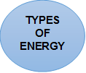  Suggested answers:  Solar, hydro, coal, natural gas, oil, wind,…  TYPES OF ENERGY
Activity 2. KNOWLEDGE FORMATION (15'- PW, IW)
* Aim:
To let students know the structure to ask and answer for explanation..
* Content: Teach some new words.
* Product: Knowing more new words. Understanding the conversation; topic of the lesson, grammar points…
* Implementation: Teacher’s instructions…
Teacher’s & Student’s activities | Content
Task 1: Listen and read the conversation. Pay attention to the highlighted questions.  * Teacher plays the record for SS to listen and read the conversation.  ** Ss listen and practice saying with their partners.  *** Teacher calls some pairs to read aloud.   Teacher corrects pronunciation if needed.  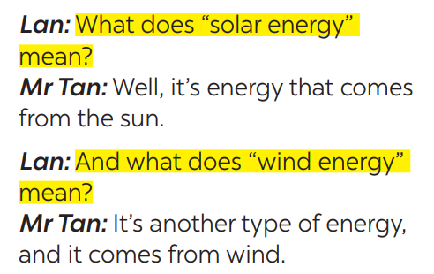  * Teacher asks Ss to pay attention to the highlighted parts and asks them some questions to elicit the new structure:  - Which tense do we use to ask and answer?  - Which question word and verb do we use?  - …..  ** Ss answer teacher’s questions to find out new structure to ask and answer for explanations  *** Some students give the new structure to the teacher.   Teacher corrects and writes on the board: | Task 1: Listen and read the conversation. Pay attention to the highlighted questions.  - Structure:  to ask:  - What do/does + S + mean?  to answer:  - S + mean(s)/be …
Activity 3. PRACTICE (15’-IW, PW, GW)
* Aim:
- To help students practise on how to ask and answer for explanations.
- To provide students with more awareness of ways to save energy and help them practice the skill of speaking
* Product: Ss can learn how to use the comparisons to do the excersises.
* Implementation: Teacher’s instructions…
Teacher’s Student’s activities | Content
Task 2: Work in pairs. Make similar conversations to ask for explanations.  * Teacher has SS look at the phrases in Ex 2 to make similar dialogue.  ** Ss work in pairs to make similar dialogue.  *** Teacher calls some pairs to present it in front of the class.   Teacher gives feedback and some comments.  * SAVING ENERGY | Task 2: Work in pairs. Make similar conversations to ask for explanations.  Suggested answers:  A: What does hydro energy mean?  B: It’s energy that comes from the sun. What does nuclear energy mean?  A: It’s energy that comes from the nuclear power.
Task 3: Work in pairs. Ask your partner the following questions and tick his or her answers in the boxes. 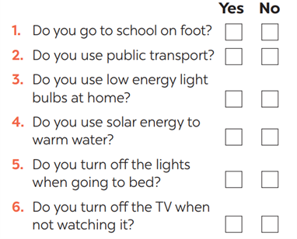 Teacher asks Ss to work in pairs and tick.  ** Ss so the task in pairs | Task 3: Work in pairs. Ask your partner the following questions and tick his or her answers in the boxes.
Task 4: Work in groups. Speech: how well your partner saves energy.  * Teacher gives students time to prepare. Meanwhile, teacher walks around the classroom to help students if they have difficulties find proper words/phrases/structures  *** Teacher calls some Ss to read aloud their work   Teacher let Ss listen and correct mistakes (if needed). | Task 4: Work in groups. Speech: how well your partner saves energy.  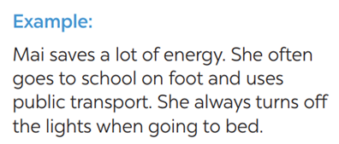
Activity 4. APPLICATION (7’-IW, PW, GW)
* Aim:
- To help students practicing speaking about saving energy
- To consolidate what students have learnt in the lesson.
* Content: present simple
* Product: Ss can remember the words. Revise and learn more new words.
* Implementation: Teacher’s instructions
Task 5: Answer the questions in 3 on your own. Speech: how well you save energy  * Teacher allows students time to answer the questions onto their notebooks and prepare.  ** Ss work individually.  *** Ss can practicing sharing to their partners   Teacher calls some students to read aloud their work. Teacher let Ss listen and correct mistakes (if needed).  Consolidation  Teacher asks students to talk about what they have learnt in the lesson.  * Home assignment  Do exercises in the workbook.  To prepare for the next lesson:  Skills 1. | Task 5: Answer the questions in 3 on your own. Speech: how well you save energy  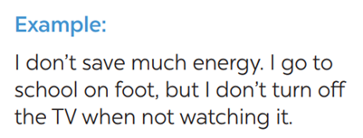  * Home assignment  Do exercises in the workbook.  To prepare for the next lesson:  Skills 1.
V. FEEDBACK:
With 7 ……………………………………………………………………………..…
With 7 …………………………...……………………………………..……………
With 7 ………………………………………………………………………….……

