|  |  |
| --- | --- |
|  | *Thời gian làm bài: 40 phút (Không kể thời gian giao đề)*  *-------------------------* |

**Họ tên thí sinh: .................................................................**

**Số báo danh: ......................................................................**

**Mã Đề: 013.**

**Câu 1.** What time was the theatre originally scheduled to open?

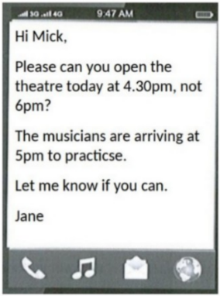

**A.** 6:00pm  **B.** 5:30pm  **C.** 5:00pm  **D.** 4:30pm

**Câu 2.** What subject does John need help with?

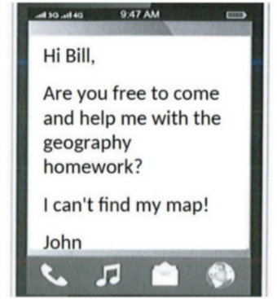

**A.** Math  **B.** Geography  **C.** History  **D.** English

**Câu 3.** **Look at the signs. Choose the best answer for the question.**

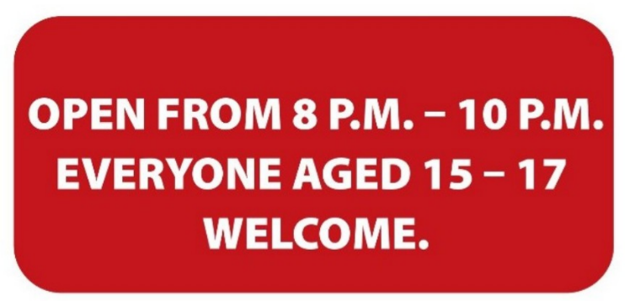

**A.** Teenagers aged 15-17 can visit the venue from 8 p.m. to 10 p.m.

**B.** The venue is open to all teenagers under the age of 17.

**C.** Only teenagers who are over 15 are allowed to enter this place.

**D.** Only 15-17 people can enter the place from 8 p.m. to 10 p.m.

**Câu 4.** Why has Jenna left a note for Marcus?

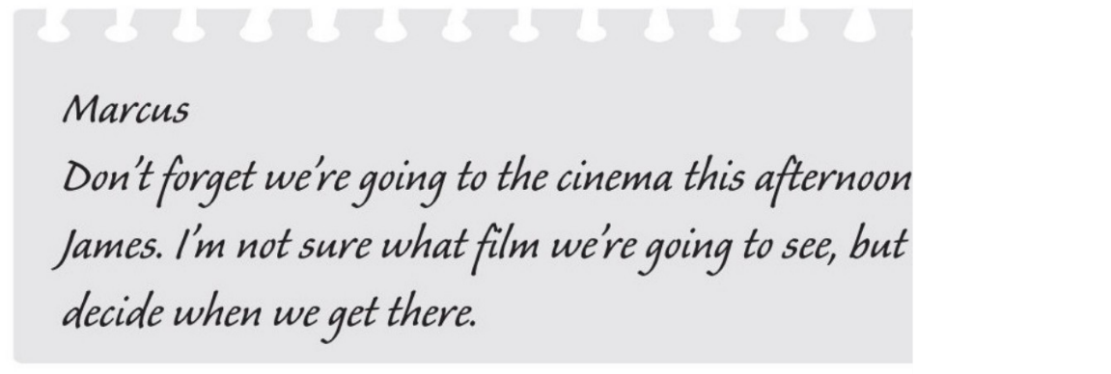

**A.** to remind him about an arrangement  **B.** to invite him to the cinema

**C.** to suggest a film which they could see  **D.** to choose the cinema

**Câu 5.** Which of the following services is NOT offered by the Village Shop?

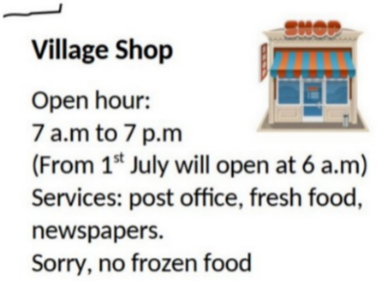

**A.** Post office  **B.** Frozen food  **C.** Fresh food  **D.** Newspapers

**Câu 6.** What is the colour of the bin for composting according to the notice?

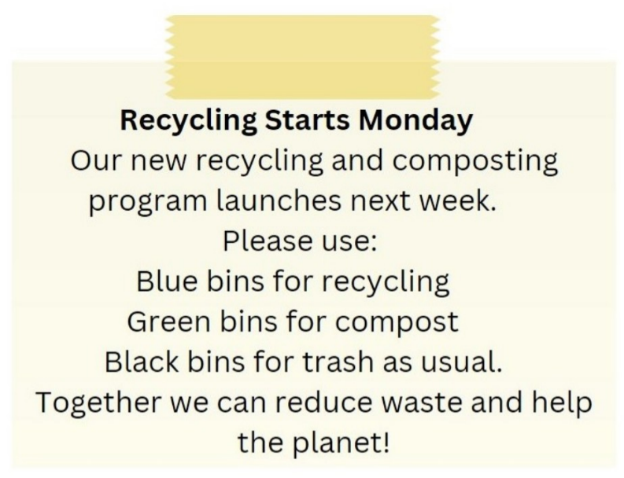

**A.** Black  **B.** Green  **C.** Blue  **D.** Red

**Câu 7.** What is true about this notice?

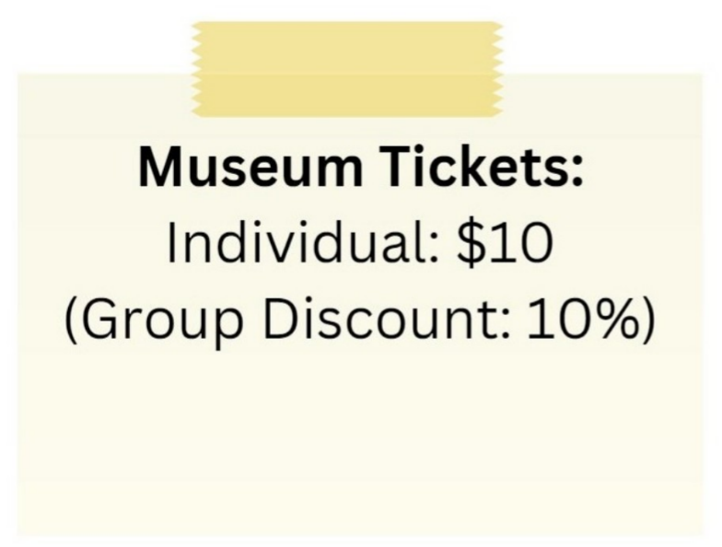

**A.** The group discount is 20%.

**B.** There is no group discount available.

**C.** The individual ticket price is $5.

**D.** The individual ticket price is $10 and there is a 10% group discount.

**Câu 8.** **Look at the signs. Choose the best answer for the question.**

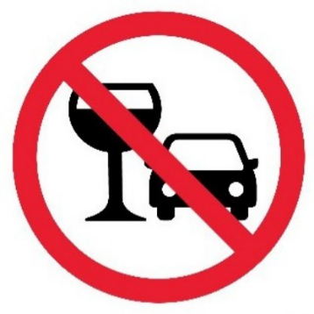

**A.** You mustn’t drink anything while you are driving.

**B.** You should stop driving if you want to drink water.

**C.** You are not allowed to drink alcohol before and while driving.

**D.** You cannot use glasses in the car.

**Câu 9.** **Look at the signs. Choose the best answer for the question.**

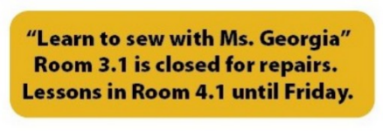

**A.** Ms. Georgia’s class will be on a different day.  **B.** Ms. Georgia will repair her room on Friday.

**C.** There is a new location for Ms. Georgia’s class.  **D.** Ms. Georgia isn’t coming to school until Friday.

**Câu 10.** **Look at the signs. Choose the best answer for the question.**

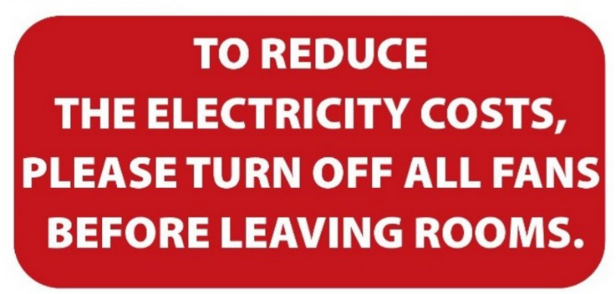

**A.** Please switch off fans when you finish using a room to save electricity.

**B.** Please reduce the costs of electricity by leaving the room.

**C.** When you leave, please reduce the number of fans in your room.

**D.** Please leave the fans in the room after you go out.

**----HẾT---**