

Tiết thứ ......
UNIT 4: MUSIC AND ARTS
Lesson 2: A closer look 1
Class | Date of teaching | Attendence
7A | ..../09/2022
7B | ..../09/2022
7C | ..../09/2022
I. OBJECTIVES: By the end of this unit, students will be able to gain the following things:
1. Knowledge:
+ use the lexical items related to the topic Music and arts;
+ pronunciation: pronounce and recognize the sounds /ʃ/ and /ʒ/.
+ Vocabulary: - Use the vocabulary to talk about Music and arts:
+ Grammar:
2. Competence:
a) General competencies:
Students will be able to know more words and phrases about music and arts; Develop communication skills and creativity; Actively join in class activities.
b) Specific competencies:
- Develop communication skills.
- Be cooperative and supportive in pair work and teamwork.
- Actively join in class activities.
3. Qualities:
- To educate the love of music and art.
- Be ready to know the words about music and arts.
- Develop self-study skills.
II. PREPARATIONS
- Teacher: Grade 7 text book, laptop, projector / TV/ pictures and cards.....
- Students : Text books, studying equipment….
III. PROCEDURE:
Notes: In each activity, each step will be represented as following:
* Deliver the task.
* Implement the task.
* Discuss.
* Give comments or feedback.
Activity 1. WARM UP (5’-IW, GW)
* Aim:
To activate students’ prior knowledge and vocabulary related to the topic, the targeted vocabulary, and its pronunciation.
To lead in the lesson about vocabulary and pronunciation.
* Content:
To have some warm-up activities to create a friendly and relaxed atmosphere to inspire Ss to warm up to the subject and new lesson.
* Product: Having a chance to speak English and focus on the topic of the lesson..
* Implementation:Teacher’s instructions…
Teacher’s & Student’s activities | Content
+ Greeting  + Guessing game: Kinds of music  * Teacher divides students into 2 groups and has them listen to some songs to guess what kinds of music they are.  * Students work in 2 groups, try to listen, and guess.  * The member in each group which has the answer can raise hand. If student has the correct answer, he/ she will get 1 point for his/ her group.  * Teacher confirms the winner.  * Teacher leads students into the lesson by telling them that “ In today lesson, we are going to learn more words to talk about Music and arts and two sounds /ʃ/ and /ʒ/.”  - Ask Ss to guess what they are going to learn about in this unit. Then write Music and Arts and ask Ss to give any words or phrases they know related to these activities.  - Ask Ss to open their book and introduce what they are going to study…. | + Greeting  + Guessing game: Kinds of music  Suggested answers:  1. Classical music:  https://www.youtube.com/watch?v=zHvBPwNUBS8&ab_channel=JervyHou  2. Rock:  https://www.youtube.com/watch?v=AW8AFTBbetI&ab_channel=Infraction-NoCopyrightMusic  3. Jazz:  https://www.youtube.com/watch?v=jUCxIbI9cak&ab_channel=bojunc  5. Pop:  https://www.youtube.com/watch?v=8xg3vE8Ie_E&ab_channel=TaylorSwiftVEVO  6. Country music:  https://www.youtube.com/watch?v=rCIXjYo9qs4&ab_channel=MusicTravelLove
Activity 2. KNOWLEDGE FORMATION (15'- PW, IW)
* Aim:
To introduce visually some words related to the topic.
* Content: Teach some new words. Read the conversation and find out new words.
* Product: Knowing more new words. Understanding the conversation; topic of the lesson, grammar points…
* Implementation: Teacher’s instructions…
Teacher’s & Student’s activities | Content
- 1. Listen and repeat these words and phrases, then write them in the correct columns. (Ex. 1, p. 42)  *Pre- teach vocabulary:  * Teacher introduces the vocabulary by:  + providing the synonyms or antonyms of the words;  + providing the pictures of the words.  - Teacher has students read the phrases aloud and corrects their pronunciation if needed.  - Teacher asks students for the Vietnamese meanings of these phrases.  ** Students say the words.  *** Other students correct if the previous answers are incorrect.   Teacher shows and says the words aloud and asks students to repeat them.  Checking techniques:  “Rub out and remember”  * Teacher asks students to listen and repeat the words independently.  ** Students work individually.  *** Teacher calls on some students to read aloud the words.   Teacher corrects their pronunciation and explains the meaning of these words/ phrases if needed.  * After that, teacher asks students work in pairs to put these words / phrases in the correct box.  ** Students work in pairs.  *** Some students read out their answers.   Teacher confirms the correct answers. | - 1. Listen and repeat these words and phrases, then write them in the correct columns. (Ex. 1, p. 42)  * Vocabulary:    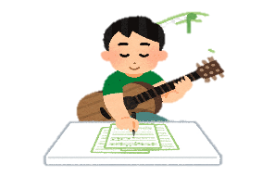      1. concert hall (n): [visual + explanation]  2. actress (n): [visual + explanation]  3. artist (n): [visual + explanation]  4. composer (n): [visual + explanation]  5. puppet (n): [visual + explanation]  6. portrait (n): [visual + explanation]  7. photography (n): [visual + explanation]  8. perform (v): [visual + explanation]  Answer key:  People Places  actress artist composer musician painter art gallery concert hall puppet theatre
Activity 3. PRACTICE (15’-IW, PW, GW)
* Aim:
To teach students how to combine a verb and a noun to talk about music and arts.
To give students practice in how to use words/ phrases related to music and arts in context.
To help students identify how to pronounce the sounds /ʃ/ and /ʒ/.
To help students practise pronouncing these sounds in words.
To help students pronounce the final sounds /ʃ/ and /ʒ/ correctly in context.
* Product: Ss can learn how to use the words and phrases to do the excersises.
* Implementation: Teacher’s instructions…
Teacher’s Student’s activities | Content
2. Match a word in A with a word or phrase in B. (Ex 2, p. 42)  * Teacher asks students to work in pairs to do the task and explains to students that in English some verbs and nouns go together, and some don’t.  ** Students work in pairs to do matching to form collocations.  *** Some students give their answers.   Teacher checks students ‘answers as a class. | 2. Match a word in A with a word or phrase in B.  Answer key:  1. e  2. d  3. a  4. c  5. b
3. Underline the correct word to complete each sentence.  * Teacher has students work individually to read the sentences carefully and look for clues to complete the sentences.  ** Students work individually to do the task.  *** One student writes the words on the board.   Teacher confirms the correct answers. | 3. Underline the correct word to complete each sentence.  Suggested answers:  1. drawing  2. composer  3. museum  4. concert  5. photography
PRONUNCIATION
*Teacher writes on the board two words musician and television. Then, teacher has students focus on the sounds of the two underlined letters “c” and “s”.
** Students practice saying the word individually.
*** Teacher calls some students to read aloud.
 Teacher corrects if needed.

* After that, teacher says “In this lesson we are going to learn how to pronounce two sounds /ʃ/ and /ʒ/”.
**Teacher asks students to watch Tiếng Anh 7 - Pronunciation video, Unit 4
(link youtube)

*** Students imitate and practise the two sounds together.
 Teacher explains if needed.
4. Lissten and repeat. (Ex 4, p. 42)
* Teacher has students read out the words first.
** Students practice saying the words independently.
***Teacher asks students to listen and try to repeat the words as a class, a group, and individually.
 Teacher may play the recording as many times as necessary and correct their pronunciation.

5. Listen and repeat, and single-underline the wprds with the sound  /ʃ/ and double – underline the words with the /Ʒ/. (Ex 5, p. 42)  * Teacher has students read the sentences and tells them to pay attention to the words with sounds /ʃ/ and /ʒ/ to underline.  ** Students read and underline words with the two sounds they have learnt.  *** Teacher plays the recording for students to listen and repeat each sentence. Teacher calls on some students to read the sentences individually.   Teacher corrects their pronunciation if needed. | 5. Listen and repeat, and single-underline the wprds with the sound  /ʃ/ and double – underline the words with the /Ʒ/. (Ex 5, p. 42)  Suggested answers:  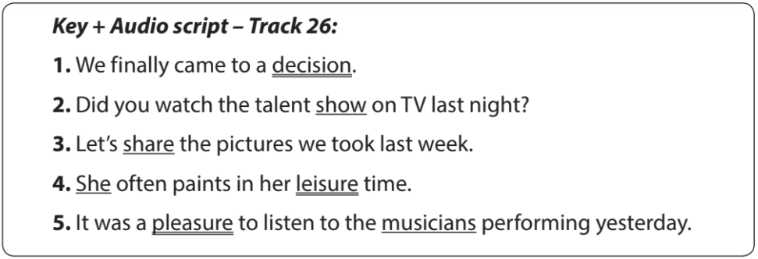
Activity 4. APPLICATION (7’-IW, PW, GW)
* Aim: To give students chances to apply what they have learnt.
* Content: Play a game: Simon says
* Product: Ss can remember the words. Revise and learn more new words.
* Implementation: Teacher’s instructions
GAME: SIMON SAYS  * Teacher prepares some words which include the two sounds students have learnt.  - Teacher gives students the rules of the game:  + If teacher says only one word all students must sit still. The person who stands up will be the loser.  + If teacher says, “Simons says …….” all students must listen carefully to identify which sound mentioned in each word.  /ʃ/: students stand up.  /ʒ/: students sit still.  + At the end of the game: the group which has more students with correct answers will be the winner.  ** Students listen to the rules of the game and can discuss with other members in their groups.  *** Students play in groups.   Teacher informs which group is the winner. | Suggested answers:  condition, ocean, measure, pleasure, shy, vision, sugar, machine, closure, dishwasher, occasion, leisure, rubbish, etc.  * Home assignment  Find 5 more words with the sound /ʃ/ and 5 more words with the sound /ʒ/. Write them down and practice pronouncing the words.
V. FEEDBACK:
With 7A ……………………………………………………………………………..…
With 7B …………………………...……………………………………..……………
With 7C ………………………………………………………………………….……

