|  |  |
| --- | --- |
| **Tiếng Anh 8 Friends Plus** | **FP 8 – REVIEW 2 - TEST 1**  **Test for Unit**  *Thời gian làm bài: 40 phút (Không kể thời gian giao đề)*  *-------------------------* |

**I. Pronunciation (1-4)**

**Câu 1.** Which word has the underlined part pronounced differently from that of the others?

**A.** behind  **B.** adventure  **C.** forest  **D.** valley

**Câu 2.** Which word has the underlined part pronounced differently from that of the others?

**A.** hike  **B.** river  **C.** bike  **D.** diving

**Câu 3.** Which word has a different stress pattern from that of the others?

**A.** alien  **B.** admiration

**C.** foreign  **D.** local

**Câu 4.** Which word has a different stress pattern from that of the others?

**A.** energy  **B.** infrastructure

**C.** ecological  **D.** project

**II. Choose the answer (A, B, C or D) that best fits the space in each question. (5-14)**

**Câu 5.** There are ______ people at the beach today. It’s summer time.

**A.** a little  **B.** few  **C.** enough  **D.** a lot of

**Câu 6.** I have _______ finished my homework.

**A.** yet  **B.** just  **C.** still  **D.** already

**Câu 7.** We haven't met before, _______?

**A.** haven't we  **B.** had we

**C.** have we  **D.** hadn't we

**Câu 8.** The Sahara is the largest hot ______ in the world.

**A.** ocean  **B.** valley  **C.** cave  **D.** desert

**Câu 9.** I have had ______ food to eat, I am not hungry anymore.

**A.** not enough  **B.** few

**C.** many  **D.** enough

**Câu 10.** A ______ is a hill of sand formed by wind, usually along the beach or in a desert.

**A.** valley  **B.** ocean  **C.** dune  **D.** cave

**Câu 11.** Niagara ______ is one of the most famous waterfalls in the world.

**A.** dune  **B.** falls  **C.** ocean  **D.** cave

**Câu 12.** Sarah is coming to the party, _______?

**A.** aren't they  **B.** doesn't she

**C.** does she  **D.** isn't she

**Câu 13.** Have you seen the new movie _______?

**A.** yet  **B.** still  **C.** already  **D.** just

**Câu 14.** How many stars will you give for this restaurant?

**A.** It's a rainy day today.

**B.** I would give this restaurant five stars for its excellent food, service, and ambiance.

**C.** My favourite one is Star Cinema.

**D.** I have three siblings.

**III. Look at the signs. Choose the best answer (A, B, C or D). (15-16)**

**Câu 15.**

Where is the proposed meeting location for the activity?

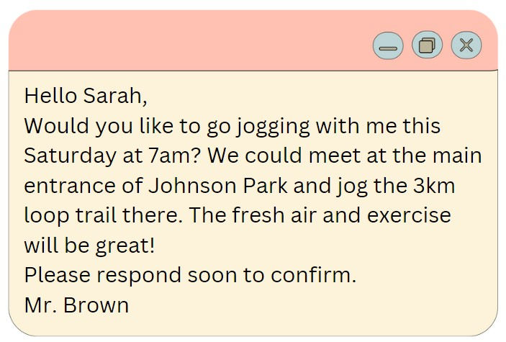

**A.** Hyde Park  **B.** Central Park

**C.** Smith Park  **D.** Johnson Park

**Câu 16.**

What activity is being proposed in the message?

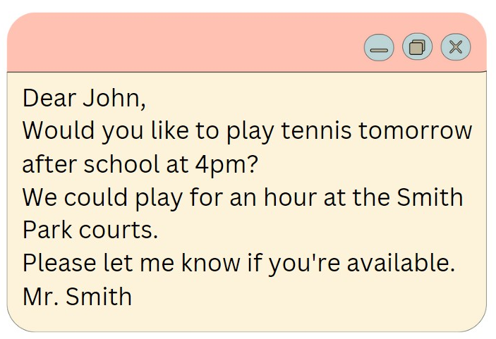

**A.** Playing tennis  **B.** Playing basketball

**C.** Going swimming  **D.** Going for a run

**IV. Read the following passage and do as direct. (17-22)**

Bungee jumping is an exhilarating sport that originated in New Zealand in the 1980s. It involves jumping from a tall structure while attached to a bungee cord. Before participating, it's important to understand the risks and choose a safe and reliable provider.

Before jumping, consider your weight, height, and overall health. You'll be fitted with a harness and bungee cord before ascending the structure. At the top, you'll be signaled to jump.

As you fall, the bungee cord will stretch, giving you a brief sensation of weightlessness. When the cord contracts, you'll be pulled back up to the top.

While bungee jumping can be safe when done properly, there are risks involved, including injury or death. It's important to choose a reliable provider and follow all safety instructions.

Some tips for bungee jumping include choosing a safe provider, being in good physical shape, understanding the risks, and following all directions. Most importantly, have fun!

**Câu 17.** Bungee jumping originated in New Zealand in the 1980s.

**A.** True  **B.** False

**Câu 18.** Bungee jumping does not involve a bungee cord.

**A.** True  **B.** False

**Câu 19.** It is not important to consider your weight, height, and overall health before bungee jumping.

**A.** False  **B.** True

**Câu 20.** Bungee jumping can be safe when done properly with a reliable provider.

**A.** True  **B.** False

**Câu 21.** What should you consider before bungee jumping?

**A.** Your weight  **B.** Your height

**C.** Your overall health  **D.** All of the above

**Câu 22.** What happens when you jump while bungee jumping?

**A.** The bungee cord stretches

**B.** You experience a brief sensation of weightlessness

**C.** The cord contracts and pulls you back up

**D.** All of the above

**V. Choose the word (A, B, C or D) that best fits the blank space in the following passage. (23-28)**

The pervasive use of technology has altered the way teenagers live and interact today. Mobile phones, social media apps and the internet have become an integral **____23___** of their lives. On an **___24____**, teenagers spend around 9 hours a day using some form of technology. While technology has its benefits, excessive usage can negatively **___25____** teenagers' health and development. It can lead to poor sleep patterns as phones are kept close at night causing disruption. Teenagers staying glued to screens have less time for **____26___** activity and family interactions. This **___27___** connectivity also makes them prone to anxiety and mood swings. Social media can make teenagers insecure and get obsessed with projecting the right image. Though developments like online learning have made education accessible, teenagers becoming overly **___28___** on technology at a young age may lack essential life skills to function effectively. Parents need to monitor and guide teenagers to use technology in moderation to avoid its ill effects.

**Câu 23.** Mobile phones, social media apps and the internet have become an integral ___ of their lives.

**A.** bit  **B.** piece  **C.** part  **D.** section

**Câu 24.** On an ____, teenagers spend around 9 hours a day using some form of technology.

**A.** usual  **B.** regular  **C.** average  **D.** normal

**Câu 25.** While technology has its benefits, excessive usage can negatively ____ teenagers' health and development.

**A.** improve  **B.** affect  **C.** touch  **D.** build

**Câu 26.** Teenagers staying glued to screens have less time for ____ activity and family interactions.

**A.** physical  **B.** running  **C.** moving  **D.** playing

**Câu 27.** This ____ connectivity also makes them prone to anxiety and mood swings.

**A.** built-in  **B.** constant  **C.** always-on  **D.** one-time

**Câu 28.** Though developments like online learning have made education accessible, teenagers becoming overly ____ on technology at a young age may lack essential life skills to function effectively.

**A.** using  **B.** wanting  **C.** relying  **D.** needing

**VI. Supply the correct form of the word given in each sentence. (29-34)**

**Câu 29.** My uncle is a __________ of wine in France. (popular)

**Câu 30.** The __________ of the rainforest is a big problem. (destroy)

**Câu 31.** Many __________ prefer to buy organic food. (consume)

**Câu 32.** Many countries are still __________ their economies. (develop)

**Câu 33.** We should avoid __________ food and water. (waste)

**Câu 34.** She is very __________ and loves to try new things. (adventure)

**VII. Rearrange the groups of words in a correct order to make complete sentences. (35-36)**

**Câu 35.** so that / we could / get / married. / We saved / money

…

**Câu 36.** my heavy bag at / woman who / helped me with / the airport. / That’s the

…

**VIII. Rewrite each of the following sentences in another way so that it means almost the same as the sentence printed before it. (37-40)**

**Câu 37.** Do they need to practice more to become better at basketball? (ORDER)

Should they …

**Câu 38.** The population of the world is increasing rapidly. (pace)

The population …

**Câu 39.** Susan started learning Japanese in 2022. (SINCE)

Susan …

**Câu 40.** Tennis is a sport that requires quick reflexes. It is popular in many countries. (Use relative clause)

Tennis, …

**IX. Listening: listen and do as direct. (41-50)**

**Câu 41.** Hardware and software are familiar terms that are used daily on phones and computers.

**A.** True  **B.** False

**Câu 42.** Computer hardware refers to physical components such as monitors, keyboards, microchips, and hard drives.

**A.** False  **B.** True

**Câu 43.** Computer programs and phone apps are hardware that instructs software to perform tasks.

**A.** True  **B.** False

**Câu 44.** Games, photo editors, and browsers are examples of software.

**A.** True  **B.** False

**Câu 45.** Hardware and software are distinct but interdependent.

**A.** False  **B.** True

**Câu 46.** Hardware is the physical device, such as a phone, while software is its operating system and apps.

**A.** False  **B.** True

**Câu 47.** Without software, our phones would function normally because they would have instructions to call, text, or go online.

**A.** False  **B.** True

**Câu 48.** Without hardware, we would have programs but no device to run them on.

**A.** True  **B.** False

**Câu 49.** Software does not require hardware to execute its commands.

**A.** False  **B.** True

**Câu 50.** As technology advances, hardware and software will continue to support it in the future, regardless of its appearance.

**A.** False  **B.** True

**----HẾT---**