

Tiết thứ ......
UNIT 4: MUSIC AND ARTS
Lesson 1: Getting started –
A talk at the school gate
Class | Date of teaching | Attendence
7A | ..../09/2022
7B | ..../09/2022
7C | ..../09/2022
I. OBJECTIVES: By the end of this unit, students will be able to gain the following things:
1. Knowledge:
- To get the topic “ Music and arts ”.
- To practice listening and reading.
- Have an overview about the topic Music and arts.
+ Vocabulary: - Use the vocabulary to talk about Music and arts: concert hall (n), actress (n), artist (n), composer (n), puppet (n), portrait (n), photography , perform
+ Grammar: - Comparisons: like, different from, (not) as … as .
2. Competence:
a) General competencies:
Students will be able to know more words and phrases about music and arts; Develop communication skills and creativity; Actively join in class activities.
b) Specific competencies:
- Students will be able to practice listening and reading the conversation between Trang and Nick. (They are talking about music and arts, what they often do in their free time, and then they agree on what to do next weekend.)
- Develop communication skills.
- Be cooperative and supportive in pair work and teamwork.
- Actively join in class activities.
3. Qualities:
- To educate the love of music and art.
- Be ready to know the words about music and arts.
- Develop self-study skills.
II. PREPARATIONS
- Teacher: Grade 7 text book, laptop, projector / TV/ pictures and cards.....
- Students : Text books, studying equipment….
III. PROCEDURE:
Notes: In each activity, each step will be represented as following:
* Deliver the task.
* Implement the task.
* Discuss.
* Give comments or feedback.
Activity 1. WARM UP (5’-IW, GW)
* Aim:
- To create an active atmosphere in the class before the lesson;
- To lead into the new unit
* Content:
To have some warm-up activities to create a friendly and relaxed atmosphere to inspire Ss to warm up to the subject and new lesson.
* Product: Having a chance to speak English and focus on the topic of the lesson..
* Implementation:Teacher’s instructions…
Teacher’s & Student’s activities | Content
+ Greeting  * Teacher plays a piece of music and lets students listen to.  https://www.youtube.com/watch?v=rotCiRkaE08&ab_channel=Dmusix  ** Students listen to music.  *** After that, teacher asks students some questions about it and calls some students to give their ideas.  **** Teacher comments on their ideas and then leads students to the new topic in Unit 4.  Teacher says: “As you can see, music and arts play an important role in our life. It can help people relax, entertain, or enrich their mind. Therefore, in Unit 4 we are going to learn more about them Music and Arts.”  SET THE SCENE: PRE- QUESTIONS  * Teacher draws students’ attention to the pictures in the textbook and asks them some questions about the pictures. Teacher don’t confirm whether their answers are right or wrong.  1. Who are they?  2. What are they doing?  3. What are you going to learn in this lesson today?  ** Students work out and answer questions in pairs.  *** Students share their answers as a whole class.  **** Teacher asks them to read and listen to the conversation to check their answers. | + Greeting  + Answer:  - Do you like the piece of music you have listened?  - Do you know what kind of music it is?  - When do you listen to music?  - How do you feel when you listen to music?  - Is music important to our life?  Suggested answers:  1. They are Trang and Nick / students.  2. Nick is playing the piano and Trang is drawing.  3. (Students’ answer)
Activity 2. KNOWLEDGE FORMATION (15'- PW, IW)
* Aim:
- To set the context for the introductory conversation;
- To introduce the topic of the unit.
* Content: Teach some new words. Read the conversation and find out new words.
* Product: Knowing more new words. Understanding the conversation; topic of the lesson, grammar points…
* Implementation: Teacher’s instructions…
Teacher’s & Student’s activities | Content
1. Listen and read: (Ex 1, p. 40)  VOCABULARY:  * Teacher introduces the vocabulary by:  + showing the pictures illustrating the words;  + providing the synonym or antonym of the words;  + providing the definition of the words.  ** Students say the words.  *** Other students correct if the previous answers are incorrect.  **** Teacher shows and says the words aloud and asks students to repeat them.  Listen and read. (Ex. 1, p. 40)  * Teacher plays the recording, asks students to underline the words related to the topic Music and arts. (Teacher may check the meaning of some words if necessary.)  - Teacher can play the recording more than once.  - Students listen and read.  ** Teacher can invite some pairs of students to read aloud.  *** Teacher refers to the questions previously asked.  **** Then, teacher confirms the correct answer: “Trang and Nick are going to tell us about their hobbies, especially about music and arts.  * Teacher asks students to answer without reading the conversation again.  ** Ss work out and answer questions in pairs.  *** Teacher asks some students to explain why they did not choose the other two options.  **** Teacher confirms the correct answer. | 1. Listen and read:  * Vocabulary  1. classical (adj): cổ điển  2. spare time (n): thời gian rảnh rỗi  3. musical instruments (n): nhạc cụ  4. landscape (n): cảnh quan  5. art gallery (n): phòng trưng bày nghệ thuật  * Key: C
Activity 3. PRACTICE (15’-IW, PW, GW)
* Aim: To help students understand more the text; to acquaint students with the grammar points and new vocabulary of the unit.
* Product: Ss can learn how to use the words and phrases;
* Implementation: Teacher’s instructions…
Teacher’s Student’s activities | Content
2. Complete the phrases under the pictures with the verbs below.  - Ask Ss to work independently to fill each blank with a word / phrase from the box.  - T may instruct them how to do the exercise: (1) read the sentences and identify the kind of information needed to fill the blanks, (2) read the conversation again and locate the place to find the words / phrases to fill the blanks.  - Allow Ss to share answers before discussing as a class.  - Write the correct answers on the board.  - If there's time, call on some Ss to read the sentences.  - Check the answers as a class. | 2. Complete the phrases under the pictures with the verbs below.  Key:  1. art gallery  2. photos  3. different from  4. like  5. musical instruments
3. Write the correct word or phrase under each picture. Then listen and repeat.  - Ask Ss to work in pairs or in groups to do the task. Tell them that some words / phrases appear in the text and some do not.  - Play the recording for Ss to check and repeat. - Check and correct their pronunciation.  - Give them the meaning of the words / phrases if necessary.  - Check the answers as a class. | 3. Write the correct word or phrase under each picture. Then listen and repeat.  - T_ Ss. Work in pairs  - Ss do it.  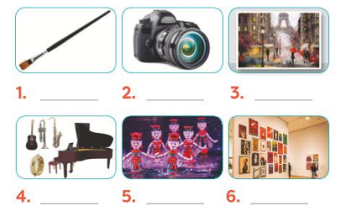  * Key:  1. paintbrush 2. Camera  3. painting 4. musical instruments  5. water puppet show 6. art gallery
Activity 4. APPLICATION (7’-IW, PW, GW)
* Aim: To help Ss revise some vocabulary related to the field of music and arts and to evaluate how artistic they are.
* Content: Doing the Quiz
* Product: Ss can remember the words. Revise and learn more new words.
* Implementation: Teacher’s instructions
4. QUIZ : How artistic are you?  * Teacher asks students to work individually to answer all the questions and add up their points.  ** Students work individually to do the task.  *** Students report to their groups how artistic they are. Then, teacher calls on some students to report to the whole class.  **** Teacher gives some comments.  * Home assignment  - Read again the conversation on page 40  - Do more exercises in workbook.  - Prepare new lesson: Lesson 2: A CLOSER LOOK _1 | 4. QUIZ : How artistic are you?  Example:  A: I think I'm very artistic. I have 4 As out of 5.  B: I'm not artistic at all. I've got only 1 A and 4 Bs.  (If a student's answer is 4 or 5 As, he / she is very artistic, if his / her answer is 3 As, he / she is somewhat artistic, if his / her answer is 0 / 1 / 2 As, he / she is not artistic (at all).)  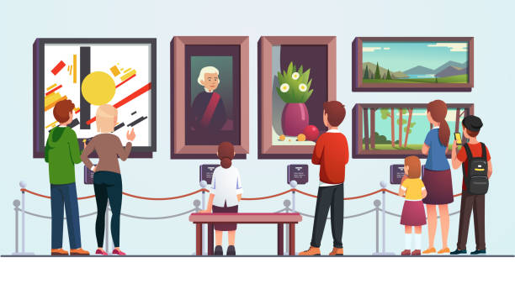  * Home assignment  - Read again the conversation on page 40  - Do more exercises in workbook.  - Prepare new lesson: Lesson 2: A CLOSER LOOK _1
V. FEEDBACK:
With 7A ……………………………………………………………………………..…
With 7B …………………………...……………………………………..……………
With 7C ………………………………………………………………………….……

