School: …………………………………………………..  Class: ……………………………………………………..  Full name: ………………………………………………. | Mark:

SPEAKING TEST 6 (SEMESTER 2)
(UNITS 11 & 12)

TASK 1 |  |  | Let’s talk about our solar system.  The following questions may help you.
 | 1. | How many planets are there in our solar system?
 | 2. | What is the order of the planets from the sun?
 | 3. | What planet is called the Red planet?
 | 4. | What planet is the smallest/ biggest in our solar system?
 | 5. | What planet is the hottest/ coldest in our solar system?

TASK 2 | Work in pairs. Each of you receives a card. Use the clues on your card to make questions about your friend’s picture. Use the picture on your card to answer your friend’s questions.

CARD A
Ask your friends about his/ her picture. Listen to his/ her answers. |  | 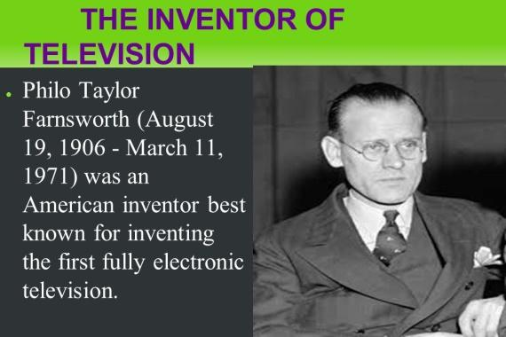
1. | What/ the name/ the inventor?
2. | What/ his/ nationality?
3. | When/ he/ born?
4. | What/ he/ invent?
5. | How/ important/ the invention/ nowadays?
 |  | Answer your friend’s questions about this picture.

CARD B
Ask your friends about his/ her picture. Listen to his/ her answers. |  | 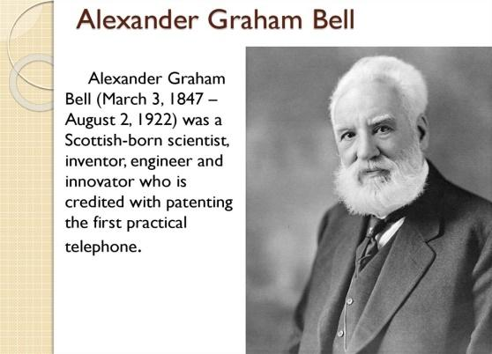
1. | What/ the name/ the inventor?
2. | What/ his/ nationality?
3. | When/ he/ born?
4. | What/ he/ invent?
5. | How/ important/ the invention/ nowadays?
 |  | Answer your friend’s questions about this picture.

