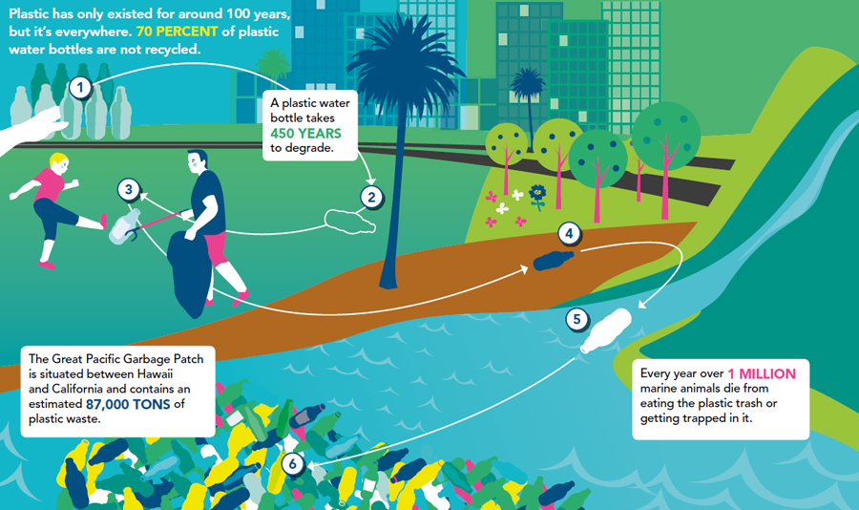**Exercise 1: Read the infographic above. Which statistic is most shocking?**

**Exercise 2: Match stages of the bottle's journey A–F with places 1–6 on the infographic. Then listen again and check.**

1. It remains on the loose and blows across open countryside through orchards, meadows and ploughed fields avoiding farmers and ditches if it can.
2. Somebody drinks the liquid and throws the bottle away – it is released into the wild and it begins its migration, avoiding eco-warriors who could lead to their extinction.
3. Eventually it reaches the open sea and joins the thriving population of plastic waste in the Pacific Ocean.
4. A plastics factory is the breeding ground for our plastic bottle. It hatches here and then moves to its natural habitat, the supermarket.
5. In built-up areas nowhere is safe – not even parks. Children want to kick it and park wardens want to catch it and put it in captivity.
6. It drops into a stream which takes it out of the foothills and onto the plain.

**Exercise 3: Discuss how much plastic you and your family throw away in a typical week and how you could cut down on plastic waste.**

**ANSWER KEY**

Exercise 1: Answers vary.

Exercise 2:

A-4 B-2 C-6 D-1

E-3 F-5

Exercise 3: Answers vary.

TRACK

A plastics factory is the breeding ground for the familiar species, the plastic bottle.

It hatches here in safety before being filled with water and going out into the big wide world.

We first encounter our plastic bottle in its natural habitat, the supermarket.

Once the water has been consumed, the bottle is discarded and released into the wild.

It encounters many predators on its journey to its final destination, a garbage patch the size of Texas in the heart of the Pacific Ocean.

As the bottle fights its way through the city, the ecowarrior is one of its most dangerous enemies and may one day be responsible for its extinction.

Ecowarriors reject single-use plastics, claiming that plastic contamination is doing irreparable damage to the environment.

After a narrow escape our plastic bottle continues to make its way through the leafy neighbourhoods of the city.

You'd think our plastic bottle would be safe in the local park but no – the litter-collecting park warden hunts the bottle and tries to catch it with his weapon.

Our plastic bottle knows that the park warden will not stop until it's in captivity.

Another dangerous enemy often encountered in the park is the child.

They love to play with their prey, kicking it around the playground.

But our brave bottle is still on the loose, continuing its miraculous migration through built-up areas, down city streets and out into the orchards and meadows of the open countryside.

The farmer is the next threat to the survival of our plastic bottle.

Many of the species end up attached to a pole to scare off birds that come and eat the seeds on a freshly ploughed field, or stuck forever in a ditch.

But not our bottle – it continues its journey.

In areas of natural beauty, the plastic bottle feels unwelcome.

Fortunately, a gust of wind picks it up and drops it in a stream where the bottle floats on the surface.

The stream flows out of the foothills and into the plain where it becomes a river.

The river currents move it ever closer to the open sea where it will be reunited with millions of its own species who have, like our bottle, been set free to roam the Californian landscape.

The sea is close now – it can feel it.

The bottle will now continue its journey across the ocean to the Great Pacific Garbage Patch which has a thriving population of millions of tons of plastic waste.

Our bottle will never disappear completely because it isn't biodegradable but will live alongside other plastic waste before breaking into tiny pieces, entering marine life's food chain and completing the cycle of life.