Period…………
LESSON PLAN
TIẾNG ANH 10 FRIENDS GLOBAL

UNIT 4: OUR PLANET
LESSON 4G: SPEAKING- PHOTO COMPARISON

I. OBJECTIVES:
By the end of the lesson, students will be able to compare and contrast photos.
1. Knowledge:
- Vocabulary: Street vocabulary
- Exam topic: Doing a photo comparison task
- Listening: Two candidates in a speaking exam
- Speaking: Comparing and contrasting photos
2. Ability:
- Main skills: Speaking and Listening skills
- Sub skills: Reading and Writing skills
** They can also use ‘must be’ and ‘can’t be’ to speculate about photos and express my opinion about a photo.
3. Quality:
- Have a positive attitude in English language learning so that they can participate enthusiastically in all classroom activities, especially with the topic conducted by the teacher.
- Know how to make comparisons precisely.

II. TEACHER AIDS AND LEARNING MATERIALS:
Lesson plan, PPT slides, student’s book, workbook, notebook, personal computer (if any), projector/TV, speakers, IWB software.

III. PROCEDURES:
A. Warm up (3’)
a) Objective: Introduce the new lesson and set the scene for students to acquire a new language; get students' attention at the beginning of the class by utilizing enjoyable as well as engaging them in the steps that followed.
b) Content: Have a small conversation about Ss opinions.
c) Outcomes: Students can gain more confidence and interest in the lesson.
d) Competence: communication.
e) Organization of the activity:

TEACHER’S ACTIVITIES | STUDENT’S ACTIVITIES | CONTENTS
LEAD-IN. (T- Ss/ S – S/ Indiv)  - Introduces the lesson with warm-up questions.  - Asks: “Where do you like to go with friends to have fun? Do you prefer being inside or outside? Why?”  - Elicits answers.  - Leads-in to Section 1. | - Pay attention to the screen while listening to the teacher.  - Volunteer to answer the questions freely in a complete structure and give reasons.  - Listen to the teacher’s comments  - Open Student’s Book. | 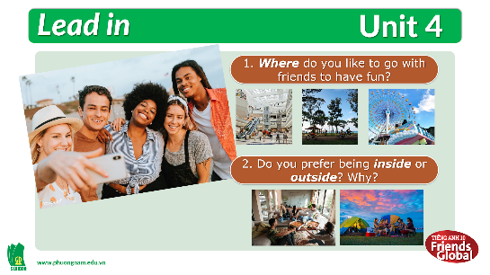

B. New Lesson (37’)
- Activity 1: DISCUSSION (2’)
a) Objective: Students describe the photos and get to know their contents/events.
b) Content: Matching photos with their events.
c) Outcomes: Students can identify the events in reality.
d) Competence: communication, critical thinking.
e) Organization of the activity:

TEACHER’S ACTIVITIES | STUDENT’S ACTIVITIES | CONTENTS
DISCUSSION (T-Ss/ S-S)  - Focuses attention on the photos and asks students to answer the question.  - Asks Ss to match the pictures with the right words.  - Checks answers as a class. | - Pay attention to the photo and answer the question.  - Matching the events with the pictures.  - Volunteer to correct the task. | 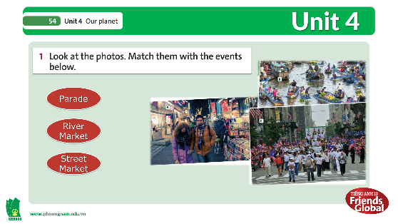  **Answer keys:  - street market  - river market  - parade

- Activity 2: VOCABULARY (5’)
a) Objective: Students gain new words.
b) Content:
- Vocabulary: pedestrian crossing, road sign, shop sign, traffic light, pavement.
- Section 2: Students look for the things in photo C.
c) Outcomes: Students know how to pronounce the new words precisely and use them appropriately.
d) Competence: communication, drilling
e) Organization of the activity:

TEACHER’S ACTIVITIES | STUDENT’S ACTIVITIES | CONTENTS
PRESENTATION. (3’)  (T-Ss/ S-S/ Individual)  - Teaches new vocabulary.  - Uses pictures and explanations to present new words.  - Has the students practiced their pronunciation drills.  PRACTICE (2’): Section 2.  - Go through the words in the box together and recheck their meaning and pronunciation.  - Asks students to look for the things in photo C.  - Check answers as a class. | - Pay attention to the slide and listen to the teacher.  - Look, listen and repeat in chorus and individuals.  - Write new words into notebook.  - Read through all the words in the box and their meaning again.  - Try to look for the things in photo C.  - Correct answer with class. | 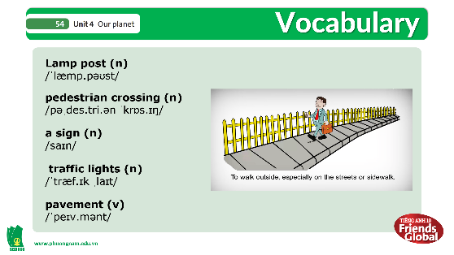  **New words:  pedestrian crossing, road sign, shop sign, traffic light, pavement.  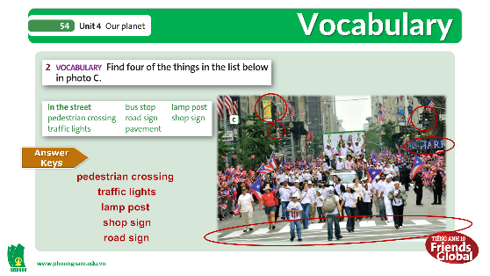  **Answer keys:  pedestrian crossing, road sign, shop sign, traffic light.

- Activity 3: LISTENING (8’)
a) Objective: Students can answer the questions to critical thinking, and they can finish the tasks in the textbook. Critical thing skills (guessing/ reasoning) and communication can also be practiced.
b) Content: Section 3 and 4.
c) Outcomes: Students can listen for general ideas to distinguish the contents of the photos.
d) Competence: communication, critical thinking.
e) Organization of the activity:

TEACHER’S ACTIVITIES | STUDENT’S ACTIVITIES | CONTENTS
PRACTICE. (T- Ss/ Individual)  - Activity 3 (5’): Speaking strategy and Comparison  - Explains to students that when they compare two or more photos, they cannot always be sure what is happening, so they have to speculate.  - Goes through the strategy together.  - Tells students they are going to listen to two candidates in an exam comparing two photos.  - Plays the recording for students to answer the questions.  - Tells students that the candidates might not be comparing the same photos.  - Check answers as a class.  - Activity 4 (3’): Learn this box! and complete sentences.  - Students listen to the first candidate again and complete the deductions.  - Mentions Ss to highlight keywords in the sentences to catch up with the necessary information while listening.  *With a weaker class, stop the recording after each question is answered.  - Check answers as a class. | - Pay attention and listen carefully when teacher elicits the ideas and meaning in the Strategy box.  - Read the Speaking Strategy individually.  - Listen to the teacher’s instructions.  - Start listening to the recording in silence.  - Notice the reminder and answer the questions.  - Correct answer with teacher.  - Listen to the recording of the first candidate again.  - Complete the deductions.  - Highlight the keywords in the sentences and keep them in mind.  - Correct answers with teacher. | 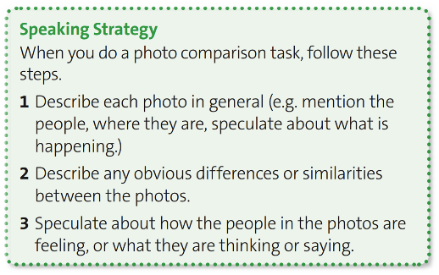  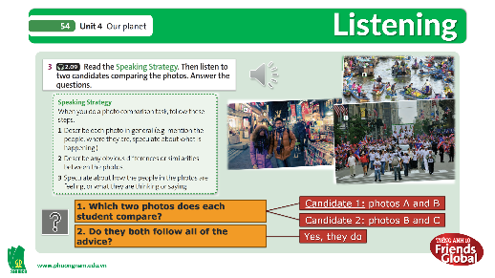  **Answer keys:  - Candidate 1: Photo A&B  Candidate 2: Photo B&C  2. Yes, they do.  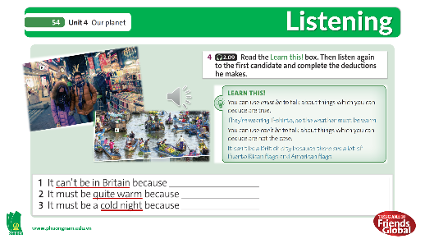  **Answer keys:  - It can’t be in Britain because some of the shop signs aren’t in English.  - It must be a rainy day because they are wearing raincoats.  - It must be a cold night because the people are wearing winter coats and scarves.

- Activity 4: GRAMMAR (12’)
a) Objective: To sum up all the important information contained in the Reading text with a competitive game.
b) Content: Key phrases – Section 5, 6 and 7.
c) Outcomes: Students can gain more confidence and remember the main ideas in the reading text.
d) Competence: communication, collaboration.
e) Organization of the activity:

TEACHER’S ACTIVITIES | STUDENT’S ACTIVITIES | CONTENTS
- PRESENTATION.  (T- Ss/ S-S/ Individual)  - Activity 5 (4’): Key Phrases  - Explain the Compare (Similarities) and Contrast (Differences) in Essay.  - Has the Ss read the key phrases together and check their meaning and pronunciation.  - Asks Ss to notice the Signal Words and be able to apply them in writing Essay.  - Practice:  - Asks Ss to have a look through the information in the given Topic and Examples below.  - Ss based on the previous definition to make their sentences from the given topic.  - Listens to Ss’ answers and corrects them.  - PRACTICE.  (T-S/S-S/Individual)  - Activity 6 (5’): Listening.  - Asks students to listen to the second candidate and say which phrases from exercise 5 she uses.  - Checks the answers as a class.  - Activity 7 (3’): Speaking Strategy.  - Asks students to work in pairs to contrast photos A and C.  - Reminds them to use the key phrases in exercise 5 and the information in the speaking strategy.  - Monitors and helps where necessary.  - Has the students performed their photo comparisons for the class. | - Pay attention to the slides and listen to teacher carefully.  - Read in silence then volunteer to read aloud.  - Note down the Signal Words in their notebook.  - Read through the information in the given Topic and Examples below.  - Make their sentences and write in their notebook.  - Ss volunteer to read their sentences.  - Ss listen to the recording of the second candidate again and select which phrases did she use.  - Correct the answers with teacher.  - Choose a partner and work in pairs.  - Review the Key Phrases and the Speaking Strategy.  - May ask for the teacher’s help if needed.  - Perform the task in pairs.  - Correct answers with teacher. | 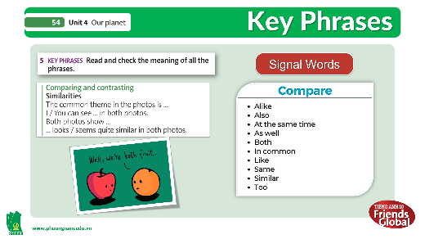  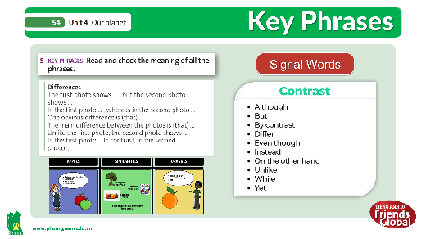  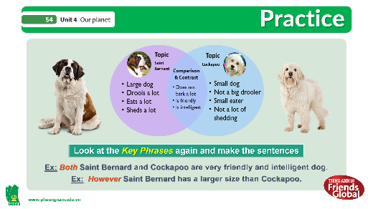  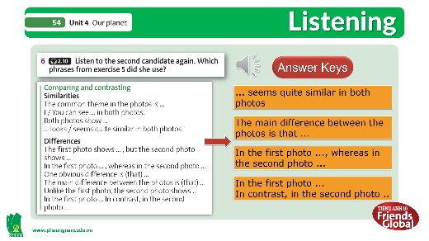  **Answer keys:  - ... seems quite similar in both photos  - in the first photo ..., whereas in the second photo ...  - The main difference between the photos is that ...  - in the first photo ... In contrast, in the second photo ...  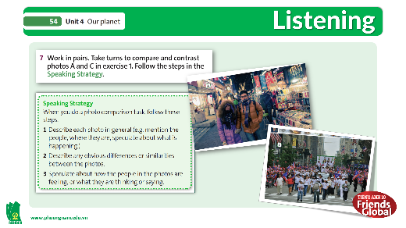

- Activity 5: OUTCOMES (10’)
a) Objective: Students start to make short essay about comparing and contrasting.
b) Content: Writing, Speaking.
c) Outcomes: Students can apply what they have learned about comparing and contrasting to writing skills.
d) Competence: communication, collaboration, presentation.
e) Organization of the activity:

TEACHER’S ACTIVITIES | STUDENT’S ACTIVITIES | CONTENTS
PRODUCT. (S – S/ T- S)  - First, let the Ss have a look through the Example of Lion and Tiger, and the Key Phrases.  - Turns on the next slide of the Sample Answer for Ss to read through.  - Divides class into 4 groups.  - Has the Ss to look at the Practice A-B-C-D slide and read through the rules.  - Explains to Ss if they still don’t understand.  - Invites each group to choose 1 letter which leads to a topic and start making a comparing and contrasting essay about 2 pictures included in the slide.  - Picks randomly some Ss from each group to perform their work in front of the class.  - Elicit and gives comments to the class. | - Ss look at the pictures of Lion and Tiger then use the given Key phrases to come up with some ideas to compare and contrast them.  - Read the Sample Answer to understand the structure and apply it to the activity which they’re going to do.  - Check what group are they in.  - Read the rules on the slide.  - May ask teacher to have a clearer understanding if needs.  - Discuss with teammates to choose 1 letter and start making their essay based on the topic they chose.  - Volunteer or Recommend some Ss from each team to come front and present their work.  - Listen to the teacher’s corrections. | 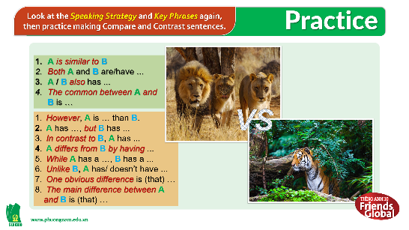  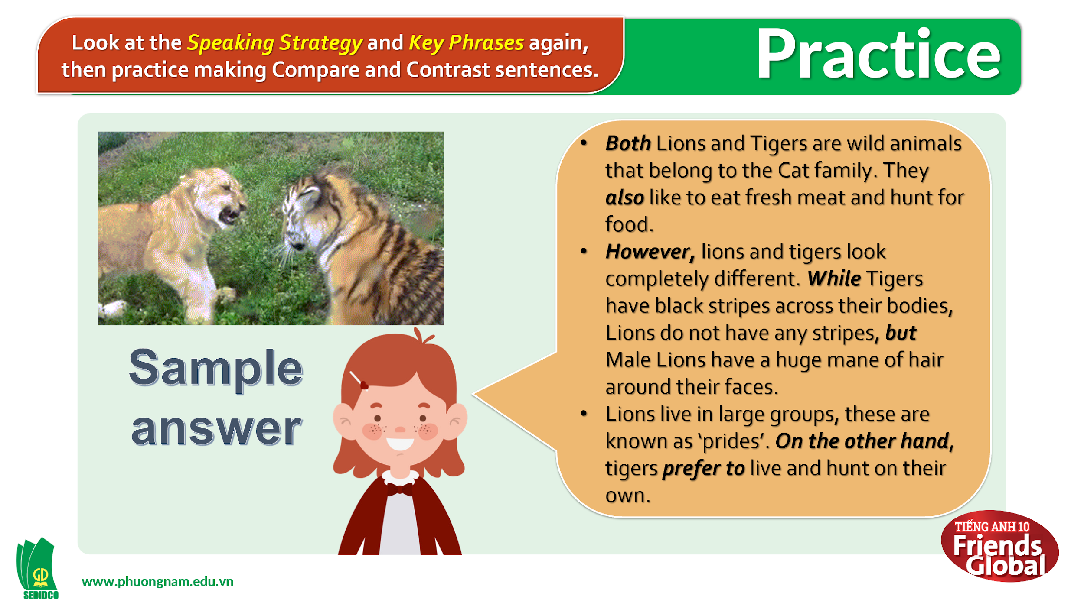  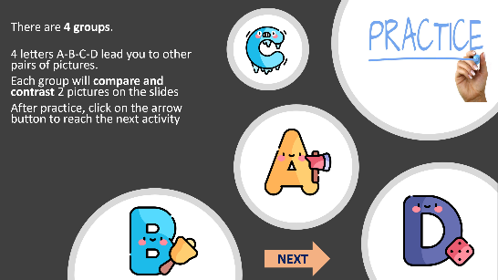  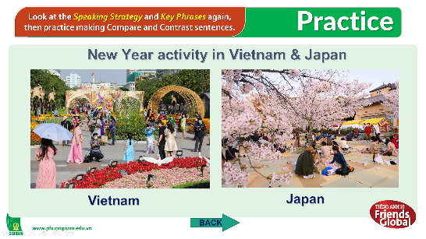  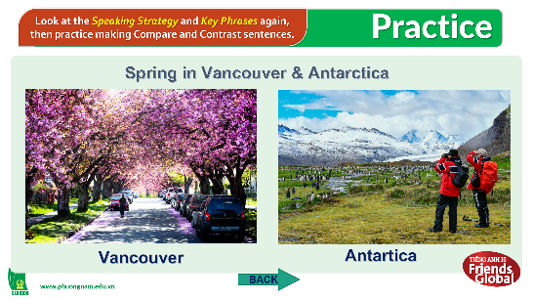  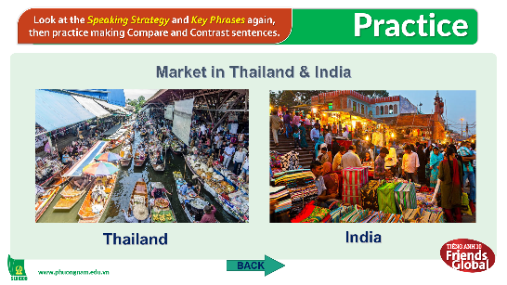  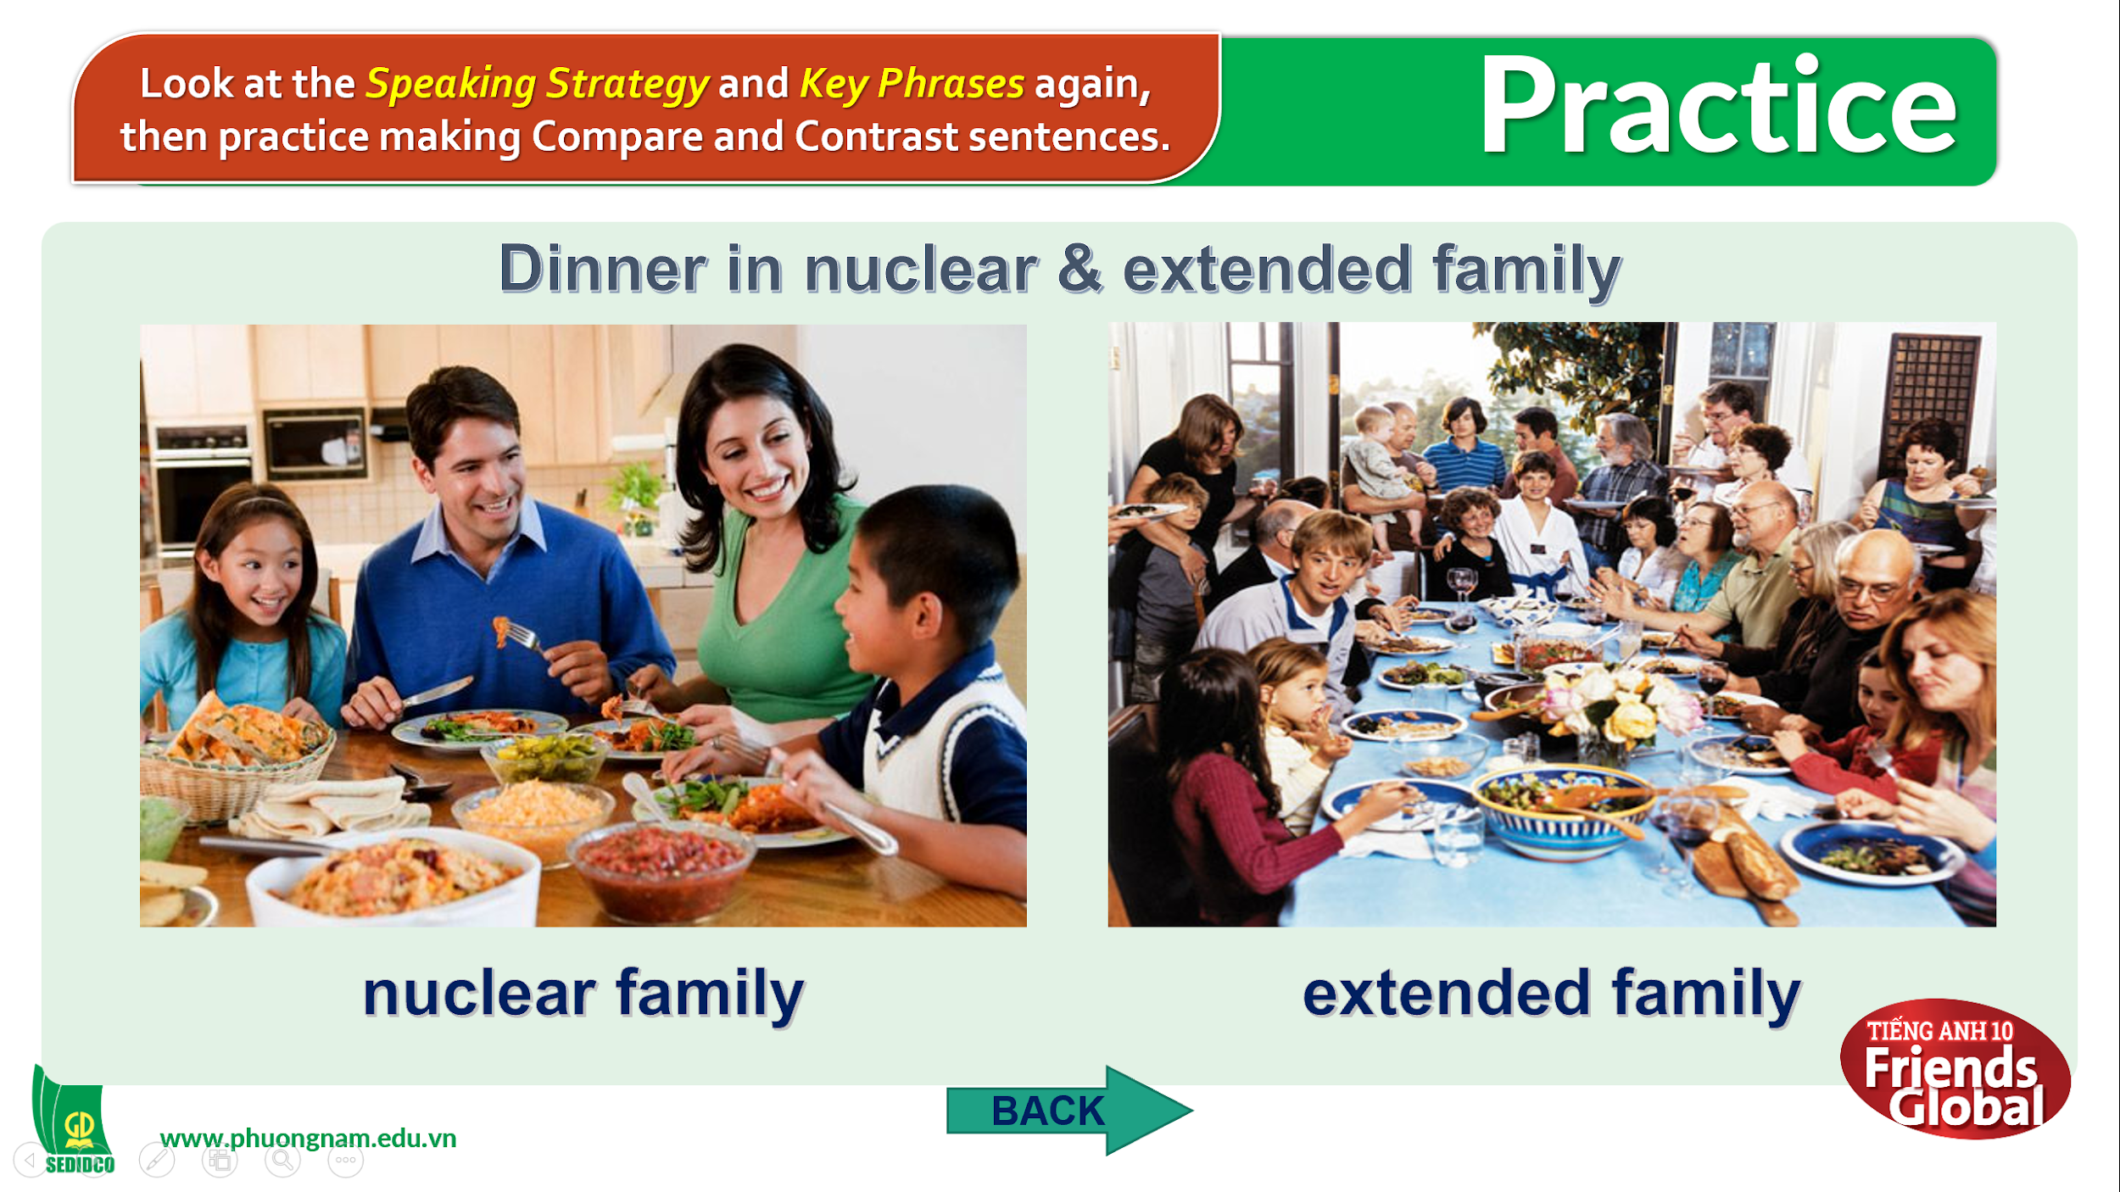

C. Consolidation (3’)
a) Vocabulary: Verb of actions and movements
b) Grammar: Past Continuous and Past Simple

D. Homework (2’)
- Learn by heart all the new words and key phrases.
- Review Speaking strategy and Signal words in Comparing and Contrasting.
- Do exercises in Workbook.
- Prepare Unit 4H – Writing (P.55).

