|  |  |
| --- | --- |
|  |  |

**Họ tên thí sinh: .................................................................**

**Số báo danh: ......................................................................**

**Mã Đề: 022.**

**Câu 1.** Why is the Chess club changing its meeting location?

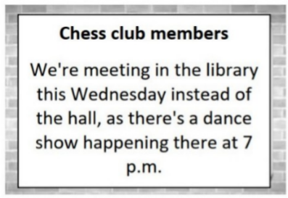

**A.** There's a dance show in the hall  **B.** The chess tables are in the library

**C.** The hall is being renovated  **D.** The library is more spacious

**Câu 2.** **Look at the signs. Choose the best answer for the question.**

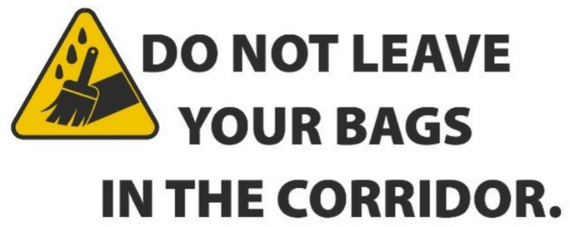

**A.** Bags will be removed from the corridor.

**B.** Don’t forget to put your bags out in the corridor.

**C.** Keep the corridor clear of bags.

**D.** If you leave your bags, it will be kept in the corridor.

**Câu 3.** What can be inferred about the new location of the post office?

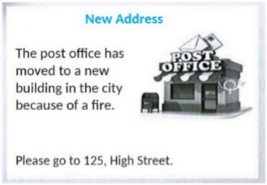

**A.** It's in a rural area  **B.** It's on High Street in the city

**C.** It's in a residential neighborhood  **D.** It's in a shopping mall

**Câu 4.** What does the sign say?

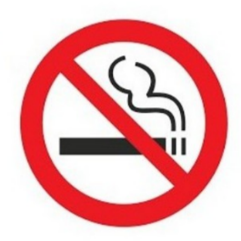

**A.** Smoking is useful here.  **B.** Smoking is not permitted here.

**C.** Smoking is compulsory here.  **D.** Smoking is optional here.

**Câu 5.** **Look at the signs. Choose the best answer for the question.**

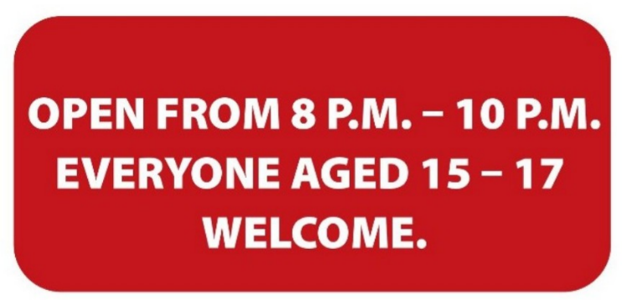

**A.** Only teenagers who are over 15 are allowed to enter this place.

**B.** Only 15-17 people can enter the place from 8 p.m. to 10 p.m.

**C.** Teenagers aged 15-17 can visit the venue from 8 p.m. to 10 p.m.

**D.** The venue is open to all teenagers under the age of 17.

**Câu 6.** Which day is the City Zoo closed?

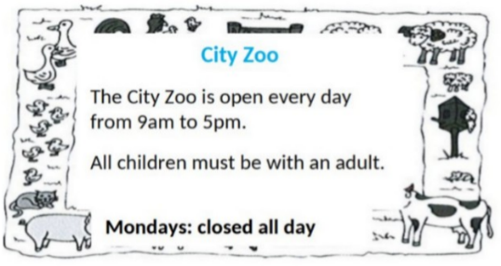

**A.** Monday  **B.** Saturday  **C.** Friday  **D.** Sunday

**Câu 7.** What caused damage to the library?

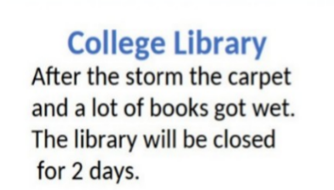

**A.** A fire  **B.** A storm  **C.** Vandalism  **D.** Renovation work

**Câu 8.** **Look at the signs. Choose the best answer for the question.**

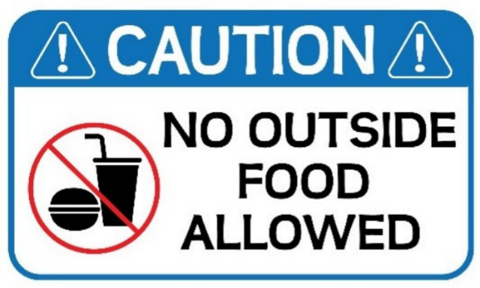

**A.** Food and drink are not allowed in this place.

**B.** Do not bring food or drink from outside into this place.

**C.** Be careful when eating and drinking outside this place.

**D.** Do not eat or drink anything outside this place.

**Câu 9.** **Look at the signs. Choose the best answer for the question.**

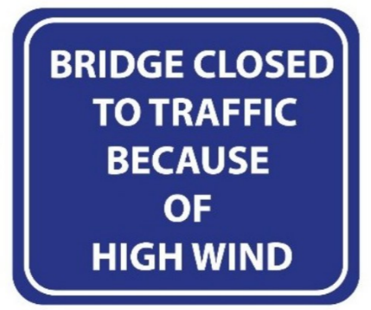

**A.** Be careful when using the bridge on windy days.

**B.** High traffic stopped people from using the bridge.

**C.** High wind prevented the bridge to be finished.

**D.** You cannot cross the bridge because the wind is so strong.

**Câu 10.** What made Michael send this message to Arthur?

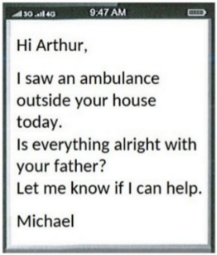

**A.** Arthur called him about an emergency  **B.** He saw an ambulance outside Arthur's house

**C.** He heard about Arthur's father being ill  **D.** He received a message from Arthur's father

**----HẾT---**