|  |  |
| --- | --- |
|  |  |

**Họ tên thí sinh: .................................................................**

**Số báo danh: ......................................................................**

**Mã Đề: 021.**

**Câu 1.** What is the main reason James cannot attend the concert?

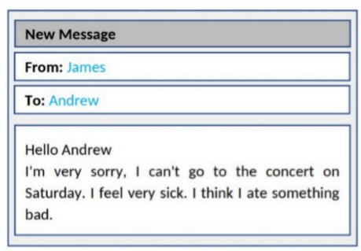

**A.** He is feeling unwell  **B.** He has another commitment

**C.** He doesn't like the music  **D.** He lost his ticket

**Câu 2.** "What does the person sending the message want to do?"

Hi there! I hope you're doing well. I wanted to see if you're interested in going to a show this weekend. There's a new play that just opened at the local theatre, and I've heard great things about it. Let me know if you're free and we can get tickets together.

**A.** Watch a movie  **B.** Visit a museum  **C.** Go to a show  **D.** Attend a concert

**Câu 3.** Which of the following is NOT mentioned about the apartment?

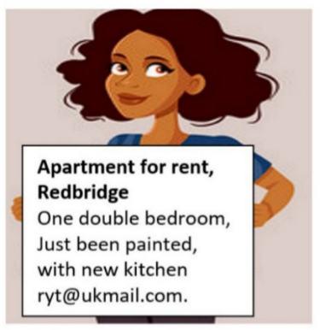

**A.** It has a balcony  **B.** It has a double bedroom

**C.** It has been recently painted  **D.** It has a new kitchen

**Câu 4.** Which day is the City Zoo closed?

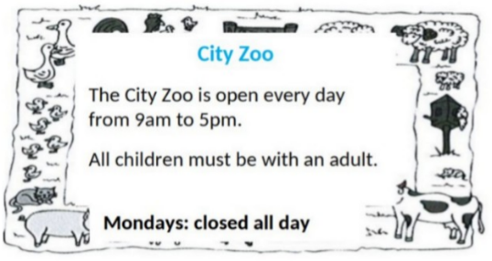

**A.** Monday  **B.** Friday  **C.** Saturday  **D.** Sunday

**Câu 5.** Which of the following statements is true?



**A.** The IT course does not provide a certificate.

**B.** The IT course is for advanced learners.

**C.** The IT course starts on 1st October.

**D.** The IT course covers hardware, software, networking, and security.

**Câu 6.** **Look at the signs. Choose the best answer for the question.**

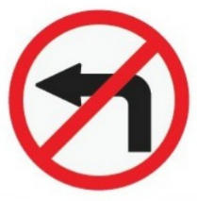

**A.** Only vehicles which turn left have to stop.  **B.** You have to stop and turn left.

**C.** You mustn’t turn left.  **D.** You don’t have to turn left at this point.

**Câu 7.** **Look at the signs. Choose the best answer for question.**

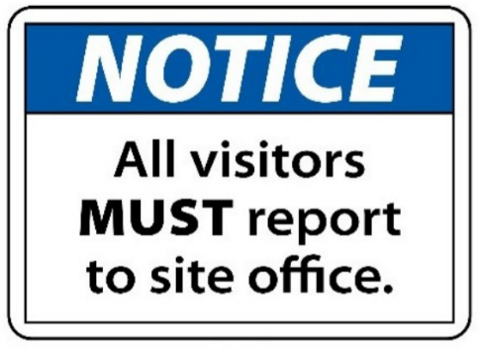

**A.** Anyone who visits must go to the site office and check in.

**B.** All visitors can enter the place through the site office.

**C.** Guests are reported to visit the site office.

**D.** The site office is for everyone to make a report.

**Câu 8.** What does this sign mean?

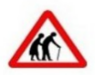

**A.** Be cautious as elderly people may be crossing the road.

**B.** There are two old people here.

**C.** Be careless as elderly people may be crossing the road.

**D.** They are wearing traditional clothing.

**Câu 9.** How much ice cream do you need to buy to get the discount?



**A.** 2kg or more  **B.** 1kg or more  **C.** Exactly 1kg  **D.** 500g or more

**Câu 10.** What time was the theatre originally scheduled to open?

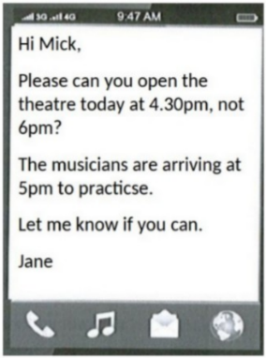

**A.** 5:00pm  **B.** 5:30pm  **C.** 4:30pm  **D.** 6:00pm

**----HẾT---**