SPEAKING ASSESSMENT ENGLISH 6
UNIT 4: MY NEIGHBOURHOOD
- Introduction - 0.4 pt (~2 ideas):
Share something about your family, school, house, friends, neighborhood,…
- Topic Speaking (Cue pictures) – 1.0 pt (~4 questions):
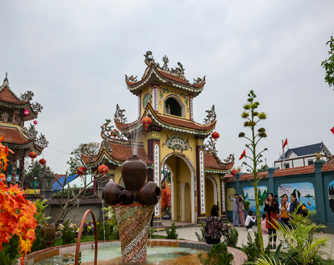  1 | 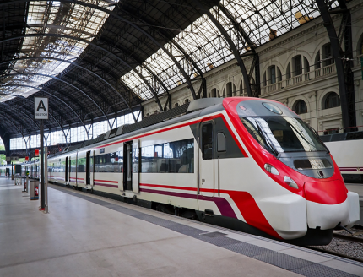  2 | 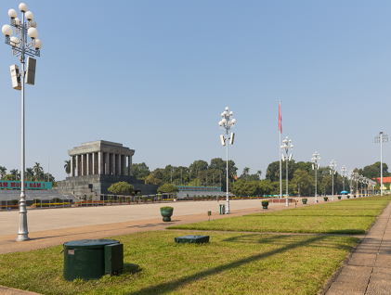  3
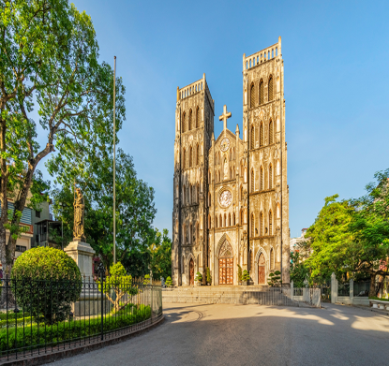  8 | - - What is this?  - What do you see in the picture?  - - How do you spell it?  - - What are there in your neighbourhood?  - - It’s a place where trains stop for people to get on or off.  - It’s a place where you can see many pictures.  8  7  - It’s a place where people grow rice.  - It’s a type of house that is very tall. | 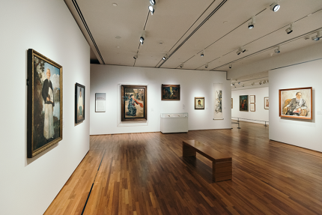  4
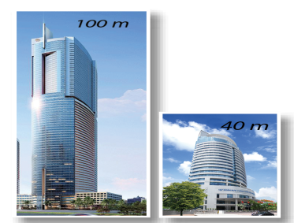  7 | 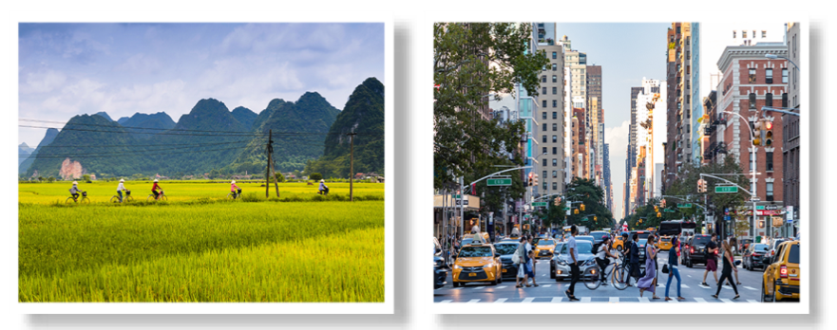  6 | 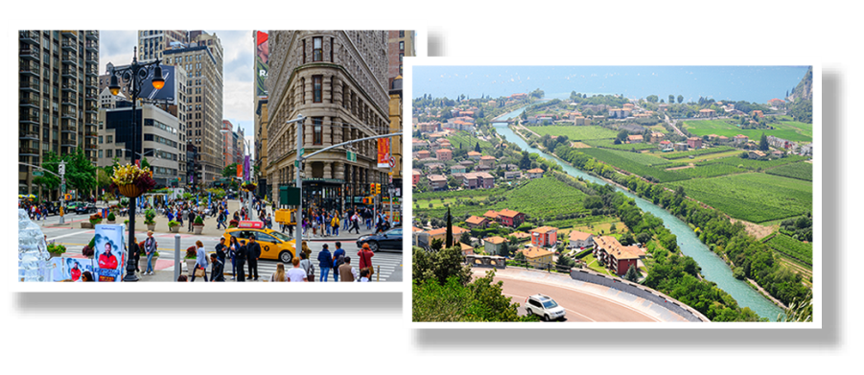  5

