
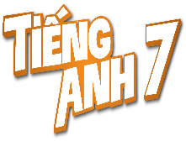
Tiết thứ ......
UNIT 4: MUSIC AND ARTS
Lesson 6: Skills 2
Class | Date of teaching | Attendence
7A | ..../09/2022
7B | ..../09/2022
7C | ..../09/2022
I. OBJECTIVES: By the end of this unit, students will be able to gain the following things:
1. Knowledge:
- Listening:
+ use the lexical items related to the topic Music and arts;
+ listen for specific information about street painting.
- Writing: write an informal letter of invitation.
2. Competence:
a) General competencies:
- Develop communication skills
- Be collaborative and supportive in pair work and team work
- Actively join in class activities
b) Specific competencies:
- Develop communication skills.
- Be cooperative and supportive in pair work and teamwork.
- Actively join in class activities.
3. Qualities:
- To educate the love of music and art.
- Be ready to know the words about music and arts.
- Develop self-study skills.
II. PREPARATIONS
- Teacher: Grade 7 text book, laptop, projector / TV/ pictures and cards.....
- Students : Text books, studying equipment….
III. PROCEDURE:
Notes: In each activity, each step will be represented as following:
* Deliver the task.
* Implement the task.
* Discuss.
* Give comments or feedback.
Activity 1. WARM UP (5’-IW, GW)
* Aim:
To activate students’ prior knowledge and vocabulary related to the lesson.
To introduce the new lesson.
* Content: “Traditional arts around the world” and asks students to think of it.
* Product: Having a chance to speak English and focus on the topic of the lesson..
* Implementation: Teacher’s instructions…
Teacher’s & Student’s activities | Content
BRAINSTORMING  Traditional arts around the world  * Teacher writes on the board the phrase “Traditional arts around the world” and asks students to think of it.  ** Students think of it and can discuss with their partners.  *** Teacher calls some students to give their answers.   Teacher listens and gives comments.  Teacher introduces students the content of the lesson: “In the lesson today, we are going to listen to find out the information about very special type of art. It called: street art/ street painting.” | BRAINSTORMING  Traditional arts around the world  Suggested ideas:  Lam vong dance of Laos; Chinese Opera; ballet of France and Russia; Origami in Japan; Kite making and flying in India; Watchmaking in Switzerland; …
Activity 2. KNOWLEDGE FORMATION (15'- PW, IW)
* Aim:
To provide students with some lexical items before reading the text.
To activate students’ knowledge of the topic of the reading text (a traditional art form).
* Content: Teach some new words.
* Product: Knowing more new words. Understanding the conversation; topic of the lesson, grammar points…
* Implementation: Teacher’s instructions…
Teacher’s & Student’s activities | Content
Vocabulary  - Teacher introduces the vocabulary by:  + Providing the synonym or antonym of the words.  + Providing the pictures of the words.  + Providing the definition of the words.  Concept check: Rub out and Remember  1. Discuss the question below with a partner (Ex. 1, p. 47)  What do you know about street painting?  Where do artists paint their pictures? Do they have to pay to paint there?  * Teacher asks students to work in pairs to ask and answer about street painting.  ** Students work with their partner to do the task.  *** Teacher calls on some students to answer.   Teacher gives comments and leads students to task 2. | Vocabulary  - Teacher introduces the vocabulary by:  + Providing the synonym or antonym of the words.  + Providing the pictures of the words.  + Providing the definition of the words.  1. pavement (n): [visual + explanation]  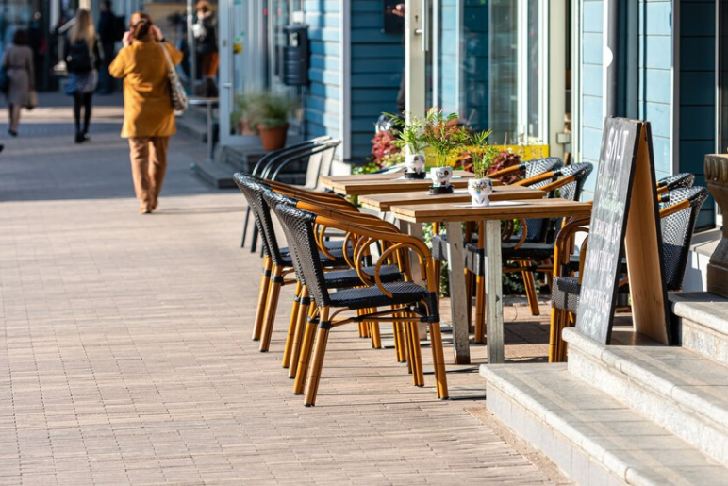  2. occur (v): [explanation]  3. support (n): [explanation]  4. huge (adj): [explanation]  Concept check: Rub out and Remember  1. Discuss the question below with a partner (Ex. 1, p. 47)  What do you know about street painting?  Where do artists paint their pictures? Do they have to pay to paint there?  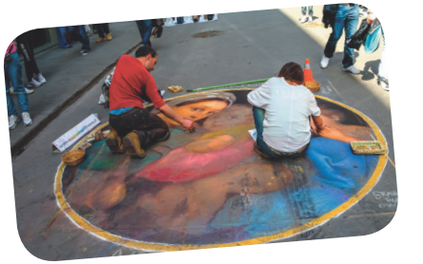  Suggested questions and answers:  - Do you know about street painting?  - Where do artists paint their pictures?  - Do they have to pay to paint there?
Activity 3. PRACTICE (15’-IW, PW, GW)
* Aim:
To help students practise listening for specific information (to find some words while listening to the recording).
To develop students’ skill of listening for specific information (scanning).
To help students retell what they have listened.
To help students learn the purpose and format of an informal letter of invitation
* Product: Ss can learn how to do the excersises.
* Implementation: Teacher’s instructions…
Teacher’s Student’s activities | Content
2. Listen to a man talking about street painting and tick (√) the words you hear. (Ex.2, p.47)  * Teacher asks students to read the five words given and try to predict what words they will hear in the listening.  ** Students work independently to read and predict. Then, teacher plays the recording once or twice for students to listen carefully and tick the words they hear.  *** Teacher calls some Ss to give the answers.   Teacher plays the recording again and confirms the correct answers for their prediction.  3. Listen to a man talking about street painting and tick (√) the words you hear. (Ex.2, p.47)  * Teacher asks students to read the questions carefully then plays the recording again to choose the correct answer to each question.  ** Students work independently to listen.  *** Students give their answers.   Teacher plays the recording as many times as necessary and confirms the correct answers. | 2. Listen to a man talking about street painting and tick (√) the words you hear. (Ex.2, p.47)  Key:  1. artists 2. painting 3. enjoy  3. Listen to a man talking about street painting and tick (√) the words you hear. (Ex.2, p.47)  Suggested answers:  1. A  2. C  3. C  4. B  Audio script – Tracks 28 + 29:  Street painting – or street art – is an old type of art. In the 16th century artists began to draw on the pavement using chalk. Today, you can see street painting events everywhere. They attract many people who come to enjoy and take part in them. Many of them are free too. So join in and become an artist yourself!  One of the largest events in the United States is the Lake Worth Street Painting Festival. It began in 1994 and now occurs every February with the support of artists and volunteers. It is free for everyone.  About 100,000 visitors come to enjoy it. About 600 artists work on the pavement to make the street a huge art gallery!
RETELLING
* Teacher asks students to work in groups and take turns to retell the information about “Street painting” as much as they can.
** Students work in groups to do the task. Teacher moves around and offers help if needed.
*** Teacher invites some students to retell it.
 Teacher confirms the correct answers.
4. Read the following letter and choose the correct answers. (Ex. 4, p. 47)  * Teacher asks students to do the task in Ex. 4, p. 47.  ** Students do the task individually.  *** Students give their answers.   Teacher corrects.  Informal letter of invitation:  * Teacher asks students to look at the letter again and try to answer some questions:  + Is it an invitation letter? (Yes. Because it invites Jack to see the water puppet show.)  + Is it formal or informal? (It is informal because Jack is Chau’s friend.)  + What is the event? (The water puppet show.)  + What time does the show begin? (At 8 p.m.)  + Where does it take place? (At 57 B Dinh Tien Hoang St, Hoan Kiem Dist.)  + What time do Chau want to meet Jack for the show? (At 7:45.)  ** Students do the task independently.  *** Teacher calls students to check their understanding.   Teacher corrects and then, asks them to read “Writing tip”. After that, teacher writes on the board the format of informal letter of invitation:  - Invitation: Let’s / How about + V-ing?  - Event  - Start time  - Place  - Time to meet | 4. Read the following letter and choose the correct answers. (Ex. 4, p. 47)  * Answer key:  1. A  2. B  Informal letter of invitation:  + Is it an invitation letter? (Yes. Because it invites Jack to see the water puppet show.)  + Is it formal or informal? (It is informal because Jack is Chau’s friend.)  + What is the event? (The water puppet show.)  + What time does the show begin? (At 8 p.m.)  + Where does it take place? (At 57 B Dinh Tien Hoang St, Hoan Kiem Dist.)  + What time do Chau want to meet Jack for the show? (At 7:45.)  - Invitation: Let’s / How about + V-ing?  - Event  - Start time  - Place  - Time to meet
Activity 4. APPLICATION (7’-IW, PW, GW)
* Aim:
To help students write an informal letter of invitation.
To peer check, cross check and final check students’ writing.
To consolidate what students have learnt in the lesson.
* Content: Write a letter to invite someone to a street painting festival.
* Product: Students’s letters.
* Implementation: Teacher’s instructions
5. Write a letter to invite someone to a street painting festival, using the following cues. (Ex. 5, p. 47)  * Teacher tells students that they are going to write a letter to invite someone to a street painting festival. Students should follow the cues and base on the format to write.  ** Students work independently to do the task and teacher goes around and helps if necessary.  * Home assignment  - To allow students finalize their letter after being checked by friends and the teacher.  - Rewrite the letter on the notebook.  - Prepare for the next lesson: Looking back and project. | 5. Write a letter to invite someone to a street painting festival, using the following cues. (Ex. 5, p. 47)  468 Lang St, Ha Noi  Nov 12, 2021  Hi Nam,  Let's go to see the Street Painting Festival this Sunday morning at 9 a.m. At the festival, you can meet street artists, draw pictures on the street. I'm sure you'll like it. It's at Central Rd.t. How about meeting at 8:45 at the bus stop? Let me know if you can make it.  Looking forward to seeing you there.  Best,  Linh  * Home assignment  - To allow students finalize their letter after being checked by friends and the teacher.  - Rewrite the letter on the notebook.  - Prepare for the next lesson: Looking back and project.
V. FEEDBACK:
With 7A ……………………………………………………………………………..…
With 7B …………………………...……………………………………..……………
With 7C ………………………………………………………………………….……

