Mã đề 7.1.6
ĐỀ KIỂM TRA GIỮA KỲ I NĂM HỌC: 2022-2023
MÔN: TIẾNG ANH LỚP 7
Thời gian làm bài: 60 phút
SECTION A: LISTENING (2 points)
Part I. You will hear five short conversations. You will hear each conversation twice. There is one question for each conversation. For questions 1-5, put () under the right answer. (1pt)
1. How will Mary travel to Scotland?  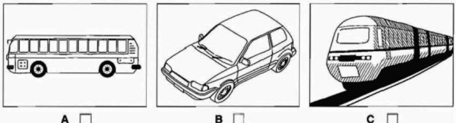  A. B. C.  2.Where are the shoes?  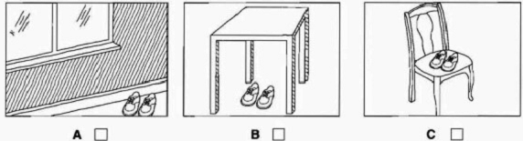  A. B. C.  3.When will the football match start next week?  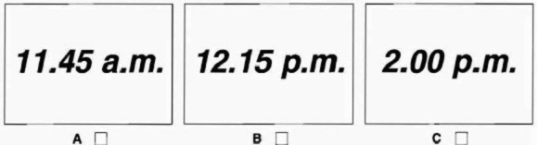  A. B. C. | 4.Which box of chocolates do they buy?  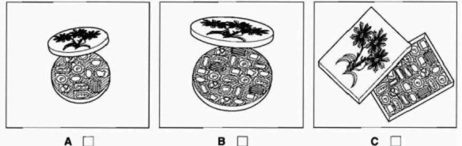  A. B. C.  5.When’s Weddy’s birthday?  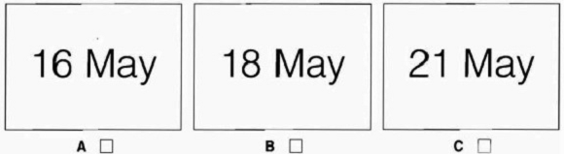  A. B. C.
Part II. You will hear a telephone conversation. A girl wants to speak to martin, but he is not there. Listen and complete question 1-5. You will hear the conversation twice.(1pt)
Phone Message
To : | Martin
From : | (1) ……………………………
Party at : | (2) ……………………………
Time : | (3) ……………………………
Please bring : | (4) A …………………………
Her phone number : | (5) ……….……………………
SECTION B: LANGUAGE – GRAMMAR – VOCABULARY (3 points)
1.Choose the word whose underlined part pronounced differently from that of the others by circling A, B, C or D
A. what B. who C. when D. where
2. Which words are stressed in this sentence: “ She is honest and kind.”
A. honest, kind B. she, kind C. is, honest D. and, kind
3. Choose the odd one out:
A. grapes B. bananas C. potatoes D. mangoes
Choose the best option (A, B, C or D) to complete the sentences numbered from 4 to 13.
4. My father used to ……………….TV after dinner 5 years ago.
A. watch B. watches C. watching D. watched
5. Peter usually get up ……....... 6:30 a.m every morning.
A. on B. in C. at D. to
6. May: What would you like today?- Mary: …………………………….
A. I’d like noodles, please B. That’s all. C. Here you are D. Thanks
7. Susan and her brother often ………….. hide- and- seek when they were small.
A. played B. play C. is played D. is playing
8. She ………………. Yoga every day.
A. plays B. makes C. goes D. does
9. There ………….. four chairs in the kitchen.
A. are B. is C. am D. has
10. Tam has ……………….
A. hair long brown B. long brown hair C. brown hair long D. long hair brown
11. Look! The girls…………..in the schoolyard.
A. skipping B. are skipping C. skip D. skips
12. Hai is very ………... . She’s always on the phone, chatting to friends.
A. shy B. talkative C. kind D. honest
13. We ………….. to the cinema at weekend.
A. often go B. go often C. often goes D. goes often
Circle A,B or C to find one mistake that needs correcting in each sentence numbered 14,15
14- She is ride her bike to the market to buy some food now.
A B C D
15.There is a lamps next to the alarm clock in my bedroom.
A B C D
SECTION 3: READING (2.5 POINTS)
I. Read the passage and then choose the correct answer to each question. (1 point)
Linh is my new classmate. Her family (1)……..4 people including her father, her mother, her younger brother and her. Her father is (2)……. engineer at a construction site near her home. Her father is very busy. He usually had to stand outside all day. So he has a tanned skin. However, one day he still spends time playing with (3)…….. Her mother is very beautiful with white teeth and black hair. She is a good housewife. Every day she can (4)………..delicious dishes that her mother cooks. She takes care of her family very well. Before she goes to bed, my mother usually reads her a story. Her brother is 10 years old this year. He is an energetic boy. She often play with him (5)…….her free time so her mom can do other things. She loves her family very much.
- A.have B.is C. has D. are
- A.a B. an C. the D. some
- A. hers B. she C. him D. her
- A. eats B.eat C. eating D. to eat
- A.in B. on C. at D. of

II. Read the passage and choose the correct answer for each question (1.5 points)

Hi, I’m Linda. I’m in the sixth grade. Today is my first day at secondary school. In the morning I put on my new uniform and get my new bag. My best friend , Laura and I walk to school together. We are both very nervous and excited. When we get school, we are shown into our classroom with our new teacher. It is quite scary because I don’t know most of the children. Then we go to our first lesson. We have lots of different subjects and the lessons are really fun. My favourite subjects are Art and English. I really like my new school, all my teacher are lovely, the lessons are really interesting and I enjoy my first day. I can’t wait to go back tomorrow!
- Who does Linda go to school with ?
A. her sister B. her brother C. her best friend D. her neighbor
2 .How does they go to school?
A. by bike B. by bus C. by car D. on foot
3 . What are her favourite subjects?
A. Art B. Math C. English D. A and C are correct
4.What does the word“ scary” mean?
A. nervous B. unhappy C.happy D. sad
5. What is the passage about?
A.The writer’s first day at school .
B. The writer and her friend’s first day at school .
C.The writer’s first day in an other country.
D..The writer her friend’sfirst day at home .
SECTION C: WRITING (2.5 POINTS)
I. Rewrite the sentence so that it has the same meaning as the first one(1pt)
1. My family has five people.
=> There are…………………………
2. Math and Geography are Rita’s favourite subjects
=> Rita’s favourite subjects……………..
3. Laura has long blond hair.
=> Laura’s hair is………………….
4.There is a sofa next to the window.
=>Next to the window,…………………………
5. Ben doesn’t play roller blading anymore.
=> Ben used to……………………………………
II. Write a paragraph(about 60 - 80 words) about Lan’s hobby using these cues.(1.5pts)
- Name of the hobby.
- When she started it .
- Who she share it with .
- Feeling about the hobby .
….…………………………………………

--------------The end------------

KEY
SECTION A: LISTENING (2 point)
I.
1.B 2.A 3.C 4.B 5.B
II.
1, Elaine 2, (the) Grand Hotel
3, 8.30 p.m/ half past eight/20.30 4,friend 5, 724 5936
SECTION B: LANGUAGE (3 POINTS)
1. B 2.A 3.C 4.A 5. C
6. A 7.B 8.D 9.A 10.B
11. B 12. B 13. A 14.A 15. B
SECTION 3: READING (2.5 POINTS)
I. Read the passage and then choose the correct answer to each question. (1 point)
1C 2B 3D 4B 5A
II. Read the passage and choose the correct answer for each question (1 point)
1C 2D 3D 4A 5B
SECTION C: WRITING (2.5 POINTS)
I. Rewrite the following sentences as directed ( using the suggested words) so that the meanings stay the same. (1.0 pt)
- There are five people in my family.
- Rita’s favourite subjects are Math and Geography.
- Laura’s hair is long and blond.
- Next to the window, there is a sofa.
- Ben used to play rollerblading.

II.
Form: 0.2 pt
- Correct form of a paragraph.
Task fulfillment:0.8 pt
- Tasks completed with relevant information: 0.6 pt
- Well-organized: 0.2pt
Language: 0.5pt
- Accurate grammar: 0.2pt
- Appropriate vocabulary: 0.2pt
- Correct spelling and punctuation: 0.1pt

