
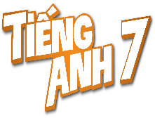
Tiết thứ ......
UNIT 10: ENERGY SOURCES
Lesson 6: Skills 2
Class | Date of teaching | Attendence
7... | ...../........./202....
7… | ..../......../202...
7…. | ..../......../202....
I. OBJECTIVES: By the end of this unit, students will be able to gain the following things:
1. Knowledge:
+ Listening
- use the lexical items related to the topic Energy sources
- listen for main ideas and specific information about the topic how to save energy at home.
+ Writing: Write a paragraph of about 70 words about how you save energy at home.
2. Competence:
a) General competencies:
- Develop communication skills
- Be collaborative and supportive in pair work and team work
- Actively join in class activities
b) Specific competencies:
- Develop communication skills.
- Be cooperative and supportive in pair work and teamwork.
- Actively join in class activities.
3. Qualities:
- Be benevolent and responsible
- Be ready to know the words about energy resources.
- Develop self-study skills.
II. PREPARATIONS
- Teacher: Grade 7 text book, laptop, projector / TV/ pictures and cards.....
- Students : Text books, studying equipment….
III. PROCEDURE:
Notes: In each activity, each step will be represented as following:
* Deliver the task.
* Implement the task.
* Discuss.
* Give comments or feedback.
Activity 1. WARM UP (5’-IW, GW)
* Aim:
To activate students’ prior knowledge and vocabulary related to the lesson.
To introduce the new lesson.
* Content: “Traditional arts around the world” and asks students to think of it.
* Product: Having a chance to speak English and focus on the topic of the lesson..
* Implementation: Teacher’s instructions…
Teacher’s & Student’s activities | Content
PASS THE CHALK  * Teacher writes on the board the word “HOW TO SAVE ENERGY” and and divide the class into 2 groups.  ** Ss take turns to go to the board  *** Teacher calls some students to give their answers.   Teacher listens and give comments.  - Teacher introduces students the content of the lesson: “In the lesson today, we are going to listen to a person talking about how to save energy at home.” | PASS THE CHALK
Activity 2. KNOWLEDGE FORMATION (15'- PW, IW)
* Aim:
To help Ss brainstorm the topic and prepare for the listening text.
To help Ss develop their skill of listening for specific information
* Content: Teach some new words.
* Product: Knowing more new words. Understanding the conversation; topic of the lesson, grammar points…
* Implementation: Teacher’s instructions…
Teacher’s & Student’s activities | Content
Task 1: What can you see in this picture? What is special about it?  * Teacher asks ss to work in pairs to answer the questions in the picture.  ** Ss work with their partner to do the task.  *** teacher calls on some ss to answer.   teacher gives comments and leads ss  Task 2: Listen and circle the phrases you hear  * Teacher asks Ss to read and underline the key words.  ** Ss work independently to guess then listen to the recording once to check their guess.  *** Teacher calls on some students to give the answers the have listened. | Suggested answers:  - Solar energy  - Turn off the tap while brushing your teeth, use paper fan, …  Task 2: Listen and circle the phrases you hear  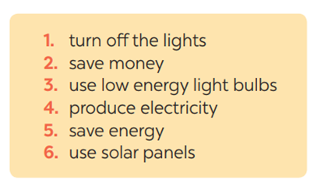What do you know about street painting?  Where do artists paint their pictures? Do they have to pay to paint there?
Activity 3. PRACTICE (15’-IW, PW, GW)
* Aim:
To help students develop their skill of listening for details.
To help Ss use what they have listened to life context.
* Product: Ss can learn how to do the excersises.
* Implementation: Teacher’s instructions…
Teacher’s Student’s activities | Content
Task 3: Listen again and tick T (True) or F (False) for each sentence  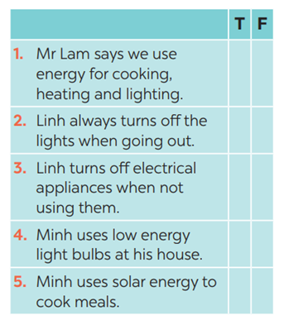  * Teacher asks Ss to read and underline the key words.  ** Ss work independently listen to the recording and tick T or F  *** Teacher calls on some students to give the answers the have listened. | Task 3: Listen again and tick T (True) or F (False) for each sentence  Answer key:  1. 3. 5.  2. 4.
Task 4: Discuss: What is the most effective way to save energy?  * Teacher tells Ss to work in groups to discuss and find out “What is the most effective way to save energy”. Write down onto the notebooks in full sentences  E.g. The most effective way to save energy is only read and write in day light  ** Ss work in groups. Teacher moves around and offers help if needed.  *** Teacher invites some Ss to share their answers.   Teacher corrects if needed. | Task 4: Discuss: What is the most effective way to save energy?
Activity 4. APPLICATION (7’-IW, PW, GW)
* Aim:
To help Ss prepare ideas to write a passage
To help Ss practise writing a passage about
70 words about how you save energy at home
To peer check, cross check and final check students’ writing.
To consolidate what students have learnt in the lesson.
To allow students finalize their passage after being checked by friends and the teacher.
To consolidate what students have learnt in the lesson.
* Content: Write a paragraph about how you save energy at home.
* Product: Students’s paragraph.
* Implementation: Teacher’s instructions
Task 5: Work in pairs. Read some ways to save energy at home. Choose three ways and write them in your notebook.  * Teacher asks Ss to write the methods they use to save energy at home then asks them to give out more if they can.  ** Ss think of it and can discuss with their partners.  *** Teacher calls on some Ss to raise their ideas.   Teacher listens and confirms.  Task 6: Write a paragraph of about 70 words about how you save energy at home.  * Teacher tells Ss that they are going to write a passage about how you save energy at home.  ** Teacher reminds Ss of the structure of a passage and steps to make an outline for the passage.  ** Ss work independently to do the task and try to use the notes from the previous tasks.  Teacher goes around and help if necessary.  Peer check and cross check  *** Teacher asks Ss to share their writing with their partners. Then, call on some Ss to show their writing in front of the class.   Teacher checks ideas, grammar, vocabulary and gives comments.  Consolidate  Teacher asks students to talk about what they have learnt in the lesson.  * Home assignment  - To allow students finalize their letter after being checked by friends and the teacher.  - Rewrite the letter on the notebook.  - Prepare for the next lesson: Looking back and project. | Task 5: Work in pairs. Read some ways to save energy at home. Choose three ways and write them in your notebook.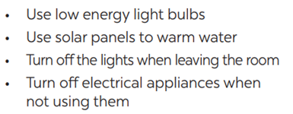  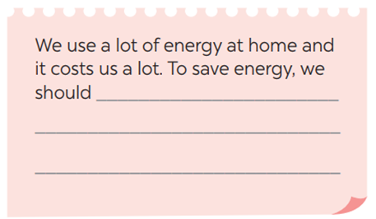  Suggested answers:  We use a lot of energy at home and it costs us a lot. To save energy, we should try making use of natural light more instead of keep the lights unnecessarily in the morning and afternoons. Moreover, we should unplug your electrical gadgets when not in use. These devices consume at least 10% of electricity even when inactive. Therefore, unplug them to save electricity. Most importantly, installing solar panels can help you excessively. They are very economical and help in saving a lot of energy. This can help in getting cheap electricity and protect the environment.  * Home assignment  - To allow students finalize their letter after being checked by friends and the teacher.  - Rewrite the letter on the notebook.  - Prepare for the next lesson: Looking back and project.
V. FEEDBACK:
With 7 ……………………………………………………………………………..…
With 7 …………………………...……………………………………..……………
With 7 ………………………………………………………………………….……

