Name:____________________ ENGLISH GRADE 5
Giaoandethitienganh.info có rất nhiều tài liệu tiếng anh file word hay, chất lượng, mời bạn đăng ký tài khoản ( chỉ 100k/ năm) để chủ động tự tải tài liệu khi cần!
Class: ____________________ UNIT 4: OUR FREE TIME ACTIVITES
PART 1: LISTENING
Task 1: Listen and circle. There is one example.
- a. always b. sometimes c. tonight
- a. never b. invite c. party
- a. address b. enjoyed c. Sunday
- a. usually b. never c. listen
- a. enjoy b. often c. tennis
Task 2. Listen and tick.
- A. 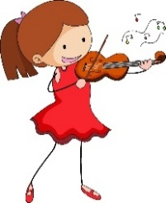 B. 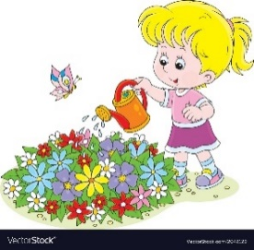 C. 
- A.  B.  C. 
- A. 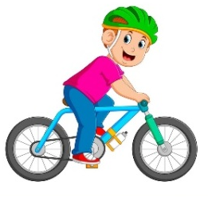 B. 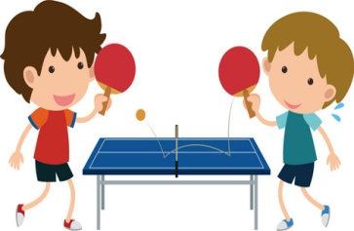 C.
- A. B.  C.

Task 3. Listen and complete.
Sally’s free-time activities
After school
She (1) ________ reads books.
In the evening
She often plays the (2) __________. She (3) __________ plays games.
At the weekend
She usually (4) __________ on Saturdays. On Sundays, she (5) __________ visits her grandparents.
PART 2: VOCABULARY AND GRAMMAR
Task 1. Look and write. There is one example.
play the violin ride the bike play table tennis
listen to music surf the internet read a book
water the flowers go for a walk

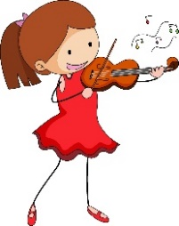
- play the violin 1. ________________ 2.________________3. _____________
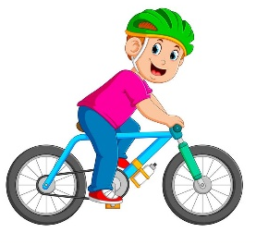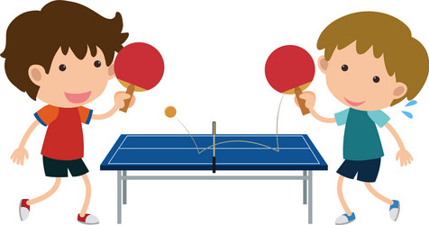
- _____________ 6. _____________ 7. _____________ 8. _______________

Task 2. Complete each phrase with a suitable verb. There is one example.
A | B | Answer
- sing | - comic books | 0 - b
- read | - English songs | 1 -
- listen | - shopping | 2 -
- go | - the Internet | 3 -
- clean | - to music | 4 -
- surf | - the floor | 5 -

Task 3. Choose the best answer. There is one example.
0. Peter often _______________ skating in his free time.
A. does B. do C. goes D. plays
1. What do you like doing _______________ your free time?
A.in B. on C. at D. of
2. My sister _______________ playing the violin in her free time.
A. like B. likes C. liking D. to like
3. What do you like _______________ in your free time? - I like playing the guitar.
A. do B. does C. doing D. to do
4. What _______________ your father do in his free time? He goes fishing.
A. did B. do C. does D. often
5. I _______________ water the flower at the weekends. 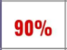
A. always B. usually C. sometimes D. never
6. My brother usually ……………….… to the cinema in his free time.
A. go B. goes C. went D. plays
7. ……….…does your mother go shopping? – Twice a week. - Once a week.
A. How often B. How C. What D. Where
8. Peter often likes…………..skating in his free time.
A. doing B. playing C. going D. watching
9. I sometimes …………..cartoons on TV .
A. go B. do C. play D. watch
10. My brother often ………….. pictures in his free time.
A. draws B. does C. paint D. plays
Task 4. Complete using the correct forms.

do go play surf watch water

Mary: Hi, Sam. What (0) do you like doing in your free time?
Sam: Hi, Mary. I like (1) _____________ for a walk and (2) _____________ a cartoon on TV.
Mary: What do you do at the weekend?
Sam: I usually (3) ____________ the internet and sometimes (4) ____________the flowers. What about you?
Mary: I also like watering flowers and (5) ____________ the violin in my free time.

PART 3: READING
Task 1. Read and tick True or False. There is one example.
Tom does many free-time activities. After school, he always rides his bike. Usually, after dinner, he plays the guitar. He can play really well! On Thursdays, he usually plays football. It’s his favourite sport. On Saturdays, Tom never stays at home. He often goes for a walk with his family. They sometimes have a picnic. On Sundays, Tom plays games and watches cartoons. He usually helps his dad clean the house. Tom’s a very active boy.
0. Tom always rides his bike after school. T/ F
1. He usually plays the violin after dinner. T/ F
2. His favourite sport is basketball. T/ F
3. He never stays at home on Saturdays. T/ F
4. Tom’s family sometimes have a picnic on Saturdays. T/ F
5. He usually helps his mum clean the house on Sunday. T/ F

Task 2. Read and answer.
My name is Huong. I’m ten years old. In my free time, I often read story books. My favourite story is Snow White and the Seven Dwarfs. I like reading books because it helps me widen knowledge. My father often watches sports programs on TV because he is a big fan of football. My mother likes cooking. She usually cooks meals for our family. My brother, Phong likes playing sports. He often does karate in his free time. At weekends, my family goes camping or goes for a picnic. We go for a picnic once a month.

- What does Huong do in her free time?
- She often reads story books.
- What does her father often do in his free time?
=>………………………………………………………………………………….
- What does her mother like doing?
=>…………………………………………………………………………………
- What does her brother like doing in his free time?
=>………………………………………………………………………………….
- What does his family do at weekends?
=>………………………………………………………………………………….
- How often do they go for a picnic?
=>…………………………………………………………………………………

PART 4: WRITING
Task 1. Reorder the words to make sentences. There are two examples.
Example: live/ you/ Where/ do/?/ => Where do you live?
- likes/ her bike/ She/ riding/ free time/ in/ her/ .
=>……………………………………………………………………………….
- doing/ in/ your/ father/ What/ does/ free/ his/like/ time/?
=>……………………………………………………………………………….
- do/ how/ go/ your/ the/ sisters/ cinema/ often/to /?
=>………………………………………………………………………………
- Nam/ in/ pictures/ drawing/ free/ usually/ his/likes/ time/.
=>………………………………………………………………………………..

Task 2. Write about your friend!
• What’s his / her name?
• What activities does he / she like?
• When does he / she do them?
• How often does he / she do them?

• What’s his / her favourite activity?

My friend’s name is _________. He / She likes______________________________
Giaoandethitienganh.info có rất nhiều tài liệu tiếng anh file word hay, chất lượng, mời bạn đăng ký tài khoản ( chỉ 100k/ năm) để chủ động tự tải tài liệu khi cần!

