UNIT 11: TRAVELLING IN THE FUTURE

Lesson 2: A closer look 1

I. OBJECTIVES
By the end of this lesson, Ss will be able to gain:
1. Knowledge
- Vocabulary:
+ use the lexical items related to the topic Travelling in the future.
Pronunciation: say sentences with correct stress
2. Core competence
- Develop communication skills.
- Be collaborative and supportive in pair work and teamwork.
- Actively join in class activities.
3. Personal qualities
- Be ready to know the words about future means of transport.
- Develop self-study skills.
II. PREPARATIONS
1. Teacher
- Grade 7 textbook, laptop, TV/Projector/ pictures and cards, speakers, lesson plan, sachmem.vn…
2. Students
- Grade 7 textbook, notebooks, school things….
III. TEACHING PROCEDURES
Notes
In each activity, each step will be represented as following
* Deliver the task
** Implement the task
*** Discuss
 Giving comments or feedback
ACTIVITY 1 – WARM – UP & INTRODUCTION (5’)
a) Aims:
- To help Ss review the previous lesson.
– To create a fun atmosphere in the class.
- To lead in the lesson about vocabulary and pronunciation.
b) Contents: Play the game “Miming”
c) Products: Suggested answers
d) Teaching steps:
Teacher’s and students’ activities | Content
* Teacher calls 1 student come to the board and whispers into Ss’ ears one means of transport.  ** Ss think of how to mine it, and the others are ready to guess  *** Ss mine the action for the others to guess the means of transport.   Teacher confirms the correct answer. The student who guesses correctly is the winner.  Teacher leads students into the lesson by telling them that “In today lesson, we are going to learn more words to talk about Future means of transport and how to say sentences with correct stress.” |   Game: Miming  Suggested answers:  1. hyperloop  2. flying car  3. train  4. bike  5. motorbike  6. boat

ACTIVITY 2 – PRESENTATION (10’)
a) Aims:
- To introduce visually some words related to the topic.
b) Contents:
- Teach the vocabularies
c) Products:
- Lists of vocabularies
- Answer key
d) Teaching steps:
Teacher’s and students’ activities | Content
* Teacher introduces the vocabulary by:  + providing the synonym or antonym of the words  + providing the pictures of the words  - Teacher have students read the phrases aloud and correct their pronunciation if needed.  - Teacher asks students for the Vietnamese meanings of these phrases.  ** Ss say the words.  *** Other Ss correct if the previous answers are incorrect.   Teacher shows and says the words aloud and asks Ss to repeat them  Checking techniques:  “Rub out and remember” | VOCABULARY  1. bamboo - copter (n): [visual +explanation]    2. skyTran (n): [visual + explanation]    3. solar - powered (a): [visual + explanation]  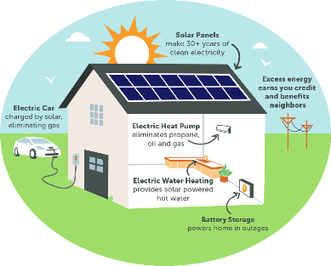  4. (to) sail: [visual + explanation]  
ACTIVITY 3 – PRACTICE (20’)
a) Aims:
- To introduce some modes of future travel.
- To help Ss learn to use the right verbs for the appropriate mode of travel.
- To help Ss practise using the learnt words in the right context.
b) Contents:
- Write the words or phrases under the correct pictures. Then listen, check, and repeat.
- Write words or phrases from 1 in the correct columns.
- Complete the sentences, using the words from the box.
c) Products:
- Answer key
- The role of marking sentence stress
d) Teaching steps:
Teacher’s and students’ activities | Content
* Teacher asks students to choose the words and phrases in the box to write under the correct pictures with their partners.  ** Ss work in pairs to do the task.  *** Teacher calls on some students to read aloud the words and asks them why they think a word / phrase should go with a picture   Teacher plays the recording for Ss to check their answers, has them to repeat chorally and individually, corrects their pronunciation and explain the meaning of these words/ phrases if needed.  * Teacher asks students to look at Ex 2 to write words and phrases in 1 in the correct columns  ** Ss work independently to do the task.  *** Some Ss give their answers.   Teacher checks students ‘answers as a class.  * Then, teacher asks Ss work in pair to add more words to each column.  ** Ss work in pairs to di the task.  *** Teacher calls on some Ss to give their answers.   Teacher confirms and corrects.  * Teacher has Ss look at the box, practice saying the words, then work individually to complete the sentence.  ** Ss work individually to do the task.  *** Some Ss read aloud the complete sentences   Teacher confirms the correct answers.  * Teacher writes the words “Sentence stress” on the board and asks them “What is sentence stress?”. Then, teacher has Ss watch the video to understand more about it.  https://www.youtube.com/watch?v=  d2SF3DHXeC8&t=228s  ** Ss work independently to do the task.  *** Teacher calls some Ss to check their understanding.   Teacher confirms, then asks them to read “Remember” in 1 minute.  + What are stressed words?  + What are unstressed words? | Task 1: Write the words or phrases under the correct pictures. Then listen, check, and repeat. (Ex. 1, p. 116)  Answer keys:  1. solar-powered ship  2. flying car  3. bamboo-copter  4. hyperloop  5. skyTran  Task 2: Write words or phrases from 1 in the correct columns. (Ex 2, p. 116)  Answer keys:  Suggested answers:  Task 3: Complete the sentences, using the words from the box. (Ex 3, p. 116)  Answer keys:  1. bamboo-copter  2. fly  3. ride  4. hyperloop  5. eco-friendly  PRONUNCIATION  Sentence Stress  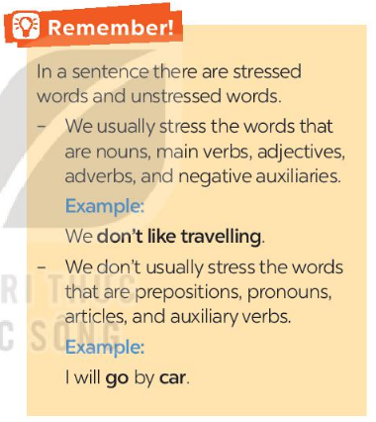
ACTIVITY 4 – PRODUCTION (7’)
a) Aims:
- To help students practise pronouncing sentences with correct stress.
- To help Ss be aware of the words they have to stress in a sentence
– To help Ss practise saying sentences with correct stress
b) Contents:
- Listen to the sentences and repeat. Pay attention to the bold syllables.
- Listen to the sentences and repeat. How many stresses are there in each sentence?
c) Products:
- Ss’ answer
d) Teaching steps:
Teacher’s and students’ activities | Content
* Teacher has students read the sentences and underline the stressed words. Then, ask them to listen to the recording once first and pay attention to the stressed syllables.  ** SS do the task independently, try to listen and repeat sentences as many times as possible as a class, a group and individually  *** Teacher calls some students to read out the sentences.   Teacher corrects their pronunciation and stress if needed.  * Teacher plays the recording for Ss to listen and repeat; then ask Ss to count the number of stresses in each sentence.  ** Ss do the task individually.  *** Teacher calls on some Ss to read the sentences in front of the class.   Teacher corrects their pronunciation if needed. | Task 4: Listen to the sentences and repeat. Pay attention to the bold syllables. (Ex 4, p. 116)  Suggested answers:  Task 5: Listen to the sentences and repeat. How many stresses are there in each sentence? (Ex 5, p.116)  Suggested answers:
IV. WRAP-UP & HOMEWORK (3’)
- Teacher asks Ss to summarise what they have learnt in the lesson by asking them some questions.
- Teacher asks Ss to do exercises in workbook.
- Teacher asks Ss to prepare the next lesson “Unit 11 – A Closer look 2”
V. FEEDBACK

……………………….…, ngày………….tháng…………..năm 2023
Duyệt của Tổ chuyên môn

