UNIT 10: OUR HOUSES IN THE FUTURE
A – TRỌNG TÂM KIẾN THỨC
I. Từ vựng
Houses in the future |  | 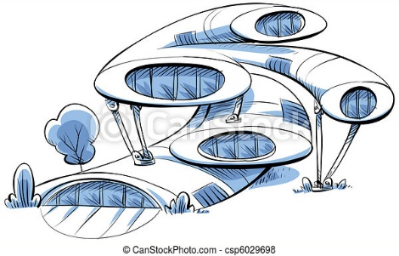
Types of house | Household Appliances
- apartment  - flat  - condominium  - penthouse  - basement  - villa  - cottage | - electric lights  - wireless TV  - dishwasher  - equipment  - solar panels  - virtual assistant  - tractor

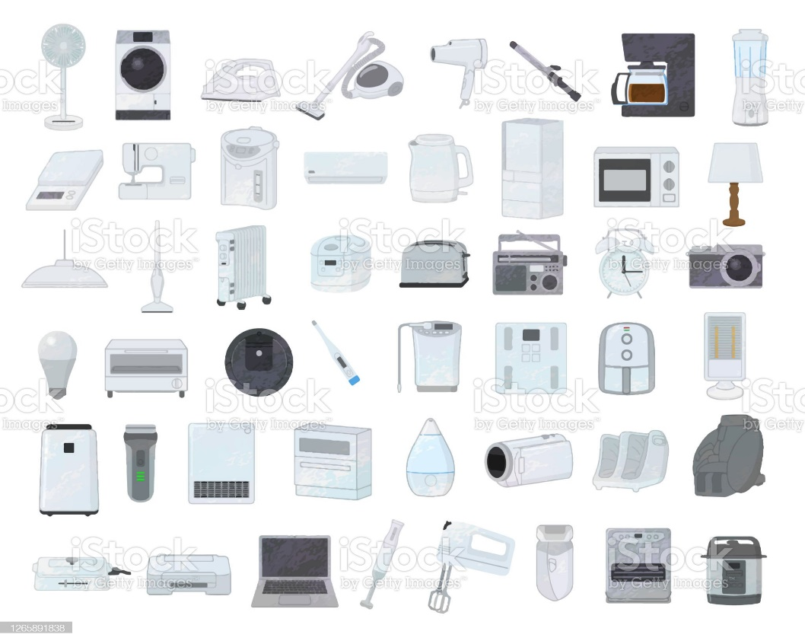 | Features of Future Houses
- futuristic
- energy-saving
- efficient
- customizable
- hi-tech
- modern
II. Ngữ âm
1. Phát âm: /θ/ vs. /ð/
Âm | Độ dài hơi | Lưỡi
/θ/ | Ngắn | Đặt ở vị trí ngay sau hàm trên và hàm dưới, rồi đẩy hơi qua khe hở | Bật hơi, không có tiếng | 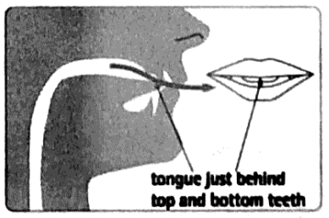
/ð/ | Ngắn |  | Không bật hơi, có tiếng
• Âm /θ/ và /ð/ có thể được nhận diện trong từ có chứa chữ th. Phân biệt:
/θ/ | thirty | Thursday | month | birthday
/ð/ | this | that | mother | other
2. Tiền tố không nhận trọng âm
Khi thêm các tiền tố sau vào (thường để hình thành từ trái nghĩa) không làm ảnh hưởng đến trọng âm của từ. Trọng âm của từ mới được hình thành rơi vào âm tiết giống với từ gốc.
-re | formation | /fɔːrˈmeɪʃn/ | reformation | /ˌrefəˈmeɪʃn/
-dis | honest | /ˈɒnɪst/ | dishonest | /dɪsˈɒnɪst/
-mis | understand | /ˌʌndərˈstænd/ | misunderstand | /,mɪsʌndərˈstænd/
-im | mature | /məˈtʃʊər/ | immature | /,ɪməˈtʃʊər/
-in | definite | /ˈdefɪnət/ | indefinite | /,ɪnˈdefɪnət/
-il | legal | /ˈliːɡl/ | illegal | /,ɪˈliːɡl/
-ir | responsible | /rɪˈspɒnsəbl/ | irresponsible | /,ɪrɪˈspɒnsəbl/
-un | employ | /ɪmˈplɔɪ/ | unemployed | /,ʌnɪmˈplɔɪ/
III. Ngữ pháp
Khi muốn nói về dự định trong tương lai gần, chúng thường sử dụng will hoặc might cùng với động từ nguyên thể. Ngoài ra, chúng ta có thể sử dụng hiện tại đơn, hiện tại tiếp diễn, hoặc cấu trúc be going to tùy vào mức độ chắc chắn của hành động.
present simple | present continuous | be going to  + bare infinitive | will / might  + bare infinitive
thời gian biểu của tàu xe, rạp phim, chương trình TV... (cố định, ảnh hưởng tới nhiều người, không thể tùy ý thay đổi) | lịch trình đã lên kế hoạch của cá nhân chắc chắn sẽ xảy ra | - lịch trình đã lên kế hoạch của cá nhân gần như chắc chắn là sẽ xảy ra  - dự đoán về việc có thể xảy ra dựa vào tình huống hiện tại | - will dùng với việc chúng ta nghĩ sẽ xảy ra trong tương lai gần;  - might dùng với việc trong tương lai gần nhưng chúng ta không chắc liệu nó có xảy ra không

B - BÀI TẬP VẬN DỤNG
I. Từ vựng
Exercise 1: Write the type of the house/building illustrated in the following pictures.
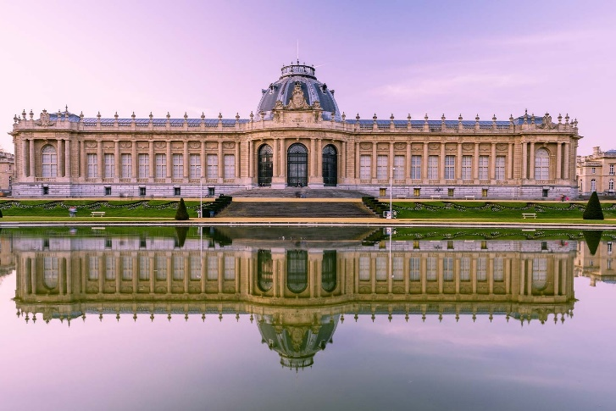 | 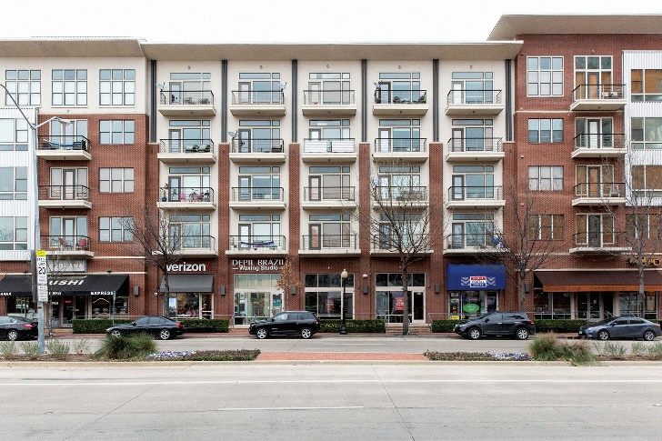
1. __________________________ | 2. __________________________
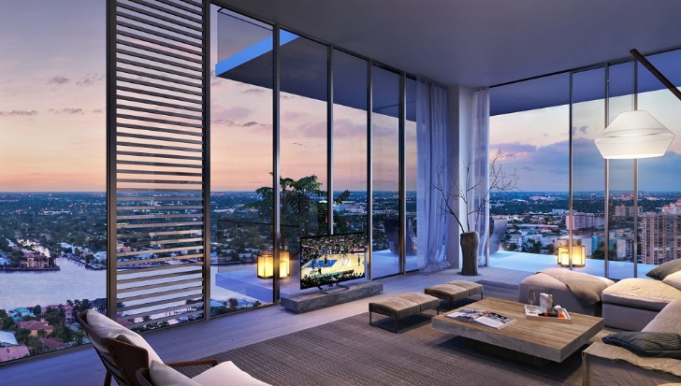 | 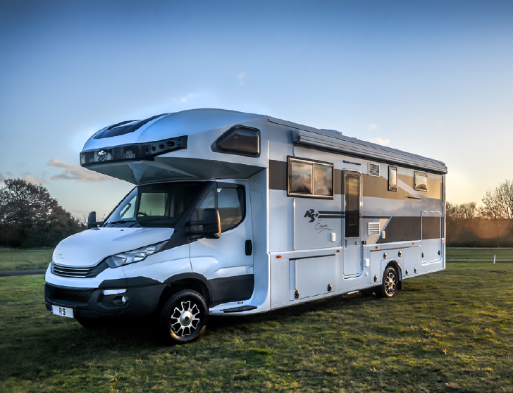
3. __________________________ | 4. __________________________
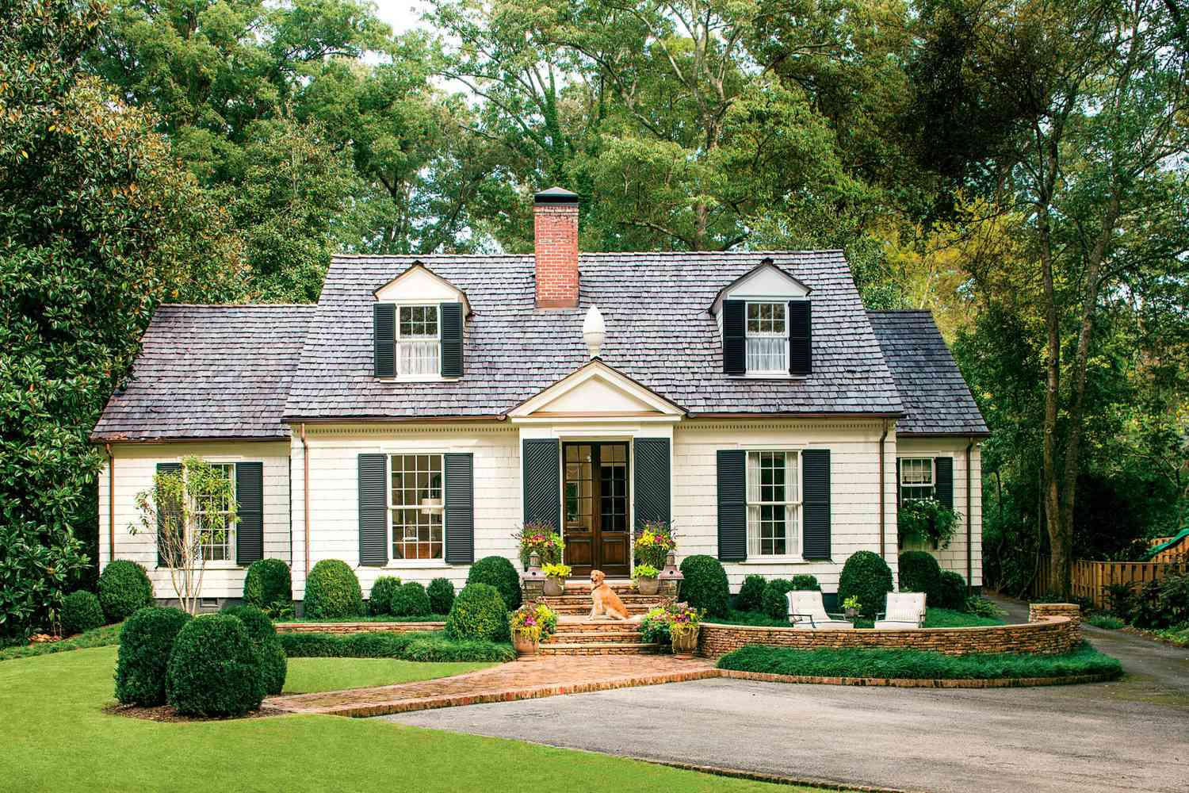 | 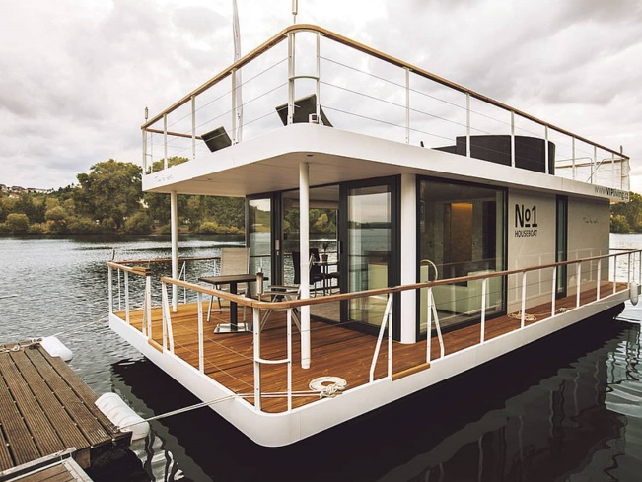
5. __________________________ | 6. __________________________
Exercise 2: Fill in the blank with given words or phrases.
appliances | modern | technology | solar | equip
electric | wireless | cottage | skyscraper | location
1. ______________ energy is a type of renewable energy that will be used more in the future.
2. Don’t forget to turn off all the ______________ lights before you leave the room.
3. My dream is to live in a charming ______________ surrounded by roses in the countryside.
4. Thanks to the advancement of ______________, we can use various types of machines to help in the house.
5. This severe winter has caused the increasing demand for modern heating ______________ of all types.
6. ______________ houses should be highly efficient in its use of energy.
7. Users can send photos or videos from a smart device such as phones or computers to a ______________ TV.
8. We ate at a restaurant at the top of the biggest downtown ______________.
9. We want to ______________ the classrooms with the latest computer and projector.
10. That beautiful bungalow is the ______________ for a film about country life.
Exercise 3: Fill in the blank with the correct form of the word given at the end of the sentence.
1. Last night our neighbourhood lost ______________ due to the storm. ELECTRIC
2. Future houses will use ______________ energy for heating and cooking. SUN
3. Do you know the of ______________ the Royal Palace? LOCATE
4. ______________ machines make our life more and more comfortable. AUTOMATE
5. I would like to live in a house with ______________ design. FUTURE
6. We can use virtual ______________ like Siri or Alexa to control our smart house. ASSIST
7. The lighting in smart houses is fully ______________ and you can adjust the brightness of different rooms. CUSTOMISE
8. Technological ______________ allow us to live conveniently. DEVELOP
9. My future house will be located on an island, ______________ by the sea. SURROUND
10. They sell a wide range of electrical ______________ such as washing machines and dishwashers. APPLY
II. Ngữ âm
Exercise 1: Put the words in the correct groups.
breathe | worthy | through | feather | soothe | bathe
theory | path | theatre | youth | author | thick
think | southern | weather | thorough | earth | further
together | Netherlands | smooth | theme | therapy | width
/θ/ |  |  | /ð/
Exercise 2: Choose the word whose underline part is pronounced differently from others.
1. A. anything | B. north | C. these | D. theory
2. A. weather | B. gather | C. method | D. thou
3. A. fourth | B. path | C. birth | D. thus
4. A. within | B. ruthless | C. throat | D. sixth
5. A. theme | B. there | C. godfather | D. either
6. A. width | B. thesis | C. though | D. ethical
7. A. smoothen | B. heath | C. lathe | D. furthermore
8. A. otherwise | B. smooth | C. rather | D. synthesis
9. A. bother | B. threaten | C. authentic | D. thief
10. A. rhythm | B. thrust | C. there | D. motherboard
Exercise 3: Choose the word whose main stress is different from the others.
1. A. unlucky | B. disagree | C. illegal | D. illicit
2. A. image | B. immoral | C. immobile | D. immune
3. A. impaired | B. impart | C. impatient | D. implement
4. A. inactive | B. enrich | C. include | D. income
5. A. unable | B. unafraid | C. unaware | D. unconvincing
6. A. uncertain | B. uncommon | C. uncountable | D. undecided
7. A. incomplete | B. unconcerned | C. unconfined | D. uncultured
8. A. undercooked | B. undamaged | C. undelete | D. undeniable
9. A. uncomfortable | B. irrelevant | C. inexpensive | D. irrational
10. A. inauthentic | B. A. irregular | C. irresponsible | D. inattention
III. Ngữ pháp
Exercise 1: Choose the best answer to complete the following sentences.
1. You have been working hard all day. You (must/ will/ could) be very tired now.
2. In the future, people (might/ must/ would) live in houses powered by solar energy.
3. It is a pity that Mary (can’t/shouldn’t/mustn’t) go to the movie theatre with us.
4. Travelling by car is so expensive these days. I (might/ can/ will) as well go to work by bus.
5. (Shall/Might/Must) we repaint our fence this weekend? I think it’s a good idea.
6. You (might/should/must) come or you can stay at home. It’s up to you.
7. The task (might/ must/ need) be finished before 2 p.m. tomorrow or your will be punished.
8. Joe (might/ will/have to) win the first prize in this singing contest, but I’m not sure.
9. (May/ Shall/Should) I ask you a favour? Could you help me with this assignment?
10. John, (may/will/shall) you come to my party this weekend?
Exercise 2: Fill in the blank with the correct modal verb (should, might, can, must) and the verb given.
1. Our plan failed this time, but I think it (work) ______________ eventually.
2. Peter is very intelligent. He (solve) ______________ these complicated math problems quickly.
3. Is that John? It (not/ be) ______________ John. He is studying abroad and won’t come back before December.
4. You (not/ walk) ______________ on the grass because it is against the rules of the park.
5. Tina, you look pale and tired. You (take) ______________ a rest.
6. Simon, you haven’t eaten anything since yesterday. You (be) ______________ really hungry now.
7. Will Ms. Brown be in charge of our class next year? I’m not sure. She (continue) ______________ teaching us or work with another class.
8. In my imagination, the future house (contain) ______________ smart devices which can be controlled by voice.
9. She is seven years old but she (not/ read) ______________ yet.
10. Why is Mary looking around the classroom? She (look) ______________ for her notebook.
Exercise 3: Fill in the blank with the verb given and will, won't or the question form.
1. I enjoy spending my time here. I (probably/ return) ______________ to this resort next year.
2. Will you come to Justin’s birthday party tonight? I (have) ______________ a date with Angela in about an hour, so I can’t come.
3. What do you think the weather (be) ______________ like tomorrow?
4. Someone is knocking the door. I (check) ______________ who that is.
5. If we get stuck in the traffic, we (arrive) ______________ at the station on time.
6. Oh, I am late, but I promise this (happen) ______________ again in the future.
7. Liam hopes that he (own) ______________ a large and modem house in the future.
8. Unless you pay more attention to the lesson, you (understand) ______________ anything.
9. When (you/ give up) ______________ this job and find a new one?
10. Whenever I meet Ms. Brown, she (give) ______________ me a hug and some cookies.
Exercise 4: Provide the correct form of the verb given (future simple, present simple and be going to).
1. I imagine my future house (be) ______________ surrounded by nature rather than buildings.
2. Do you know that Jane has fallen ill recently? Really, I (visit) ______________ her tomorrow.
3. I really hope the weather (be) ______________ fine tomorrow.
4. The train (leave) ______________ early at 6 a.m. tomorrow so don’t be late.
5. The sky is clear, so I don’t think it (rain) ______________.
6. They (possibly/ construct) ______________ a bridge across this river to make transportation easier.
7. We have to hurry. The ferry (depart) ______________ in fifteen minutes.
8. Jeremy, ______________ (you/ go) camping with us this weekend?
9. Who do you think (win) ______________ this competition?
10. They have decided that their wedding (take place) ______________ at the local church.
11. I promise I (not/ come) ______________ to class late again.
12. Probably the President (not/ deliver) ______________ the opening speech this morning.
13. When the spring (come) ______________, the Smiths will renovate their front garden.
14. My friend and I have made reservation at a seaside resort. We (spend) ______________ our summer vacation there.
15. Once they have finished decorating the room, the party (begin) ______________.
Exercise 5: Rewrite the following sentences so that the meaning does not change.
1. You had better listen to what the doctor says. SHOULD
You
2. If I were you, I would apply to that university. SHOULD
I think
3. May I use your phone to contact my family? MIND
Would
4. Could you please keep quiet for a while? MIND
Would
5. You are not allowed to make noise during the examination. MUST
You
6. They will expect you to wear smartly during the interview. HAVE
You
7. Peter will arrive at the airport. Right after that he will call you. SOON
Peter
8. I will complete my homework, then I will send it to my instructor. HAVE
Once
9. Probably we will buy a bungalow and spend our retirement there. MIGHT
We
10. Perhaps the manager is in his office now. MIGHT
The

C - BÀI TẬP LUYỆN TẬP
Exercise 1: Choose the word whose underlined part is pronounced differently from others.
1. A. robot | B. connect | C. coexist | D. role
2. A. programme | B. contact | C. product | D. complex
3. A. further | B. breath | C. sunbathing | D. though
4. A. houseboat | B. privatise | C. decrease | D. cease
5. A. palace | B. necklace | C. birthplace | D. solace
Exercise 2: Choose the word whose main stress is different from the others.
1. A. dishwasher | B. housework | C. order | D. suppose
2. A. invite | B. equip | C. locate | D. maintain
3. A. wireless | B. receive | C. surround | D. allow
4. A. appliance | B. energy | C. arrival | D. surroundings
5. A. automatic | B. examination | C. economic | D. biology
Exercise 3: Choose the best answer.
1. The washing machine and dryer will take good ______________ our clothes.
A. care to B. care of C. look at D. look after
2. Wireless TV can be connected to a PC or laptop to ______________ photos, music, or videos.
A. receive B. respond C. convey D. present
3. Modern appliances in the future house will make housework less ______________.
A. time-saving B. time-consuming C. comfortable D. convenient
4. I think future vehicles will run ______________ alternative energy such as solar power.
A. on B. in C. by D. at
5. Future robots will have the ability ______________ us in many aspects of life.
A. to help B. help C. helping D. helped
6. In the future, we might have our meals ______________ by robots.
A. cook B. cooked C. to cook D. cooking
7. Some people predict that we ______________ spend our holiday on the Moon or Mars in the future.
A. might B. should C. must D. have to
8. With the rapid development of technology, I think many household chores can be done ______________ by machines.
A. automated B. automatic C. automatically D. automation
9. My future house will be surrounded ______________ flowers and trees as I love nature.
A. by B. under C. in D. with
10. Where is Mary? I’m not sure. She ______________ in her room.
A. might sleep B. might be sleeping C. must be sleeping D. must sleep
Exercise 4: Fill in the blank with correct form of the verb given.
do | make | send | surf | water | wash | cook | clean
1. ______________ the windows can take a lot of time so I need some help from machines.
2. Do you think modem fridge ______________ our fruits besides keeping them fresh?
3. I hope my future house will have modern facilities that ______________ the bed for me.
4. Do you think robots can ______________ meals as well as a chef?
5. In the future, humans will let automatic dishwasher ______________ the dishes.
6. Modern technology allows us to ______________ the Internet using smart devices such as phones or smart watches.
7. I really need a robot assistant that helps me ______________ my house plant regularly.
8. We now can ______________ voice chat to our friends and relatives instead of text messages.
Exercise 5: Complete the sentences below using: might, might not. must, mustn't, can, can't.
1. Don’t stay up too late before the examination. You ______________ perform well if you feel tired.
2. You really ______________ put more effort in your work or you will get fired from your job.
3. You ______________ be serious when you propose that idea. That is ridiculous.
4. ______________ you help me with this task? It’s hard to do it without your support.
5. The lecturer hasn’t recovered from illness yet. She ______________ deliver the lecture tomorrow.
6. Students ______________ cheat in the exam. Otherwise, they will be heavily punished.
7. Tomlinson is an excellent student. He ______________ do well in both academic subjects and extra-curricular activities.
8. It hasn’t been decided yet but we ______________ spend our retirement in the countryside.
Exercise 6: Fill in the blank with the correct form of the word given.
1. I hope my future house will be located in pleasant ______________. SURROUND
2. Is this your dream to live in a ______________ penthouse? LUXURY
3. Mr. Smith is planning to buy some new household ______________. APPLY
4. Scientists and architectures are trying to ______________ our house. MODERN
5. ______________ chargers help us to reduce the number of cables. WIRE
6. Our life used to be ______________ due to the shortage of electricity. COMFORT
7. What is the ______________ between a palace and a castle? DIFFER
8. We visited an ______________ UFO-shaped house last week. USUAL
Exercise 7: Put a tick () at the beginning of the correct sentence. Put a cross () if the sentence contains a mistake and correct it.
1. ________ The weather forecast says that it is going to be cold and rainy all weekend.
2. ________ As soon as the night will fall, our party will begin.
3. ________ Mary’s got stuck in the traffic and she might arrive late.
4. ________ Jane has bought some reference books. She will use them to revise for the exam.
5. ________ Instead burning coal and oil, we can use solar or wind energy to power our future house.
6. ________ I hope that my future house will be equipped with modem machines.
7. ________ These kids had better to stop climbing that tree because it is too dangerous.
8. ________ Do you think the future house can take care for itself, like doing the cleaning automatically?
Exercise 8: Choose the best answer to complete the following passage.
Whenever we mention solar power, we often think of modern technology and the wave of the future. (1) ____________, using solar energy can be cost-efficient, easy to set up, and more common (2) ____________ you think: if s the thing of the present. Even if you can’t invest in a solar electric system, there (3) ____________ still some uses of solar energy that can help (4) ____________ money and energy. For example, you can harness solar energy to heat water and it can be a reasonable alternative (5) ____________ conventional gas or electric-powered models. In (6) ____________, instead of electric light bulbs, you can use outdoor solar lights (7) ____________ use solar cells to convert sunlight into electricity. In short, finding ways to maximize the solar power efficiency in your home is absolutely achievable, and there are solar units to (8) ____________ the needs of any homeowner.
1. A. Therefore | B. But | C. However | D. Because
2. A. than | B. that | C. when | D. though
3. A. is | B. are | C. have | D. has
4. A. save | B. to save | C. saving | D. Both A and B
5. A. for | B. at | C. about | D. to
6. A. short | B. addition | C. consequence | D. result
7. A. which | B. who | C. what | D. where
8. A. get | B. meet | C. talk | D. have
Exercise 9: Read the following passage and answer the questions.
Preparing for A New World: Building Homes in the Age of Climate Change
All housing needs to meet the demands of the new world. There are two important ways that these demands will change what our homes look like.
Environmental efficiency: Homes have to become greener
If we’re going to do anything to stop or slow the effects of climate change, our houses are going to have to work harder to reduce energy expenditure. Tesla has been hard at work on their solar roofs for a while now, and we’re expecting this technology to become more commonplace soon. More sleekly designed than solar panels of the past, these tiles can power your entire house. And while the technology itself costs a pretty penny, once installed, they’re actually less expensive than most people’s monthly electricity bill.
Resistance to extreme weather: Homes have to deal with unpredictable storms
Houses of the future are going to need to withstand more weather, no matter where they’re located. While we can’t know what the future will bring, we do know that more moisture in the air will lead to more storms. So we have to raise the standard for what we deem acceptable when we say “up to code.” Expect to see fire-proof and earthquake-proof bunkers included in home listings. At the very least, you should see flood and storm insurance rates increase. That’s the cost of living in the future.
1. According to the second paragraph, what will future house need to do to slow the effects of climate change?
___________________________________________________________________________________
2. What technology has Tesla been working on?
___________________________________________________________________________________
3. Is the installation cost of solar roofs high?
___________________________________________________________________________________
4. What are the second change to the future home that is mentioned in the passage?
___________________________________________________________________________________
5. What are the examples of disasters mentioned in the third paragraph?
___________________________________________________________________________________
6. What is mentioned as the cost of living in the future?
___________________________________________________________________________________
Exercise 10: Rewrite the following sentences so that the meaning does not change.
1. Jim has the ability to compose music and sing well. CAN
Jim
2. It says here that we should submit the assignment before June 6th. SUPPOSED
It says here that we are
3. I have an important test tomorrow, so I ought to leave now. BECAUSE
I had
4. You are required to take off your shoes before entering any Japanese household. MUST
You
5. I had to present my ideas clearly so my peers could understand. NECESSARY
It
6. It is forbidden to take photos in the museum. ALLOWED
You
7. It will be better for you to do your homework by yourself. RATHER
I would
8. We might not find it easy to complete our project in two days. COULD
It

