Full name: .............................................................

School: ..................................................................

Class: .....................................................................

Mark:

**Speaking Test – Unit 5**

Now let's talk about holidays. Are you ready?

**TASK 1**

1. Where do you like to go on summer holiday: a beach, a mountain or a city? Why?
2. Who do you often travel with?
3. Which country do you want to travel to?
4. What do you want to see and do there?

Each of you will now receive a card. On the card there is a picture and clues for five questions. You should use the words to make questions and ask your friends. Your friend will answer the questions based on the picture he/ she has.

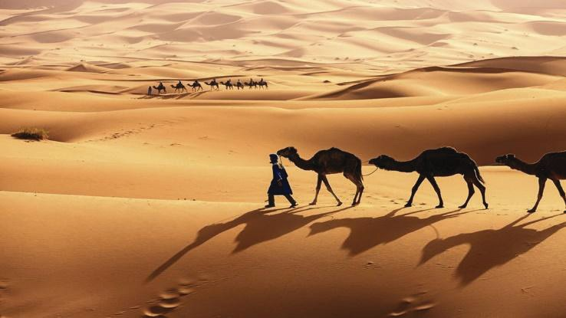

Sahara Desert

Now, your friends will ask you questions about your picture. Answer his/ her questions.

**Card A**

*Use the words given below to make questions. Ask your friend about his/ her picture and listen to the answers.*

1. What/ name/ place?
2. What/ on/ water?
3. What/ weather/ like?
4. What/ should/ bring/ travel/ here?
5. What/ natural wonder/ you/ like most?

66

**TASK 2**

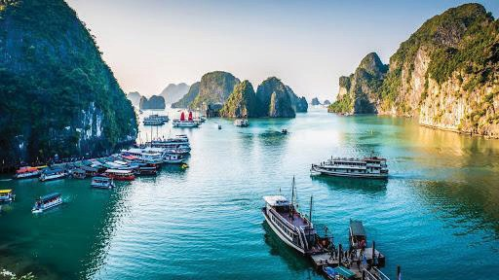

Ha Long Bay

*Now, your friends will ask you questions about your picture. Answer his/ her questions.*

**Card B**

*Use the words given below to make questions. Ask your friend about his/ her picture and listen to the answers.*

1. What/ place?
2. What/ weather/ like?
3. What/ behind/ the man?
4. What/ should/ bring/ travel/ here?
5. You/ want/ visit/ this place? Why/ Why not?

67