SPEAKING TEST ENGLISH 7
UNIT 2: HEALTHY LIVING
A. Introduction - 0.4 pt (~3 ideas):
Share something about your hobbies/ school/ friends/
B. Cue pictures (Vocabulary) – 1.0 pt (~5 questions):
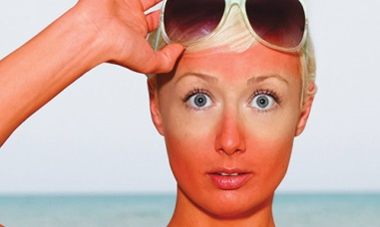  1 | 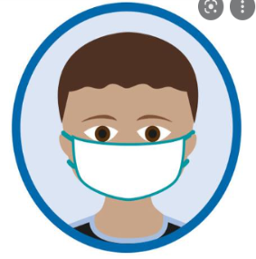  2 | 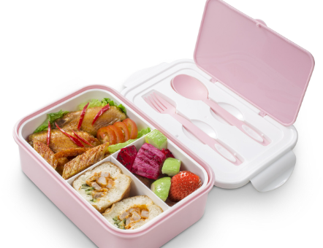  3 |   4
  12 | 1. What is this? 3/7/11  2. What problem does he/ she get? 1/5/8/10/12  3. It is an activity that helps you keep fit and stay healthy. 6  It’s an activity played by two teams of 11 players. 9  4. It’s a thing that you wear over your face to protect you from COVID-19. 2  5. What happens when you go out without hat and suncream? 1  6. This food helps you have a good health. 4 |  | 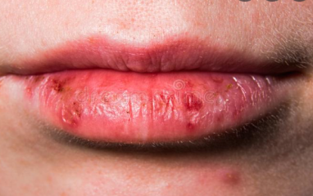  5
  11 |  |  |   6
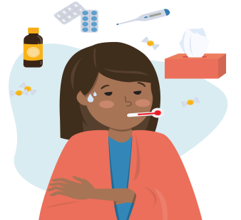  10 |   9 | 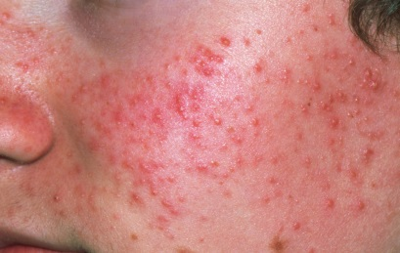  8 |   7

C-Interview/ Role-play – 0.6 pt (~3 questions/ 1 student)

Student A - B/ / Student - Teacher
1. How should you wash your face?
2. What food is good for your health?
3. How many hours a day do you need to sleep?
4. What activities do people often do to keep fit?
5. What do fruit and vegetables provide with?
6. What do healthy habits help you avoid?

SUGGESTED KEY for SPEAKING:

A. Introduction - 0.4 pt (~3 ideas):
B. Cue pictures (Vocabulary) – 1.0 pt (~5 questions):

1-sunburn 2-wear a mask 3- lunch box 4 – (coloured)vegetables
5-chapped lips 6-(do) exercise 7-soft drink 8-red spots/acne
9- playing sports/ football/… 10-flu 11-junk/fast food 12-avoid crowds
C-Interview/ Role-play – 0.6 pt (~3 questions/ 1 student)
Student A - B/ / Student - Teacher
1. With soap for acne (but no more than twice a day) – Skills 1
2. fruit, (coloured)vegetables, fish, white meat,…. - Communication
3. about 8 hours – Skills 2
4. play sports/ do morning exercise/ wash your hands/ eat tofu, vegetables/…..
5. vitamins –Skills 2
6. disease(s) – Skills 2
***Teachers depend on Ss’ answers to mark their speaking test flexibly

