|  |  |
| --- | --- |
| **Tiếng Anh 8 Friends Plus** | **FP 8 – REVIEW 1 - TEST 1**  **Test for Unit**  *-------------------------* |

**I. Pronunciation (1-4)**

**Câu 1.** Which word has the underlined part pronounced differently from that of the others?

**A.** amazingly  **B.** fad

**C.** apparently  **D.** absolutely

**Câu 2.** Which word has the underlined part pronounced differently from that of the others?

**A.** general  **B.** gadget  **C.** friend  **D.** trend

**Câu 3.** Which word has a different stress pattern from that of the others?

**A.** obvious  **B.** patterned  **C.** amazing  **D.** social

**Câu 4.** Which word has a different stress pattern from that of the others?

**A.** trousers  **B.** hoodie  **C.** design  **D.** alpaca

**II. Choose the answer (A, B, C or D) that best fits the space in each question. (5-14)**

**Câu 5.** Do you have a favourite shoe brand? – ‘___________’

**A.** I hope they will open new branches soon.

**B.** My favourite store is nice, I visit it all the time.

**C.** I have a few shoe brands that I really like, but I wouldn't say I have a favourite.

**D.** I really like my shoe brand.

**Câu 6.** ___________, the movie is fully booked and we can't get tickets anymore.

**A.** Unfortunately  **B.** Happily

**C.** Luckily  **D.** Sadness

**Câu 7.** The ___________ was packed with people and loud music.

**A.** library  **B.** park  **C.** museum  **D.** club

**Câu 8.** While Mary ___________ in the garden, her husband ___________ her.

**A.** was working/ called  **B.** work/ called

**C.** worked/ calling  **D.** was working/ calls

**Câu 9.** This jacket is so cool, I will try it ___________.

**A.** at  **B.** on  **C.** with  **D.** for

**Câu 10.** 50 years ago, only a few people ___________ computers, but most of them were very large.

**A.** can afford  **B.** can not afford

**C.** could not afford  **D.** could afford

**Câu 11.** My grandmother always tells me about how she ___________ to cook for her whole family when she was young.

**A.** cooks  **B.** cook

**C.** used to cook  **D.** cooking

**Câu 12.** What's your go-to outfit for a first date? – ‘___________’

**A.** I like our outfit too.  **B.** I usually wear something casual but nice.

**C.** For a first date, I’m always on time.  **D.** I don’t mind changing clothes.

**Câu 13.** Social media and online gaming are some of the recent trends ___________ teenagers.

**A.** about  **B.** for  **C.** at  **D.** from

**Câu 14.** I need to buy a new ___________ for my friend's wedding.

**A.** presents  **B.** cake  **C.** gifts  **D.** dress

**III. Look at the signs. Choose the best answer (A, B, C or D). (15-16)**

**Câu 15.**

What is the current promotion at the store?



**A.** 10% discount on everything on Saturday  **B.** 20% discount on everything on Sunday

**C.** 20% discount on everything on Saturday  **D.** 50% discount on everything on Saturday

**Câu 16.**

What is the current promotion at the clothes store?

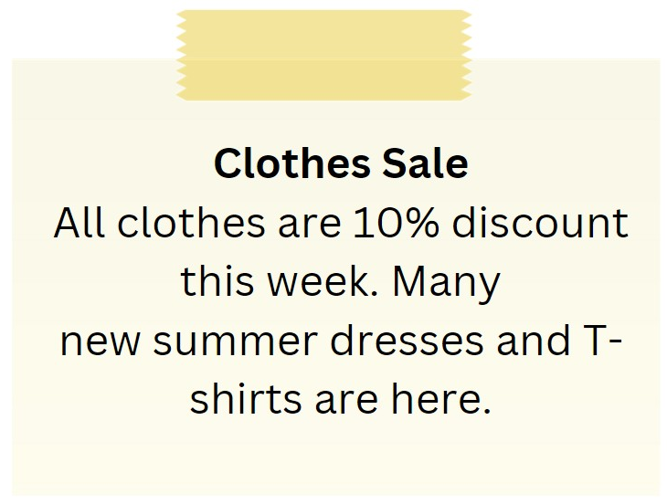

**A.** Buy one get one free on summer dresses  **B.** 10% discount on all clothes

**C.** 20% discount on all clothes  **D.** Free T-shirt with every purchase

**IV. Read the following passage and do as direct. (17-22)**

A lot of people wear jeans. Many people regularly wear jeans. They are cozy and simple to wash.

Jeans come in a variety of hues. Blue is the most typical colour. However, you may also buy jeans in green, grey, and black. Strong cotton is used to make jeans. They can be washed frequently because they are made of cotton. Some jeans contain patterns or holes. Young people enjoy these trendy jeans. Simple blue jeans, though, are timeless.

All ages can wear jeans. They are worn by both young and old people. Jeans can be worn casually at work or on the weekends. They are typical student attire. Jeans are useful. Due to their comfort, affordability, and compatibility with a wide range of tops and shoes, they are among the most often worn types of pants worldwide.

**Câu 17.** Jeans are difficult to wash.

**A.** False  **B.** True

**Câu 18.** Blue is the most common colour for jeans.

**A.** True  **B.** False

**Câu 19.** Jeans are only worn by young people.

**A.** False  **B.** True

**Câu 20.** Jeans are made of strong cotton.

**A.** True  **B.** False

**Câu 21.** What other colours can jeans come in?

**A.** Orange, pink, and brown  **B.** Red, yellow, and purple

**C.** Green, grey, and black  **D.** White, silver, and gold

**Câu 22.** Why are jeans popular?

**A.** They are uncomfortable and expensive

**B.** They are comfortable, affordable, and compatible with a wide range of tops and shoes

**C.** They are only compatible with a few tops and shoes

**D.** They can only be worn on special occasions

**V. Choose the word (A, B, C or D) that best fits the blank space in the following passage. (23-28)**

My friend Sarah **___23____** on a fantastic trip last summer. She visited the **___24____** city of Edinburgh in Scotland. Sarah stayed in a cosy bed and breakfast in the heart **___25____** the city. During her trip, she explored the historic Edinburgh Castle and **___26____** along the famous Royal Mile. Sarah also took a day trip to the stunning Scottish Highlands, **___27____** she saw breathtaking landscapes and enjoyed the fresh mountain air. She even tried haggis, a traditional Scottish dish, and was pleasantly surprised by how delicious it was. In the evenings, Sarah enjoyed live music **___28____** in small pubs and bars. Overall, Sarah had an amazing time on her trip and can't wait to visit Scotland again someday.

**Câu 23.** My friend Sarah ___ on a fantastic trip last summer.

**A.** gone  **B.** went  **C.** goes  **D.** go

**Câu 24.** She visited the ___ city of Edinburgh in Scotland.

**A.** noisy  **B.** crowded  **C.** polluted  **D.** beautiful

**Câu 25.** Sarah stayed in a cosy bed and breakfast in the ___ of the city.

**A.** suburbs  **B.** outskirts

**C.** countryside  **D.** heart

**Câu 26.** During her trip, she explored the historic Edinburgh Castle and ___ along the famous Royal Mile.

**A.** flew  **B.** ran  **C.** drove  **D.** walked

**Câu 27.** Sarah also took a day trip to the stunning Scottish Highlands, ___ she saw breathtaking landscapes and enjoyed the fresh mountain air.

**A.** who  **B.** where  **C.** which  **D.** when

**Câu 28.** In the evenings, Sarah enjoyed live music ___ in small pubs and bars.

**A.** performances  **B.** shows

**C.** concerts  **D.** gigs

**VI. Supply the correct form of the word given in each sentence. (29-34)**

**Câu 29.** She stared in ________ at the beautiful sunset. [amaze]

**Câu 30.** He ________ refused to go to the party. [absolute]

**Câu 31.** The dress she wore was beautifully ________ with flowers and leaves. [pattern]

**Câu 32.** Despite his best efforts, he was ________ in winning the race. [success]

**Câu 33.** The ________ of the trip was more than he had expected. [expensive]

**Câu 34.** The colours of the old photograph had ________ over time. [fade]

**VII. Rearrange the groups of words in a correct order to make complete sentences. (35-36)**

**Câu 35.** perfume company / James Bell has / worked for a / for over twenty / years.

…

**Câu 36.** of roses. / smell anything, even / the fragrances / She can’t

…

**VIII. Rewrite each of the following sentences in another way so that it means almost the same as the sentence printed before it. (37-40)**

**Câu 37.** Mary has been studying French for 5 years.

Mary started …

**Câu 38.** You should always wear a helmet when riding a bike.

You ought …

**Câu 39.** How about going for a walk in the park? (we)

Why don't …

**Câu 40.** It's important to turn off the lights when leaving the room.

Don't forget …

**IX. Listening: listen and do as direct. (41-50)**

*A dialogue between two friends talking about food:*

**Câu 41.** Which of the following is a Thai dish?

**A.** Sushi  **B.** Pad Thai  **C.** Tacos  **D.** Pizza

**Câu 42.** What did Friend 2 have at the Thai restaurant?

**A.** Pizza  **B.** Pad Thai  **C.** Tacos  **D.** Sushi

**Câu 43.** How did Friend 2 describe the Pad Thai?

**A.** Salty  **B.** Spicy  **C.** Bland  **D.** Sweet

**Câu 44.** What type of food does Friend 1 usually go for?

**A.** Thai  **B.** Chinese  **C.** Italian  **D.** Mexican

**Câu 45.** Why did Friend 2 suggest trying sushi?

**A.** Because it's Italian  **B.** Because it's boring

**C.** Because it's new  **D.** Because it's Thai

**Câu 46.** What did Friend 1 say about trying new things?

**A.** They only like trying Italian food  **B.** They're getting bored of Italian food

**C.** They're allergic to new things  **D.** They don't like trying new things

**Câu 47.** What type of food did Friend 2 suggest trying besides Thai?

**A.** Sushi  **B.** Chinese  **C.** Italian  **D.** Mexican

**Câu 48.** What did Friend 1 say about sushi?

**A.** They've never tried sushi  **B.** They love sushi

**C.** They don't like sushi  **D.** They're allergic to sushi

**Câu 49.** What did Friend 2 say about going to the sushi place?

**A.** They love sushi  **B.** They don't want to go alone

**C.** They're too busy to go  **D.** They're allergic to sushi

**Câu 50.** What was Friend 1's response to being invited to the sushi place?

**A.** They said they were too busy to go.  **B.** They declined the invitation

**C.** They accepted the invitation  **D.** They said they were allergic to sushi

**----HẾT---**