School: ……………………………………….. | Date:……………………………………..
Class: ……………………………..................... | Period: …………………………….........

UNIT 6: LIFE ON OTHER PLANETS
Lesson 1.1 - Vocabulary and Reading (pages 54 & 55)
I. OBJECTIVES
By the end of the lesson, Ss will be able to:
1.1. Language knowledge and skills
- talk about life on other planets, using phrases: live on Earth, Mars, Venus, oxygen, space station, gravity, temperature.
- practice reading and understanding general and specific information about different places people can live in the future.
1.2. Competences
- improve communication, collaboration, analytical and critical thinking skills.
1.3. Attributes
- be aware of the home humans will live in in the future.
II. TEACHING AIDS AND LEARNING MATERIALS
1. Teacher’s aids: Student book and Teacher’s book, class CDs, Digital Book (DCR phần mềm tương tác SB, DHA (từ vựng/ cấu trúc) phần mềm trò chơi tương tác), projector/interactive whiteboard / TV (if any), PowerPoint slides.
2. Students’ aids: Student’s book, workbook, notebook.
III. ASSESSMENT EVIDENCE
Performance Tasks | Performance Products | Assessment Tools
- Introduce some nouns about future home.  - Fill in the blanks according to pictures and descriptions.  - Listen and repeat.  - Discuss which place students would like to visit.  - Read the magazine article and complete the reading tasks.  - Talk about places students would prefer to live. | - Ss’ answers in notebooks.  - Ss’ answers.  - Ss’ answers/ presentation.  - Ss’ answers.  - Ss’ answers. | - T’s feedback.  - T’s observation/ DCR.  - T’s observation.  - T’s feedback/Peers’ feedback.  - T’s feedback/Peers’ feedback.
IV. PROCEDURES
A. Warm up: (5’)
a) Objective: Introduce the new lesson and set the scene for Ss to acquire new language; get students' attention at the beginning of the class by enjoyable and short activities as well as to engage them in the follow-up steps.
b) Content: Introducing some nouns and nouns phrases related to future home.
c) Expected outcomes: Ss have general ideas about the topic of the new lesson: “Life on other planets”.
d) Organization of the activity:
TEACHER’S ACTIVITIES | STUDENTS’ ACTIVITIES
Asking questions:  - Show the picture on the interactive whiteboard / TV.  - Ask Ss about their predictions about where humans will live in the future.  What can you see in the picture?  Who are they?  Where are they?  Do you think humans will live on a different planet in the future? Why (not)?  - Set time for this activity.  - Get the answers from students.  - Lead to the new lesson. | - Discuss the questions.  - Give answers.  Ss’ own answers

B. New lesson (35’)
- Activity 1: Pre-Reading (Vocabulary) (12’)
a) Objective: Ss know some nouns/ noun phrases about the future home humans will live in.
b) Content:
- Vocabulary study (live on Earth, Mars, Venus, planet, oxygen, space station, gravity, temperature, view).
- Speaking: Discuss where humans will live in the future.
c) Expected outcomes: Ss know how to pronounce the new words correctly and use them in appropriate situations.
d) Organization of the activity:
TEACHER’S ACTIVITIES | STUDENTS’ ACTIVITIES
- Have Ss work in pairs and ask What can you see in each picture?  - Lead to teach vocabulary.  Teaching Vocabulary  - Explain the meaning of the new vocabulary, using pictures, examples and explanations.  - Earth (Definition: the world which humans live on.)  - Mars (Explanation: Its color is red.)  - Venus (Explanation: It's the 2nd planet from the sun. Its color is yellow.)  - planet (Earth, Mars and Venus are planets.)  - space station (picture)  - oxygen (Example: The symbol for oxygen is O2.)  - gravity (picture)  - temperature (picture)  - Have Ss read the words.  - Check Ss’ pronunciation and give feedback.  - Check Ss’ understanding by matching pictures and words on the interactive whiteboard / TV (Books closed).  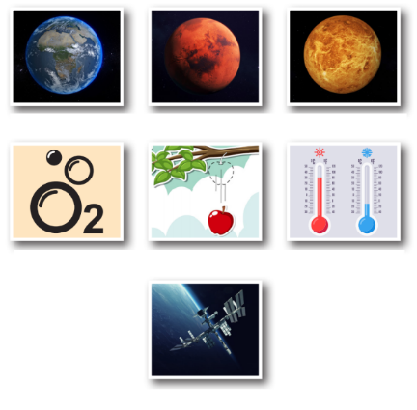  - Call Ss to give answers (read or write).  - Check answers as a whole class.  - Call some Ss to read the words again.  - Correct Ss’ pronunciation if necessary.  Task a. Look at the pictures and fill in the blanks.  - Have Ss discuss the sentences in pairs to fill the blanks.  - Have Ss share their ideas.  - Check answers as a whole class.  Task b. In pairs: Would you like to visit another planet or a space station? Why (not)?  - Have pairs discuss whether they would like to visit another planet or a space station and the reason.  - Give feedback. | - Work in pairs.  - Listen.  - Read.  - Give answers.  Answer keys  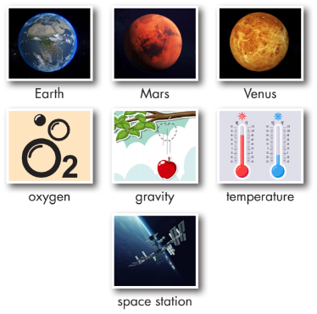  - Read/ Write the words.  - Read the words again.  - Work in pairs.  - Share their ideas.  Answer keys  - temperature 3. gravity  - Mars 5. Venus  - space station 7. oxygen  - Work in pairs.  Suggested answer  Yes, I'd like to visit a space station. It would be really cool to see Earth from there.
- Activity 2: While - Reading (17’)
a) Objective: Students can develop their reading skill.
b) Content: Reading the magazine article about A New Home in the Future and choosing the main idea, reading the questions and giving the correct answers.
c) Expected outcomes: Students can read and understand general and specific information related to future home.
d) Organization of the activity:
TEACHER’S ACTIVITIES | STUDENTS’ ACTIVITIES
Task a. Read the magazine article. What is it about?  - Use DCR to show the task. Ask Ss to read two options and find out key words in the text to select the correct answer.  - Have Ss read the article individually.  - Have Ss choose the correct answer.  - Have some Ss share their answers with the class (read), and explain their answers.  - Give feedback and correct Ss’ answers.  Task b. Now, read and answer.  - Use DCR to show the task.  - Have Ss read the text again and review the steps: read the questions, identify and underline the key words, find them in the text, and give the correct answers.  - Have Ss check answers with their partners.  - Call Ss to give answers and explain.  - Give feedback.  Task c. Listen and read.  - Play audio. Have Ss listen and read.  - Provide feedback on pronunciation and intonation if needed. | - Work individually.  - Choose the correct answer.  - Read and explain the answers.  - Check answers.  Answer keys  Reading a. 1. different places people can live in the future.  - Read, underline, find key words, and give the correct answers.  - Do the task.  - Check answers.  Answer keys  Reading b.  2. It's much lower.  3. It’s very hot.  4. Because people won't have to  travel far.  5. B. recently made  - Listen and read the text aloud.
- Activity 3: Post - Reading (6’)
a) Objective: Students can use the vocabulary and ideas from the reading text to develop their speaking skill.
b) Content: Speaking: Would you prefer to live on Mars, Venus, or a space station? Why?
c) Expected outcomes: Students can talk about their preferences and reasons for future home, and show their interest in what other students say.
d) Organization of the activity:
TEACHER’S ACTIVITIES | STUDENTS’ ACTIVITIES
Task d. In pairs: Would you prefer to live on Mars, Venus, or a space station? Why?  - Have students work in pairs to talk about their preferences and explain the reasons.  - Divide the board into two parts (on other planets and on a space station). Give each pair sticky notes to write down their ideas.  - Tell Ss to stick them on the boards when they finish the task.  - Set the time for the activity.  - Move around to assist Ss if needed.  - Call some pairs to share their ideas with the whole class.  - Give feedback.  - If there is time left, have Ss walk to the board and read their classmates’ preferences.  - For more practice, have Ss play the consolidation games, using DHA. | - Discuss in pairs and give the answers.  - Write down the ideas on sticky notes.  - Stick them on the board.  - Share the ideas.  Ss’ own answers

C. Consolidation and homework assignments (5’)
* Consolidation:
- Nouns/ noun phrases about future home: live on Earth, Mars, Venus, oxygen, space station, gravity, temperature.
* Homework:
- Learn the new words.
- Practice talking about future home.
- Do the exercises in WB: Unit 6 - Lesson 1 - New words + Reading (pages 32 & 33).
- Do the exercises in Tiếng Anh 8 i-Learn Smart World Notebook (pages 46 & 47).
- Play the consolidation games in Tiếng Anh 8 i-Learn Smart World DHA App on www.eduhome.com.vn
- Prepare: Lesson 1.2 – Grammar (pages 55 & 56 – SB).
V. Reflection
a. What I liked most about this lesson today:
………….………………………………………………………………………………
- What I learned from this lesson today:
…………………………………………………………………………………………
c. What I should improve for this lesson next time:
…………………………………………………………………………………………

