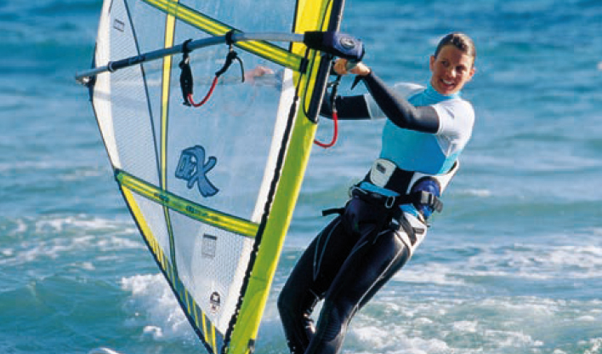**Exercise 1: Listen to an interview with Jackie Smith, a windsurfing champion. Answer the questions.**

1. Who were her role models when she started windsurfing?
2. What other water sports has she tried?
3. Who are her role models now?

**Exercise 2: Listen again and complete the sentences with NO MORE THAN THREE WORDS.**

1. Jackie was ____________ when she won the international windsurfing championship.
2. When Jackie's mum was ____________, she took part in windsurfing events herself.
3. Jackie learnt to swim when she was about ____________.
4. Although Jackie is ____________ younger, she has always admired Rachel.
5. Jackie and Rachel both became members of a ____________ when they were young.
6. Jackie's mum encouraged her when she took up ____________.
7. In Jackie's first windsurfing competition, she finished in ____________ place.
8. Jackie thinks that she is very much like her ____________.

**ANSWER KEY**

Exercise 1:

1. Her mum and cousin Rachel.
2. Sailing, swimming, rowing
3. Mum and Rachel.

Exercise 2:

1-sixteen 2-a teenager 3-seven 4-two years

5-children’s sailing club 6-rowing 7-fifth 8-mom

TRACK

1.24

Presenter: Welcome back to the Sports Programme. The topic of today's programme is role models. We have sixteen-year-old Jackie Smith in the studio, and she's going to talk to us about the people who encouraged her to take up competitive sport. First of all, congratulations Jackie. Last month you became the world under eighteen windsurfing champion!

Jackie: Yes, that's right. Thank you.

Presenter: So, why did you take up windsurfing? Who inspired you?

Jackie: Two people really: my mum and my cousin, Rachel. I first went windsurfing with my mum. We lived near the sea, and we spent every summer on the beach. My mum had entered windsurfing competitions when she was a teenager. She didn't win anything, but she really enjoyed it. She started to teach me how to windsurf as soon as I could swim and I picked it up really quickly. I was only about seven years old. My cousin Rachel was there too. She and her family lived near us. My mum gave us both lessons together. Rachel's two years older than me and I've always looked up to her. I still do.

Presenter: Was your cousin a good windsurfer?

Jackie: Yes, she was good at a wide range of sports. But she wasn't big-headed about it – she's a very modest person. She was a really good example for me – I wanted to be sporty like her, but I also learnt a lot about being a better person.

Presenter: So you grew up near the sea. What other water sports did you do?

Jackie: All sorts. At first, windsurfing wasn't my favourite thing. I liked other water sports like swimming and sailing. Rachel talked me into joining the children's sailing club. We spent all our weekends there, even in winter. We did lots of sailing, and then Rachel thought we should try out rowing. I wasn't sure about rowing at first – I found it a bit boring and slow, which put me off. To be honest, I think I'm more of an individual sports person, and with rowing you're dependent on at least one other person. But my mum thought it was a good idea. Now I'm glad I did it because it made my arms strong, and that helped my windsurfing.

Presenter: So when did windsurfing become your number one sport?

Jackie: Well, it was thanks to Rachel. She went in for a windsurfing competition when she was fifteen – I always wanted to do the same as her so I entered the competition too. She came second and I came fifth! But I really enjoyed myself, and that was the moment when I decided that windsurfing was my sport. I'm quite ambitious as well as competitive and I wanted to come first, not fifth.When I set my mind on something, I never give up so I was determined to go in for more competitions.

Presenter: Well, you've certainly succeeded! Are your mum and your cousin still your role models?

Jackie: Yes, definitely. I think I take after my mum – I hope I have some of the same qualities anyway. And Rachel is like a big sister to me. They both come to all my competitions to cheer me on.